HanuAi ML Assessment – Task 2
Stakeholder Report: Radio and Display Failures in 1,000 Service Events
Prepared by Velamala Balakrishna | October 2026 | Dataset: Hanuai task2 assignment.csv (1,000 events, Aug 2019 – Jun 2021)

1. Summary
I went through 1,000 service events and used the free-text notes (what the customer said, what the technician found, what was done) to pull out structured tags, group them into issue categories and cluster them into failure themes. The short version:
- It is almost all one system. The infotainment unit is the problem. The radio is named in about 70% of customer complaints and the display in about 39%. Black screen, inoperative and intermittent behaviour are the most common symptoms.
- The fix is nearly always a new radio. The radio was replaced in 86% of events and the new unit was programmed or updated in about 77%. Only 8.5% were fixed by programming or an update alone. That means most of the cost is parts and labour for a full swap.
- Hardware and communication faults are the biggest causes. 46% of events were classed as hardware component failure and 28% as communication / connectivity loss. Software / programming is next at 14%, and wiring or electrical at 10%.
- Seven natural failure groups came out of the text. The two biggest are "software, USB and phone-link problems" (29%) and "radio module with no power or lost communication" (27%). Smaller but very specific groups are rear-view camera, XM signal drop-outs, blank display, internal fault found by scan and navigation SD-card errors.
- Time to failure is short. About one in five events happened within 90 days of the vehicle going into service and 75% within a year (median 228 days, based on 924 events with a valid date).
- Technicians often need help. 30.1% of notes mention TAC, Techline or engineering, so a lot of these cases cannot be solved at the dealer alone.

2. Data and approach
The file has 1,000 rows and 20 columns. Each row is one event with the customer complaint, the technician's cause and correction notes, build and in-service dates, plant, make and model, plus two dealer codes (complaint code and causal code). Only 5 rows had the tag columns (Trigger, Failure Component, Failure Condition, Additional Context, Fix Component, Fix Condition) filled in, so I used those as a style guide and filled the rest from the text.
Cleaning was light: dates were converted, blank notes were treated as missing, one missing in-service date was filled with build date plus the median gap (91 days), and 3 missing causal codes were set to "Unknown". There were no duplicate events. 76 events were opened before their recorded in-service date, which cannot be right, so I flagged them and left their time-in-service empty rather than keep negative numbers. The model year column has only one value (2020), so it is not useful.
Tagging uses dictionaries of keywords and patterns that I wrote after reading a lot of the notes. I chose this over a pre-trained entity model because the notes are short, mostly capital letters, full of shop shorthand (C/S, SPS, TAC, DTC) and often have words stuck together. Clustering uses TF-IDF on the combined text with K-Means (7 clusters).

3. What the data shows

3.1 Who and where
Fort Wayne (21.7%), Flint (20.8%) and Silao (19.9%) built the most affected vehicles, followed by Spring Hill (16.9%) and Lansing Delta (14.2%). ThunderVolt is the largest make at 48.8%, then NovaSprint at 33.5%. The top models are HyperFury X (148 events), TurboFlare (117) and QuantumRider (109).
Careful: I do not have production volumes, so these are counts, not failure rates. A plant with more events may simply have built more vehicles.
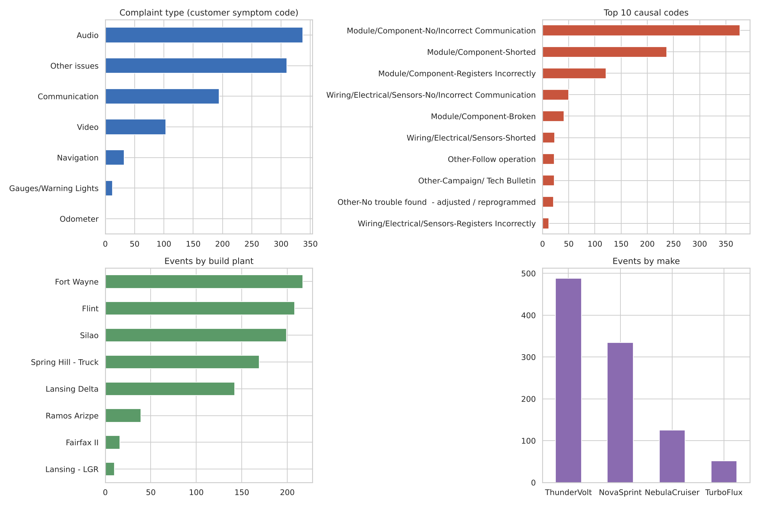
Figure 1: Complaint types, causal codes, build plants and makes

3.2 Over time
Events start in August 2019 and climb quickly to 67–69 per month in January to March 2020. They stay high (about 45–65 per month) through the rest of 2020 and slowly fall during 2021. The last months look low because the data stops in mid-2021, so I would not read that as an improvement without checking the extract date.
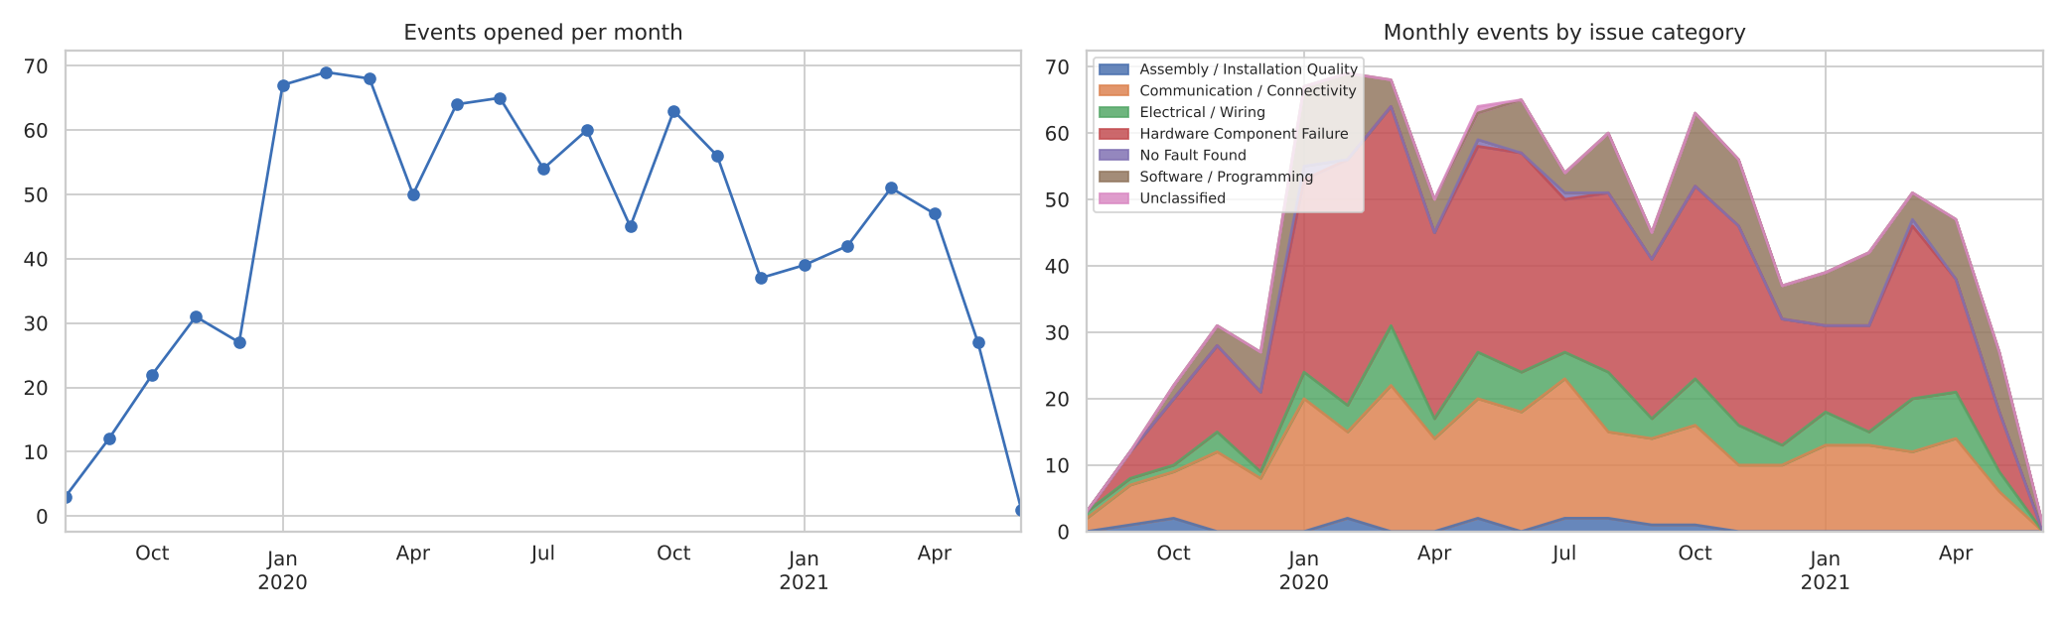
Figure 2: Events per month, and by issue category

4. Text mining results
The tables below show the most common tags found. A single event can carry several tags.
Failure component | Events | Failure condition | Events
Radio | 703 | Inoperative | 284
Display | 388 | Black screen | 250
Audio / speakers | 164 | Intermittent | 198
Camera | 133 | Connectivity failure | 121
Satellite radio | 122 | Error / warning message | 112
Bluetooth / phone | 77 | Reboot / reset | 105
Navigation / GPS | 65 | No sound | 103
OnStar / telematics | 36 | Malfunction | 83

Fix action | Events | What the technician found | Events
Replaced | 880 | Internal module fault | 251
Programmed | 735 | Software / programming | 207
Software updated | 226 | Loss of communication | 116
Repaired | 82 | Diagnostic trouble code stored | 109
Cleared codes | 61 | Short / overload | 66
Reset | 56 | Poor connection / terminal | 43
No fault found | 25 | Battery / voltage | 28
No repair action recorded | 30 | Could not duplicate | 22

Two things I could not do. First, the actual trouble code numbers (for example U0100) are not in the text, so I only know whether a code was mentioned (153 events), not which one. Second, 5 labelled rows is too few to measure tagging accuracy properly. On those 5 rows my tags found about 80% of the human failure components and 50–60% of the fix tags and conditions, but two of the five have very short or cut-off notes, so I treat that as a rough check only.
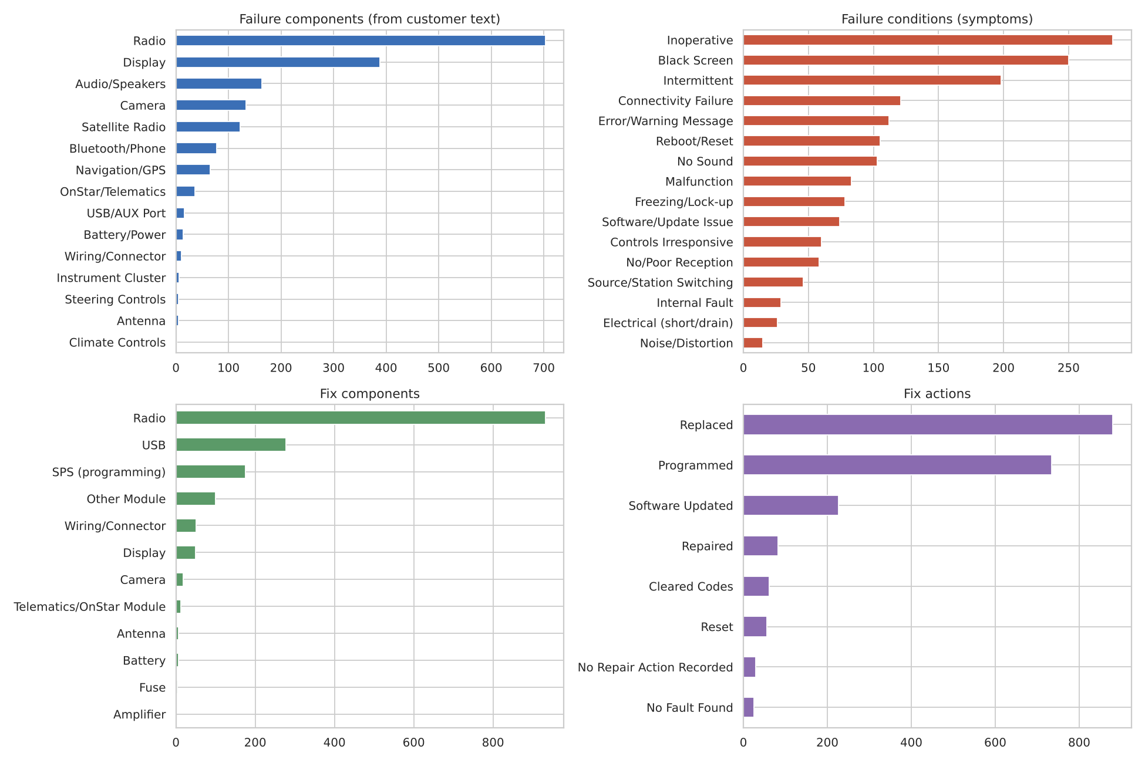
Figure 3: Most common extracted tags

5. Issue categories
I grouped events into six categories using the tags, the technician text and the dealer causal code. It is a scoring rule, not a trained model, because there are no labels to train on.
Issue category | Events | Share | Typical evidence
Hardware component failure | 463 | 46.3% | Internal module fault, radio replaced, shorted or broken module
Communication / connectivity | 280 | 28.0% | Lost communication with the radio, no or incorrect communication code
Software / programming | 141 | 14.1% | Fixed by reprogramming or update, bulletin or campaign, freezing and reboots
Electrical / wiring | 97 | 9.7% | Poor connection, terminal, short, battery or voltage, wiring repaired
Assembly / installation quality | 13 | 1.3% | Wrong part installed, connector not seated, pinched or misrouted
No fault found | 5 | 0.5% | Could not duplicate and nothing replaced
Unclassified | 1 | 0.1% | Not enough text

Hardware is the largest bucket partly because replacing the radio is the standard repair, so it appears in almost every row. That is why I weighted the technician's diagnosis more than the repair action. The split between hardware and communication is the least certain part of this analysis, because a radio that "lost communication" can be a bad radio or a bad network.
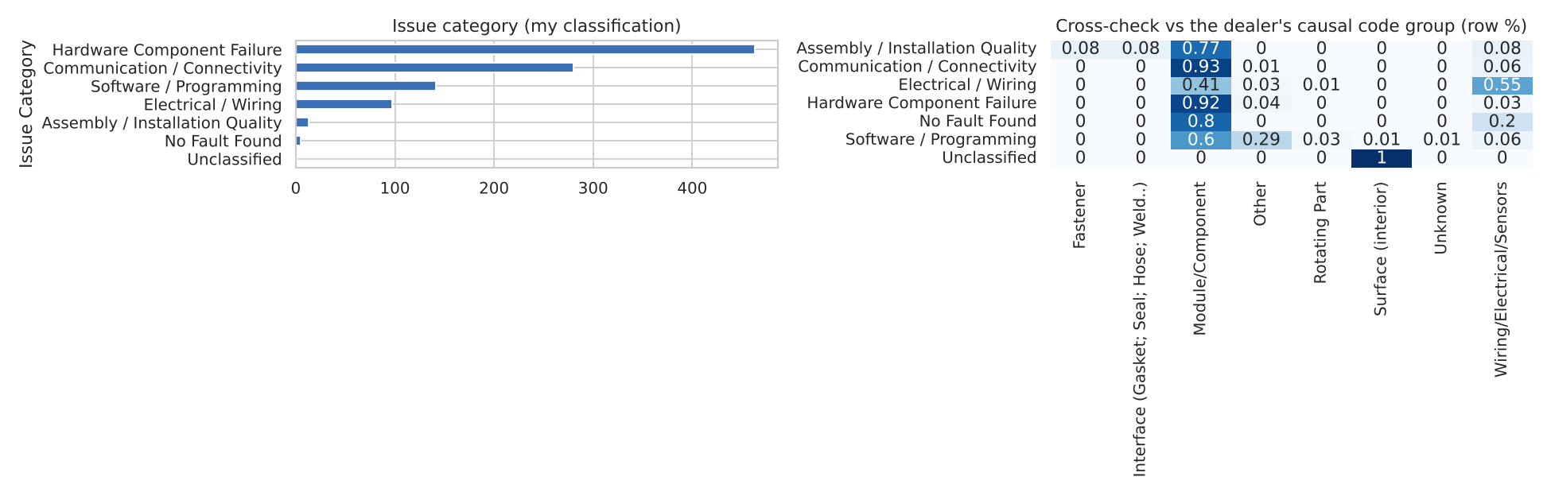
Figure 4: Issue categories and cross-check with dealer causal code groups

6. Failure clusters and likely root causes
K-Means on TF-IDF vectors gave seven groups. The clusters are named by me after reading top terms and sample notes. The silhouette score is low (about 0.03), which is normal for short notes that all talk about the same radio, so treat the clusters as themes with overlap, not clean boundaries.
Cluster | Events | Top terms | Likely root cause (my reading)
Software, USB and phone-link problems | 286 (28.6%) | usb, update, program, phone, software, sps | Software or calibration defects; USB and phone connection handling. Many are solved by reprogramming.
Radio module: no power / lost communication | 269 (26.9%) | module, power, communication, ground, circuits | Power and ground test fine but the module does not respond: internal radio failure or a communication bus fault.
Blank / black display | 134 (13.4%) | screen, blank, goes blank, display | Display or video link dropping out while audio can keep playing; possible software rendering fault.
XM / audio signal drop-outs | 122 (12.2%) | xm, signal, stations, antenna | Tuner, antenna or antenna connection; signal loss on cold start or while driving.
Rear-view camera / video cable | 85 (8.5%) | camera, backup, coax, cable, video | Camera video cable or connector fault between the camera and the radio.
Internal radio fault confirmed by scan | 58 (5.8%) | internal fault, scan codes, replace radio | Clear hardware failure inside the radio found during scan.
Navigation SD-card errors | 46 (4.6%) | sd card, navigation, card removed, error | Card reader or card compatibility; navigation data not recognised.

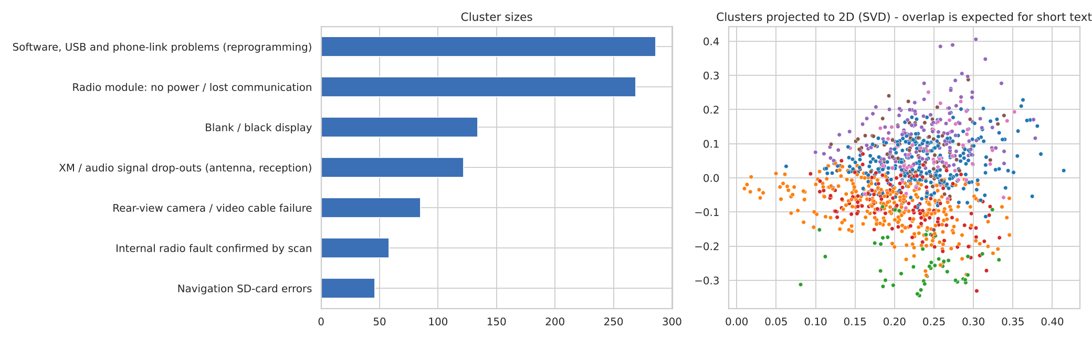
Figure 5: Cluster sizes and a 2D projection of the text vectors
A few smaller plants stand out in specific clusters (for example Lansing LGR and Fairfax II in the camera, XM and internal-fault groups), but they only have 10 and 16 events each, so that is far too small to conclude anything. Among the large plants, Lansing Delta has a higher share of communication issues (37%) than Silao (24%) or Fort Wayne (22%); that is worth a look but needs production volumes first.

7. Business impact and recommended actions
- Check before you swap. The radio was replaced in 86% of events. For the camera, XM and display groups, a short checklist (camera coax, antenna connection, display link) before ordering a radio could avoid some unnecessary replacements. I do not have cost data, so I cannot put a dollar value on this, but each avoided swap saves a part, labour and a repeat visit.
- Fix the software side at the source. About 14% of events are classed as software and another large group of notes is about USB, phone and updates. A software release or a technical bulletin aimed at the USB / phone-link and display-blanking behaviour would address the biggest cluster without hardware cost.
- Open a supplier quality review on the radio module. The "no power / lost communication" and "internal fault" groups together are about a third of all events, and about a quarter of events show an internal module fault in the technician's notes. Returned radios should be analysed to separate component defects from bus or software problems.
- Reduce the load on TAC. About 30% of events involve TAC or engineering. Turning the most common TAC answers (reset, reprogram, check power and ground) into a guided diagnostic flow could help dealers close more cases locally.
- Improve the data itself. Capture the real trouble code numbers, require a repair outcome and a cause in structured fields, and fix the in-service date errors. This would make the analysis much more reliable.
- Watch early-life failures. About 21% of events happen within 90 days of service. Tracking time-to-failure by build week and plant, once volumes are available, would show whether specific build periods are worse.

8. Technical learnings and future improvements

What I learned
- Messy, shop-style text (all caps, abbreviations, words run together, a few Spanish and French notes) is where simple dictionaries work well but need a lot of iteration. Checking matches against raw examples caught several bad rules.
- Negation matters. A note that says "wiring ok" or "no corrosion found" should not tag wiring or corrosion, so I added a simple negation check before matches.
- The fix tags needed the words around a repair verb (replaced, programmed), otherwise every part that was only inspected got tagged as fixed.
- Cluster quality is limited when every note shares the same vocabulary. Low silhouette scores here are an honest signal, and sample reading was needed to name the clusters.

What I would do next
- Replace the keyword rules with sentence embeddings and BERTopic, or a small open-source LLM for entity extraction, and compare it against the rules.
- Hand-label 100 to 200 events to measure tagging and category accuracy properly.
- Add production volumes to turn plant and model counts into failure rates, and run a survival analysis on time to failure.
- Translate or detect non-English notes before tagging.
- Build a small dashboard so stakeholders can filter by plant, model, cluster and month.

Appendix: files delivered
- Task2_EDA_TextMining_Clustering.ipynb – annotated notebook with all code and outputs
- Hanuai_task2_tagged.csv / .xlsx – dataset with extracted tags, issue category and cluster for every event
- figures/ – all charts used in this report

