**Scenario:** When multiple developer are pushing the code to the repository.

**Example:**

Developer 1 – same file  same lines i.e (2nd line) – pushed to the repository at 12:30:01PM

Developer 2 –same file  same lines i.e (2nd line) –pushed to the repository at

12:30:02 PM

**Developer 2 will face an issue failed to push some refs to**

**Updates were rejected because the remote contains work that you do not have locally.**

**Resolution:**

**Step 1: Do rebase- you will find the reasons**

**--rebase does it will get all files in the master**

**--also mention the reason here it is merge conflict**

**Step 2: Use mergetool for resolution**

**Step 3:  Choose the lines in Developer 1 and Developer 2 and save it.**

**Step 4: Once changes are done check the file content**

**Step 5: use rebase continue**

**Step 6: Now push to the repository**

Snippet 1: **Developer 2 pushing the code to the repository**

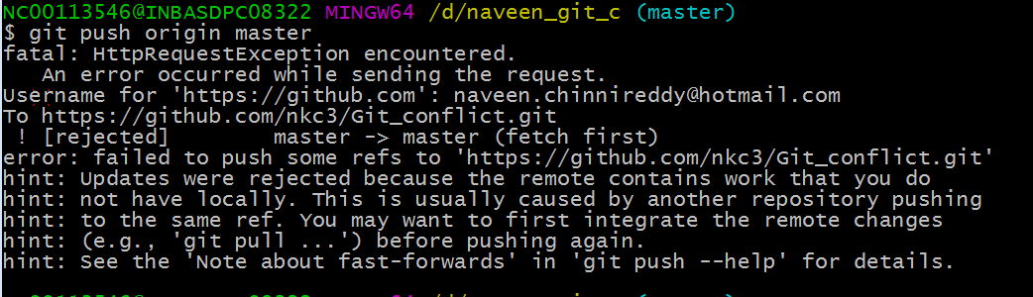

Snippet2: **Do rebase- you will find the reasons**

**--rebase does it will get all files in the master**

**--also mention the reason here it is merge conflict**

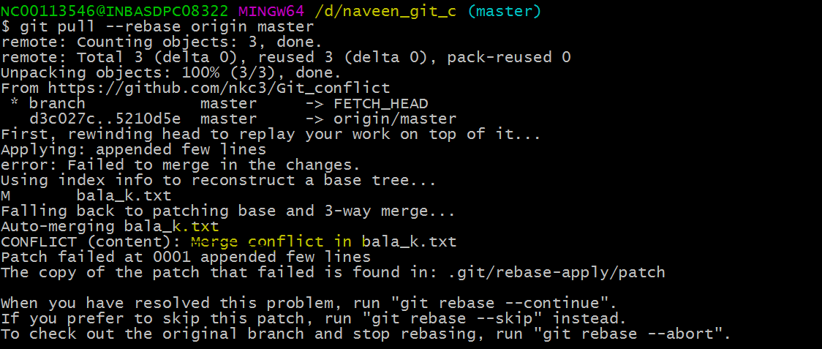

**Snippet3: Use mergetool for resolution**

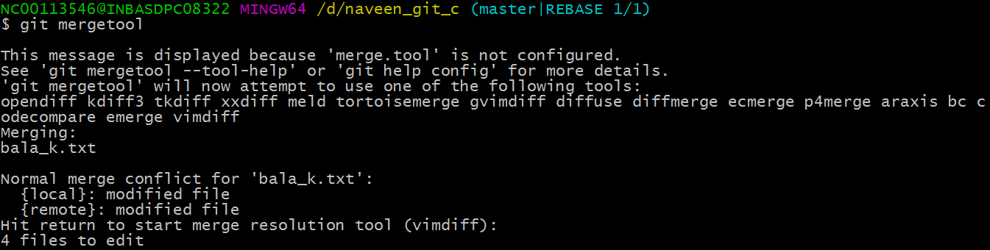

**Snippet4:  Choose the lines in Devloper 1 and Developer 2 and save it.**

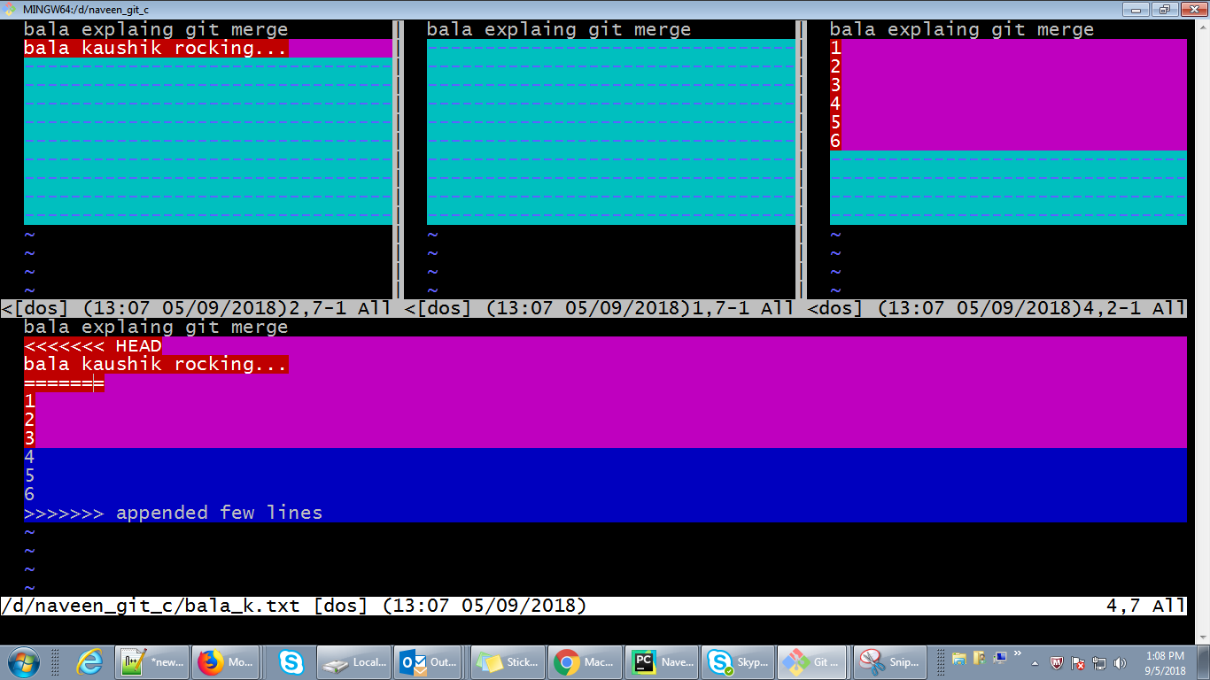

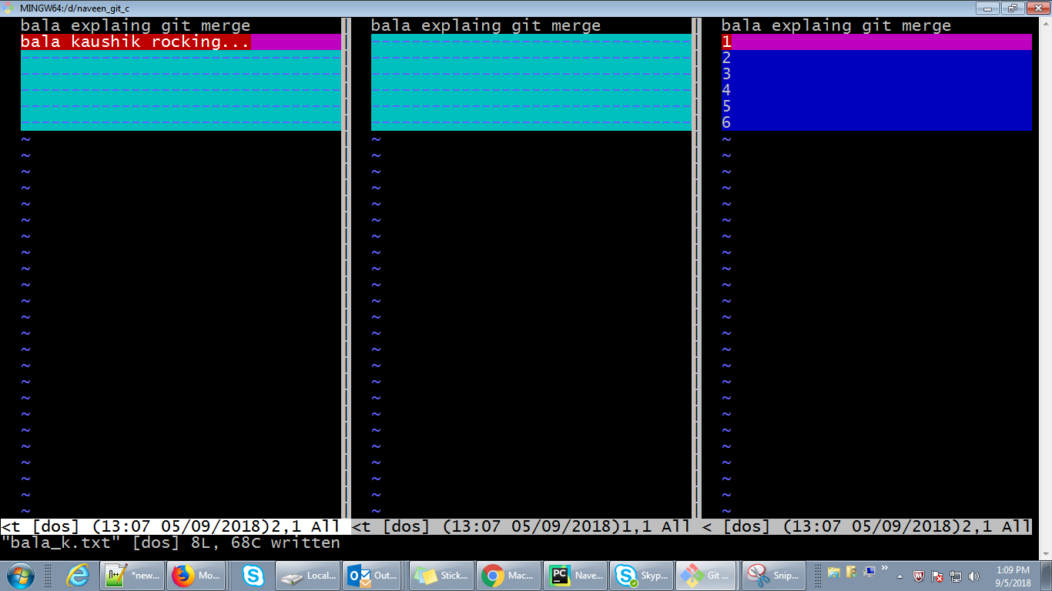

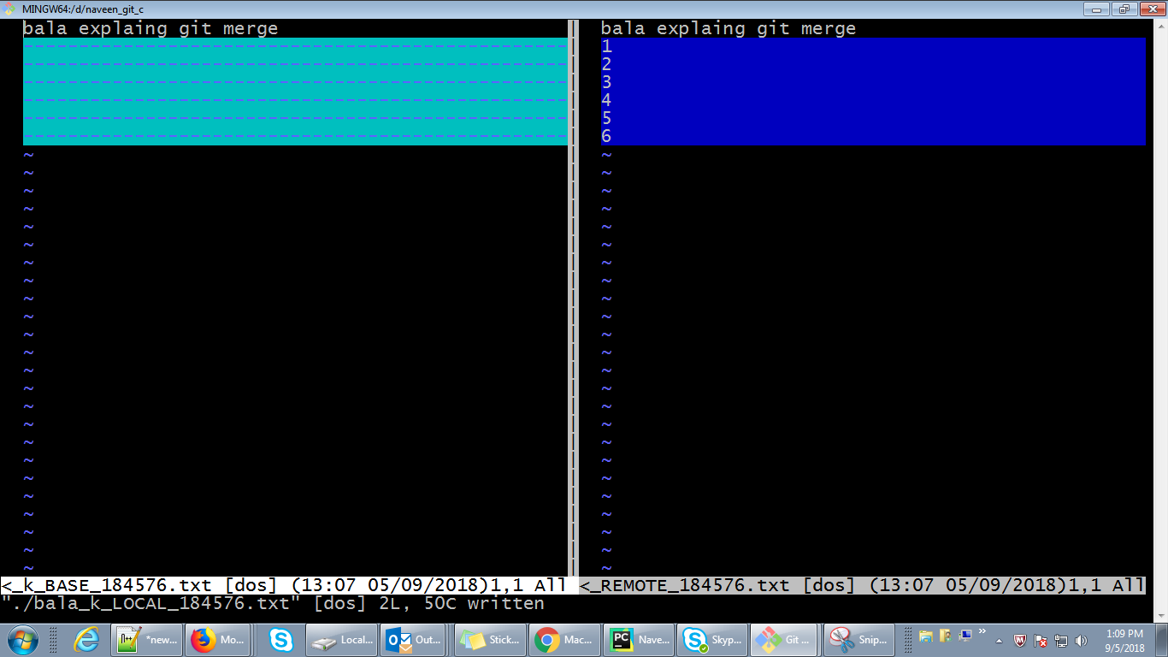

**Snippet 5:Once changes are done check the file content**

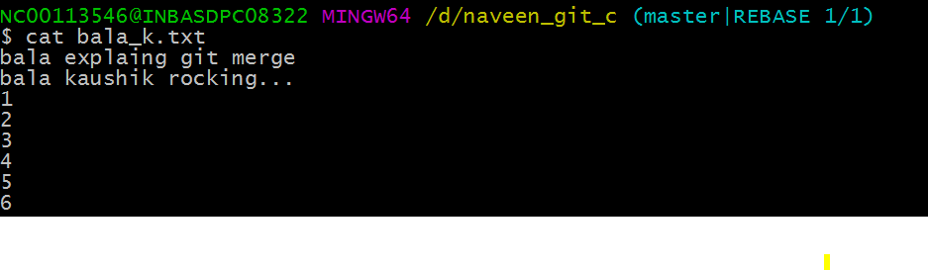

**Snippet 6: use rebase continue**



**Snippet7: Now push to the repository**

