Lab No 5:Computer Network Design using HUB in GNS3
Name:M.V.Balaji
Registration:210905400

1. Design network configuration shown in Figure 5.29 for all parts. Connect all four VMs to a
single Ethernet segment via a single hub as shown in Figure 5.29. Configure the IP addresses for
the PCs as shown in Table 6.1
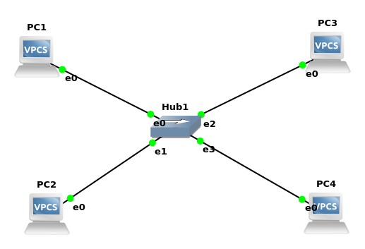
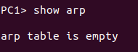
a. On PC1, view the ARP cache with show arp

b. Start Wireshark on PC1-Hub1 link with a capture filter set to the IP address of PC2.

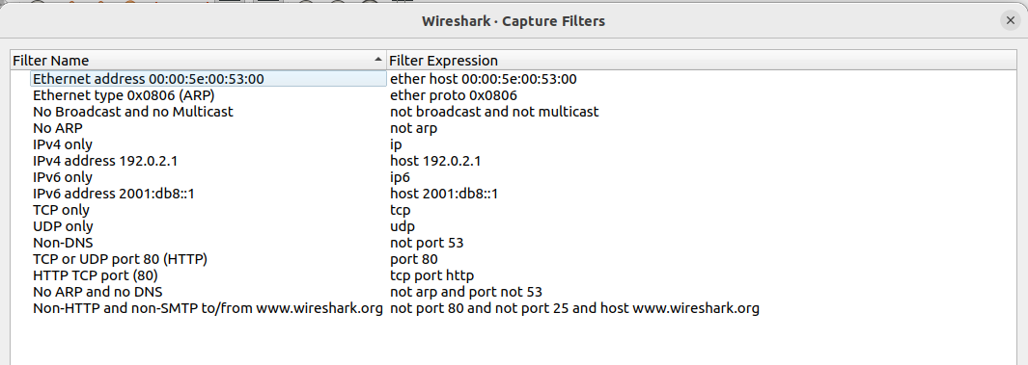

c. Issue a ping command from PC1 to PC2:
ping 10.0.1.12 –c 3
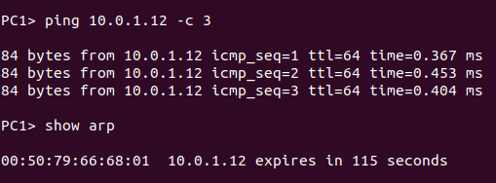

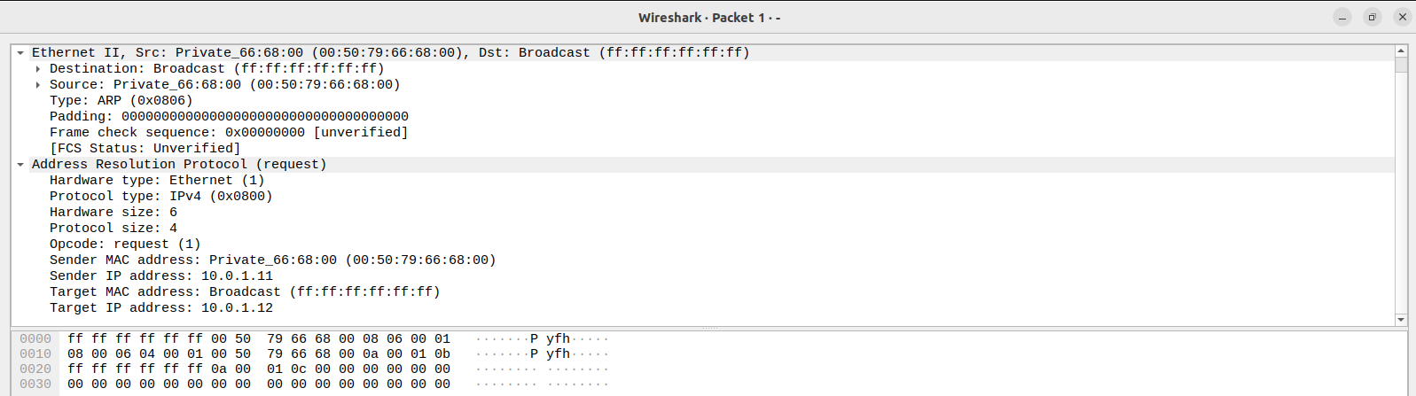
• The destination MAC address of the ARP Request packets:
=>Target MAC address: Broadcast (ff:ff:ff:ff:ff:ff)
• The Type Field in the Ethernet headers of ARP packets:
=>Type: ARP (0x0806)

d.View the ARP cache again with the command arp -a. Note that ARP cache entries can get
refreshed/deleted fairly quickly (~2 minutes).

2.To observe the effects of having more than one host with the same (duplicate) IP address
in a network.
=>Two machines on the same network can’t hav the same IP address.

3.To test the effects of changing the netmask of a network configuration.
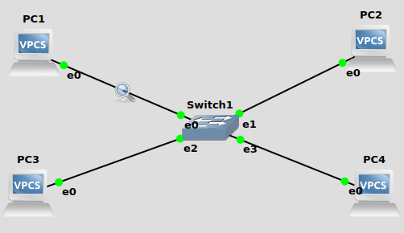

a. Design the configuration as Exercise 1 and replace the hub with a switch, two hosts (PC2 nd PC4) have been assigned different network prefixes.
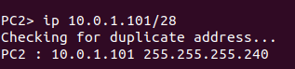
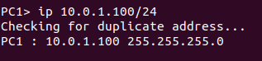
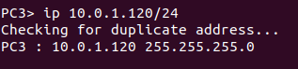
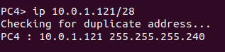

b. Run Wireshark on PC1-Hub1 link and capture the packets for the following scenarios
i. From PC1 ping PC3.
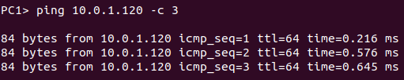

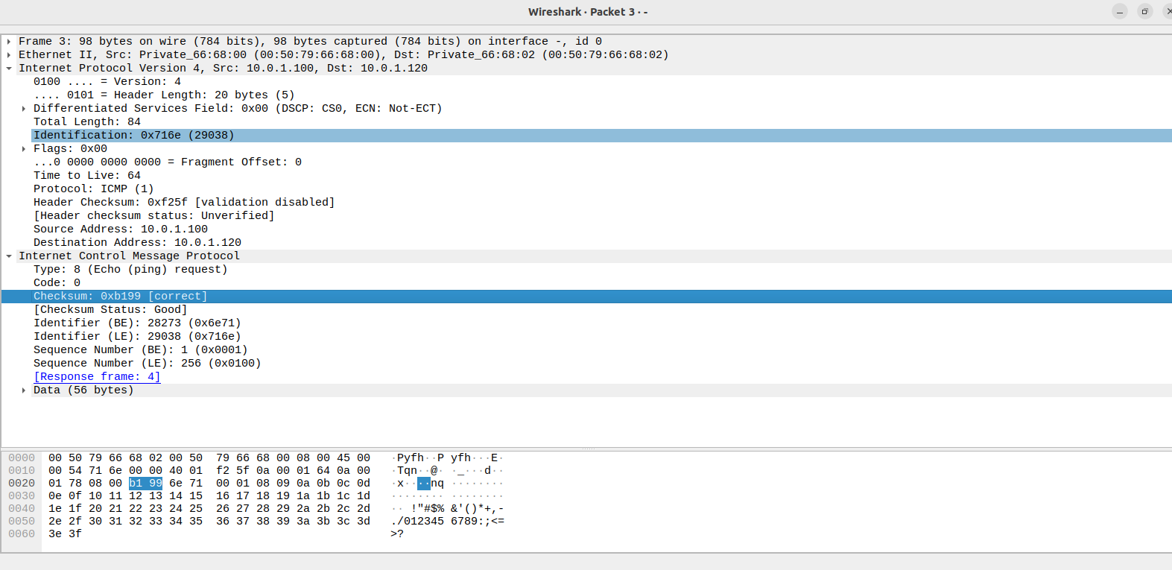

ii. From PC1 ping PC2.
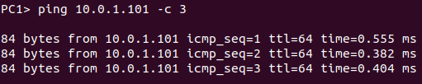

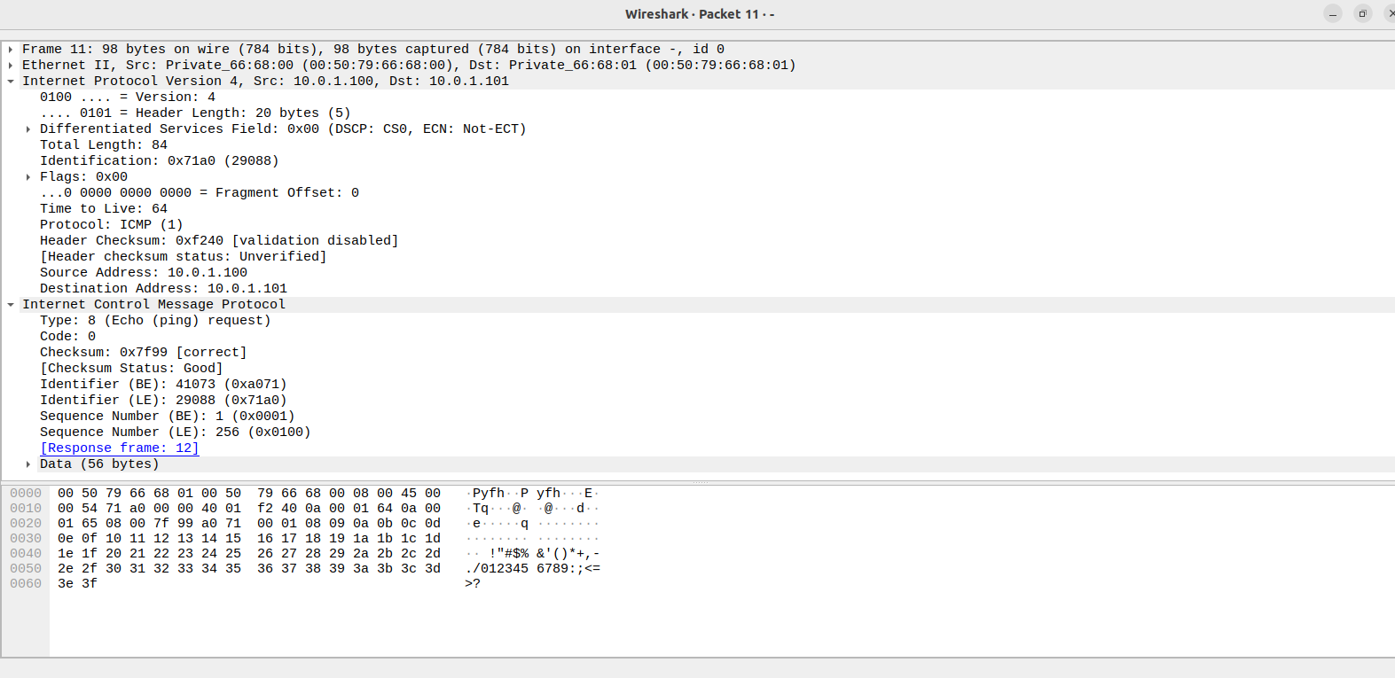

iii. From PC1 ping PC4.
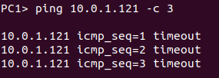

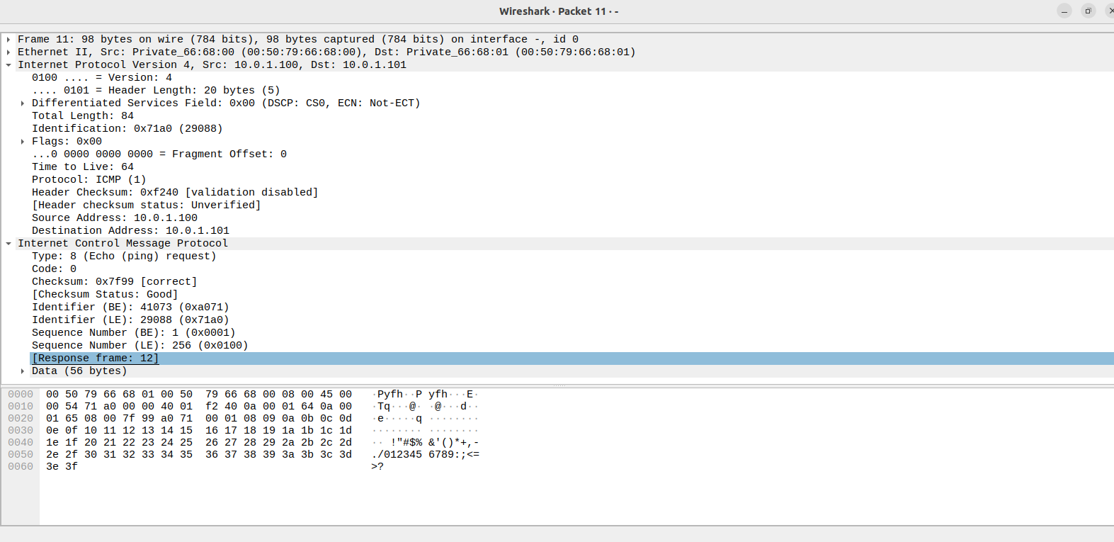

iv. From PC4 ping PC1.
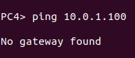

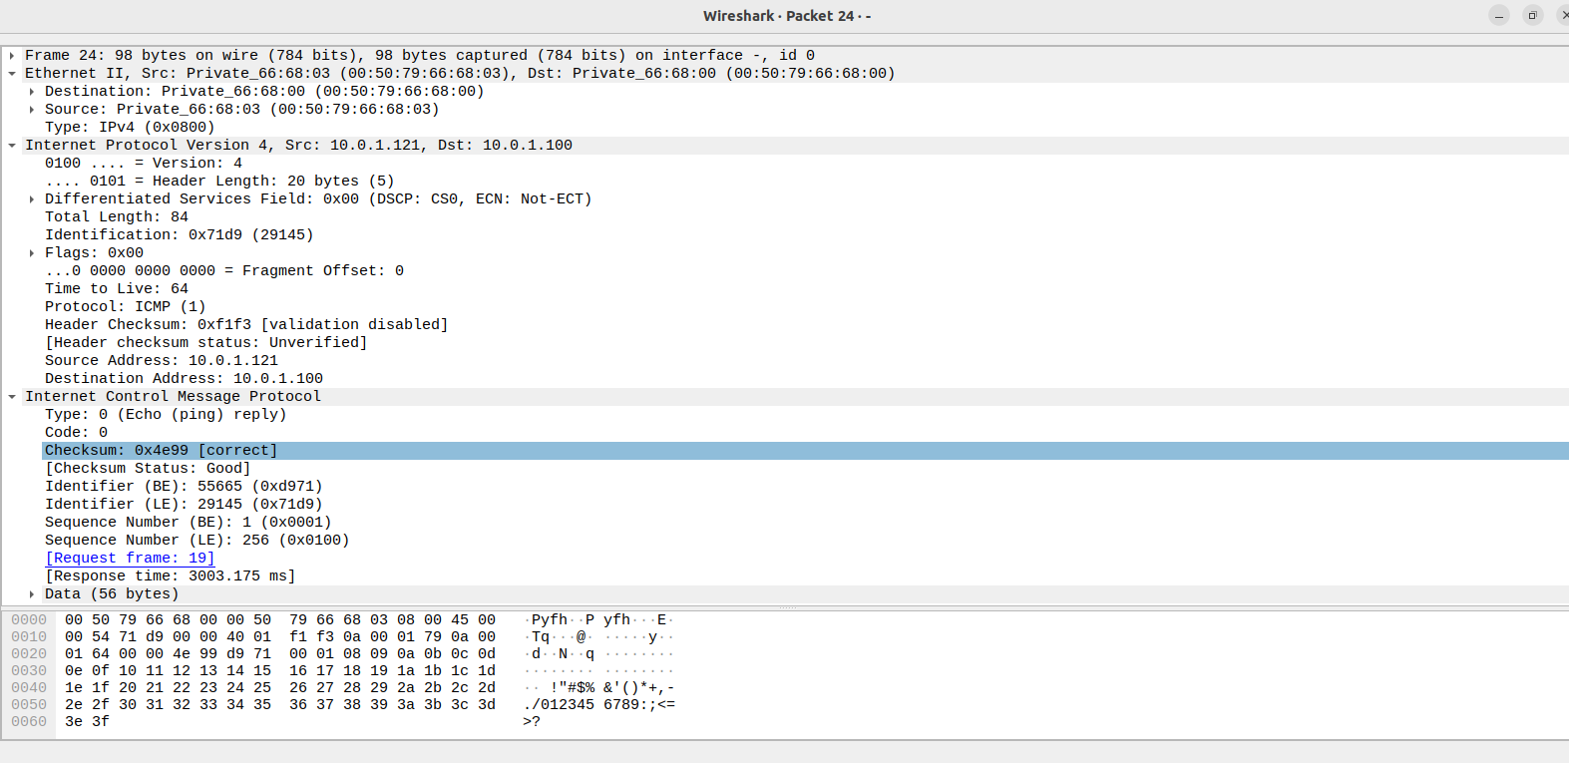

v. From PC2 ping PC4.
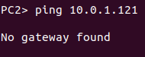

vi. From PC2 ping PC3.
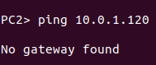

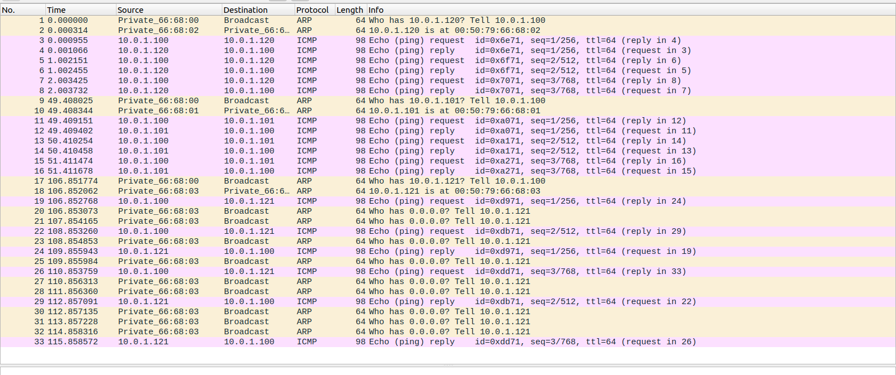

c.Save the Wireshark output to a text file (using the “Packet Summary” option from “Print”) ,
and save the output of the ping commands. Note that not all of the above scenarios are
successful. Save all the output including any error messages.

