LAB No 6:Computer Network Design using SWITCH and ROUTERS in GNS3

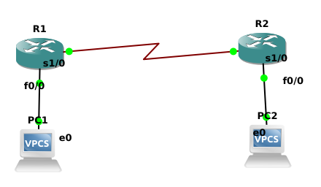
1.Network Design for Question 1:

Configuring PC IP addresses:

PC1:
ip 10.0.0.10 255.0.0.0 10.0.0.1

PC2:
ip 30.0.0.10 255.0.0.0 30.0.0.1

Configure Routers:
R1:
conf t
inter f0/0
ip address 10.0.0.1 255.255.255.0
no shutdown
exit

conf t
inter s1/0
ip address 20.0.0.1 255.255.255.0
no shutdown
exit

R2:
conf t
inter f0/0
ip address 30.0.0.1 255.255.255.0
no shutdown
exit

conf t
inter s1/0
ip address 20.0.0.2 255.255.255.0
no shutdown
exit

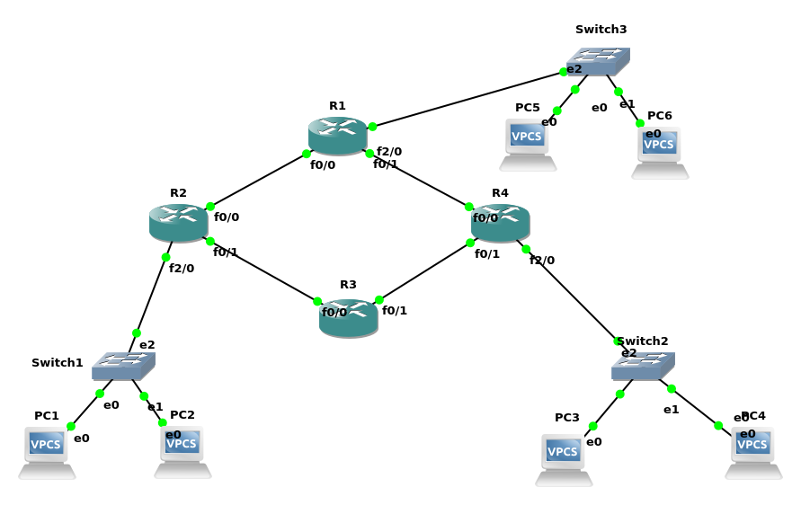
2.Network Design for Question 2:

Configuring PC IP addresses:

PC1:
ip 30.0.0.1/8 30.255.255.254

PC2:
ip 30.0.0.2/8 30.255.255.254

PC3:
ip 172.16.0.1/16 172.16.255.254

PC4:
ip 172.16.0.2/16 172.16.255.254

PC5:
ip 192.168.1.1/24 192.168.1.254

PC6:
ip 192.168.1.2/24 192.168.1.254

Configure Routers:
R1:
conf t
inter f2/0
ip address 192.168.1.254 255.255.255.0
no shutdown
exit

inter f0/1
ip address 40.0.0.2 255.0.0.0
no shutdown
exit

inter f0/0
ip address 10.0.0.2 255.0.0.0
no shutdown

R2:
conf t
inter f2/0
ip address 172.16.255.254 255.255.0.0
no shutdown
exit

inter f0/0
ip address 50.0.0.1 255.0.0.0
no shutdown
exit

inter f0/1
ip address 40.0.0.1 255.0.0.0
no shutdown

R3:
conf t
inter f0/1
ip address 20.0.0.2 255.0.0.0
no shutdown
exit

inter f0/0
ip address 50.0.0.2 255.0.0.0
no shutdown

R4:
conf t
inter f2/0
ip address 30.255.255.254 255.0.0.0
no shutdown
exit

inter f0/0
ip address 10.0.0.1 255.0.0.0
no shutdown
exit

inter f0/1
ip address 20.0.0.1 255.0.0.0
no shutdown

Configuring Routes:

R1:
ip route 172.16.0.0 255.255.0.0 40.0.0.1
ip route 30.0.0.0 255.0.0.0 10.0.0.1

R2:
ip route 192.168.1.0 255.255.255.0 40.0.0.2
ip route 30.0.0.0 255.0.0.0 50.0.0.2

R3:
ip route 30.0.0.0 255.0.0.0 20.0.0.1
ip route 172.16.0.0 255.255.0.0 50.0.0.1

R4:
ip route 192.168.1.0 255.255.255.0 10.0.0.2
ip route 172.16.0.0 255.255.0.0 20.0.0.2

