LAB7:Study OF Domain Name Server

1. Configure the below topology to setup DNS server. R1 will use R2 as DNS server to make
DNS resolutions.

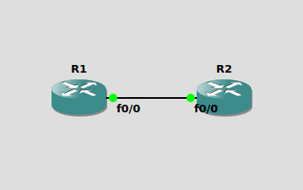

Conigurating Routers

For R1:

R1#conf t
R1(config)#interface f0/0
R1(config-if)#ip address 10.0.0.1 255.255.255.0
R1(config-if)#no shut
R1(config-if)#do wr
Building configuration...
[OK]
R1(config-if)#
*Mar 1 00:02:17.247: %LINK-3-UPDOWN: Interface FastEthernet0/0, changed state to up
*Mar 1 00:02:18.379: %LINEPROTO-5-UPDOWN: Line protocol on Interface FastEthernet0/0, changed state to up
R1(config-if)#end

For R2:

R2#conf t
R2(config)#interface f0/0
R2(config-if)#ip address 10.0.0.2/24
R2(config-if)#ip address 10.0.0.2 255.255.255.0
R2(config-if)#no shut
R2(config-if)#do wr
Building configuration...
[OK]
R2(config-if)#
*Mar 1 00:04:50.247: %LINK-3-UPDOWN: Interface FastEthernet0/0, changed state to up
*Mar 1 00:04:51.275: %LINEPROTO-5-UPDOWN: Line protocol on Interface FastEthernet0/0, changed state to up
R2(config-if)#end

Set R2 as DNS Server

R2(config)#ip dns server
R2(config)#ip host loopback.R2.com 2.2.2.2
R2(config)#interface loopback 1
R2(config-if)#
*Mar 1 00:33:59.299: %LINEPROTO-5-UPDOWN: Line protocol on Interface Loopback1, changed state to up
R2(config-if)#ip address 2.2.2.2 255.255.255.255
R2(config)#exit
R2#conf t
*Mar 1 00:46:44.259: %SYS-5-CONFIG_I: Configured from console by console
R2#ping loopback.R2.com
Type escape sequence to abort.
Sending 5, 100-byte ICMP Echos to 2.2.2.2, timeout is 2 seconds:
!!!!!
Success rate is 100 percent (5/5), round-trip min/avg/max = 1/2/4 ms

Setting Up R1 to resolve hostnames using R2

R1(config)#ip domain lookup
R1(config)#ip name-server 10.10.10.2
R1(config)#ip route 0.0.0.0 0.0.0.0 10.10.10.2
R1(config)#end
R1#
*Mar 1 00:53:30.851: %SYS-5-CONFIG_I: Configured from console by console
R1#ping loopback.R2.com

2.Suppose you are connecting to www.mycsemit.com to read a page, you are a user sitting at a client's machine. You can access the www.mycsemit.com web server. The server machine finds the page you requested and sends it to you. Build a scenario using GNS3 to demonstrate the interaction of the DNS Server and DNS Client. Place DNS Server behind two routers.
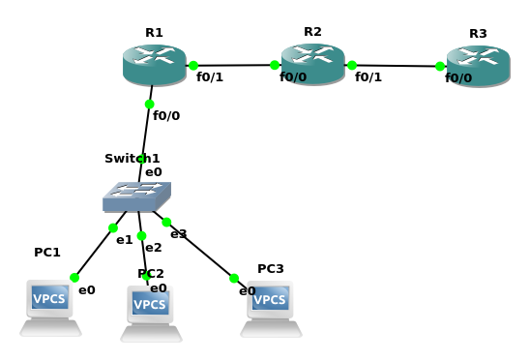

IP for Pcs:
PC1:10.0.0.1/8
PC1> ip 10.0.0.1
Checking for duplicate address...
PC1 : 10.0.0.1 255.255.255.0
PC2:10.0.0.2/8
PC2> ip 10.0.0.2
Checking for duplicate address...
PC2 : 10.0.0.2 255.255.255.0
PC3:10.0.0.3/8
PC3> ip 10.0.0.3
Checking for duplicate address...
PC3 : 10.0.0.3 255.255.255.0

R1(f0/0):30.255.255.254/8

R1(config-if)#ip address 30.255.255.254 255.255.255.0
R1(config-if)#no shut
*Mar 1 00:08:01.951: %LINK-3-UPDOWN: Interface FastEthernet0/0, changed state to up
*Mar 1 00:08:02.951: %LINEPROTO-5-UPDOWN: Line protocol on Interface FastEthernet0/0, changed state to up
R1(config-if)#do wr
Building configuration...
[OK]
R1(config-if)#end

R1(f0/1):20.0.0.01/8

R1(config)#interface f0/1
R1(config-if)#ip address 20.0.0.01 255.255.255.0
R1(config-if)#no shut
R1(config-if)#do wr
*Mar 1 00:09:57.531: %LINK-3-UPDOWN: Interface FastEthernet0/1, changed state to up
*Mar 1 00:09:58.531: %LINEPROTO-5-UPDOWN: Line protocol on Interface FastEthernet0/1, changed state to up
R1(config-if)#do wr
Building configuration...
[OK]

R2(f0/0):20.0.0.02/8

R2(config)#interface f0/0
R2(config-if)#ip address 20.0.0.2 255.255.255.0
R2(config-if)#no shut
R2(config-if)#dp
*Mar 1 00:07:11.115: %LINK-3-UPDOWN: Interface FastEthernet0/0, changed state to up
*Mar 1 00:07:12.115: %LINEPROTO-5-UPDOWN: Line protocol on Interface FastEthernet0/0, changed state to up
R2(config-if)#do wr
Building configuration...
[OK]
R2(config-if)#end

R2(f0/1):10.0.0.01/8

R2(config)#interface f0/1
R2(config-if)#ip address 10.0.0.1 255.255.255.0
R2(config-if)#no shut
R2(config-if)#
*Mar 1 00:08:52.163: %LINK-3-UPDOWN: Interface FastEthernet0/1, changed state to up
*Mar 1 00:08:53.163: %LINEPROTO-5-UPDOWN: Line protocol on Interface FastEthernet0/1, changed state to up
R2(config-if)#do wr
Building configuration...
[OK]
R2(config-if)#end

R3(f0/0):10.0.0.02/8

R3(config)#interface f0/0
R3(config-if)#ip dns server
R3(config-if)#ip address 10.0.0.2 255.255.255.0
R3(config-if)#no shut
*Mar 1 00:07:56.847: %LINK-3-UPDOWN: Interface FastEthernet0/0, changed state to up
*Mar 1 00:07:57.847: %LINEPROTO-5-UPDOWN: Line protocol on Interface FastEthernet0/0, changed state to up
R3(config-if)#do wr
Building configuration...
[OK]
R3(config-if)#end

