Q1. While tcpdump host your_host is running in one command window, run ping 127.0.0.1 from
another command window. From the ping output, is the 127.0.0.1 interface on? Can you see any
ICMP message sent from your host in the tcpdump output? Why?

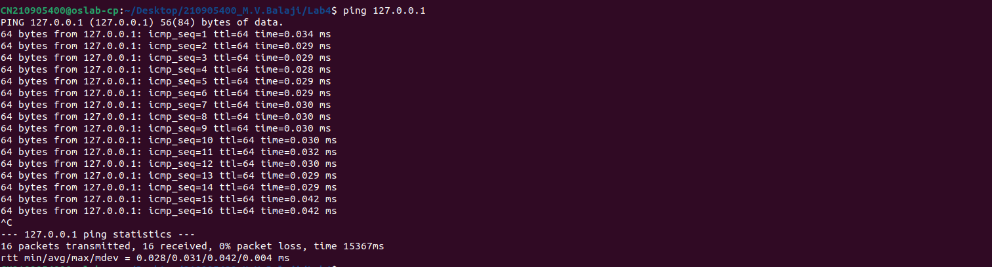
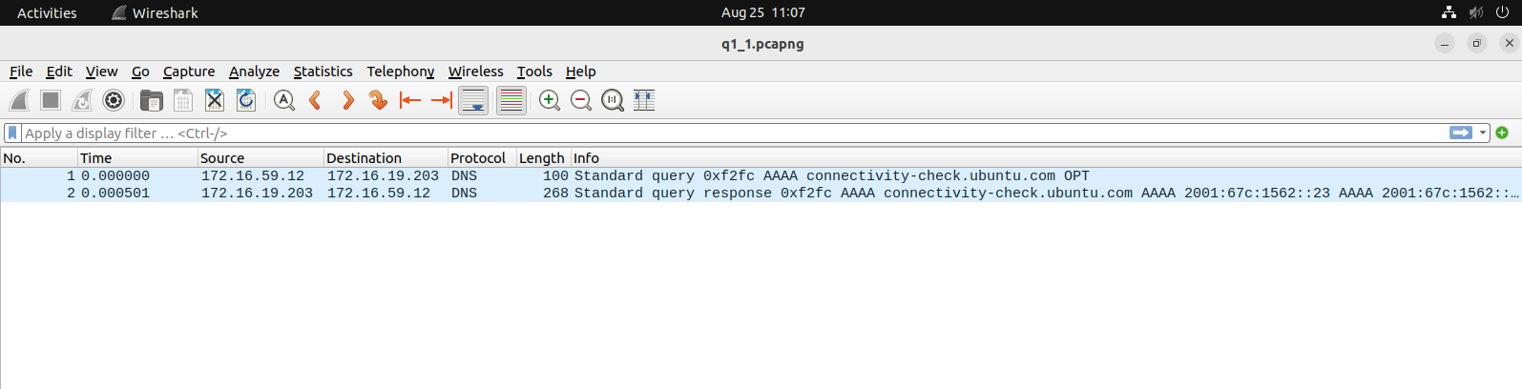
Q2.While tcpdump host your_host is running to capture traffic from your machine, execute telnet
128.238.66.200. Note there is no host with this IP address in the current configuration of the lab
network. Save the tcpdump output of the first few packets for the lab report. After getting the
necessary output, terminate the telnet session. From the saved tcpdump output, describe how the
ARP timeout and retransmission were performed. How many attempts were made to resolve a
non-existing IP address?

3. Briefly explain the purposes of the following tcpdump expressions.

a. tcpdump udp port 520
- Find packet transmitted over UDP protocol on port 520

b. tcpdump -x -s 120 ip proto 89
- Show the packet’s contents in both hex and ascii and print absolute sequence numbers transmitted over protocol 89.

c. tcpdump -x -s 70 host ip addr1 and (ip addr2 or ip addr3):
- Shows the packet’s contents in both hex and ascii and print absolute sequence numbers for ip addr1 and for any one from ipaddr 2 or 3

d. tcpdump -x -s 70 host ip addr1 and not ip addr2
- Shows the packet’s contents in both hex and ascii and print absolute sequence numbers only for ip addr1 and dont show for ipaddr2

4. Basic packet decoding
1) Write a tcpdump command to dump network traffic from an Ethernet connection to the
screen in human readable output format. Perform the following operation and write down
the observations.

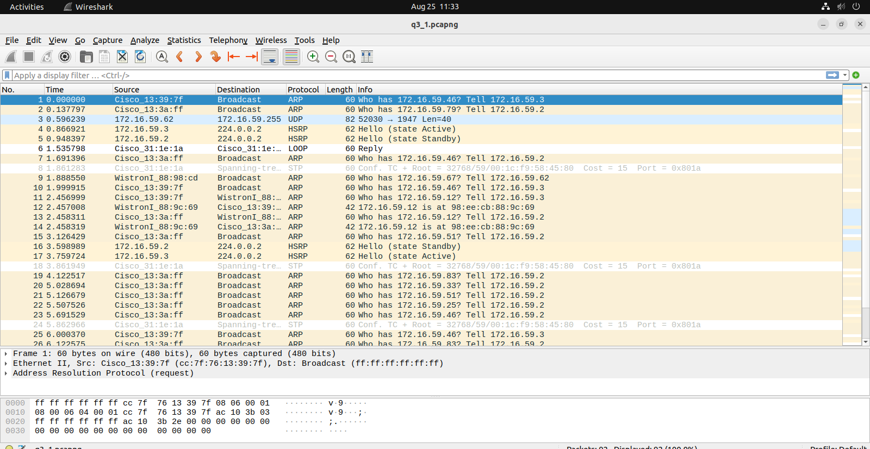
a)sudo tcpdump -i any -s 65535 -tttnnx
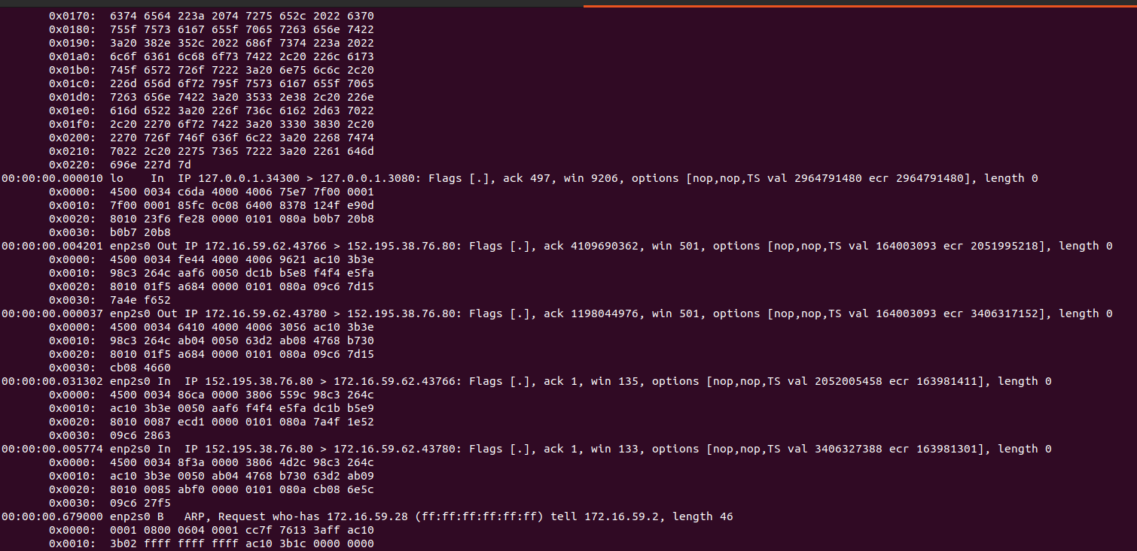
b)IP addr:Source Address: 127.0.0.1
TCP Packet Length:87
TCP Flag:PSH And ACK

