Lab 8:STUDY OF DHCP PROTOCOL

Q1.Configure two VMs that will be used to test connectivity from end to end and R1 will
serve as a DHCP server to distribute IP addresses.

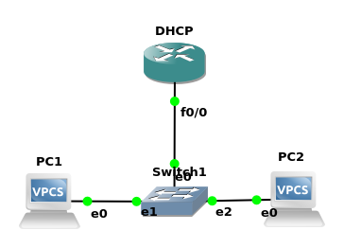

R1:
DHCP(config)#IP dhcp pool NAME
DHCP(dhcp-config)#Network 192.168.3.0 255.255.255.0
DHCP(dhcp-config)#Default-router 192.168.3.1
DHCP(dhcp-config)#exit
DHCP(config)#interface f0/0
DHCP(config-if)#no shut
DHCP(config-if)#
*Mar 1 00:02:39.395: %LINK-3-UPDOWN: Interface FastEthernet0/0, changed state to up
*Mar 1 00:02:40.395: %LINEPROTO-5-UPDOWN: Line protocol on Interface FastEthernet0/0, changed state to up
DHCP(config-if)#ip address 192.168.3.1 255.255.255.0
DHCP(config-if)#exit

PC1:
PC1> dhcp
DDORA IP 192.168.3.2/24 GW 192.168.3.1

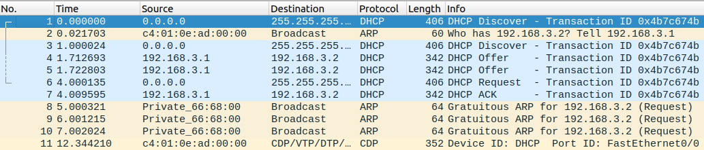

PC2:
PC2> dhcp
DDORA IP 192.168.3.3/24 GW 192.168.3.1

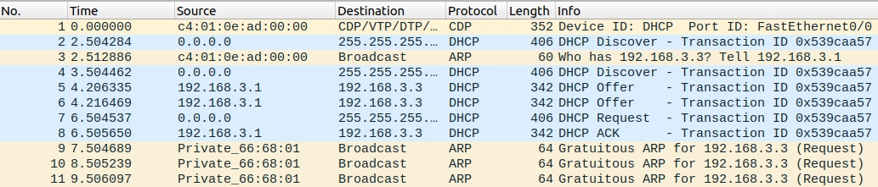
Q1(Part2):
