Lab9:VLANs using GNS3

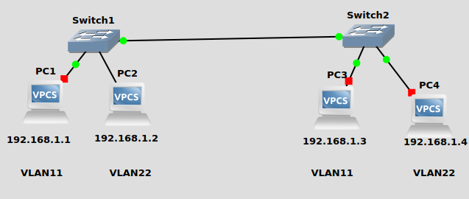

PC1> ip 192.168.1.1/24
Checking for duplicate address...
PC1 : 192.168.1.1 255.255.255.0

PC2> ip 192.168.1.2/24
Checking for duplicate address...
PC2 : 192.168.1.2 255.255.255.0

PC3> ip 192.168.1.3/24
Checking for duplicate address...
PC3 : 192.168.1.3 255.255.255.0

PC4> ip 192.168.1.4/24
Checking for duplicate address...
PC4 : 192.168.1.4 255.255.255.0

Q1)Configure following inter-VLAN example in GNS3 and verify the working using Wireshark tool.
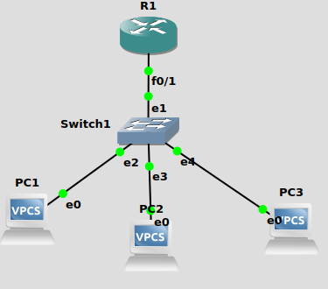
A)

R1(config)#interface f0/1
R1(config-if)#ip address 192.168.10.1 255.255.255.240
R1(config-if)#interface f0/1.2
R1(config-subif)#encapsulation dot1q 2
R1(config-subif)#ip address 192.168.1.65 255.255.255.192
R1(config-subif)#interface f0/1.10
R1(config-subif)#encapsulation dot1q 10
R1(config-subif)#ip address 192.168.1.129 255.255.255.224
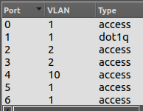

PC1> ip 192.168.10.66
Checking for duplicate address...
PC1 : 192.168.10.66 255.255.255.0

PC2> ip 192.168.10.67
Checking for duplicate address...
PC2 : 192.168.10.67 255.255.255.0

PC1> ping 192.168.10.67

84 bytes from 192.168.10.67 icmp_seq=1 ttl=64 time=0.415 ms
84 bytes from 192.168.10.67 icmp_seq=2 ttl=64 time=0.396 ms
84 bytes from 192.168.10.67 icmp_seq=3 ttl=64 time=0.424 ms
84 bytes from 192.168.10.67 icmp_seq=4 ttl=64 time=0.433 ms
84 bytes from 192.168.10.67 icmp_seq=5 ttl=64 time=0.445 ms

