AGR Support

ASCII Grid files with the following format:

NCOLS 601
NROWS 401
XLLCORNER 714000
YLLCORNER 4328800
CELLSIZE 25
NODATA_VALUE -999
33.381 33.279 33.102 32.982 32.809……

are now supported. Coordinates MUST be UTM.

Use:
- Create a folder named “agr” in the same folder where you have the “project” folder (or the father’s and sons’ folders in multitrack projects). E.g. if you are working on c:\project, create a folder c:\agr.
- Copy the needed .agr files to the folder you created in the step 1). Rename those files with extension .agr if needed.
- Use the scripts as usual. Following the steps recommended on screen the s2_elevation step will be skipped as we already have elevation data.

NOTE: if you have grids with a different format you can use free software to convert them (like SAGA-GIS, import your grid ant then select Module Import/Export - Grids \ Export ESRI Arc/Info Grid, using ASCII format and corner geo-reference).
http://sourceforge.net/projects/saga-gis/

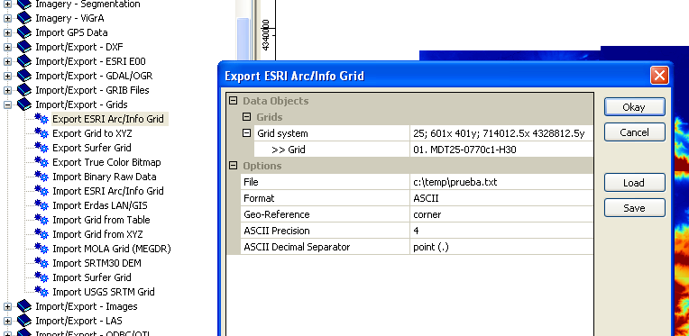

NOTE: .agr grids with 25m spacing can be downloaded for free for Spain. Just create an user and download MDT25 files.
http://centrodedescargas.cnig.es/CentroDescargas/
Using the code of the following grid, downloading is easier:
http://centrodedescargas.cnig.es/CentroDescargas/equipamiento/cuadricula_MTN50.png

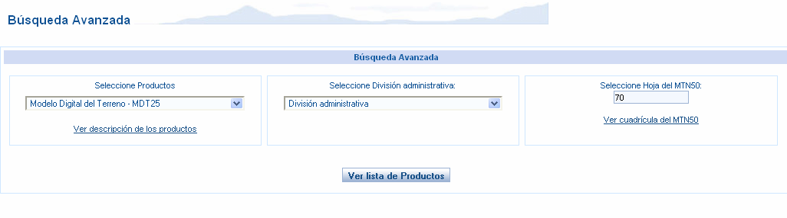

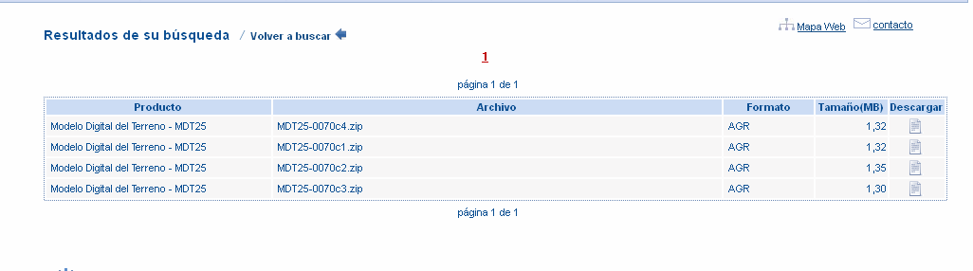

NOTE: for Catalonia, grids with 15m spacing can be downloaded for free from Se pueden http://www.icc.cat/vissir2/?lang=es_ES
just clicking on the map and choosing "otras" section. The format is exactly the same used in the cnig web, but the spacing is better. File extensions should be changed from “.txt” to “agr”.

NOTE: .hgt files can be opened with 3dem to project them to UTM (Operation\Change Projection)
http://www.viewfinderpanoramas.org/3dem.zip

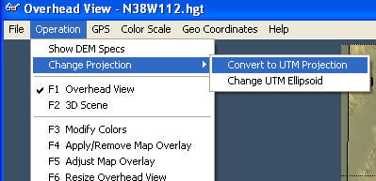

Then saved as Geotiff dem file:

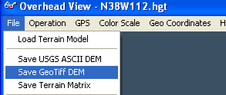

And imported with SAGA GIS:

