Threshold feature of GMSH

One way of controlling the triangles size with gmsh is giving each point a characteristic length (4th parameter in their definition). The problem with characteristic lengths is that gmsh creates too many triangles for U-shaped tracks (or segments of a track). For example:
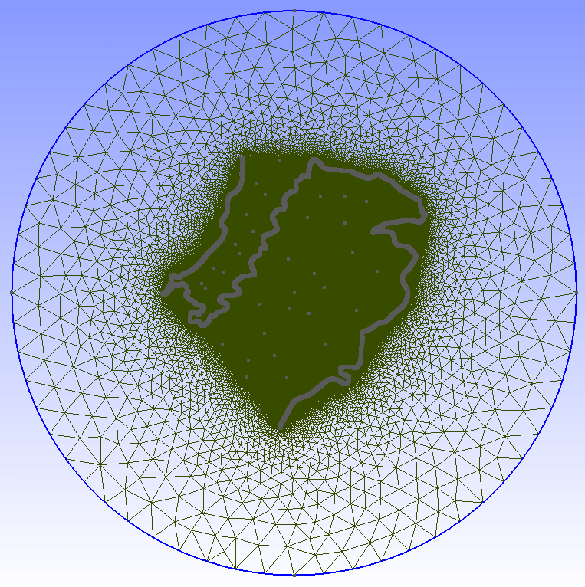

Another way of controlling triangles’ size is using threshold fields. For example you can ask gmsh to assign each triangle a size that is a function of the distance to the track.

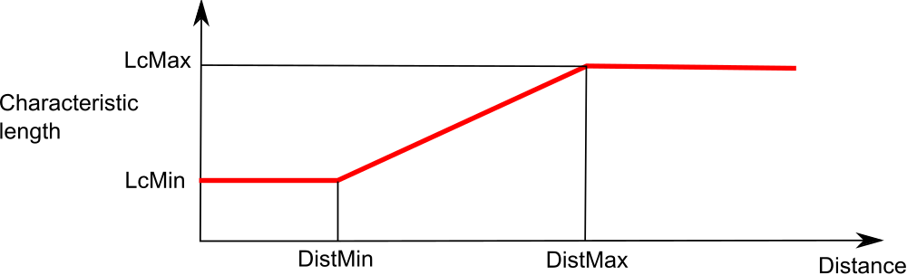
The result may be as good as follows:
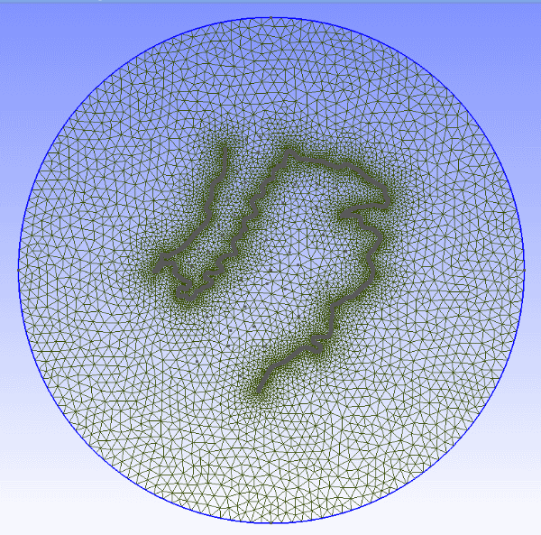

Gmsh code for using a threshold field is:

Field[1] = Attractor;
Field[1].NodesList = {1:3342}; //List of point of the track

Field[2] = Threshold;
Field[2].IField =1;
Field[2].LcMin = 20;
Field[2].LcMax = 2000;
Field[2].DistMin = 1;
Field[2].DistMax = 10000;
Field[2].StopAtDistMax = 0;

Mesh.CharacteristicLengthExtendFromBoundary = 0;

Background Field=2;

mallado_regular script includes for each track (in anchors_carretera.geo) the code needed for using the threshold fields. But it is not activated by default.

If you want to activate the threshold, just open the geo with a text editor and search for line If (0) and change it to If (1). That line can be found below the points that define each track. If you are creating a multitrack project you will find several If clauses, one for each track. You can only activate one threshold field unless you use a Min Field (read the notes at the end of this document)

The default parameters in the geo are set to:
LcMin = 20; //(Characteristic length at a distance LcMin and below)
LcMax = 2000; //(Characteristic length at a distance LcMax and above)
DistMin = 1;
DistMax = 10000;

NOTE:

It is also possible to change the threshold parameters within gmsh:
Select Mesh > Define > Fields.
In the Fields window click Threshold.
For example we reduce element sizes approaching the boundary limits:
1) Enter LcMax = 1000
2) Apply
3) Click 1D meshing.
Note: You should 1D before 2D each time new Threshold parameters are entered.
4) Click 2D meshing.

NOTE:

If you want to apply the threshold considering the distance to more than one track you can use Min Field, with a code similar to this one:

Field[4]=Min;
Field[4].FieldsList={2,3}; //List of threshold fields
Background Field = 4;

