Threshold feature of GMSH

One way of controlling the triangles size with gmsh is giving each point a characteristic length (4th parameter in their definition). The problem with characteristic lengths is that gmsh creates too many triangles for U-shaped tracks (or segments of a track). For example:
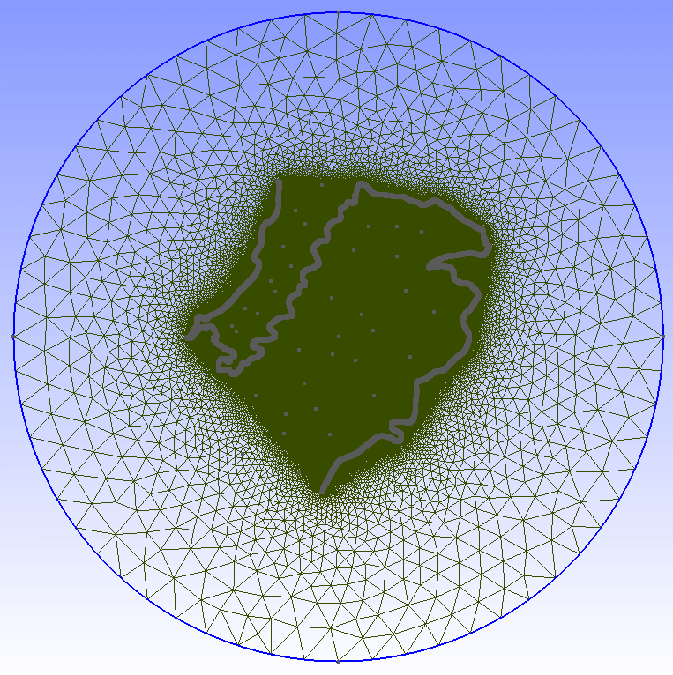

Another way of controlling triangles’ size is using threshold fields. For example you can ask gmsh to assign each triangle a size that is a function of the distance to the track.

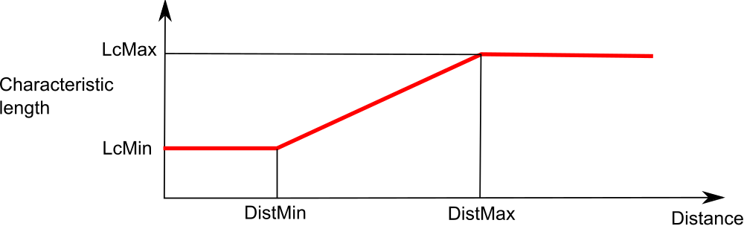
The result may be as good as follows:
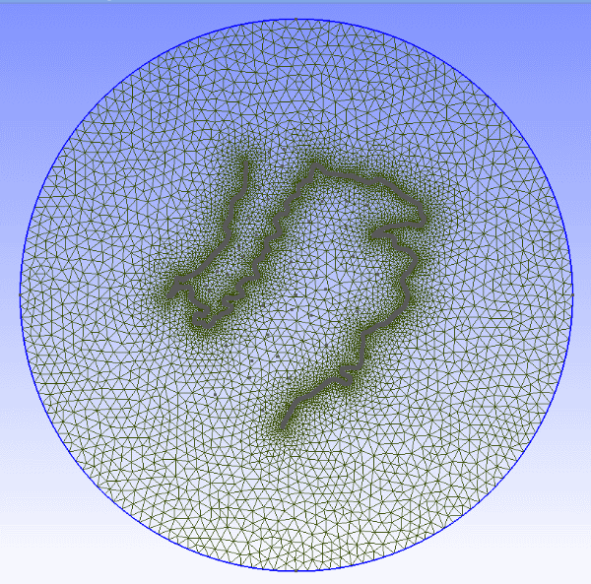

Gmsh code for using a threshold field is:

Field[1] = Attractor;
Field[1].NodesList = {1:3342}; //List of point of the track

Field[2] = Threshold;
Field[2].IField =1;
Field[2].LcMin = 20;
Field[2].LcMax = 2000;
Field[2].DistMin = 1;
Field[2].DistMax = 10000;
Field[2].StopAtDistMax = 0;

Mesh.CharacteristicLengthExtendFromBoundary = 0;

Background Field=2;

mallado_regular or join_geos scripts include (in anchors_carretera.geo or joined.geo) the code needed for using the threshold fields. It is activated by default.

If you don’t want to activate the thresholds, just open the geo with a text editor and search for line If (1) and change it to If (0).

You can only activate one threshold field unless you use a Min Field (read the notes at the end of this document). The threshold that is included automatically uses all the points defined so fat in the .geo file, so all the tracks are considered for that threshold in multitrack projects.

The default parameters in the geo are set to (read s1_mesh\thresholds.txt):
LcMin = 20; //(Characteristic length at a distance LcMin and below)
LcMax = 2000; //(Characteristic length at a distance LcMax and above)
DistMin = 1;
DistMax = 10000;

NOTE:

It is also possible to change the threshold parameters within gmsh:
Select Mesh > Define > Fields.
In the Fields window click Threshold.
For example we reduce element sizes approaching the boundary limits:
1) Enter LcMax = 1000
2) Apply
3) Click 1D meshing.
Note: You should 1D before 2D each time new Threshold parameters are entered.
4) Click 2D meshing.

