Using LiDAR data

Example of files used with InkScape (waste previous) and with the scripts:
http://www.mediafire.com/file/nu5hgpf9jbs4b24/waste_part1.7z
http://www.mediafire.com/file/gmy4n4xmzc5616s/waste_part2.7z
The difference with a normal project created with the scripts, is that as we have very good elevation resolution, we are not going to trust .kml routes created from satellite images. Instead of that we will use elevation data to create an image that shows us where the roads are and we will create routes that match the roads on the image. This way BTB roads will be placed with high precision.

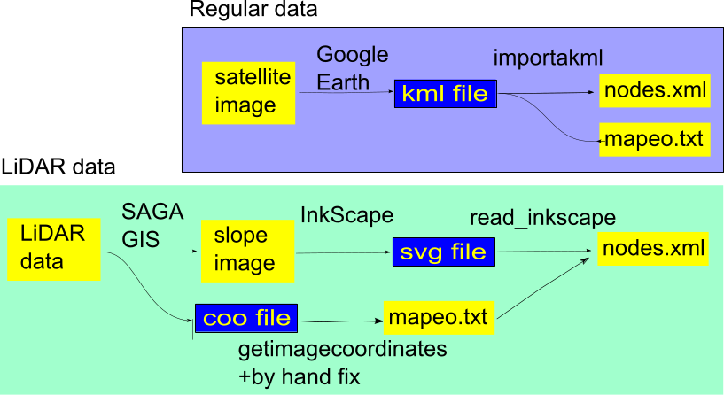

Step 1)

Use SAGA-GIS (http://sourceforge.net/projects/saga-gis/) to import.ASC files
- Import/Export - Grids\Import ESRI Arc/Info grid
- Terrain Analysis-Morphometry\Local Morphometry

If you have .las files, you can also use SAGA-GIS to import the data. For example, opening SAGA and following these steps:
- Import/Export-LAS\Import LAS Files
- Shapes\Point Cloud to Grid (1m grid)
- Grid Tools\Close gaps
- Terrain Analysis – Morphometry\Local Morphometry (slope)

And finally export the “slope” data using .jpg format:
- Import/Export Images\Export Image

Step 2)

Use FUSION (http://forsys.cfr.washington.edu/fusion/FUSION_Install.exe) to transform all the individual ASCII grids to DTM grid format

c:\FUSION\ASCII2DTM N4414A3.dtm m m 1 0 0 0 N4414A3.asc

.dtm files must be copied in a folder called “lidar” placed in the same folder where we have the project folder or the father’s and sons’ folders in multitrack projects (e.g. if we have c:\project, then copy them to c:\lidar).

If we have a .las file I recommend filtering data to remove vegetation rebounds (example shown filters data with feet units to create 1m grid. If working with meters use 1 instead of 3.28084):

c:\FUSION\GroundFilter %1f.lda 3.28084 %1.las
c:\FUSION\GridSurfaceCreate %1f.dtm 3.28084 f f 1 0 0 0 %1f.lda

Step 3)

Import the slope .jpg with InkScape (don’t resize or move the image) and create routes following the bright paths (low slope zones) that show where roads are. Create a path for each track in the project. Adjusting width in pixels to match the bright zones you can have a hint of the real width of the road (you may need that value later when using btb06).
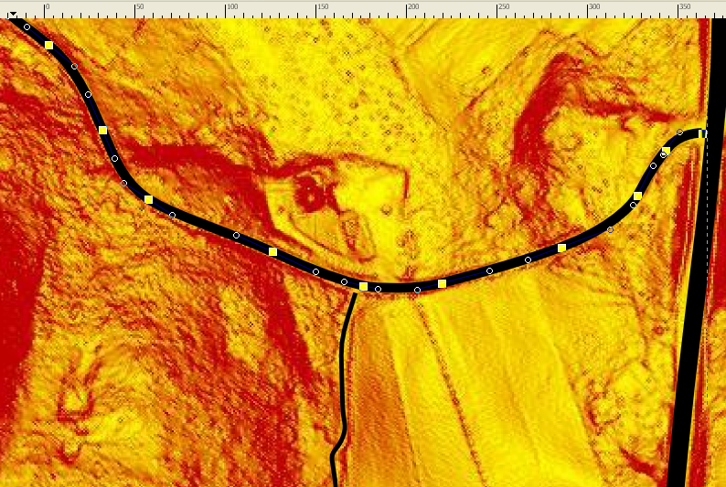

NOTE: In the general options of InkScape, SVG output section, select that relative coordinates are not allowed. This way the bezier curves should contain only M and C letters, and not m or c.
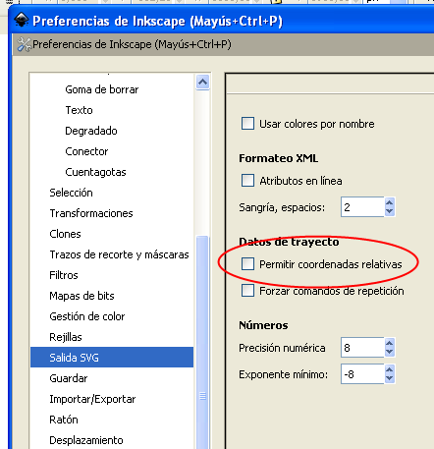

May be after changing Inkscape general options existing paths still use relative coordinates, so I recommend using Edit\Edit XML within InkScape and make a symbolic change to the path data (add a space character and undo the change) and select “Apply”). After that operation all the letters in the path should be uppercase: M or C.
Path nodes should be “s(mooth)”-type. All the nodes can be forced to be s-type selecting all the nodes in the path (ctrl-a) and then clicking on the appropriate icon in the top bar (shift-s does it, but usually InkScape crashes with this operation. Save your file before you try).
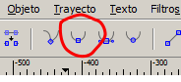

Step 4)

In the .svg file you should have included only one image. If we have the coordinates of the image we can translate the routes to real coordinates. So for this image you have to create a .coo file containing the UTM coordinates of the image: (lasinfo from lastools, http://www.cs.unc.edu/~isenburg/lastools/download/lastools.zip, gives us that info if we use lastools, otherwise SAGA-GIS also informs of the characteristics of the data imported). Z coordinate (elevation) will not be used but the scripts require it for compatibility issues. X1, Y1, Z1, X2, Y2, Z2 must be replaced with actual values.

min x y z X1 Y1 Z1
max x y z X2 Y2 Z2

The .coo file can be used to create a first version of mapeo.txt
getimagecoordinates(‘fichero.coo’,1).
The mapeo.txt can be fixed by hand to center the terrain (or may be change feet values to meters, if it is the case).

Step 5)

The .svg file must be processed along with the .coo of the image we used (in the example files I merged 6 images and created a .coo for the merged image):
read_inkscape ('pennsylvania.svg' ,'combinado.coo')

Before processing the .svg file I recommend opening it with a text editor and check that for every path only “s” letter is used (example: sodipodi:nodetypes= "sssssssssssssssssssssss"). If we see other letters, like “c” we should open again the .svg with InkScape and force all the nodes of that path to be “smooth”. “c” nodes at the start and end of the string are normal and should not be a problem.

The output from read_inkscape is a .xml file for each path included in the .svg. Those .xml files can be renamed as nodes.xml, copied to the Venue folder of the scripts and then processed with btb06. But create_sons can do that step for us, as explained below. Before using the scripts mapeo.txt file has to be placed in the root folder of the project (or root folder of the father). Then we can go on with the use of the scripts the same way as if we had used importakml.

Step 6)

I download the scripts using subversion. I copy mapeo.txt in the root folder of the father.

Now create_sons can create the sons automatically from the .xml files located inside a folder (e.g. create_sons(‘c:\temp\pennsylvania’)). It also copies the .xml files as Venue\nodes.xml for each son.

Nevertheless we can also do that task by hand:
- Use create_sons(N) in the root folder of the father to create N sons
- Copy .xml files as nodes.xml inside Venue folders of father and sons

Step 7)

Use the scripts as usual. FUSION must be installed in C:\FUSION. FUSION will use the .dtm files to give elevation to the points when needed.
For creartrack1 it is recommended to use 1 as parameter: creartrack1(1). This makes road elevation be calculated for points in the center line of the road. Otherwise road elevation profile is calculated taken into account points on the boundaries of the road.

NOTE: LiDAR data can be downloaded for a few USA states from:
http://lidar.cr.usgs.gov/LIDAR_Viewer/viewer.php

