Install of the graphical Interface (GUI)

1) Install GTK (gtk-dev-2.12.9-win32-2.exe)
http://sourceforge.net/projects/gladewin32/files/gtk%2B-win32-devel/2.12.9/gtk-dev-2.12.9-win32-2.exe/download

We select the first 2 options:
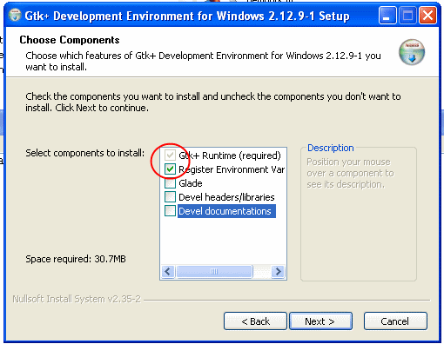

3) Install gtk-server (gtk-server-2.3.1-installer.exe)
http://downloads.sourceforge.net/gtk-server/gtk-server-2.3.1-installer.exe

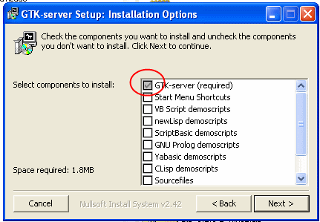

We select the option “add to the PATH”:
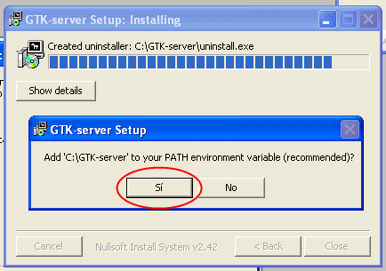

4) And finally we add the script’s folder to the octave’s search path and run zgui

> addpath(‘c:\project\scripts’)
> cd c:\project
> zgui

zgui: interface for the first half of the scripts (before gmsh)
zgui(1): interface for the second half of the scripts (when we have created anchors_carretera.msh)

NOTE: Multitrack (read “Multi track scripts.pdf”):
NORMAL and FATHER have 2 interfaces. SONs only have zgui, but not zgui(1).

NOTE: sometimos the interface refuses to perform an action for no reason. If that happens, close the GUI, open it again and try again. If that doesn’t work you can close the GUI and type the commands on the text-mode octave window. The error messages on screen will help to diagnose the problem.

