**Overview**

There are 3 parts to this coding test. You have 2 hours to complete as much as possible. Please read the directions for each section before starting as the objective of subsequent sections may influence how you code earlier ones. Screenshots are provided to give you an idea of what it should look like and what the behavior should be. You may use any resources you need to complete the test (ie google, stack overflow, etc)

In general, use as few lines of code as possible while maintaining semantic markup. Also keep in mind best practices for accessibility, page performance and SEO. Please comment all your code, as it will give a better idea of what you are trying to accomplish.

If a solution requires javascript, the jquery library is already linked, but feel free to use any javascript library you’re comfortable with.

Finish as much of this as you can. If you run out of time, please add comments and/or pseudo code that will give an idea of what you’re trying to accomplish.

A directory structure is provided. Images are located in the i directory. Please place your files in the appropriate locations. Create directories as needed.

**Part 1**

**Objective:**

Build an image highlighter widget that uses only HTML and CSS. Mousing over an image will darken the other images and leave the moused over image bright. You are **NOT** allowed to use JavaScript to complete this. If you cannot find a solution using only HTML and CSS, then use Javascript. You should use the image sprite provided to display each image and they should appear in the order shown in Figure 1a.

**Figure 1a –** Full screen

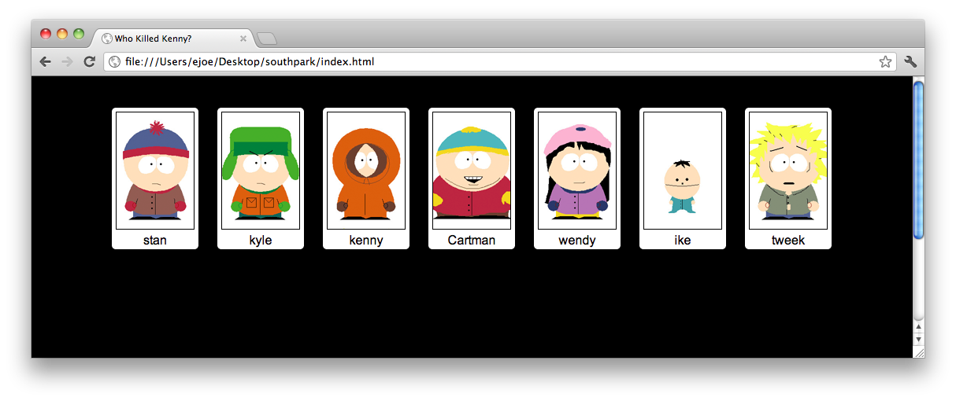

**Figure 1b –** Images wrap around when the width of browser is made smaller.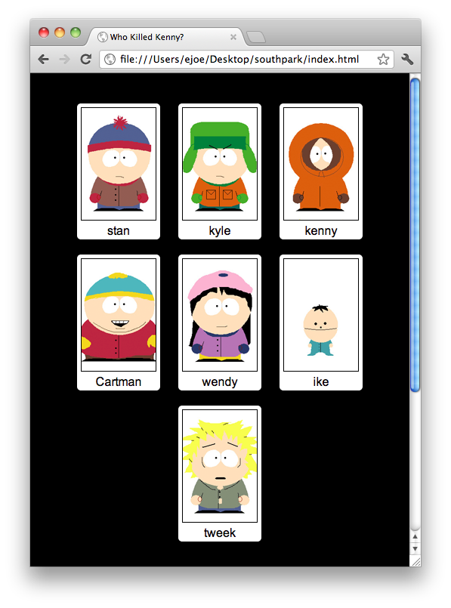

**Figure 1c –** When you mouse over an image, all the other images will darken.

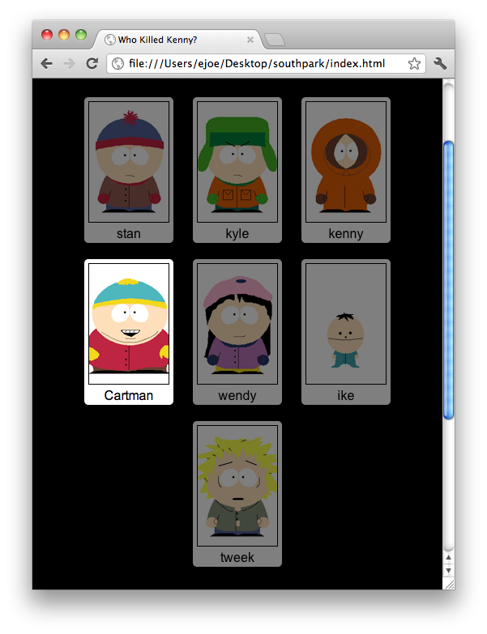

Part 2:

**Objective:**

Add a title and some directions to the page.

Build functionality that will allow you change the sort order of the images. Clicking on an image will move it into the section below and display the images in the new sort order. You may use Javascript for this.

In figure 2a, Kenny, Cartman, Ike and Tweek have been clicked on, in that order. Clicking on Kyle will move Kyle into the lower section after Tweek.

**Figure 2a –** Clicking on the highlighted image moves it to the section below.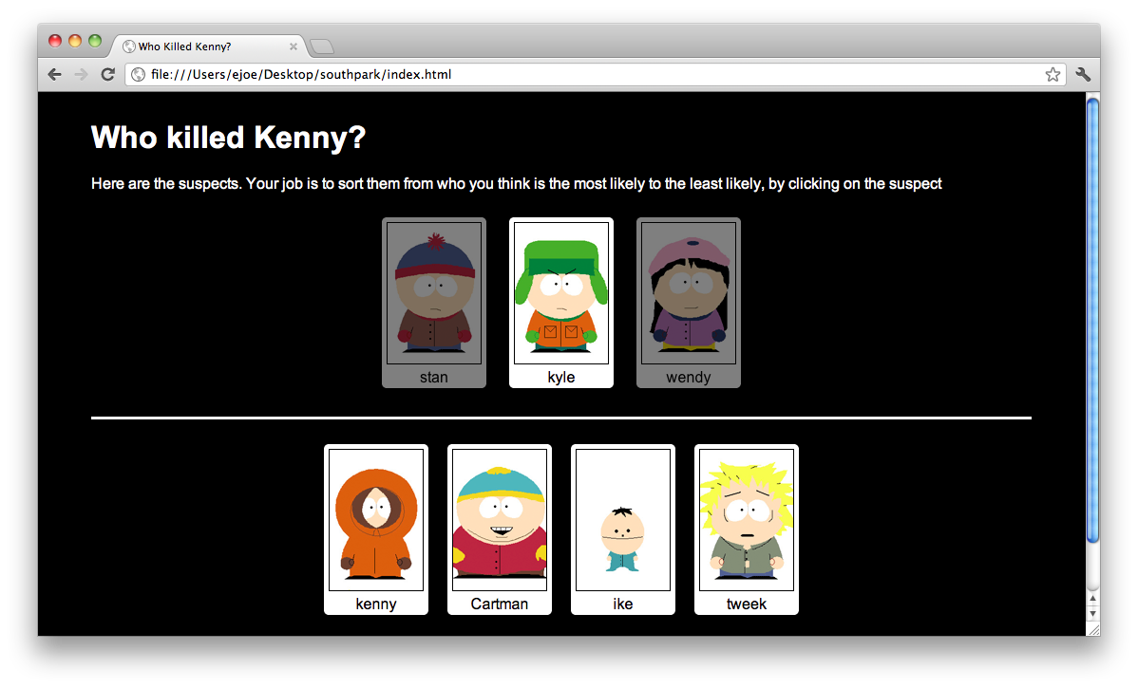

Part 3:

**Objective:** Add a button labeled Reset and Save. Clicking Reset will clear section displaying the newly resorted images and redisplay the images in the upper section in their original display order. No click action for Save needs to be implemented.

**Figure 3a –** Add a row of buttons below the resorted images.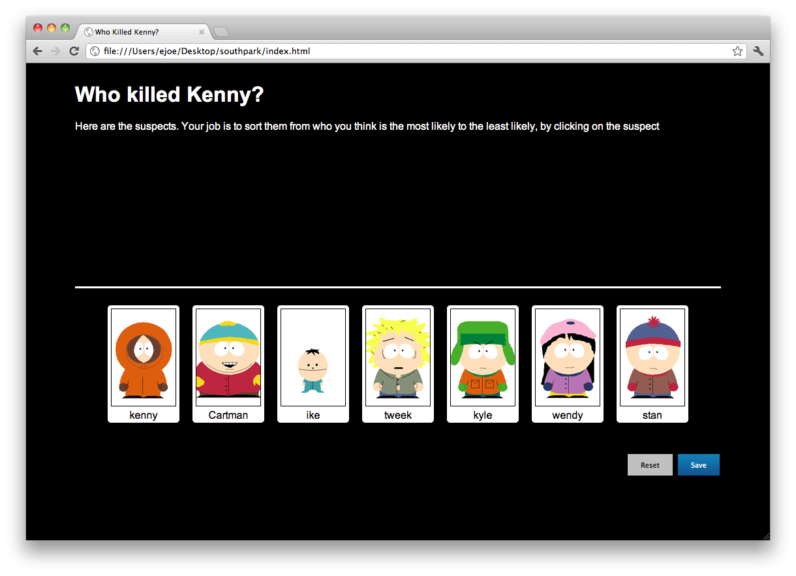**Figure 3b –** Clicking on Reset removes images in the bottom section and restores the images in the upper section.