That is my database structure

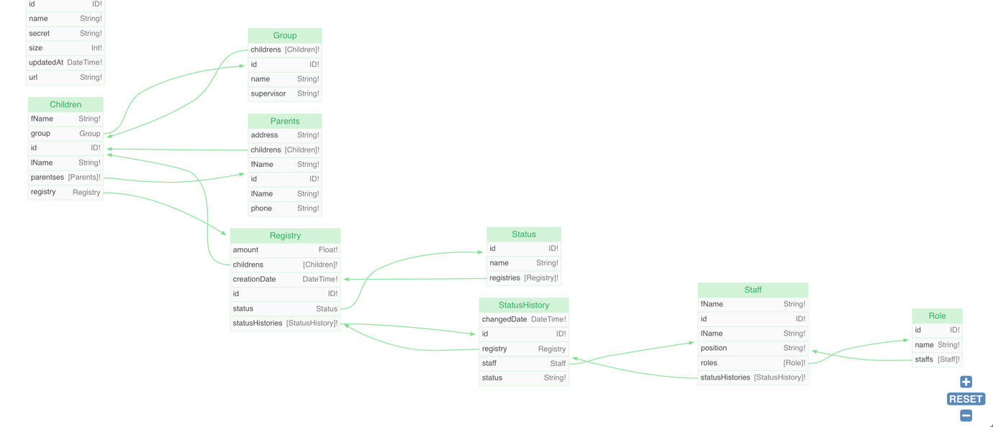

1. Admin-api - to manage data about staff member. It will have features like adding, deleting, granting role to staff members, also add, delete and update children data.
2. Registry-api – for accountants and for parent to create application to create new registry, to update status of registry, overally control process about registry
3. Children-api - for managing data about children, kindergarden and groups in kindergarden
4. Children-attendance-api – microservice to manage child attendance, attach documents about missing days,