Assignment 1

1. Choose a project topic

“Kindergarden” system for accountants and nurses

1. Logically split your project into small-gained components with well-defined boundaries of responsibility (at least 4 microservices).

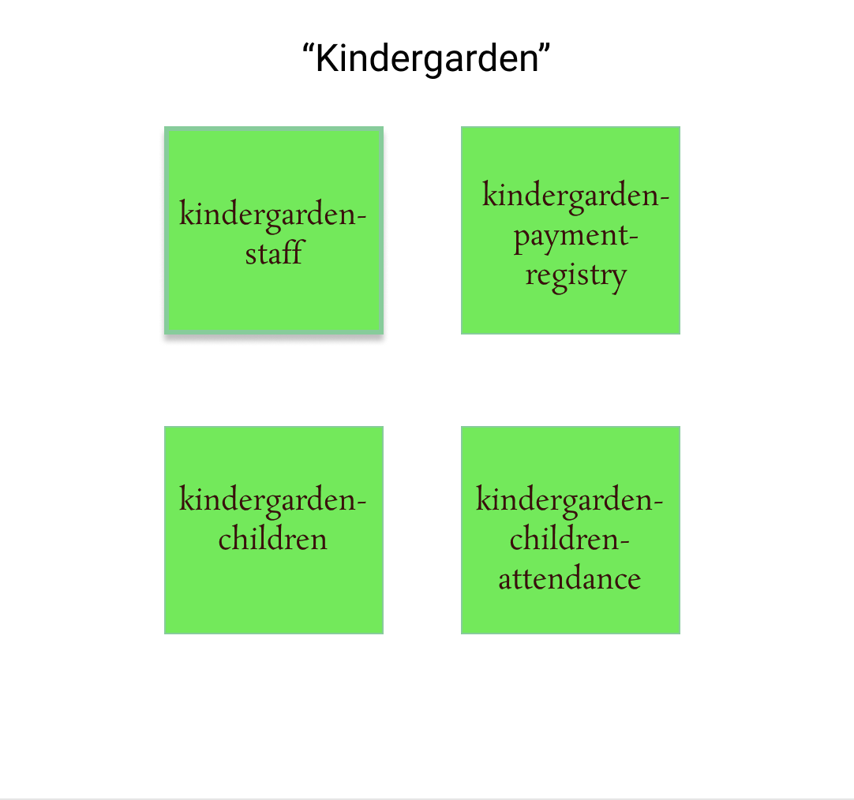

1. Briefly define responsibilities of each component. Identify and describe basic API methods.

* /staff - to manage data about staff member. It will have features like adding, deleting, granting role to staff members, also add, delete and update children data.
* /registry – for accountants and for parent to create application to create new registry, to update status of registry, overally control process about registry
* /children - for managing data about children, kindergarden and groups in kindergarden, microservice to manage children attendance, attach documents about missing days,
* /kindergarden – to manage kinder garden data

1. Describe how these microservices communicate with each other (illustrate in diagram if needed).

/staff

* to create and add staff member we have we need list of kindergardens

/registry

* to create new registry, we have to retrieve list of kindergardens with microservice /kindergarden
* after list of group depending on kindergarden /kindergardern/group
* after children /children

/children

* to create new children, we have to retrieve list of kindergardens with microservice /kindergarden
* when retrieve for every nurse we have to check from /staff/role rolw of staff worker and retrieve list of childrens to check the attendance and attach needed documents in case when children didn’t come to kindergarden