1. **Data cleaning**

* **Raw File with single table changed into Multiple Sheets ( four excel) to reduce Redundance**
* **Field with No data is updated with text and numbers by observing the data in the table**

1. **Data sourcing** 
   * **All the Tables are uploaded into SQL Server* and linked them with PowerBI**

**File \***

Questions to find the solution of churn analysis

1. Identify the total number of customers and the churn rate

Power BI

* A screenshot of a number

  Description automatically generatedA screenshot of a number

  Description automatically generatedCreated cards and calculated column of churn percentage

Churned

1. Find the average age of churned customers

Power BI – Average age

Churned

1. Discover the most common contract types among churned customers

Power BI – count of customer Id & measure for churned customers

1. Analyze the distribution of monthly charges among churned customers

Power BI – Bar chart with x-axis as churn status, churn category and churn reason and Y as sum of monthly charges ( Drill Down)

1. Create a query to identify the contract types that are most prone to churn

Power BI – Month-to-Month contracts with (1655/1869 )

SQL query - Below

Used left join to combine purchase and churn tables to find the reasons as well with filter of only month-to-month contracts

1. Identify customers with high total charges who have churned
   1. Power BI – Divided the age into 3 categories Age>=50 Aged ; Age =<30 Young and Middle

* 1. SQL query

Subquery + join to get list

1. Calculate the total charges distribution for churned and non-churned customers

SQL – Barchart

1. Calculate the average monthly charges for different contract types among churned customers

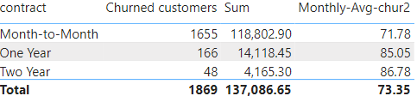

1. Identify customers who have both online security and online backup services and have not churned

SQL – filters

1. Determine the most common combinations of services among churned customers

Power BI – selected columns to value field

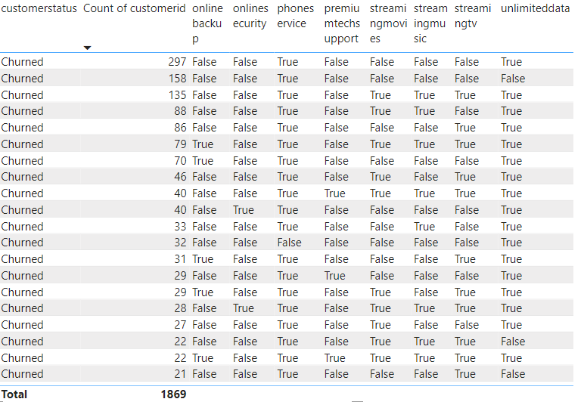

1. Identify the average total charges for customers grouped by gender and marital status

Power BI – selected columns to value field

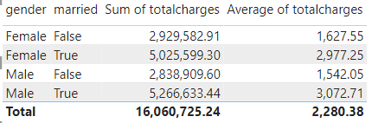

1. Calculate the average monthly charges for different age groups among churned customers

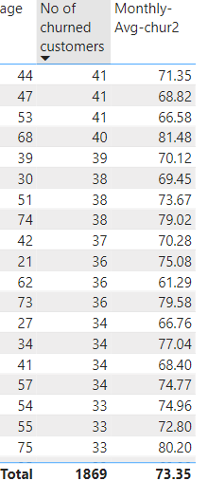

1. Determine the average age and total charges for customers with multiple lines and online backup

1. Identify the contract types with the highest churn rate among senior citizens (age 65 and over)

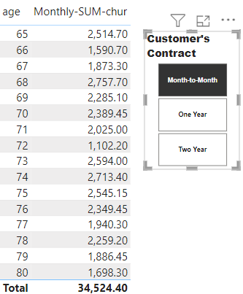

1. Calculate the average monthly charges for customers who have multiple lines and streaming TV

1. Identify the customers who have churned and used the most online services

1. Calculate the average age and total charges for customers with different combinations of streaming services

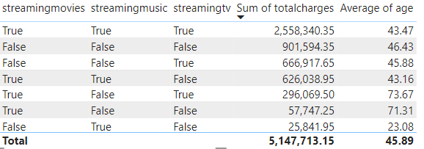

1. Identify the gender distribution among customers who have churned and are on yearly contracts

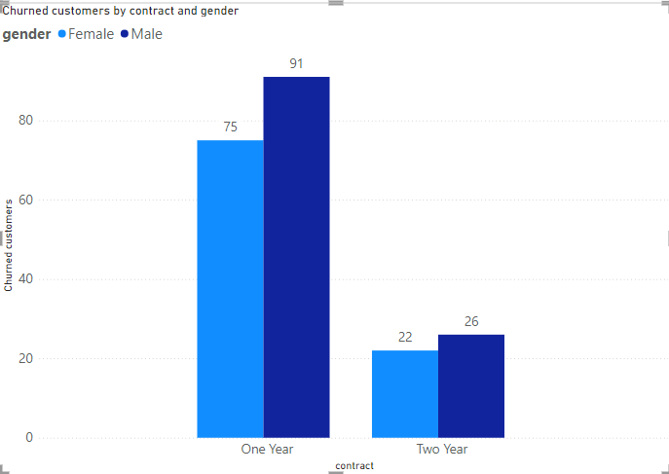

1. Calculate the average monthly charges and total charges for customers who have churned, grouped by contract type and internet service type

Power BI – Filter and Measure

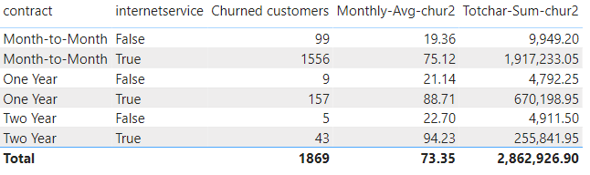

1. Find the customers who have churned and are not using online services, and their average total charges

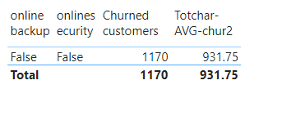

1. Calculate the average monthly charges and total charges for customers who have churned, grouped by the number of dependents

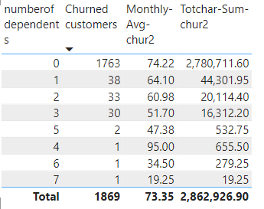

1. Identify the customers who have churned, and their contract duration in months (for monthly contracts)

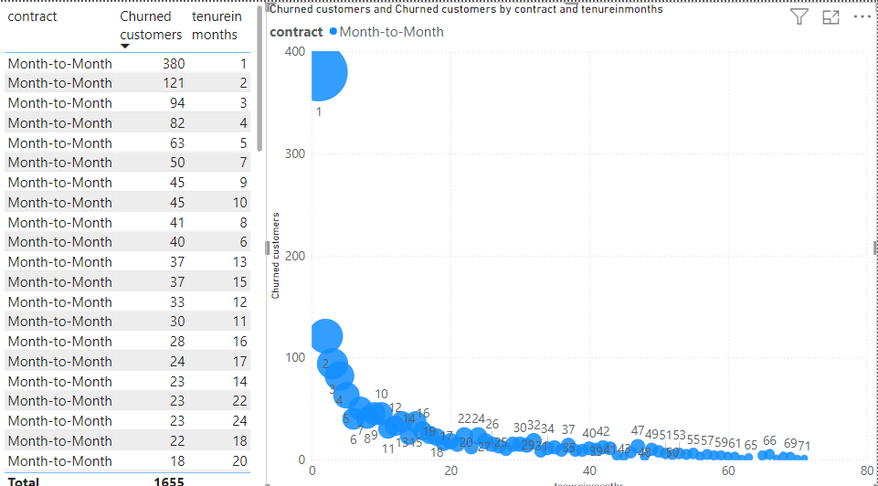

1. Determine the average age and total charges for customers who have churned, grouped by internet service and phone service

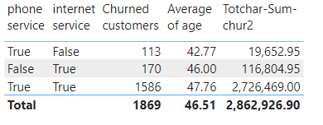

1. Create a view to find the customers with the highest monthly charges in each contract type

SQL – create view

1. Create a view to identify customers who have churned, and the average monthly charges compared to the overall average

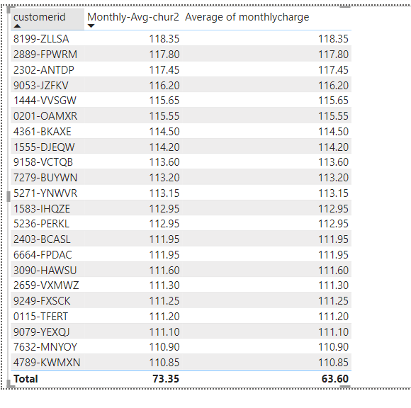

26. Create a view to find the customers who have churned and their cumulative total charges over time

27. Stored Procedure to Calculate Churn Rate

28. Stored Procedure to Identify High-Value Customers at Risk of Churning.

Formulae

POWER BI

For Ques1 -Caluclated column

Churn% = ('public churn'[Churn No]/COUNTA('public churn'[customerstatus]))*100

For Ques3 – Measure

* Churned customers = calculate(

COUNTA('public churn'[customerstatus]) , 'public churn'[customerstatus] = "Churned" )

For Ques 8

* Monthly-SUM-chur = CALCULATE( SUM('public payment'[monthlycharge]),'public churn'[customerstatus] = "Churned")
* Monthly-Avg-chur2 = CALCULATE( AVERAGE('public payment'[monthlycharge]),'public churn'[customerstatus] = "Churned")

For Ques 19

* Totchar-Sum-chur2 = CALCULATE( SUM('public payment'[totalcharges]),'public churn'[customerstatus] = "Churned")
* Totchar-AVG-chur2 = CALCULATE( AVERAGE('public payment'[totalcharges]),'public churn'[customerstatus] = "Churned")

SQL -query

Ques 5 -

Select a.customerid, a.monthlycharge , b.churncategory, b.churnreason

from payment as a

left join churn as b on a.customerid = b.customerid

where a.contract = 'Month-to-Month'

group by a.customerid , monthlycharge, b.churncategory, b.churnreason

Que -6

select a.customerid, b.age, a.totalcharges, a.contract

From payment as a

Right join

(select customerid, age

from customer

where customerid in (Select customerid from churn where customerstatus = 'Churned')) as b

on a.customerid = b.customerid

Q-24

* Create view High_Monthly_Charges As

SELECT customerid, contract, monthlycharge

from payment

order by monthlycharge desc

* Select * from High_Monthly_Charges
* Drop view High_Monthly_Charges

Q25

CREATE VIEW churned_customer_avg_charges AS

SELECT

customerid, monthlycharge,

(select sum(monthlycharge))as overall_average

From payment

where customerid in (select customerid from churn where customerstatus ='Churned' )

group by customerid, monthlycharge

Select * from churned_customer_avg_charges

drop view churned_customer_avg_charges

Q27