NUnit Testing Version-2.6.4

Description:

NUnit is a open source framework designed for writing and running tests in Microsoft .net programming languages.

Purpose:

Unit Testing.

Minimum Requirement:

.Net Framework,Windows XP.

How to Download it ? :

Download to the NUnit software from http://nunit.org/index.php?p=download.

How to Plugin into Visual studio ? :

                - Create a new C# class project.
                - Add reference nunit.framework.dll .
Path:“C:\Program Files\NUnit 2.6.4\bin\net-2.0\framework\nunit.framework.dll”.

How to create test cases using NUnit attributes:
We learn about,
1.Assertions
2.Attributes
1.Assertions:

Assertion is a static class that is used to identify the status (Pass/Fail) of test cases. It compares the actual result and expected result to derive the status of a test case.

NUnit Provide many types of assertions:

■ Equality
AreEqual, AreNotEqual
■ Identity
AreSame, AreNotSame, Contains
■ Condition
IsTure, IsFalse, IsNull, IsNaN, IsEmpty, IsNotEmpty
■ Comparison
Greater, Less, IsIsnstanceOf, IsAssignableFrom

2.Attributes:

NUnit uses attributes that can tell which classes and methods are testable.

Categories:

When categories are used, only the tests in the selected categories will be run.
■ TestFixture
Syntax :
[TestFixture] [Category (“LongRunning“)]
public class Tests
■ Test
Syntax :
[Test] [Category Long“)]
public void VeryLongTest

Useful Test Cases Assertions:

You can use many attributes to run a single test with different parameters:
TestCase
■ A single set of parameters per attribute.
Range, Random, Values
■ Multiple simple-typed parameters.
TestCaseSource, ValueSource
■ Use a public property or a void Method to transfer parameters.

How to create a test script ? :

            - Create a simple class with ‘TestFixture’ as attribute in class project.
            - Then create a method attribute with ‘Test’ which will have our test.
            - Build the project.
            - It will create a DLL for Test Case.

How to Run the Test Case ? :

NUnit provides two utilities to run test cases:
1. Nunit-gui.exe: GUI tool
2. Nunit-console.exe: Console tool

Both of them have same feature set, the only difference is that one is GUI based and the other one is console based tool.
Running Test case in Nunit-gui:
Steps:

1.Open the Nunit GUI Tool.

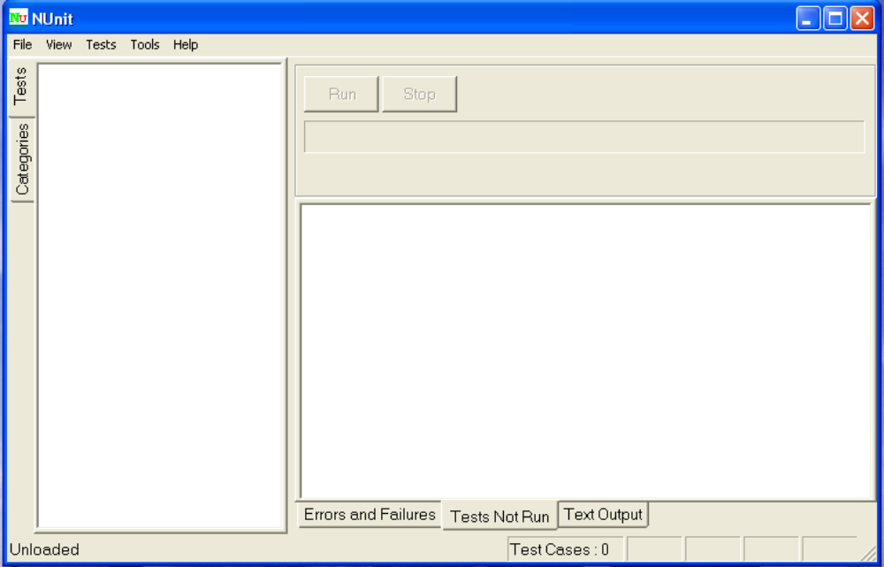

2.Click on file – Open project and select our test DLL.

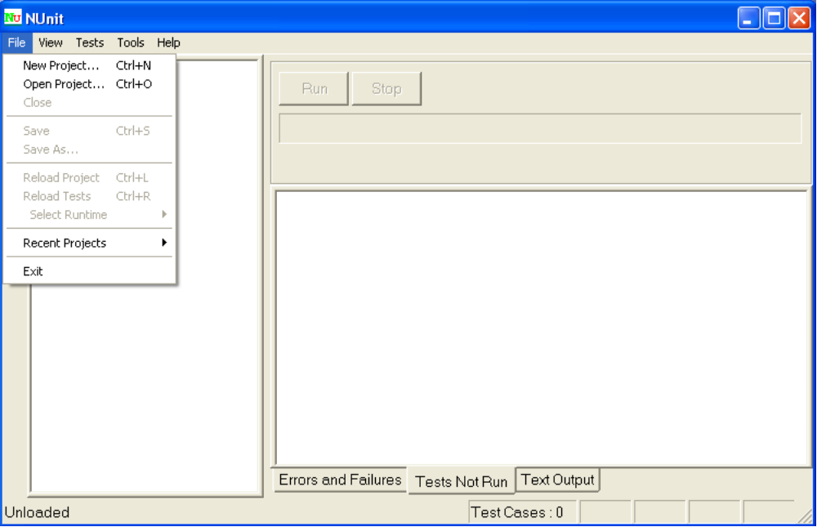

3.Click RUN.
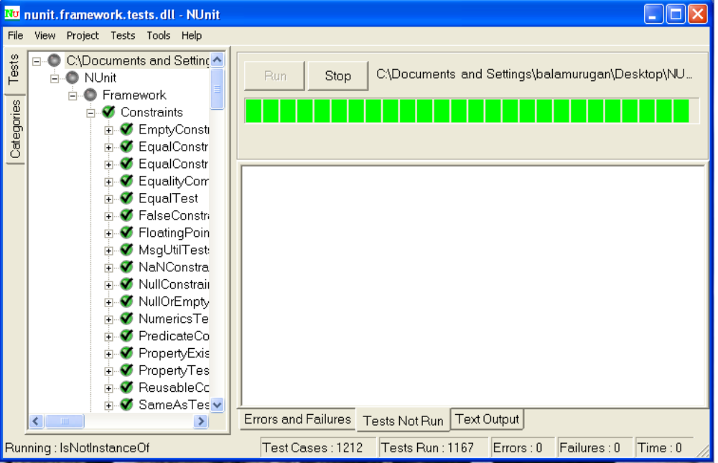

Shortcuts in GUI Tool:

F5-Default run all the test.
F6-Only run selected test.
F7-Only run failed test.

Colors Notification for NUnit Test Case:

Red:Test case failed.
Green:Test case success.
Yellow:Mention Ignore Test case.(Not run)

Running Test Case in Nunit-console:
The nunit-console.exe program is a text-based runner and don’t need a red/yellow/green indication of success or failure. The console interface always creates an XML representation of the test results. This file by default is called TestResult.xml and is placed in the working directory.

Steps:

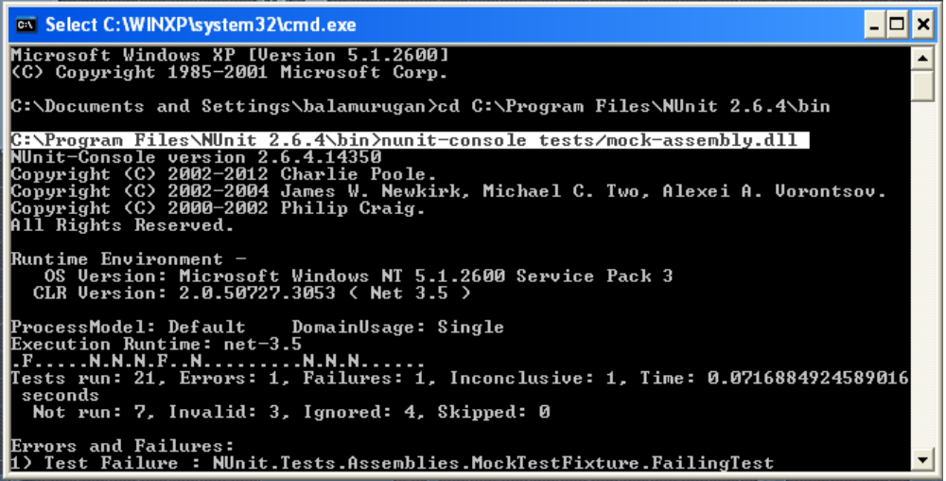
From Screen shot:
1.Mention the working directory -C:\programFiles\Nunit 2.6.4\bin
2.After that mention “nuint-console” is a keyword.
3.Enter the dll folder name and then “/” test file.

Specify the Fixture:
Ex: nunit-console /fixture:NUnit.Tests.AssertionTests nunit.tests.dll

Specifying the Version of the CLR:
Ex: clr net-2.0 nunit-console nunit.tests.dll

Specifying Test Categories to Include or Exclude:
Ex: nunit-console myassembly.dll /include:BaseLine

Redirecting Output:
Ex: nunit-console nunit.tests.dll /out:TestResult.txt

Specifying the XML file name
Ex: nunit-console /xml:console-test.xml nunit.tests.dll

Specifying Multiple Assemblies
Ex: nunit-console assembly1.dll assembly2.dll assembly3.dll

How to Name Conventions in Class Library Project ? :

1.Create separate assembly for your test cases. Suffix Test in the project name.
2.Create separate class to test each class in the application. Suffix Test in the class name.
3.Test cases should be prepared before actual development and should be prepared from requirement document.
4.Categorize the test cases using Category attribute.

What are the Advantages of using NUnit ? :
1.Don’t need to manually test all the scenarios after making some changes in the existing functionality.
2.It saves time as we can see the effect of the change immediately.
3.It’s Free.
4.Don’t need to learn a new programming language or a scripting language to write your test cases.
5.It provides configuration option to choose the .Net framework version to run against.
6.No need to have the VS Open and Running.
7.Quick Response.

