Experiment no:6 QR Code

Date:

Introduction:
The ATM Cash Withdrawal System is a banking application that allows customers to withdraw money from their accounts through an Automated Teller Machine (ATM). The system ensures secure authentication, accurate transaction processing, and reliable service. The Use Case Diagram represents the interactions between the customer and the ATM system, highlighting the functional requirements from the user’s perspective.
Objective:
The main objectives of this experiment are:
• To understand UML Use Case Diagram modeling
• To identify the primary actor and system functionalities
• To represent user–system interactions graphically
• To model the ATM cash withdrawal process at a high level
• To analyze system requirements before implementation
Tools and Technologies Used:
• UML Modeling Tool (Rational Rose / Draw.io / StarUML / etc.)
• Computer System
• Microsoft Word for documentation
System Description:
The ATM system allows customers to perform financial transactions such as withdrawing cash. The system verifies the user through PIN authentication, communicates with the bank server, checks account balance, and dispenses cash if sufficient funds are available. It also provides transaction feedback and returns the ATM card after completion.
Actor Identification:
Primary Actor:
• Customer (ATM User)
Supporting Systems:
• Bank Server
• Account Database
6. Use Cases Identified
• Insert ATM Card
• Enter PIN
• Authenticate User
• Select Withdraw Cash Option
• Enter Withdrawal Amount
• Check Account Balance
• Dispense Cash
• Print Receipt (Optional)
• Eject Card
• End Transaction
Use Case Diagram:
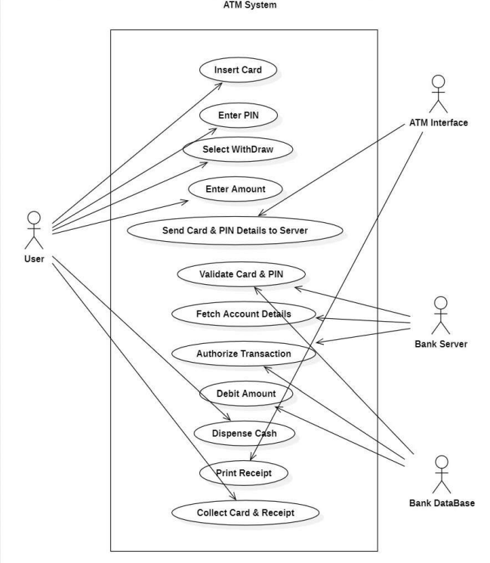
Inference:
The Use Case Diagram clearly shows the interaction between the customer and the ATM system during the cash withdrawal process. It helps in understanding system functionality at a high level and ensures that all required operations are identified. The diagram also highlights alternative scenarios such as invalid PIN or insufficient balance.
Advantages:
• Provides clear understanding of system functionality
• Helps in requirement analysis
• Improves communication between stakeholders
• Identifies system boundaries and actors
• Serves as a foundation for further UML modelling.
Limitations:
• Does not show internal system processing
• Cannot represent detailed logic or algorithms
• Limited to high-level functional view
Conclusion:
The ATM Cash Withdrawal Use Case Diagram successfully represents the interactions between the user and the system. It provides a clear and simplified view of system operations and serves as an essential step in software design. Understanding such models helps in developing reliable and secure banking applications.

