EX.No:9
DATE:

DATA FLOW DIAGRAM FOR LIBARARY MANAGEMENT
SYSTEM

Aim
The aim of this project is to design and represent a Library Management System using a structured Data Flow Diagram that clearly shows the interaction between different entities such as students, library staff, and the system database. The objective is to manage library activities like searching books, issuing and returning books, maintaining student records, and calculating fines in an efficient and organized manner.
Problem Description
In traditional library systems, managing book records, issuing books, tracking due dates, and calculating fines manually is time-consuming and often leads to errors. There is a need for a system that simplifies these operations and ensures smooth communication between students and library staff. The system should allow students to search and request books, while staff can manage book details, issue books, and handle returns efficiently. It should also automatically track due dates and generate fines for overdue books.
Given Conditions / Constraints
The system must include key entities such as students, library staff, library server or database, notification system, and fine management system. It should support basic operations like searching books, issuing and returning books, maintaining student details, and calculating fines. The design must be simple, clear, and easy to understand, ensuring proper data flow between all entities. It should also maintain data consistency and operate within limited resources while following a structured design approach.
Approach / Methodology
The approach involves designing a Data Flow Diagram that represents how data moves between different components of the system. First, the main entities such as student, staff, and system are identified. Then, interactions like searching books, issuing books, returning books, storing records, and calculating fines are mapped. The Library Management System is designed as a central component that connects all entities. This centralized approach ensures efficient communication and smooth handling of data across the system.
Planning and Estimation
The planning phase includes identifying system requirements, defining system components, and estimating the time required for each stage of development. Tasks such as requirement analysis, diagram design, and validation are planned in sequence. Time estimation is done based on the complexity of the system, ensuring sufficient time is allocated for each stage to achieve accurate and effective design.
Diagram:
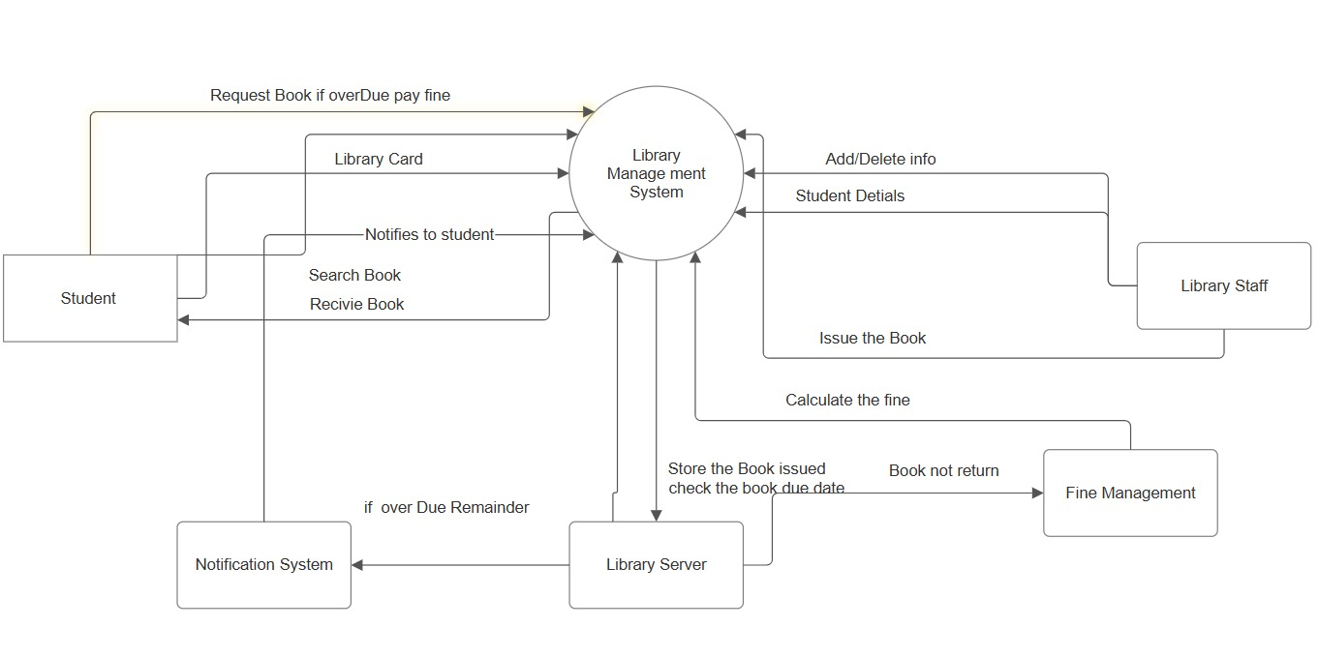
Scheduling / Design Considerations
The scheduling involves organizing the work step-by-step, starting from requirement analysis to final diagram completion. Design considerations include maintaining clarity in the diagram, proper labeling of processes, and accurate representation of data flow. The system should be user-friendly and logically structured so that interactions between students, staff, and the database are clearly understood. Special attention is given to ensuring all functionalities like notifications and fine calculations are properly represented.
Feasibility Analysis
The system is feasible in terms of technical, operational, and economic aspects. Technically, it can be implemented using standard software tools and database systems. Operationally, it simplifies library management by automating tasks such as issuing books, tracking due dates, and calculating fines. Economically, it requires minimal resources as it is primarily a design-based solution. Therefore, the system is practical, efficient, and beneficial.
Result
The result is a well-designed Library Management System Data Flow Diagram that clearly represents the interactions between students, library staff, and the system. It successfully demonstrates key functionalities such as book search, issue, return, fine calculation, and notification handling in an organized manner.
Conclusion
The designed Library Management System effectively addresses the challenges of manual library operations. It improves efficiency, reduces errors, and ensures smooth communication between all entities involved. The Data Flow Diagram provides a clear understanding of system processes and serves as a strong foundation for future system development and implementation.

