
Experiment No: 5 QR CODE
Date:

Experiment Title:
Design, Analysis and Modeling of ATM Cash Withdrawal System using UML Diagram
Aim:
To analyze, design, and model the ATM Cash Withdrawal System using UML tools such as Class Diagram and Sequence Diagram in order to understand system requirements, structure, behavior, and control flow.
Introduction:
Automated Teller Machines (ATMs) are real-time embedded systems widely used in banking for providing secure and fast customer services. UML modeling plays an important role in understanding and documenting such systems before implementation.
Problem Description:
The ATM Cash Withdrawal System must authenticate users, verify account details, check available balance, dispense cash, and generate transaction receipts. The system should also handle exceptional cases such as insufficient balance and invalid credentials in a safe and reliable manner.
Scope of the System:
The scope includes only the cash withdrawal functionality of the ATM. Other services such as fund transfer, deposit, and account management are outside the scope of this experiment.
Objectives:
- To identify system entities and their relationships
- To model static structure using class diagram
- To model dynamic behavior using sequence diagram
- To understand conditional and alternative flows
- To apply UML-based software engineering principles
Given Conditions / Assumptions:
It is assumed that the ATM hardware, bank server, and network connectivity are functioning correctly. Security threats such as hacking are not considered. The focus is limited to software design and modeling aspects.
Requirement Analysis:
Functional requirements include authentication, balance validation, cash dispensing, and receipt generation. Non-functional requirements include security, reliability, availability, and ease of maintenance.
Approach / Methodology:
The system was analyzed by identifying requirements and constraints. A class diagram was developed first to represent the static structure. A sequence diagram was then created to represent the interaction flow during the cash withdrawal process.
System Components:
The major components include User, ATM Machine, Bank Server, Account, Authentication Module, Transaction Module, and Cash Dispenser.
UML Class Diagram:
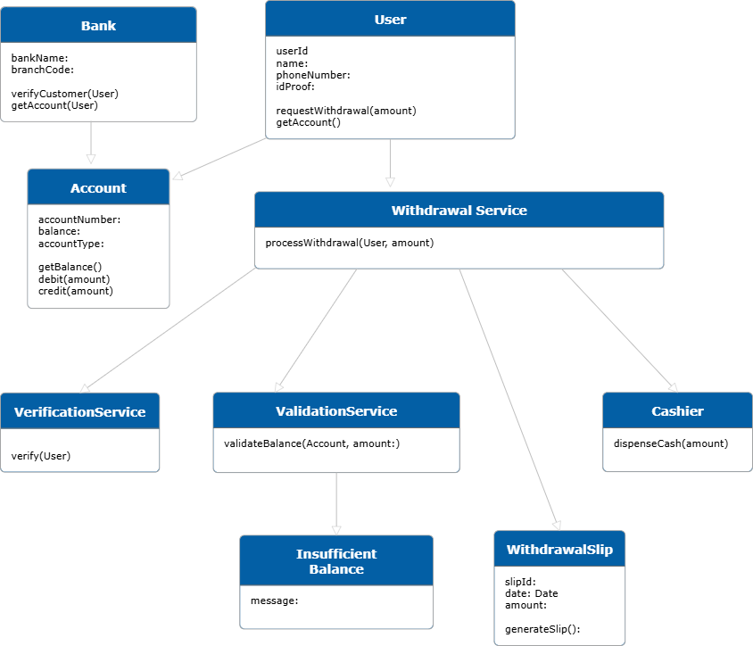
Class Diagram for ATM Cash Withdrawal System
UML Sequence Diagram:
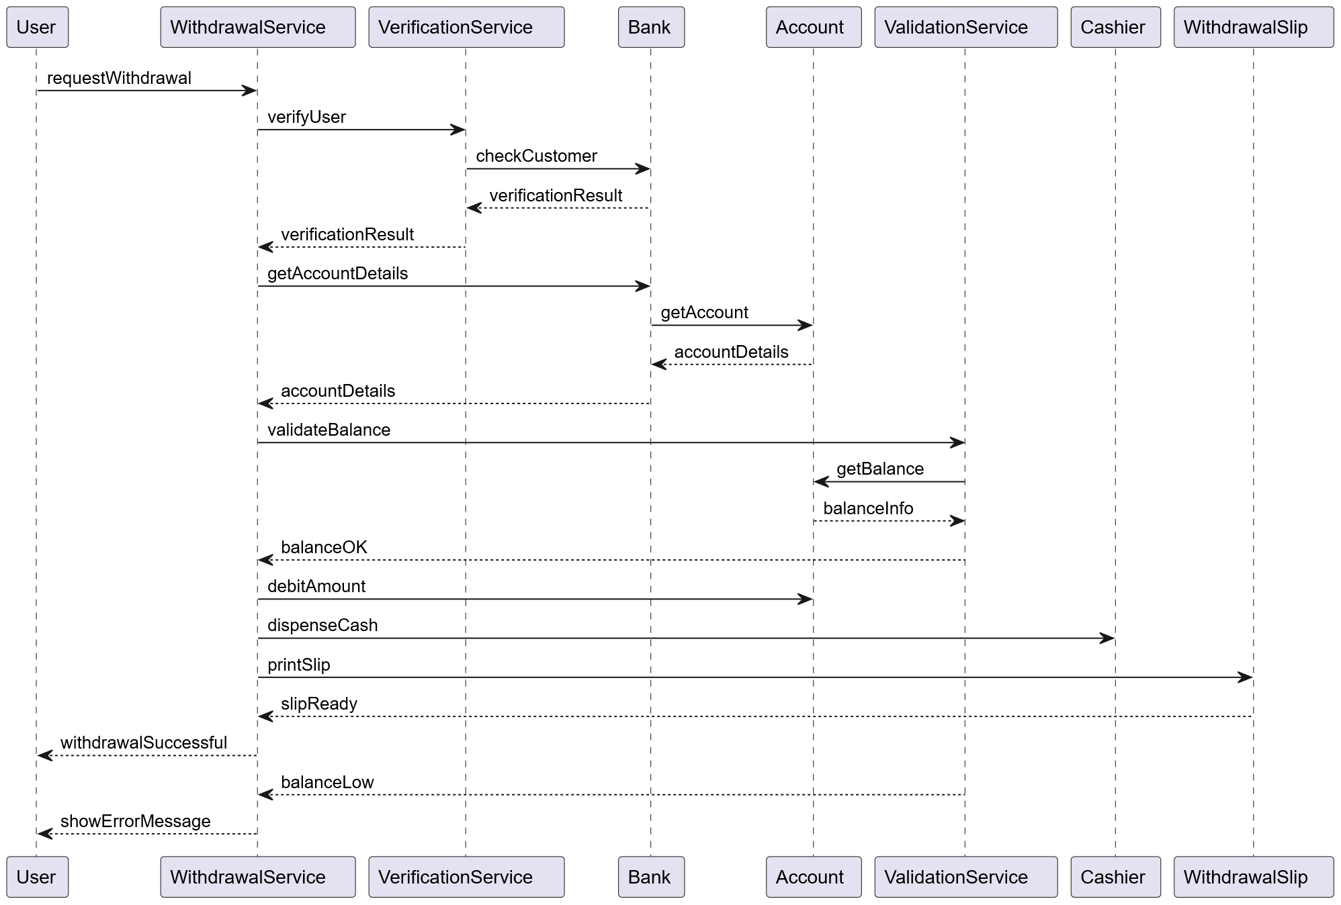
UML Sequence Diagram for ATM Cash Withdrawal System
Design Considerations:
The design focuses on modularity, low coupling, high cohesion, and clear responsibility assignment. Each class performs a specific function to improve maintainability.
Risk Analysis:
Possible risks include transaction failure, insufficient balance, and unauthorized access. These risks are handled through validation checks and alternative flows in the sequence diagram.
Observation:
The class diagram effectively represents system structure and data organization. The sequence diagram clearly explains interaction flow and decision points. Both diagrams together provide a complete understanding of system behavior.
Advantages of UML Modeling:
- Provides clear system visualization
- Helps in early detection of design flaws
- Improves documentation quality
- Enhances communication among stakeholders
Learning Outcome:
This experiment improves understanding of UML modeling techniques and their application in real-world system design.
Result:
Thus, the ATM Cash Withdrawal System was successfully analyzed and modeled using UML Class Diagram and Sequence Diagram.
Conclusion:
The experiment demonstrates the effectiveness of UML diagrams in software engineering. Proper modeling leads to reliable, secure, and maintainable system design.

