TITLE

Zero Trust Network Access (ZTNA) with Zscaler: Securing User-to- Application Connectivity.

GROUP DETAILS:

S.no | Name | College | Contact
1. | M.Balamurugan | Angappa college of arts and science | ramkumarram2374@gmail.com
2. | R.Stevina | Angappa college of arts  and science | stevinastevina134@gmail.com
3. | V.Harini | Angappa college of arts and science | iamharini50@gmail.com

Project Details:
Title: Zero Trust Network Access (ZTNA) with Zscaler: Securing User-to-Application Connectivity.

INTRODUCTION:
AI-Enhanced User Protection (AIUP) is a next-generation security framework that leverages artificial intelligence and machine learning to verify user identities and protect online platforms from cyber threats. Unlike traditional security measures that rely on static credentials like passwords or even two-factor authentication (2FA), AIUP continuously analyzes user behavior to create a dynamic, evolving "trust score" for each individual.
AIUP is essential for modern online security because it addresses the limitations of perimeter-based defenses. As cyber threats become more sophisticated—with attackers using stolen credentials, phishing, and social engineering—relying solely on "what you know" (passwords) or "what you have" (tokens) is no longer sufficient. AIUP adds a third, continuous layer: "who you are" based on how you behave. This system helps organizations prevent account takeovers, reduce fraud, and ensure that the person interacting with a platform is genuinely who they claim to be, throughout their entire session.

Abstract:
The limitations of legacy VPN architectures in addressing modern security threats, particularly lateral movement and over-privileged network access, necessitate a paradigm shift towards Zero Trust principles. This project details the comprehensive design, deployment, and management of a Zero Trust Network Access (ZTNA) solution leveraging Zscaler Private Access (ZPA) within a large- scale institutional network. The project aims to replace broad network-level access with application-specific, identity- driven connectivity. By deploying Zscaler App Connectors within the data center and integrating the platform with existing Identity Providers (Azure AD) and endpoint security tools, the architecture ensures that all user-to-application connections are established through a cloud-native broker. This approach renders internal applications "invisible" to the internet, eliminating the attack surface. Furthermore, the project explores the integration of Zscaler with security ecosystems, including SIEM platforms (like QRadar) for centralized logging and MISP for consuming threat intelligence to enable adaptive access policies. The result is a robust, scalable security framework that enforces least-privilege access, provides comprehensive audit trails, and significantly enhances the institution's resilience

Use Case Scenarios:
Scenario 1:Secure Remote Access for Faculty to ERP System
A faculty member working from home needs to access the university's ERP system to upload student grades. Using Zscaler Private Access (ZPA), they connect securely without being placed on the internal network. The system verifies their identity via Azure AD MFA and checks their device posture before granting access.

Output:
- User identity verified (Faculty_Group)
- Device posture compliant (AV active, OS up-to-date)
- Secure micro-tunnel established to ERP Application only
- Network remains completely invisible to the user

Scenario 2: External Researcher Accessing a Specific Database
An external research collaborator from another institution requires temporary access to a single research database hosted on VIT's servers. The administrator creates a time-limited, application- specific policy in Zscaler. The researcher accesses only the authorized database without any visibility into the rest of the VIT network.

Output:
- External user identity verified via temporary credentials

- Access policy enforced (Time-limited: 7 days, Application: Research-DB only)
- Database server remains hidden from internet scanners
- Session automatically terminates after policy expiry

Scenario 3: Student Access to Online Examination Portal
During final exams, thousands of students simultaneously access the internal online examination portal from various locations.
Zscaler ZPA ensures that only authenticated students with compliant devices can reach the exam server. The system prevents DDoS attacks on the login page and blocks any attempts to access other internal resources.

Output:
- Mass user authentication handled via cloud scalability
- Each student connected only to the exam application
- Lateral movement to grade database or other servers blocked
- Exam server IP address remains concealed from the internet

Scenario 4: IT Administrator Performing Server Maintenance
An IT administrator needs to perform critical updates on an internal application server. Instead of connecting via VPN and gaining full network access, they use ZPA to connect directly to the specific server's management interface. The session is

monitored in real-time, and any anomalous behavior (e.g., accessing unauthorized servers) is automatically terminated.

Output:
- Admin identity verified with MFA
- Direct micro-tunnel to Server-Management-Interface only
- All admin keystrokes and commands logged for audit
- Attempt to access another server automatically blocked

Scenario 5: Mergers and Acquisitions – Temporary Contractor Access
A contractor hired during a university system upgrade needs temporary access to a specific file server to migrate data. Using Zscaler ZPA, the contractor is granted application-specific access without being added to the university's Active Directory or given VPN credentials. The access is revoked automatically after the project timeline.

Output:
- Contractor identity verified via separate IdP integration
- Access granted to File-Server-Migration share only
- All file transfer activities logged in Zscaler and SIEM
- Access automatically revoked after 30-day project end date

Title:Zero Trust Network Access (ZTNA) with Zscaler: Securing User-to- Application Connectivity.

Overview: -
The project aims to develop an AI-driven identity verification system that enhances online security by analysing and verifying user identities based on their online behaviour patterns. This system uses advanced machine learning techniques to create a robust user profile, distinguishing between legitimate users and suspicious activities. It addresses the pressing issue of unauthorised access, fraudulent transactions, and cyber threats across various online platforms and services.
The primary objective is to enhance online security significantly by scrutinising and validating user identities through their online behaviour. The system employs advanced machine learning techniques such as deep learning, neural networks, and natural language processing to establish comprehensive behavioural profiles for each user, which adapt and evolve with the user's behaviour over time. Real-time anomaly detection is a key feature of the system, identifying deviations from established user behaviour profiles and responding promptly to mitigate potential security threats.
Multi-factor verification is also implemented to bolster security, triggering additional verification steps when anomalies are detected. User and administrator alerts ensure transparent communication and provide guidance on resolving potential security issues. Secure data storage and management

components are included to protect sensitive user profiles and anomaly data.
The system includes an integration layer for seamless interaction with various online platforms and services. Monitoring and reporting are integrated for performance and security, providing transparency and accountability. Scalability and load balancing are designed to handle growing user bases, while security and compliance are prioritised by encrypting data in transit and at rest, employing firewalls, intrusion detection systems, and adhering to data protection and privacy regulations.
Cloud infrastructure is an optional option for flexibility and scalability. Continuous training and optimization of machine learning models ensure the system remains effective against evolving threats and user behaviours. Geographic distribution can enhance redundancy and performance by deploying components in multiple geographic regions.
Multi-factor verification is also implemented to bolster security, triggering additional verification steps when anomalies are detected. User and administrator alerts ensure transparent communication and provide guidance on resolving potential security issues. Secure data storage and management components are included to protect sensitive user profiles and anomaly data.
The system includes an integration layer for seamless interaction with various online platforms and services. Monitoring and reporting are integrated for performance and security, providing transparency and accountability. Scalability and load balancing are designed to handle growing user bases, while security and

compliance are prioritised by encrypting data in transit and at rest, employing firewalls, intrusion detection systems, and adhering to data protection and privacy regulations.
Cloud infrastructure is an optional option for flexibility and scalability. Continuous training and optimization of machine learning models ensure the system remains effective against evolving threats and user behaviours. Geographic distribution can enhance redundancy and performance by deploying components in multiple geographic.

S.NO | Vulnerability name | CWE/CVE no.
1 | Relative Path Traversal | CWE-23
2 | Active Debug Code | CWE-489
3 | Unimplented or Unsupported Feature in UI | CWE-447
4 | Weak Encoding for Password | CWE-261
5 | Missing XML Validation | CWE-112
6 | External Control of File Name or Path | CWE-73
7 | Empty Password in Configuration File | CWE-258
8 | Missing Support for Integrity Check | CWE-353
9 | Improper Output Neutralization for logs | CWE-117
10 | Uncaught Exception | CWE-248

Report:
Vulnerability name: Relative Path Traversal CWE/CVE number:CWE-23
Owasp category: A01:2025 Broken Access Control

Description:Relative Path Traversal is a vulnerability where an attacker manipulates file paths (using ../) to access files and directories outside the intended directory. This can allow unauthorized access to sensitive system files.
Business impact:Exposure of confidential data (password files, configs)

Unauthorized system access

Data breach and compliance issues

Damage to organization reputation
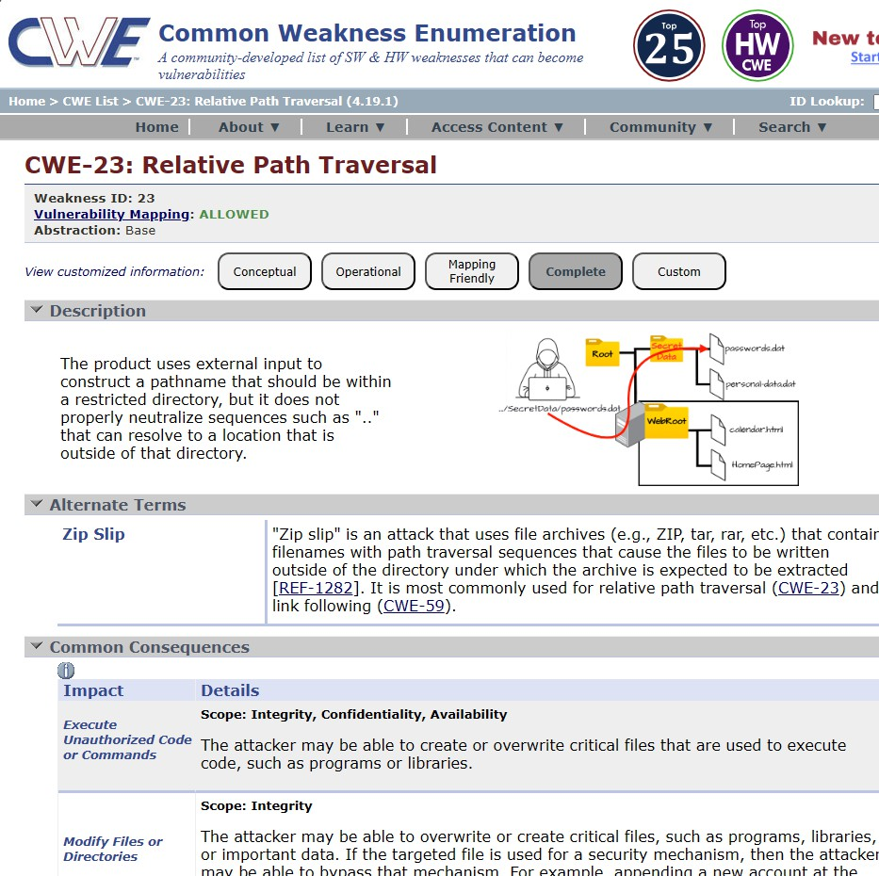

Report:
Vulnerability name: Active Debug code CWE/CVE number:CWE-489

Owasp category: A02:2025 Security Misconfiguration

Description:Debug code left in production applications can expose internal system details, logs, and execution flow, which attackers can exploit.
Business impact:Information leakage

Easier exploitation by attackers

Increased attack surface

Security misconfiguration risks

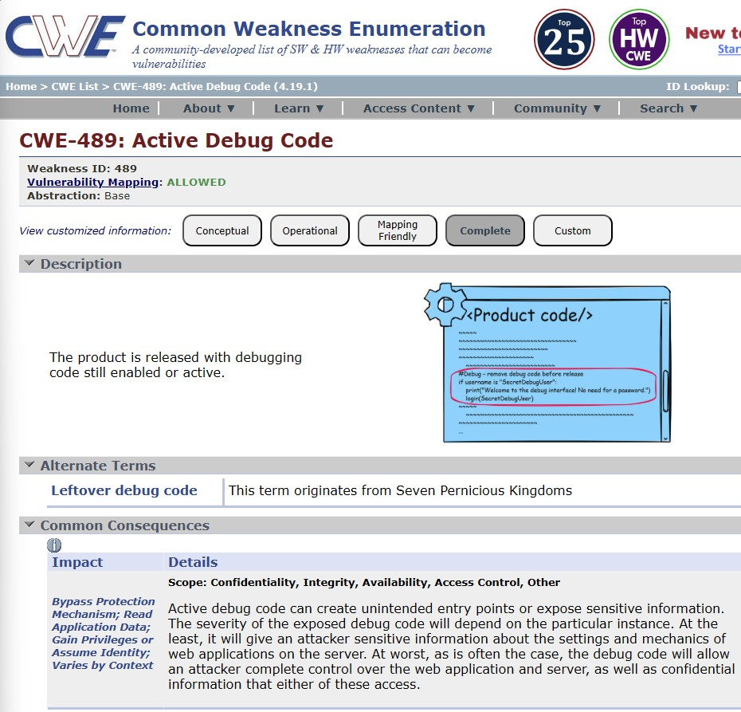

Report:
Vulnerability name: Unimplemented or unsupported Feature in UI CWE/CVE number:CWE-447

Owasp category: A03:2025 Software Supply Chain Failures

Description:UI elements that are not fully implemented or supported may lead to unexpected behavior, potentially exposing backend functionality.
Business impact:Application instability

Unauthorized feature access

Poor user experience

Potential security loopholes

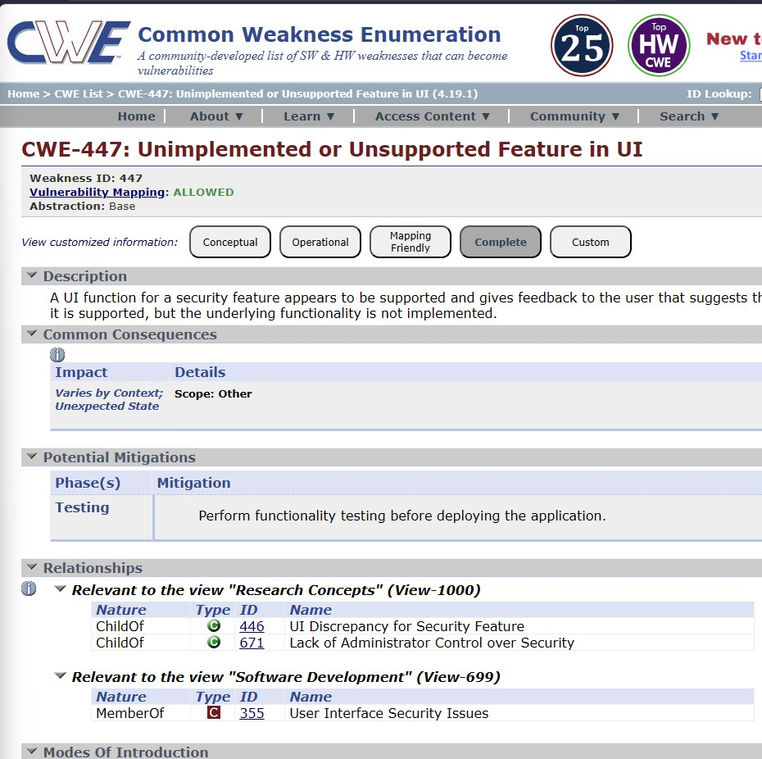

Report:
Vulnerability name: Weak Encoding for Password CWE/CVE number:CWE-261

Owasp category: A04:2025 Cryptographic Failures

Description:Passwords stored using weak encoding instead of strong hashing (like bcrypt) can be easily decoded by attackers.
Business impact:User account compromise

Credential theft

Legal and compliance issues

Loss of customer trust

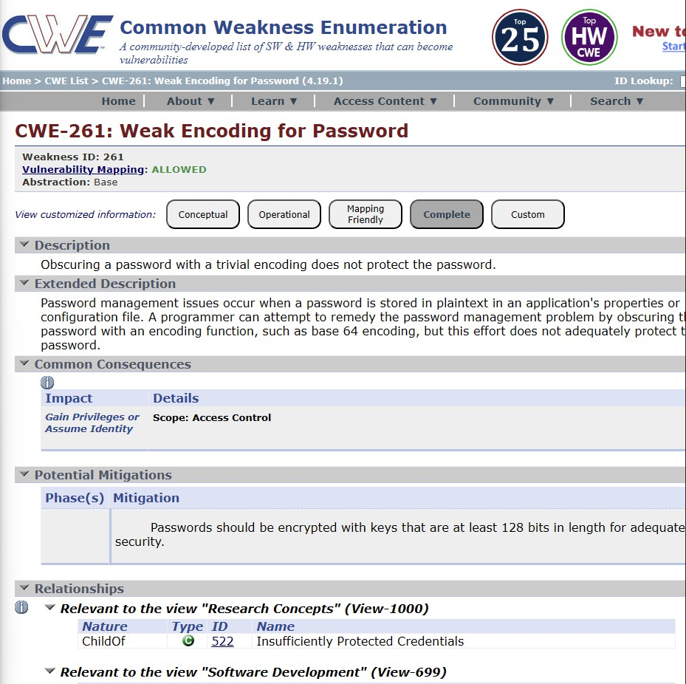

Report:
Vulnerability name: Missing XML Validation CWE/CVE number:CWE-112

Owasp category: A05:2025 Injection

Description:Failure to validate XML inputs can lead to XML injection or XXE (XML External Entity) attacks.
Business impact:Data leakage

Remote code execution

System compromise

Unauthorized access

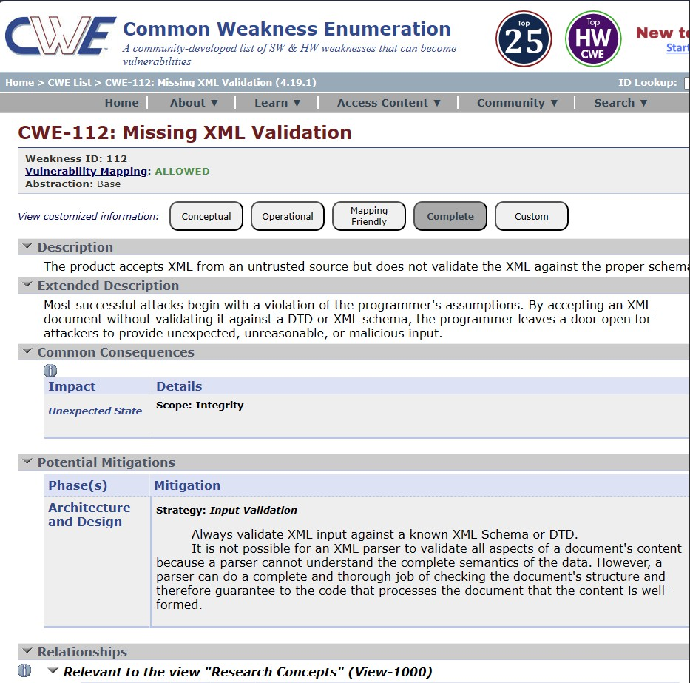

Report:
Vulnerability name: External Control of File Name or Path CWE/CVE number:CWE-73

Owasp category: A06:2025 Insecure Design

Description:When user input controls file names or paths without validation, attackers can manipulate file access.
Business impact:File overwrite or deletion

Unauthorized file access

System compromise

Data integrity loss

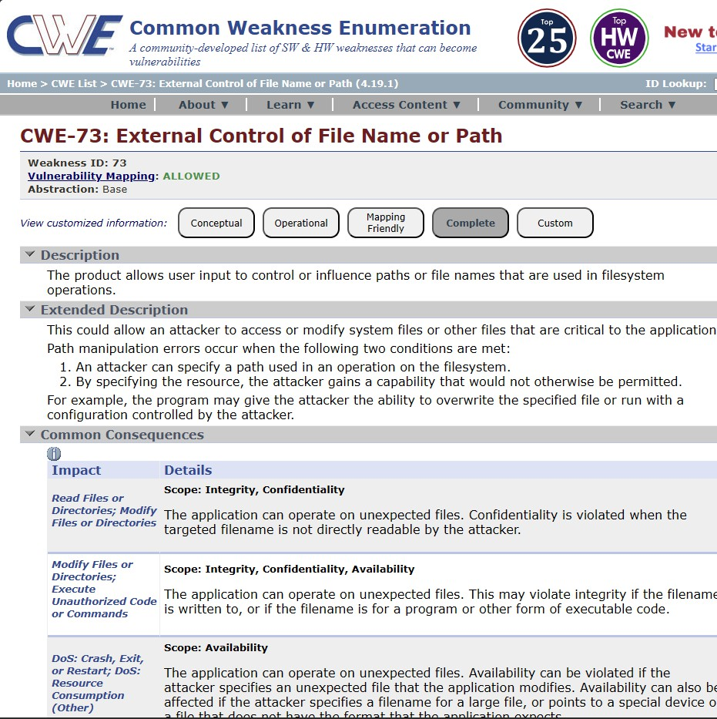

Report:
Vulnerability name: Empty Password in Configuration File CWE/CVE number:CWE-258
Owasp category :A07:2025 Authentication Failures

Description:Sensitive configuration files with empty passwords allow attackers to gain easy access.

Business impact:Unauthorized admin access

System takeover

Data breaches

Compliance violations

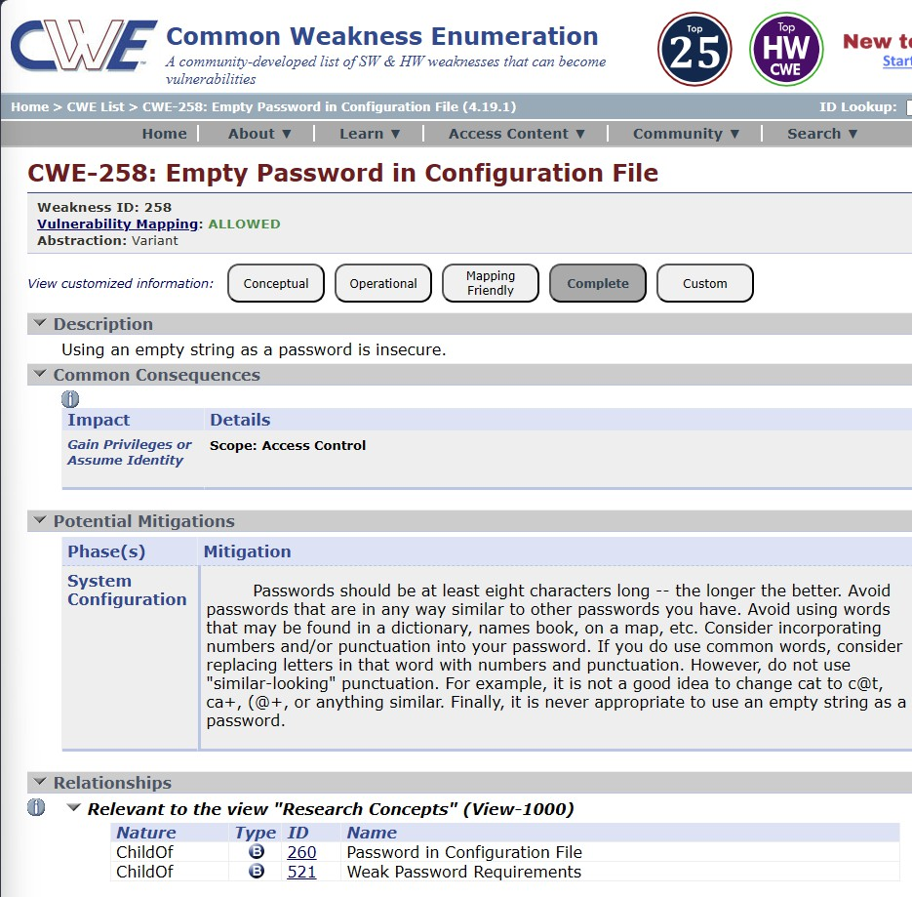

Report:
Vulnerability name: Missing Support for Integrity Check

CWE/CVE number:CWE-353

Owasp category: A08:2025 Software or Data Integrity Failures

Description:No mechanism to verify data integrity allows tampering without detection.
Business impact:Data manipulation

Loss of trust in system

Fraud and incorrect processing

Security compromise

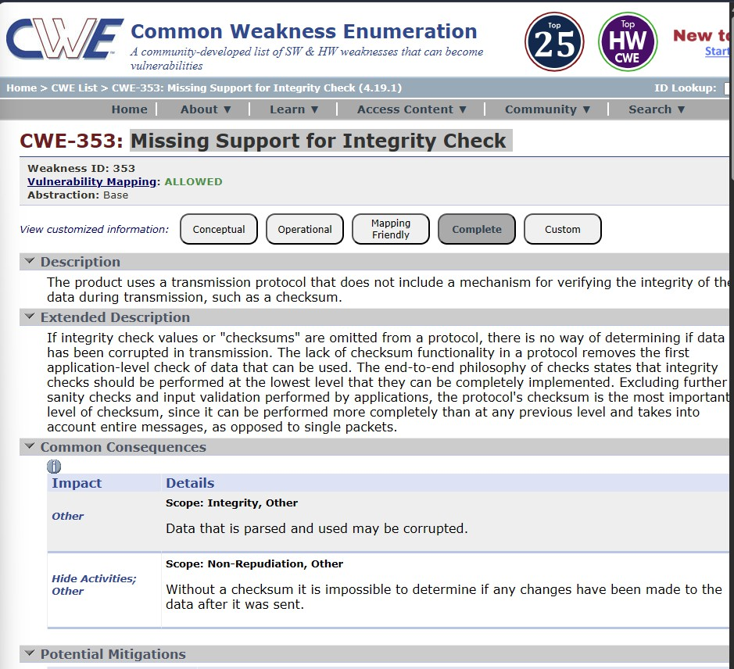

Report:
Vulnerability name: Improper Output Neutralization for Logs

CWE/CVE number:CWE-117

Owasp category: A09:2025 Security Logging & Alerting Failures Description:Log injection occurs when user input is not sanitized before logging. Business impact:Tampered logs

Misleading audit trails

Security monitoring failure

Incident response issues

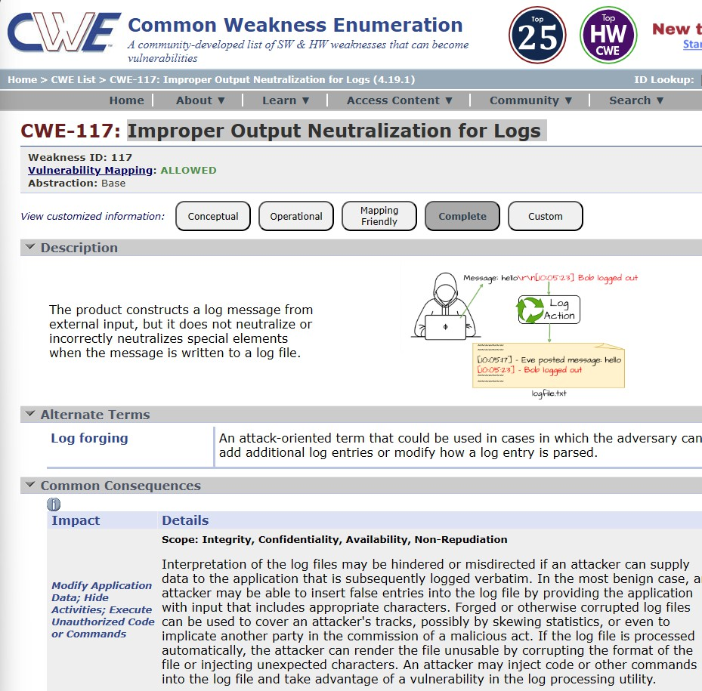

Report:
Vulnerability name: Uncaught Exception
CWE/CVE number:CWE-248

Owasp category: A10:2025 Mishandling of Exceptional Conditions

Description:Unhandled exceptions expose system errors and stack traces to users.
Business impact:Information disclosure

Application crashes

Poor user experience

Increased attack opportunities

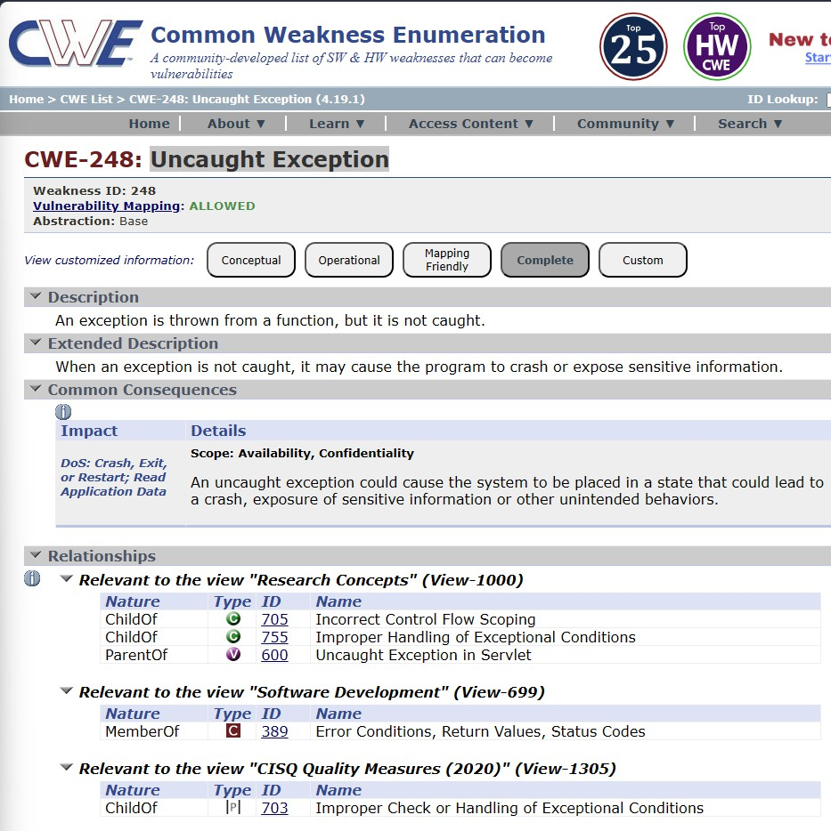

Stage:2 Overview :-
Nessus is a vulnerability scanner developed by Tenable, Inc. It is a remote scanner, meaning that it does not need to be installed on the target host to scan it. Nessus works by sending a variety of probes to the target host in order to identify vulnerabilities. These probes can include network traffic, operating system commands, and application requests.
Nessus uses a plugin-based architecture. Plugins are small pieces of code that are designed to identify specific vulnerabilities. There are over 1200 plugins available for Nessus, covering a wide range of vulnerabilities in operating systems, applications, and network devices.
When Nessus scans a host, it first uses a discovery plugin to identify the operating system and services running on the host. Once the host has been discovered, Nessus runs a series of plugins to test for vulnerabilities. For each vulnerability that Nessus finds, it provides a detailed report that includes the severity of the vulnerability, the steps to reproduce the vulnerability, and the steps to remediate the vulnerability.
Nessus can be used to scan a variety of targets, including single hosts, networks, and web applications. It can also be used to scan specific ports and services.
Nessus can be configured to run scans on a schedule or manually. Here is a step-by-step explanation of how Nessus works:
- Nessus connects to the target host using a variety of protocols, including TCP, UDP, and ICMP.
- Nessus sends a series of probes to the target host in order to identify its operating system and services.
- Nessus runs a series of plugins to test for vulnerabilities.

- Nessus generates a report that includes the severity of each vulnerability, the steps to reproduce the vulnerability, and the steps to remediate the vulnerability.
Nessus is a valuable tool for security professionals who need to identify and remediate vulnerabilities in their networks. It is easy to use and provides comprehensive reports that can be used to prioritise remediation efforts.
Here are some of the benefits of using Nessus:
  - Comprehensive vulnerability coverage: Nessus has over 1200 plugins available, covering a wide range of vulnerabilities in operating systems, applications, and network devices.
  - Easy to use: Nessus has a user-friendly interface that makes it easy to configure and run scans.
  - Comprehensive reporting: Nessus provides detailed reports that include the severity of each vulnerability,the steps to reproduce the vulnerability, and the steps to remediate the vulnerability.
  - Scalability: Nessus can be used to scan a variety of targets, including single
hosts, networks, and web applications.
  - Flexibility: Nessus can be configured to run scans on a schedule or manually.
Nessus is a powerful tool that can be used to improve the security of any network. It is a valuable asset for any security professional.
Target website — https://ginandjuice.shop/
Target ip address:-34.249.203.140
34.246.169.176

List of vulnerability —

s.no | Vulnerability name | Severity | plugins
1 | Traceroute Information | INFO | 10287
2 | SSL Root Certificate Authority  Certificate Information | INFO | 94761
3 | Shor’s Harvest Now Decrypt  Later | INFO | 298387
4 | Remote Services Not Using Post-  Quantum Ciphers | INFO | 277650
5 | OS Fingerprints Detected | INFO | 209654
6 | Open Port Re-check | INFO | 10919
7 | Host Fully Qualified Domain  Name(FQDN) Resolution | INFO | 12053
8 | Additional DNS Hostnames | INFO | 46180
9 | SSL/TLS Versions Supported | INFO | 56984
10 | SSL/TLS Recommended Cipher  Suites | INFO | 156899
11 | TLS Next Protocols Supported | INFO | 62564
12 | TLS Supported Groups | INFO | 277654
13 | SSL Certificate Information | INFO | 10863
14 | SSL Cipher Block Cipher Suites  Supported | INFO | 70544
15 | SSL Cipher Suites Supported | INFO | 21643
16 | SSL Perfect Forward Secrecy  Cipher Suites Supported | INFO | 57041
17 | TLS Version 1.2 Protocol  Detection | INFO | 136318
18 | Nessus Scan Information | INFO | 19506
19 | Nessus SYN Scanner | INFO | 11219
20 | Service detection | INFO | 22964
21 | Web Server Crafted Request Vendor/Version Information  Disclosure | INFO | 11239
22 | Web Server No 404 Error Code | INFO | 10386

 | Check
23 | TLS ALPN Supported Protocol  Enumeration | INFO | 84821
24 | TLS NPN Supported Protocol  Enumeration | INFO | 87242
25 | HSTS Missing from HTTPS  server(RFC 6797) | MEDIUM | 142960
26 | HyperText Transfer protocol (HTTP) information | INFO | 24260
27 | HSTS Missing from HTTPS Server | INFO | 84502
28 | HTTPS server type and version | INFO | 10107

REPORT:-
Vulnerability Name:- Traceroute Information-10287
severity : -INFO Plugin:-10287 Description:
Reveals network path and infrastructure details between user and server.

Solution:

Disable ICMP responses

Use firewall rules to block traceroute

Hide internal network structure

Business Impact:

Helps attackers map network

Increases risk of targeted attacks

Vulnerability Name:- SSL Root Certificate Authority Certificate Information- 94761
severity : -INFO Plugin:-94761 Description:
Displays details about certificate authority used by server.

Solution:

Use trusted CA

Avoid exposing unnecessary certificate info

Business Impact:

Minor info disclosure

Can aid attackers in reconnaissance

Vulnerability Name:- Shor’s Harvest Now Decrypt Later -298387
severity : -INFO Plugin:- 298387
Description:

Data encrypted today may be decrypted in future using quantum computing.

Solution:

Implement post-quantum cryptography

Use strong encryption standards

Business Impact:

Future data breach risk

Sensitive data exposure

Vulnerability Name:- Remote Services Not Using Post-Quantum Ciphers- 277650
severity : - INFO

Plugin:- 277650
Description:
Services are not using quantum-resistant encryption.

Solution:

Upgrade to quantum-safe algorithms

Business Impact:

Long-term data security risk

Vulnerability Name:- OS Fingerprints Detected-209654
severity : - INFO
Plugin:- 209654
Description:

Reveals operating system details of the target.

Solution:

Disable OS fingerprinting

Use firewalls and masking

Business Impact:

Helps attackers choose exploits

Vulnerability Name:- Open Port Re-check-10919
severity : - INFO
Plugin:- 10919
Description:

Identifies open ports on the system.

Solution:

Close unused ports

Use firewall restrictions

Business Impact:

Entry point for attacks

Vulnerability Name:- Host Fully Qualified Domain Name(FQDN) Resolution- 12053
severity : - INFO
Plugin:- 12053
FQDN Resolution

Description:

Shows domain name mapping to IP.

Solution:

Restrict DNS exposure

Business Impact:

Helps attackers identify systems

Vulnerability Name:- Additional DNS Hostnames-46180
severity : - INFO
Plugin:- 46180
Description:

Reveals additional hostnames linked to system.

Solution:

Limit DNS records exposure

Business Impact:

Expands attack surface

Vulnerability Name:- SSL/TLS Versions Supported-56984
severity : - INFO Plugin:- 56984 Description:

Shows supported SSL/TLS versions.

Solution:

Disable old versions (SSLv2, SSLv3, TLS 1.0)

Use TLS 1.2/1.3

Business Impact:

Vulnerable to downgrade attacks

Vulnerability Name:- SSL/TLS Recommended Cipher Suites-156899
severity : - INFO
Plugin:- 156899
Description:

Lists supported encryption ciphers.

Solution:

Enable strong ciphers only

Business Impact:

Weak encryption risk

Vulnerability Name:- TLS Next Protocols Supported-62564

severity : -INFO Plugin:- 62564
Description:

Provides information about server configuration, protocols, or encryption.

Solution:

Minimize information exposure

Harden server configuration

Use secure protocols

Business Impact:

Helps attackers during reconnaissance

Increases likelihood of targeted attacks

Vulnerability Name:- TLS Supported Groups-277654
severity : -INFO Plugin:- 277654
Description:

Provides information about server configuration, protocols, or encryption.

Solution:

Minimize information exposure

Harden server configuration

Use secure protocols

Business Impact:

Helps attackers during reconnaissance

Increases likelihood of targeted attacks

Vulnerability Name:- SSL Certificate Information-10863
severity : - INFO
Plugin:- 10863
Description:

Provides information about server configuration, protocols, or encryption.

Solution:

Minimize information exposure

Harden server configuration

Use secure protocols

Business Impact:

Helps attackers during reconnaissance

Increases likelihood of targeted attacks

Vulnerability Name:- SSL Cipher Block Cipher Suites Supported-70544
severity : - INFO
Plugin:- 70544
Description:

Provides information about server configuration, protocols, or encryption.

Solution:

Minimize information exposure

Harden server configuration

Use secure protocols

Business Impact:

Helps attackers during reconnaissance

Increases likelihood of targeted attacks

Vulnerability Name:- SSL Cipher Suites Supported-21643
severity : - INFO
Plugin:- 21643
Description:

Provides information about server configuration, protocols, or encryption.

Solution:

Minimize information exposure

Harden server configuration

Use secure protocols

Business Impact:

Helps attackers during reconnaissance

Increases likelihood of targeted attacks

Vulnerability Name:- SSL Perfect Forward Secrecy Cipher Suites Supported- 57041
severity : - INFO
Plugin:- 57041

Description:

Provides information about server configuration, protocols, or encryption.

Solution:

Minimize information exposure

Harden server configuration

Use secure protocols

Business Impact:

Helps attackers during reconnaissance

Increases likelihood of targeted attacks

Vulnerability Name:- TLS Version 1.2 Protocol Detection-136318
severity : - INFO
Plugin:- 136318
Description:

Provides information about server configuration, protocols, or encryption.

Solution:

Minimize information exposure

Harden server configuration

Use secure protocols

Business Impact:

Helps attackers during reconnaissance

Increases likelihood of targeted attacks

Vulnerability Name:- Nessus Scan Information- 19506
severity : - INFO
Plugin:- 19506

Description:

Provides information about server configuration, protocols, or encryption.

Solution:

Minimize information exposure

Harden server configuration

Use secure protocols

Business Impact:

Helps attackers during reconnaissance

Increases likelihood of targeted attacks

Vulnerability Name:- Nessus SYN Scanner-11219
severity : - INFO
Plugin:- 11219
Description:

Provides information about server configuration, protocols, or encryption.

Solution:

Minimize information exposure

Harden server configuration

Use secure protocols

Business Impact:

Helps attackers during reconnaissance

Increases likelihood of targeted attacks

Vulnerability Name:- Service detection-22964
severity : - INFO
Plugin:- 22964
Description:

Provides information about server configuration, protocols, or encryption.

Solution:

Minimize information exposure

Harden server configuration

Use secure protocols

Business Impact:

Helps attackers during reconnaissance

Increases likelihood of targeted attacks

Vulnerability Name:- Web Server Crafted Request Vendor/Version Information Disclosure -11239

severity : - INFO Plugin:- 11239 Description:
Provides information about server configuration, protocols, or encryption.

Solution:

Minimize information exposure

Harden server configuration

Use secure protocols

Business Impact:

Helps attackers during reconnaissance

Increases likelihood of targeted attacks

Vulnerability Name:- Web Server No 404 Error Code Check-10386
severity : - INFO
Plugin:- 10386

Description:
Provides information about server configuration, protocols, or encryption.

Solution:

Minimize information exposure

Harden server configuration

Use secure protocols

Business Impact:

Helps attackers during reconnaissance

Increases likelihood of targeted attacks

Vulnerability Name:- TLS ALPN Supported Protocol Enumeration-84821
severity : - INFO
Plugin:- 84821
Description:

Provides information about server configuration, protocols, or encryption.

Solution:

Minimize information exposure

Harden server configuration

Use secure protocols

Business Impact:

Helps attackers during reconnaissance

Increases likelihood of targeted attacks

Vulnerability Name:- TLS NPN Supported Protocol Enumeration-87242
severity : - INFO
Plugin:- 87242
Description:

Provides information about server configuration, protocols, or encryption.

Solution:

Minimize information exposure

Harden server configuration

Use secure protocols

Business Impact:

Helps attackers during reconnaissance

Increases likelihood of targeted attacks

Vulnerability Name:- HSTS Missing from HTTPS server(RFC 6797)- 142960
severity : - MEDIUM
Plugin:- 142960
Description:

HSTS not enabled allows downgrade attacks (HTTPS → HTTP).

Solution:

Enable HSTS header

Force HTTPS connections

Business Impact:

Man-in-the-middle attacks

Data interception

Vulnerability Name:- HyperText Transfer protocol (HTTP) information-24260
severity : - INFO Plugin:- 24240 Description:
Reveals HTTP headers and server details.

Solution:

Hide server headers

Use secure configurations

Business Impact:

Information leakage

Vulnerability Name:- HSTS Missing from HTTPS Server-84502
severity : - INFO
Plugin:- 84502
Description:

Reveals HTTP headers and server details.

Solution:

Hide server headers

Use secure configurations

Business Impact:

Information leakage

Vulnerability Name:- HTTPS server type and version-10107
severity : - INFO

Plugin:- 10107

Description:

Discloses server software and version.

Solution:

Mask server version

Regularly update software

Business Impact:

Helps attackers exploit known vulnerabilities

Stage-3

Report: -

Title: - Implementing Zero Trust Network Access (ZTNA) with Zscaler: Securing User-to-Application Connectivity

Zero Trust Network Access (ZTNA)
Zero Trust Network Access (ZTNA) is an IT security framework that provides secure remote access to an organization's internal applications and data based on clearly defined access control policies. Unlike traditional Virtual Private Networks (VPNs), which grant users broad access to the entire network, ZTNA operates on a "never trust, always verify" principle. It grants users access only to the specific applications they need, and only after their identity and device have been verified.
ZTNA is a critical component of modern security architecture. It helps organizations move away from the concept of a trusted internal network and an untrusted external network (the "castle-and-moat" model). By hiding the internal network from the internet and establishing one-to-one,encrypted connections between users and applications, ZTNA drastically reduces the attack surface and stops common threats like lateral movement by attackers.
- The ZTNA Access Cycle
The ZTNA cycle is a continuous process of verifying identity, establishing secure connections,and enforcing policy for every access request. It typically consists of the following steps:

- User Request: A user, from any location (office, home, coffee shop), requests access to a specific internal application (e.g., an HR portal, a finance server, or an internal code repository).
- Identity and Device Verification: Before any connection is established, the ZTNA solution verifies who the user is (via multi-factor authentication, or MFA) and checks the security posture of their device. This includes ensuring the device has up-to-date antivirus, a healthy firewall, and is not compromised.
- Policy Enforcement: The ZTNA solution checks the access policy. Does this specific user, with this specific device, have permission to access the requested application at this specific time?
- Establish Secure Connection: If the policy allows access, the ZTNA solution creates a highly secure, encrypted micro-tunnel between the user's device and the target application. Crucially, the user never gains access to the underlying network, only to the application itself.
- Continuous Monitoring: The ZTNA solution continues to monitor the connection for anomalies. If the user's behavior becomes suspicious or their device posture changes, the connection can be terminated in real-time.
- Logging and Analytics: All access attempts, successful and failed, are logged and analyzed. This data is used for auditing, threat hunting, and refining access policies.
  - Zscaler (Zscaler Internet Access / Zscaler Private Access)
Zscaler is a cloud-native security platform that delivers its services entirely from the cloud,eliminating the need for on-premises hardware like VPN concentrators. For ZTNA, Zscaler offers Zscaler Private Access (ZPA) . ZPA is a service that provides seamless, identity-based access to private applications without ever placing users on the network. Zscaler ZPA operates on a simple principle: the application is "inside" the Zscaler cloud, and the user connects to it there. It collects data from a variety of sources, including:

- Identity Providers (IdP): Such as Azure AD, Okra, or Ping Identity, to verify user identities.
- Device Posture Partners: Such as CrowdStrike, Tanium, or Microsoft Defender for Endpoint, to check the health of the endpoint.
- Business Applications: The internal web apps, file servers, and legacy applications hosted in data centers or public clouds (e.g., AWS, Azure).
- Zscaler App Connectors: Lightweight software components deployed in the data center or cloud that initiate outbound connections to the Zscaler cloud, making internal servers invisible to the internet.

Zscaler then enforces policies based on this data, including:
- Identity-Based Access: Policies are built around user and group identities, not IP addresses.
- Application Segmentation: Users are granted access to specific applications, not entire subnets.
- Least Privilege Access: Ensures users have the minimum level of access required to perform their jobs.

  - The Zscaler ZTNA Cycle
The Zscaler ZTNA cycle is the practical application of the ZTNA principles using the Zscaler cloud. The cycle typically consists of the following steps:
- User Login and Authentication: A user attempts to access an internal application. They are Redirect-ed to their organization's Identity Provider (IdP) for authentication and MFA.
- Device Posture Check (Integration): Zscaler checks with integrated endpoint protection tools to ensure the device is compliant with security policies.

- Policy Lookup and Decision: The Zscaler cloud evaluates the request against the defined access policies. It verifies that the user, device, and context (time, location) are authorized for that specific application.
- Establishing the Micro-tunnel: Once authorized, the Zscaler cloud instructs the user's Zscaler Client Connector and the appropriate Zscaler App Connector in the data center to establish an encrypted connection. The user is now connected to the application.
- Traffic Inspection (Optional): For sanctioned applications, Zscaler can optionally inspect the traffic for data loss prevention (DLP) or to detect malware.
- Logging and Analytics: All activity is logged in the Zscaler cloud portal for reporting, threat hunting, and compliance.

  - MISP (Malware Information Sharing Platform) Integration
While Zscaler is a primary access control tool, it can be enhanced by integrating with threat intelligence platforms like MISP.
- Threat Intelligence Feed: MISP can aggregate and share threat intelligence about malicious domains, IPs, and URLs. This list of indicators of compromise (IOCs) can be fed into Zscaler's cloud.
- Proactive Blocking: If a user, even one authorized by ZPA, attempts to access a known malicious site that has been flagged by the MISP feed, Zscaler Internet Access (ZIA) can block the request, preventing a potential infection.
- Enhanced Visibility: Security teams can use MISP to cross-reference Zscaler logs. If a user's behavior is anomalous, the team can check MISP to see if the destination IP or domain is associated with a known threat actor or campaign.
  - Your College Network Information
This infrastructure presents a large attack surface, especially with the need for remote learning and administrative access. The network includes:

  - Core routers and switches
  - Distribution routers and switches
  - Wireless access points
  - Firewalls and Intrusion Detection Systems (IDS)
  - Internal Application Servers: Hosting the student information system, library
resources, research data repositories, and administrative portals.
  - Legacy VPN Concentrator: Currently providing broad network-level access for faculty and staff working remotely.
The need for ZTNA arises from the limitations of the current VPN model:
  - Over-permissioned Access: Once on the VPN, a faculty member's compromised laptop could potentially scan and attack the entire internal network (lateral movement).
  - Hidden Applications: Some research applications need to be accessed by
external collaborators without granting them full network access.
  - User Experience: The legacy VPN can be slow and cumbersome, often requiring
users to route all their internet traffic through the university.
  - How you think you deploy ZTNA using Zscaler in your college
To deploy Zscaler ZTNA (ZPA) in your college, you would start by identifying the specific applications that need to be secured and the user groups that need access to them. This is a shift from securing the network to securing access to applications.
The plan would need to include the following:
- Application Discovery: Catalog all internal applications (e.g., ERP, library system, research servers, file shares) and identify which ones are currently exposed via the VPN.

- User Segmentation: Define user groups (e.g., Students, Faculty - Research, Faculty - Admin, IT Staff, External Collaborators) and the specific applications each group needs.
- Deploying Zscaler App Connectors: Install lightweight App Connector VMs in the university's data center. These connectors will establish outbound connections to the Zscaler cloud, making the application servers invisible to the public internet.
- Integrating Identity Provider: Connect Zscaler to the university's existing Identity Provider (e.g., Microsoft Azure AD) to leverage current usernames, passwords, and MFA policies.
- Configuring Access Policies: Create granular policies in the Zscaler admin portal. For example: "The 'Faculty' group can access the 'ERP Application' from any device that has antivirus enabled, after MFA."
- Deploying Zscaler Client Connector: Students, faculty, and staff will install the Zscaler Client Connector on their laptops and mobile devices. This small client intelligently routes traffic for private applications through ZPA and public traffic through ZIA.
  - Threat Intelligence
In the context of Zscaler and ZTNA, threat intelligence is used to understand who is trying to access what, and from where. It helps move beyond simple identity checks to a more contextual understanding of risk.
Sources include:
- Zscaler Cloud Logs: Internal logs provide real-time data on who is accessing which applications, from which locations, and on what devices.
- External Threat Feeds (MISP): Information about new malware campaigns, phishing kits, or command-and-control servers being used by attackers.

- Identity Provider Logs: Anomalies in login attempts, such as a user logging in from two geographically impossible locations in a short time, can signal a compromised account.
This intelligence is used for:
- Adaptive Access Control: If threat intelligence suggests a user's location is high- risk, Zscaler can step-up authentication requirements or block access entirely.
- Hunting for Compromised Accounts: Analysts can use Zscaler logs to see if a user is suddenly accessing applications they never have before, which could be a sign of credential theft.
- Blocking Malicious Communication: Threat intelligence feeds can be used by Zscaler Internet Access (ZIA) to block outbound connections to known malicious sites, even if they originate from a user inside the university.
  - Incident Response (Adapted for ZTNA)
Incident response in a ZTNA model is faster and more targeted because the environment is inherently more controlled.
- Detection: The SOC team detects an anomaly. For example, a faculty account is downloading an unusually high volume of data from a research server at 3 AM. Zscaler logs provide the exact details: the user, the device, the application, and the amount of data transferred.
- Containment: The SOC team can instantly isolate the user. In the Zscaler portal, they can simply deactivate that user's access or block their specific device. Because there is no network- level access, this action immediately severs all connections to every application, preventing lateral movement.
- Eradication: The compromised device is taken offline for malware scanning and cleaning by the IT helpdesk.
- Recovery: Once the device is clean and the user's password is reset, the Zscaler policy is re- enabled, granting the user access again.

- Post-incident review: The security team analyzes the logs to understand how the account was compromised (e.g., a phishing email) and updates Zscaler policies, perhaps by adding a block for similar malicious domains or tightening access rules for that specific research application.
Benefits of this incident response approach:
- Near-Instant Containment: Actions take seconds in a cloud dashboard, not minutes or hours configuring firewall rules.
- No Lateral Movement: The attacker is contained to the single compromised application, protecting the rest of the university's network.
- Granular Forensics: Zscaler provides a detailed audit trail of every connection, making investigations faster and more accurate.
- Compliance: This model helps demonstrate compliance with data protection regulations by proving that access to sensitive student or research data is tightly controlled and audited.
  - Understanding about the tool (Zscaler ZPA)
Zscaler Private Access (ZPA) is a cloud service that embodies the ZTNA principle of "connect a user to an app, not the network." Here are the key things to understand:
- It is "Application-Centric," Not "Network-Centric": You define policies based on applications (e.g., "SAP Server 01"), not network constructs like IP subnets. This aligns security with how businesses actually operate.
- It Hides the Network: ZPA uses App Connectors inside your data center that only make outbound connections to the Zscaler cloud. Your internal servers never need to open inbound firewall ports, making them invisible to port scanners and attackers on the internet.
- It uses a "Dark Cloud" Approach: To an external scanner, the organization's applications simply don't exist. They only become visible to authorized users after a multi-step verification process.

- It Provides a Superior User Experience: Users don't have to mess with clunky VPN clients. The Zscaler Client Connector works silently in the background. For web apps, access can even be agentless, requiring only a modern browser.
- It is Inherently Scalable: Because it's a cloud service, ZPA scales instantly to handle thousands of concurrent users, unlike a legacy VPN appliance that needs to be manually upgraded.
Conclusion: -
In conclusion, exploring the realm of AI for web security using IBM QRadar has been an insightful journey through various stages.
In Stage 1, understanding web application testing unveiled the critical importance of assessing vulnerabilities and ensuring the security of web-based systems. This foundational knowledge served as a cornerstone for comprehending the subsequent stages.
Stage 2 delved into the intricacies of Nessus reports, emphasising the significance of detailed vulnerability assessments. Analysing these reports provided valuable insights into potential threats, enabling informed decision-making for robust security measures.
Stage 3 introduced the pivotal concept of Zero Trust Network Access (ZTNA) and its implementation using Zscaler Private Access (ZPA). It demonstrated a paradigm shift from traditional VPN-based network access to secure, identity-based user-to- application connectivity. The solution showcased the power of hiding internal applications from the internet, enforcing granular access policies, and eliminating lateral movement. This underscores the need for modern, proactive cybersecurity strategies in an era of remote work and cloud adoption.Considering the future scope.
Stage 1 illuminated the evolving landscape of web application testing. With advancements in AI, there is a promising avenue for more sophisticated testing methodologies, ensuring even higher levels of security for web applications.

Stage 2 highlighted the future trajectory of the testing process, indicating a shift towards more automation and integration of AI-driven tools. This evolution promises quicker, more accurate vulnerability assessments, enhancing overall cybersecurity postures.
Stage 3 illuminated the future potential of Zero Trust Network Access (ZTNA) and Zscaler technologies. With AI integration and machine learning, these systems are poised to become more intelligent and adaptive, enabling real-time risk assessment based on user behavior and device posture. Enhanced automation in policy enforcement, predictive analytics for threat detection, and improved scalability are anticipated, empowering organizations to stay ahead of sophisticated cyber threats in an increasingly distributed world.
In essence, the project not only provided a deep understanding of the current state zero trust using ZSCALER but also offered a glimpse into the exciting future of cybersecurity. Embracing these advancements will be crucial for organisations aiming to fortify their digital landscapes in the face of ever-evolving cyber threats.
Future Scope: -
Future of web application testing
The future of WAT is bright, as web applications become increasingly complex and sophisticated. Organizations are increasingly reliant on web applications to conduct business, and they need to be confident that their web applications are secure and reliable.
Here are some of the key trends that are expected to shape the future of WAT:
- Increased focus on security: Security is a top priority for all organizations, and WAT is essential for identifying and mitigating security vulnerabilities. In the future, we can expect to see even more emphasis on security testing, as web applications become increasingly targeted by cyberattacks.
- Rise of artificial intelligence (AI) and machine learning (ML): AI and ML are already being used in WAT, and their role is expected to grow in the future. AI and ML can be used to automate repetitive tasks, such as test case generation and

execution. They can also be used to identify complex patterns and anomalies that may be difficult to detect with traditional testing methods.
- Shift to cloud-based testing: More and more organizations are moving their web applications to the cloud. This trend is driving the growth of cloud-based WAT platforms. Cloud-based testing platforms offer a number of advantages, such as scalability, flexibility, and cost-effectiveness.
- Increased focus on user experience (UX) testing: UX testing is essential for ensuring that web applications are easy to use and meet the needs of users. In the future, we can expect to see more focus on UX testing, as organizations increasingly recognize the importance of providing a positive user experience.
Future scope of the testing process
The future scope of the testing process is bright, as software becomes increasingly complex and sophisticated. Organisations are increasingly reliant on software to conduct business, and they need to be confident that their software is high-quality and reliable.
Here are some of the key trends that are expected to shape the future of the testing process:
- Increased focus on continuous testing: Continuous testing is a methodology that involves testing software throughout the SDLC, from development to deployment. This helps to identify defects early and prevent them from causing problems later in the development process.
- Rise of AI and ML: AI and ML are already being used in the testing process, and their role is expected to grow in the future. AI and ML can be used to automate repetitive tasks, such as test case generation and execution. They can also be used to identify complex patterns and anomalies that may be difficult to detect with traditional testing methods.
- Shift to cloud-based testing: Cloud-based testing platforms offer a number of advantages, such as scalability, flexibility, and cost-effectiveness. This is driving the growth of cloud-based testing platforms.

- Increased focus on testing automation: Testing automation is the use of software to execute test cases without human intervention. Testing automation can help to save time and resources, and it can also help to improve the quality and efficiency of testing.
Future scope of SOC / SEIM:-
The future scope of Zero Trust Network Access (ZTNA) and the broader Zero Trust framework is poised for significant evolution, driven by emerging technologies and changing threat landscapes:
- AI-Driven Zero Trust (AI-ZTA): Future Zero Trust implementations will leverage advanced AI and deep learning to move beyond static policies. Systems will continuously learn user behavior, predict anomalous activities before they occur, and dynamically adjust access privileges in real-time based on contextual risk, creating a truly "adaptive" security posture.
- Integration with Edge Computing and IoT: As organizations deploy more IoT devices and edge computing nodes, Zero Trust principles will extend to these resource-constrained environments. Expect the development of lightweight Zero Trust agents and protocols that can authenticate and secure machine-to-machine (M2M) communication at the edge, preventing large-scale botnet attacks.
- Identity-Centric Everything: The future will see identity become the ultimate security perimeter. Zero Trust will evolve to incorporate advanced identity verification methods, including continuous behavioral biometrics (keystroke dynamics, gait analysis) and decentralized identity solutions using blockchain, ensuring that the user behind the session is verified at all times.
- Convergence with SASE Architecture: Zero Trust will be a core component of the Secure Access Service Edge (SASE) framework. This convergence will provide organizations with a unified, cloud-delivered stack that combines ZTNA, Secure Web Gateways (SWG), Cloud Access Security Brokers (CASB), and Firewall-as-a- Service (FWaaS), simplifying management and ensuring consistent security for all users, regardless of location.

- Zero Trust for Operational Technology (OT) and Critical Infrastructure: Sectors like energy, manufacturing, and healthcare will increasingly adopt Zero Trust to protect critical infrastructure. Future scope includes air-gapped Zero Trust solutions and specialized protocols designed to secure legacy industrial control systems (ICS) and SCADA environments from nation-state attacks.
- Automated Threat Hunting and Response: Future Zero Trust platforms will integrate with Security Orchestration, Automation, and Response (SOAR) tools to enable automated threat hunting. Upon detecting a compromised identity or device, the system will not just block access but automatically initiate investigation playbooks, isolate affected systems, and even roll back malicious changes.
Topics explored: -
Data Collection and Aggregation, Standardization and Normalisation, Enrichment and Analysis, Sharing and Distribution, Integration with Security Tools, Customization and Flexibility, Automation and Orchestration, Community Involvement, Incident Response Support, Threat Intelligence Feeds, Soc and Siem
Tools explored: -
Nmap, Metasploit, Nessus, Kali Linux, OWASP ZAP, Burp Suite

