Tech Saksham

Case Study Report

Data Analytics with Power BI

Real-Time Analysis of Bank Customers

Government Arts College, Dharmapuri

|  |  |
| --- | --- |
| NM ID | NAME |
| A3B2305DC40819DADF54B6E42288B43B | BALAMURUGAN K |

Trainer Name : R UMAMAHESWARI

Master Name : R UMAMAHESWARI

**ABSTRACT**

In the Digital Life, Data is one of the best and valuable assets for every field. But also, in the Banking Sector it is most important thing in generating new ideas or plans or decisions. In this view we had to get a most important topic called analytics, it has played a huge role in every decision-making situation. In this section we have to analyze the customers data in Realtime Environment and Making a Better Insights of new Decisions. In this analyze we particularly use software called Power BI, using this software we can get a data-driven exploration of customers. In these analytics we analyze the customers behaviors , preferences, transactions, age, gender ,etc. This project will also contribute to increasing innovations, profits, efficiency and many more.

**INDEX**

|  |  |  |
| --- | --- | --- |
| **Sr. No** | **Table of Contents** | **Page No.** |
| 1 | Chapter 1: Introduction | 4 |
| 2 | Chapter 2: Services and Tools Required | 6 |
| 3 | Chapter 3: Project Architecture | 7 |
| 4 | Chapter 4: Modeling and Result | 8 |
| 5 | Conclusion | 9 |
| 6 | Future Scope | 9 |
| 7 | References | 10 |
| 8 | Links | 10 |

**CHAPTER 1**

**INTRODUCTION**

* 1. **Problem Statement**

In many various sectors have problem with the efficiency of a customer behavior, preferences. This will play a major role in Banking Sector. However, this problem creating a crucial effect of banking history. Traditional data analysis has a problem with this trend which is rapidly changing, time consuming and lack to provide insightful solution.

* 1. **Proposed Solution**

The proposed solution is taking a most advanced Software’s to create insightful real-time analytics. In this project we using a one of powerful Analytical tool called Power BI. We have to real-time dashboard of a bank customers data with Power BI. Using this tool, we can analyze the data for customer preferences and tailoring the User Experience for the customers.

* 1. **Feature**
* **Real-Time Analysis:** The dashboard will provide a real-time analysis of customer data
* **Customer Segmentation:** It will segment customers based on various parameters like age, gender, behavior, etc.
* **Predictive Analysis:** It will use previous data to forecast the customer behavior.
* **Trend Analysis:** The dashboard will display the trends of customer behavior.
  1. **Advantages**
* **Data-Driven Decisions:** Banks can make insightful decisions with real-time data.
* **Increased Efficiency:** From the analytics the we can get the efficiency of handling the customer’s data.
* **Increased Revenue:** By Identifying the flaws, we can grow the trust of customers and increasing the revenue.
  1. **Scope**
* The Scope of the project is widely used for all sector other than banking.
* This project can be extended for more data resources.
* We can also build stronger analytics with data.

**CHAPTER 2**

**SERVICES AND TOOLS REQUIRED**

**Tools:**

* **Power BI:** The main tool for this project Power BI, which is use to create interactive dashboards for real-time data visualization.
* **Power Query:** This is a data connection technology that enables you to discover, connect, combine, and refine data across a wide variety of source.

**Software Requirements:**

* **Power BI Desktop:**  This is a windows application that you can create reports and publish them to Power BI.
* **Power BI Service:** This is an Online SaaS (Software as a Service) Service that you use to publish reports, create new dashboards, and share insights.
* **Power BI Mobile:** This is a mobile application that you can use to access your reports and dashboards on the go.

**CHAPTER 3**

**PROJECT ARCHITECTURE**

**3.1 Architecture**

**      **





* **Data Collection:** Real-time customer data collected from various sources(transactions, web interaction).
* **Data Storage:** Collected Data is stored in database and Servers.
* **Data Processing:** Non sensitive data is processed to take analysis.
* **Analytics :** Processed Data is analyzed by experts.

**CHAPTER 4**

**MODELING AND RESULT**

**Manage Relationship**

In this Project CSV file with name ‘Real-Time Analysis of Bank Customers’ is added for analytics.

**Dashboard**

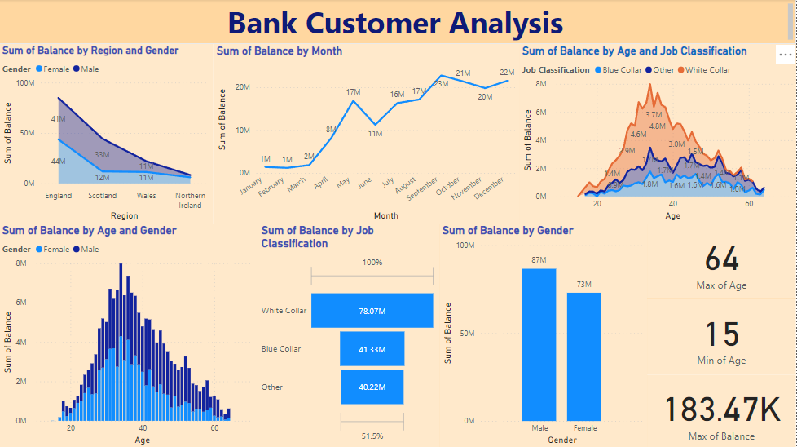

**CONCLUSION**

From the project “Real-Time analysis of Bank Customers” using Power BI has successfully created and we conclude the major effects of project from our dashboard. The real-time data provided lots of valuable information for our insightful analytics for customer behavior, preferences and we can improve our efficiency on customer’s personalized experience improvement. This project has enhanced our ability to provide efficient services for customers. The project has highlighted the importance of simplifying the complex data for easy to understand in simple terms. The presented data is easy appealing to understand.

**FUTURE SCOPE**

The future scope of this project is vast. Using the advanced analytics and machine learning, Power BI can be leveraged to predict future trends based on historical data. As data privacy and security become increasingly important, future iterations of this project should focus on implementing robust data governance strategies. This would ensure the secure handling of sensitive customer data while complying with data protection regulations. The project could explore the integration of real-time data streams to provide even more efficient insights. This could potentially transform the way banks interact with their customers, leading to improved customer satisfaction.

**REFERENCE**

<https://powerbi.microsoft.com/en-us/desktop/>

**LINK**

[**https://github.com/whitesparrow345/PowerBI_A3B2305DC40819DADF54B6E42288B43B**](https://github.com/whitesparrow345/PowerBI_A3B2305DC40819DADF54B6E42288B43B)