1st transformation extracts an Excel file and destructively load the contents to a MySQL table. You can use any Excel file of your choice.

2nd transformation extracts a JSON file and destructively load some of the contents in the file to another MySQL table. You can use any JSON file other than the one that was used in class.

3rd transformation reads one of the MySQL targets tables above as a source table and incrementally load the data into a new table.

Build a Kettle job that includes all those three transformations. The name of the job must be assign1_main_[FirstName].kjb.

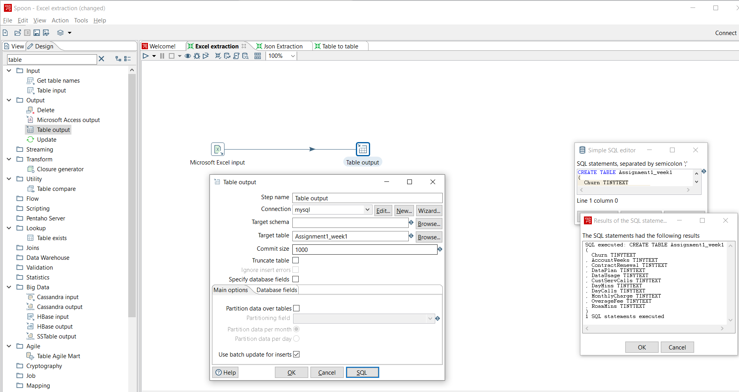

Excel extraction

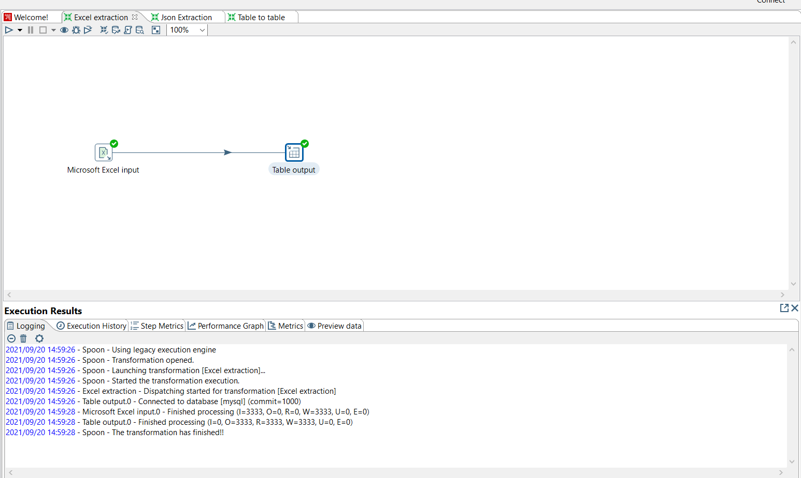

Excel Transformation

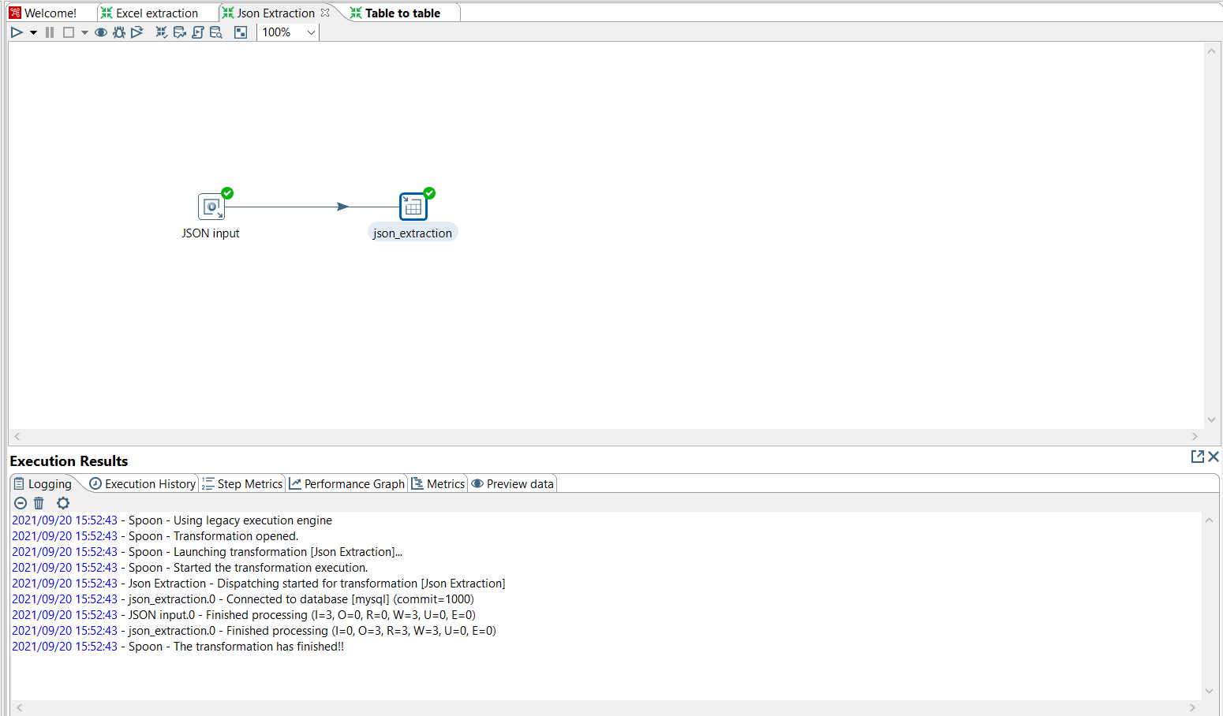

JSON Transformation

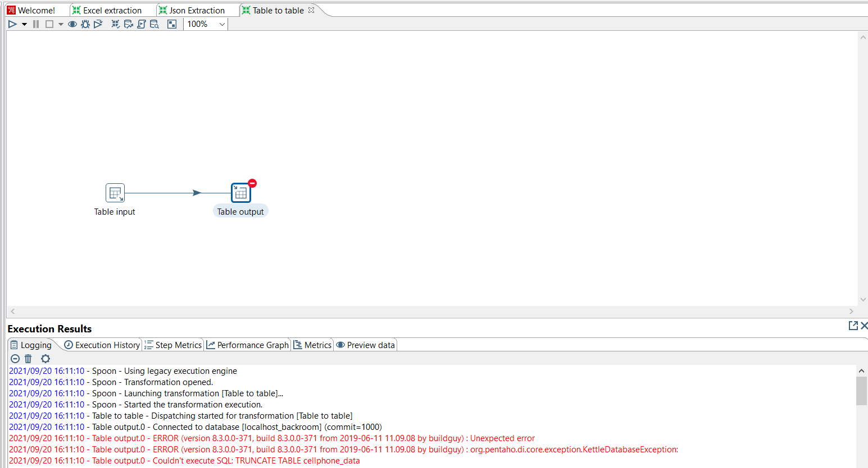

Error while loading table incrementally

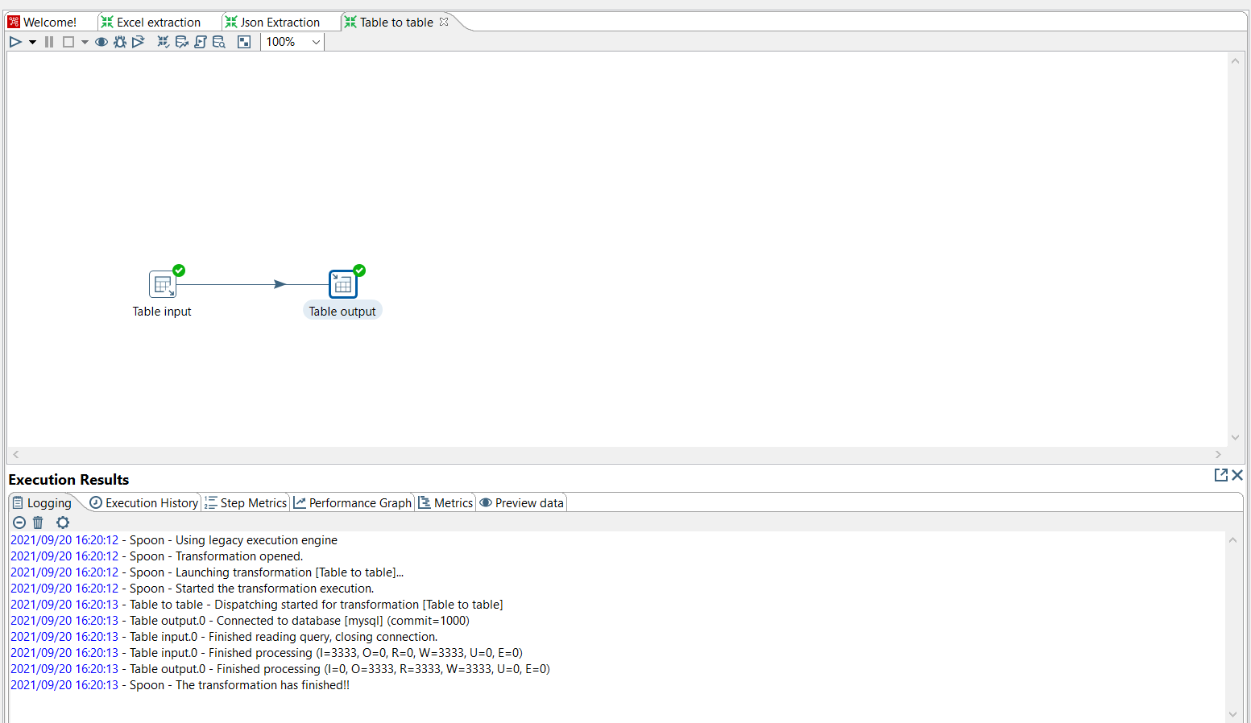

Table to Table Transformation

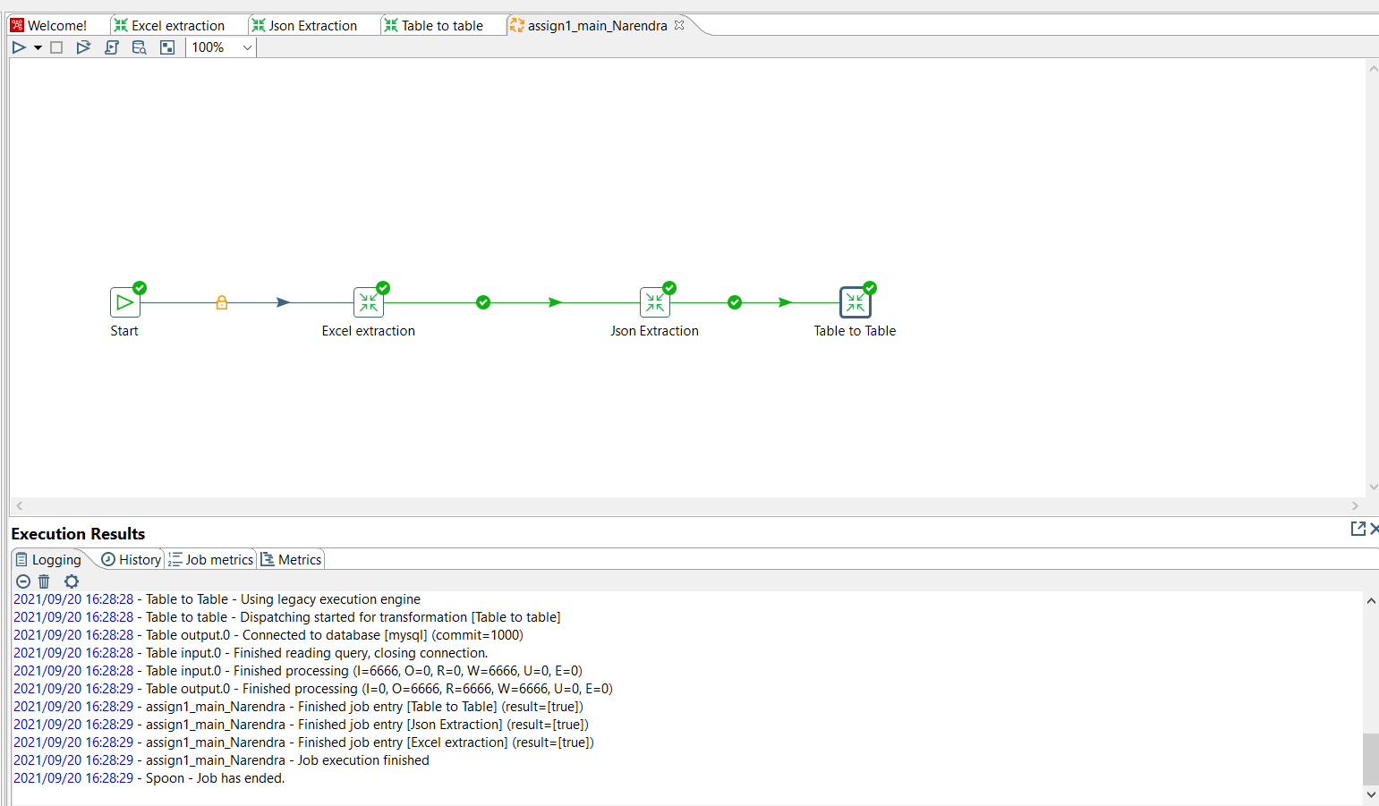

Job1 screenshot