Homework 5

Screenshots:

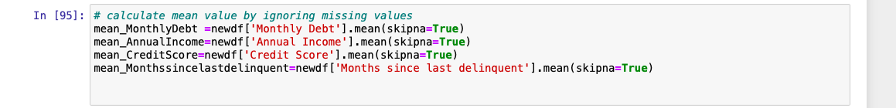

Data Transformation

**Feature Selection:**

