**Assignment 3**

Screenshots:

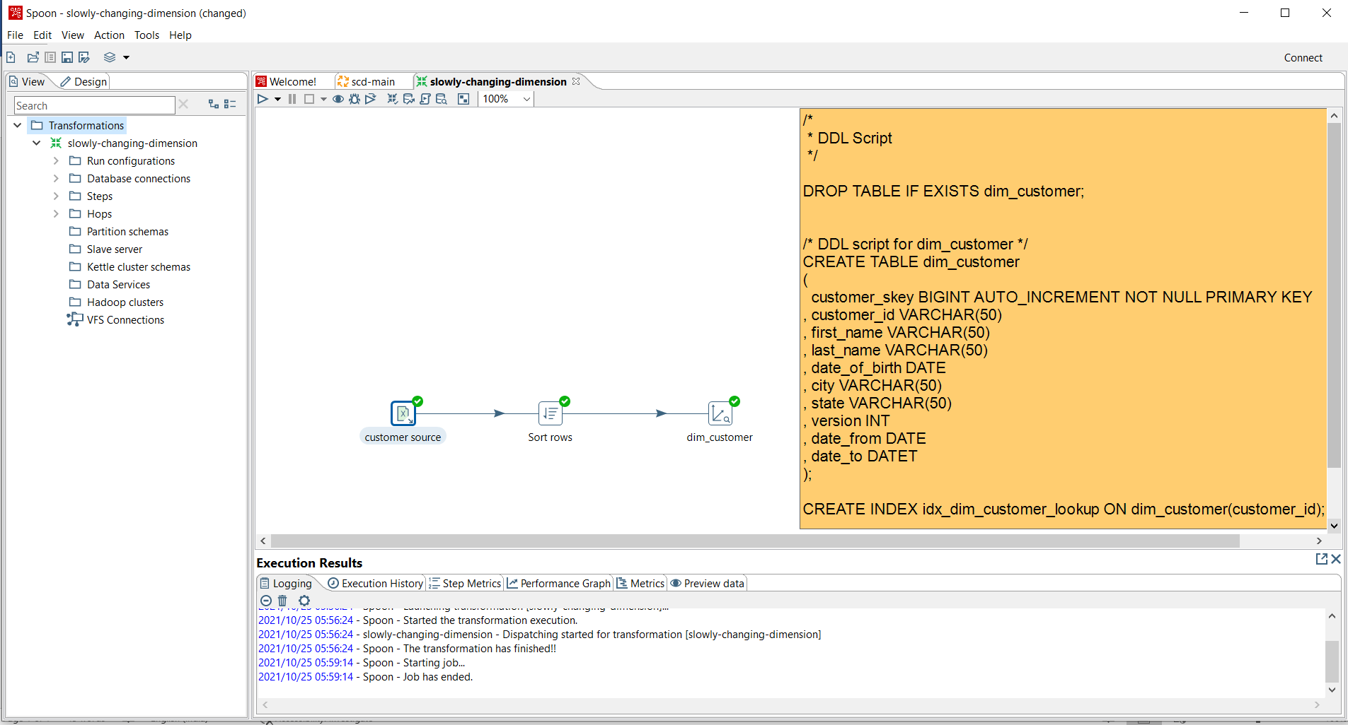

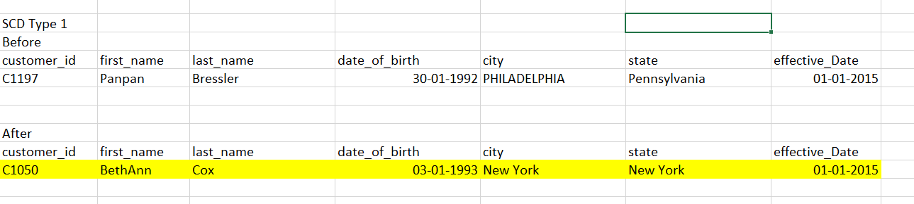

Application of SCD type1 is applied to the first name, last name, city, state and effective date as the type1 is direct replacing of the old value, the last value in the csv is updated for each record of the customer C1050.

