ADAPTIVE REINFORCEMENT LEARNING FOR COLD-CHAIN TEMPERATURE CONTROL AND SPOILAGE PREVENTION

23IT54C – SIMULATION USING MODERN TOOLS

Submitted by

JEYAPIRIYA J | 2403957620522015
SIVA SANKARI R | 2403957620522028
BALA NITHYA M | 2403957620522039

In partial fulfillment for the award of the degree of
BACHELOR OF TECHNOLOGY
in

INFORMATION TECHNOLOGY

NATIONAL ENGINEERING COLLEGE
(An Autonomous Institution affiliated to Anna University, Chennai)

K.R. NAGAR, KOVILPATTI – 628503

OCTOBER 2026

NATIONAL ENGINEERING COLLEGE
(An Autonomous Institution affiliated to Anna University, Chennai)


K.R. NAGAR, KOVILPATTI - 628503

BONAFIDE CERTIFICATE

This is to certify that this project report, “ADAPTIVE REINFORCEMENT LEARNING FOR COLD-CHAIN TEMPERATURE CONTROL AND SPOILAGE PREVENTION”, is the Bonafide work of JEYAPIRIYA J (2403957620522015), SIVA SANKARI R (2403957620522028), and BALA NITHYA M (2403957620522039) who carried out the project work under my supervision.

Course Instructor

Submitted to the 23IT54C – SIMULATION USING MODERN TOOLS Viva-Voce examination held at National Engineering College, K.R. Nagar, Kovilpatti on 21.10.2026.

Internal Examiner Co Examiner

ABSTRACT

The Adaptive Reinforcement Learning System for Cold-Chain Temperature Control and Spoilage Prevention is an intelligent thermodynamic simulation and control system designed to automatically analyze cold-chain sensor streams, model biological degradation kinetics, optimize closed-loop refrigeration actuation, and preserve digital audit evidence for further review. Traditional cold-chain monitoring depends heavily on continuous manual observation and static On-Off thermostats. Such monitoring becomes difficult in complex multi-echelon transit and warehouse environments because multiple reefer units, temperature zones, door status, ambient heatwaves, and perishable commodity types must be monitored simultaneously. Important thermal anomaly events such as compressor degradation, door propping, ambient heat spikes, and sub-zero boundary violations may therefore be missed.
The system processes cold storage telemetry by first ingesting continuous sensor readings and then tracking thermodynamic state transitions across consecutive time steps. The recorded state variables are further analyzed using mathematical models such as Newton-Fourier heat transfer balance, Arrhenius biological spoilage kinetics, Markov Decision Process continuous state quantization, composite reward formulation, Bellman temporal difference updates, and epsilon-greedy exploration decay to understand chamber thermal evolution and biological decay velocity. Based on these analyses, optimal compressor cooling levels (Off, Eco, High, Turbo) are applied to prevent product spoilage and automatically capture timestamped anomaly evidence. The processed telemetry records and incident logs are then made available through the centralized monitoring dashboard, providing live multi-unit surveillance, 3D digital twin simulation, AI decision explainability, strategy benchmarking, and forensic analytics.

TABLE OF CONTENTS
CHAPTER  NO. | TITLE | PAGE  NO.
 | ABSTRACT | iii
1 | INTRODUCTION | 1
1.1 | INTRODUCTION | 1
1.2 | PROBLEM STATEMENT | 2
1.3 | OBJECTIVES | 2
2 | ADAPTIVE COLD-CHAIN RL SYSTEM ARCHITECTURE AND MODULES | 3
2.1 | TECHNOLOGY / ALGORITHM | 3
2.2 | MODULE'S DESCRIPTION | 5
2.3 | SYSTEM REQUIREMENTS | 7
3 | COMPANION SYSTEM DIAGRAMS AND FLOWCHARTS | 9
3.1 | WORK FLOW DIAGRAM | 9
3.2 | SYSTEM ARCHITECTURE DIAGRAM | 10
4 | MATHEMATICAL MODEL AND FORMULATION | 12
4.1 | EQUATIONS AND DERIVATIONS | 12
5 | SIMULATION AND EXECUTION OF MODEL | 16
5.1 | APPLICATION OF MODELLING TECHNIQUES | 16
5.2 | USE OF MODERN TOOLS / SOFTWARE | 17
5.3 | EXECUTION OF MODEL | 17
5.4 | IMPLEMENTATION RESULTS | 19
6 | INTERPRETATION OF RESULTS | 23
6.1 | RESULTS AND DISCUSSIONS | 23
7 | REFERENCES | 25
 | APPENDIX | 26

LIST OF FIGURES
FIGURE  NO. | FIGURE NAME | PAGE  NO.
3.1 | END-TO-END ADAPTIVE COLD-CHAIN RL SYSTEM WORKFLOW DIAGRAM | 8
3.2 | MULTI-LAYERED ADAPTIVE COLD-CHAIN SYSTEM ARCHITECTURE | 9
4.1 | MATHEMATICAL FORMULATION – THERMAL HEAT BALANCE AND Q-LEARNING SPOILAGE DYNAMICS | 11
5.4.1 | COLD-CHAIN FLEET MONITORING DASHBOARD | 19
5.4.2 | 3D DIGITAL TWIN SIMULATION AND MANAGEMENT INTERFACE | 19
5.4.3 | LIVE MULTI-UNIT TELEMETRY FEED | 20
5.4.4 | AI DECISION AND Q-VALUE EXPLAINABILITY RESULTS | 20
5.4.5 | THERMAL ANOMALY AND RISK DETECTION RESULTS | 21
5.4.6 | INCIDENT AUDIT RECORDS AND EVENT REPORTING | 21
5.4.7 | FORENSIC REPLAY AND 3D SCENARIO GALLERY | 22
5.4.8 | COLD-CHAIN ANALYTICS AND STATISTICAL VISUALIZATION | 22

LIST OF TABLES
TABLE  NO. | TABLE NAME | PAGE  NO.
2.1 | TECHNOLOGY STACK SPECIFICATIONS | 3
5.1 | APPLICATION OF MODELLING TECHNIQUES | 16
5.2 | SOFTWARE TOOLCHAIN | 17
6.1 | FUNCTIONAL PERFORMANCE SUMMARY | 23

CHAPTER 1

INTRODUCTION

INTRODUCTION
In modern perishable logistics systems, effective temperature control is an essential requirement for maintaining product integrity, ensuring compliance with food and pharmaceutical regulations, and managing increasingly complex cold-chain environments. Logistics operators rely heavily on continuous surveillance of refrigerated warehouses, reefer containers, and transit corridors where multiple commodities, cooling zones, door actuations, and power availability must be monitored simultaneously. As cold-chain scale and route complexity increase, manual monitoring becomes a bottleneck because human operators cannot consistently observe every sensor feed and every thermal disturbance throughout continuous logistics operations. Important events such as heatwave spikes, door loading incursions, compressor brownouts, and unsafe thermal drift may therefore be missed, resulting in reduced cooling efficiency and delayed identification of commodity spoilage.
Traditionally, cold storage surveillance has depended heavily on manual temperature logging and simple On-Off thermostats, where operators intermittently check sensor values and identify critical thermal breaches. Manual monitoring becomes particularly difficult in multi-commodity warehouses and dynamic transit routes because diverse products (such as dairy, fresh produce, seafood, meats, and vaccines) appear simultaneously and their thermal bounds must be continuously respected. Identifying a unit's temperature trajectory, spoilage accumulation rate, energy draw, cooling level, or breach into an unsafe danger zone requires continuous analysis over multiple time steps. The limitations of conventional manual surveillance create a need for an automated system capable of analyzing cold-chain telemetry, identifying thermal anomalies, and preserving evidence for further review.
Modern intelligent cold-chain monitoring systems can utilize reinforcement-learning-based analysis to transform continuous telemetry into actionable operational intelligence. Such a system can monitor reefer containers, warehouse chambers, and transit assets while tracking individual commodity states throughout the storage lifecycle. By analyzing thermodynamic state transitions and applying adaptive Q-Learning policies, the system can identify thermal anomalies, optimize multi-stage cooling actuation, and prevent product spoilage. Mathematical models such as Newton-Fourier heat transfer, Arrhenius reaction kinetics, state quantization, reward computation, and risk estimation can further support the interpretation of cold-chain activity.
To address the limitations of manual monitoring, the proposed system automatically analyzes cold storage telemetry to track unit states, optimize cooling levels, and preserve forensic evidence. It models internal chamber temperatures, commodity degradation kinetics, and electrical power consumption, identifies major thermal breaches, captures incident logs, and provides fleet.

PROBLEM STATEMENT
Logistics departments face significant challenges in continuously monitoring distributed cold storage units and transit reefers using conventional thermostat methods. The core problem addressed by this project is developing an automated system to analyze sensor telemetry, track thermal states, optimize closed-loop cooling actions, and preserve evidence for review. The critical cold-chain challenges addressed by this project include:
    - Manual Monitoring Limitation: Continuous manual temperature logging makes it difficult to consistently track all storage units, ambient fluctuations, and sudden heat spikes. Important thermal breaches may be missed during prolonged transit.
    - Difficulty in Identifying Violations: Loading dock door incursions, compressor brownouts, and rapid ambient heatwaves may be missed when multiple units operate simultaneously. Manual observation becomes less reliable in complex logistics networks.
    - Complex Thermodynamic Analysis: Effective cold-chain control requires tracking chamber states and analyzing convective heat flux, cargo thermal inertia, Arrhenius spoilage kinetics, and power consumption. Simple visual inspection is insufficient for accurately interpreting these physical dynamics.
    - Need for Automated Evidence: A reliable system must automatically detect thermal anomalies, preserve timestamped evidence, and generate structured incident records for review. This reduces manual effort and supports efficient cold-chain monitoring and decision-making.

OBJECTIVES
The primary objective of this project is to develop an automated cold-chain monitoring and reinforcement learning control system that analyzes telemetry data, optimizes compressor cooling actions, prevents commodity spoilage, and provides operational events and statistics through a centralized monitoring dashboard. The specific technical objectives are as follows:
    - Telemetry Acquisition and Ingestion: To ingest temperature, humidity, ambient weather, and door contact sensor streams across multi-unit cold storage assets.
    - State Tracking and Movement Estimation: To track chamber thermal states and estimate cooling trajectory, thermal drift, and spoilage accumulation.
    - Thermal Violation Identification: To identify critical temperature breaches, prolonged unsafe exposure, compressor degradation, and high-risk thermal events.
    - Interactive 3D Digital Twin Simulation: To simulate cold storage operations using an interactive 3D WebGL Digital Twin with commodity-specific models, motorized fan rotors, airflow particles, and autonomous AGV robots.
    - Evidence Capture and Incident Record Generation: To automatically capture thermal violation evidence and generate structured incident audit records.
    - Centralized Monitoring and Analytics: To provide fleet statistics, Q-value explainability, and multi-strategy benchmarks through a centralized control room dashboard.

CHAPTER 2
ADAPTIVE COLD-CHAIN RL SYSTEM ARCHITECTURE AND MODULES

TECHNOLOGY / ALGORITHM
The Adaptive Cold-Chain RL System is engineered using a modular software architecture designed for automated telemetry processing, thermal state estimation, reinforcement learning decision-making, mathematical analysis, anomaly identification, evidence generation, and centralized cold-chain monitoring. The system uses Python as the core development and processing environment, with Tabular Q-Learning for adaptive control policy optimization, Newton-Fourier differential solvers for thermodynamic heat transfer, and Arrhenius kinetics for modeling biological degradation. The architecture further integrates FastAPI for communication between the simulation engine and monitoring dashboard, React with Vite for the frontend interface, SQLite for storing unit details, product profiles, and incident records, and Recharts for telemetry and benchmark visualization.

    - Technology Stack Specifications
Table 2.1 summarizes the technology stack used throughout the proposed cold-chain system, including the programming environment, RL algorithms, thermodynamic solvers, backend, frontend, database, and visualization technologies.
Table 2.1: Technology Stack Specifications

Category | Technology /  Tool | Version | Operational Role
Programming Language | Python | 3.14.4 | Core development, thermodynamic  processing, mathematical calculations, and RL control
RL Algorithm | Q-Learning | Tabular | 180-state MDP optimization,  Bellman updates, and 4-level cooling action selection
Thermodynamic Engine | Newton-Fourier | 4.x Custom | Heat balance solver, ambient  thermal flux, and convective heat transfer
Biological Kinetics | Arrhenius Kinetics | Latest | Exponential shelf-life degradation and spoilage rate modeling
Mathematical Processing | NumPy | 2.4.6 | State quantization, vector calculations, and matrix operations
Backend API | FastAPI | 0.x | Connect the simulation engine with the monitoring dashboard via REST and WebSocket
Frontend | React + Vite | React 19.x / Vite 7.x | Build the centralized cold-chain monitoring and 3D digital twin dashboard
Database | SQLite | 3.x | Store unit records, 15 product profiles, and incident audit logs
Visualization | Three.js / Recharts | Three r174 / Recharts 2.x | Render 3D warehouse digital twin  and display real-time telemetry charts

    - Algorithmic Overview and Reinforcement Learning Paradigm
The fundamental algorithmic approach of this project is based on transforming raw sensor telemetry into structured operational intelligence through continuous state tracking, mathematical modelling, and reinforcement-learning-based cooling actuation. Instead of relying only on static threshold rules, the system follows the thermal trajectory of storage units across consecutive time steps and analyzes their thermodynamic and biological behavior.
Given a sequence of telemetry readings, the framework executes the following major processing stages:
      - Telemetry Ingestion: FastAPI processes incoming sensor streams and identifies relevant chamber parameters including temperature, humidity, ambient weather, and compressor status.
      - State Discretization: The system discretizes continuous multi-dimensional telemetry into
180 discrete MDP state bins, allowing complex physical dynamics to be tracked deterministically.
      - Movement and Mathematical Analysis: The recorded temperature and cooling values are used to calculate convective heat flux, thermal drift velocity, Arrhenius reaction rates, and energy consumption.
      - Reinforcement Learning Policy Evaluation: The Q-Learning agent evaluates the 180x4 Q-matrix to select optimal compressor cooling levels (Off, Eco, High, Turbo) using an epsilon-greedy strategy.
      - Thermal Violation Detection and Evidence Generation: When critical temperature thresholds are breached, the anomaly is identified, and timestamped forensic evidence is captured for review.
      - Cold-Chain Monitoring and Reporting: Detected events, incident records, and fleet statistics are presented through the centralized monitoring dashboard and 3D digital twin.

MODULE'S DESCRIPTION
The overall system functionality is partitioned into ten distinct, interconnected software modules. Each module performs a specialized sensing, state tracking, mathematical analysis, controlactuation, evidence generation, storage, or visualization task within the end-to-end cold-chain pipeline.

Cold-Chain Telemetry Input and Preprocessing Module
Serves as the initial gateway for acquiring reefer and warehouse sensor streams. The input consists of temperature, humidity, ambient weather, and door contact signals. The telemetry frames are preprocessed and smoothed before state estimation to ensure reliable and consistent sensor data for subsequent modules.

MDP Continuous State Discretization Module
Converts continuous multi-dimensional telemetry into discrete state indices (180 total states) partitioned into 5 temperature zones, 3 humidity bands, 3 spoilage levels, and 4 risk categories. This structured representation enables efficient state evaluation by the Q-Learning model.

Q-Learning Decision and Policy Optimization Module
Maintains the 180-state Q-table and evaluates optimal compressor cooling actions (Off, Eco, High, Turbo) based on learned state-action values to maximize cumulative shelf-life preservation. The module continuously updates the policy based on observed rewards and system responses.

Newton-Fourier Thermodynamic Heat Balance Solver Module
Solves the differential convective heat transfer equation accounting for ambient heat flux, door incursion, cargo thermal mass, and active evaporator cooling. The solver estimates temperature changes under different cooling conditions and provides the resulting thermal state to the control system.

Arrhenius Biological Spoilage Kinetics Module
Calculates instantaneous biochemical reaction rate constants and tracks cumulative shelf-life degradation using temperature-dependent exponential reaction kinetics. The module accounts for autocatalytic degradation factors, relative humidity deviations.

Multi-Objective Reward Computation Module
Computes immediate composite step rewards by balancing competing operational priorities in real time. It awards positive reinforcement for maintaining chamber temperatures strictly within safe biological boundaries, exponential spoilage velocity, excessive compressor electrical power draw, and high-frequency actuator switching chatter. This multi-objective formulation steers the Reinforcement Learning policy toward maximal food and drug preservation at minimal energy cost.

Physical Hazard and Stress Disturbance Injection Module
Generates realistic dynamic thermodynamic stress scenarios to evaluate controller resilience and closed-loop recovery performance. It supports one-click injection of real-world disturbances-including external desert highway heatwaves, convective warm air intrusion from loading dock doors propped open, and compressor electrical brownouts—enabling operators to stress-test adaptive cooling strategies under extreme operating conditions.

Interactive 3D WebGL Digital Twin Chamber Module
Renders a studio-lit, real-time 3D cold-storage warehouse cutaway built with Three.js and WebGL running at 60 FPS. The digital twin features dynamic 3D physical models tailored to 15 unique commodity categories (such as cryogenic vaccine dewars with glowing halos, milk crates, fish tubs, and produce boxes), variable-speed motorized evaporator chiller fan rotors, drifting cold mist airflow particle streams, an animated AGV floor patrol robot, and interactive 360-degree orbit camera controls.

Multi-Strategy Benchmarking and Comparative Evaluation Module
Executes automated 100-step controlled stress experiments comparing the Adaptive Q-Learning algorithm against traditional control baselines—including PID feedback control, Fixed On-Off Rule heuristics, and Random exploration policies. The module computes and visualizes standardized performance metrics such as final cumulative spoilage, total energy consumption (kWh), thermal recovery time, and mean temperature deviation.

Cold-Chain Dashboard, Storage and Analytics Module
Serves as the unified control and intelligence hub for fleet management, combining a FastAPI Python backend, SQLite relational storage via SQLAlchemy ORM, and a modern React 18 frontend with Vite. It provides real-time multi-unit telemetry streaming via WebSockets, plain-English AI.

SYSTEM REQUIREMENTS

The following system requirements provide a practical execution environment for the development, simulation, testing, and demonstration of the proposed cold-chain monitoring and adaptive reinforcement learning system. The requirements are organized into hardware and software configurations to support real-time telemetry processing, Q-Learning model execution, 3D digital twin rendering, mathematical calculations, backend services, and database operations.

2.1.1 Hardware Requirements

The hardware specifications required for simulation and dashboard execution are:
- Processor: Intel Core i5 / AMD Ryzen 5 or higher
- System RAM: 8 GB minimum (16 GB recommended)
- Disk Storage: 256 GB Solid State Drive (SSD)
- Graphics Unit: Dedicated NVIDIA GPU or Iris Xe
- Display Unit: Full HD monitor (1920 × 1080 px)
- Network Link: Ethernet or Wi-Fi communication

2.1.2 Software Requirements

The software tools and runtime environments utilized to build the system are:
- Language: Python (v3.10+) with NumPy and SciPy
- RL Engine: Tabular Q-Learning discrete model
- Physics Core: Newton-Fourier & Arrhenius models
- Backend: FastAPI with Uvicorn and WebSockets
- Database: SQLite relational storage with ORM
- Frontend: React.js (v19) configured with Vite
- 3D Graphics: Three.js WebGL digital twin engine
- Web Client: Modern browser with WebGL enabled

CHAPTER 3
COMPANION SYSTEM DIAGRAMS AND FLOWCHARTS

WORK FLOW DIAGRAM
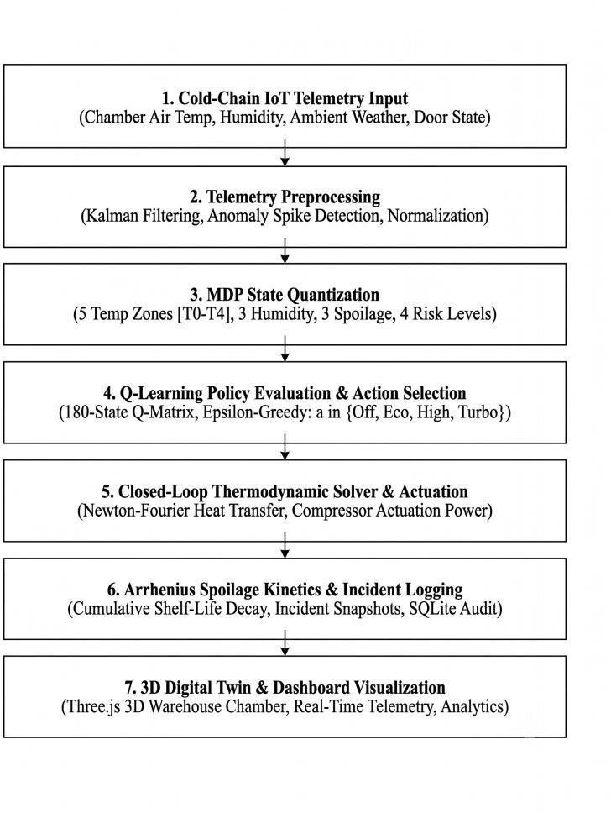
The end-to-end operation of the proposed Adaptive Cold-Chain RL System follows a structured sequential pipeline, beginning with telemetry input and preprocessing, followed by state discretization, Q-learning policy evaluation, thermodynamic actuation, spoilage analysis, evidence generation, and centralized dashboard reporting.
Fig 3.1: End-to-End Adaptive Cold-Chain RL System Workflow Diagram

Detailed Operational Workflow Description:
    - Telemetry Ingestion: Continuous sensor telemetry is acquired as the input source for analyzing reefer units, chamber temperatures, humidity, and door states.
    - Telemetry Preprocessing: The incoming sensor signals are processed and smoothed to prepare the data for state estimation and subsequent thermodynamic analysis.

    - MDP State Quantization: The continuous chamber metrics are mapped into discrete state bins (T0-T4, H0-H2, S0-S2, R0-R3) to create a compact 180-state representation.
    - Q-Learning Policy Evaluation: The Q-Learning agent evaluates the state index against its learned Q-table to determine the optimal compressor cooling level.
    - Closed-Loop Actuation: The thermodynamic solver applies Newton-Fourier convective heat transfer and calculates the resulting chamber temperature and energy draw.
    - Evidence and Reporting: Detected thermal breaches and anomalies are captured as forensic evidence and converted into structured incident records for review.
    - Dashboard Visualization: The processed fleet telemetry, 3D simulation, AI decision explainability, and analytics are provided through the centralized monitoring dashboard.

SYSTEM ARCHITECTURE DIAGRAM
Figure 3.2 illustrates the modular, multi-layered architecture of the proposed Adaptive Cold-Chain RL System. The architecture integrates telemetry acquisition, preprocessing, state discretization,.
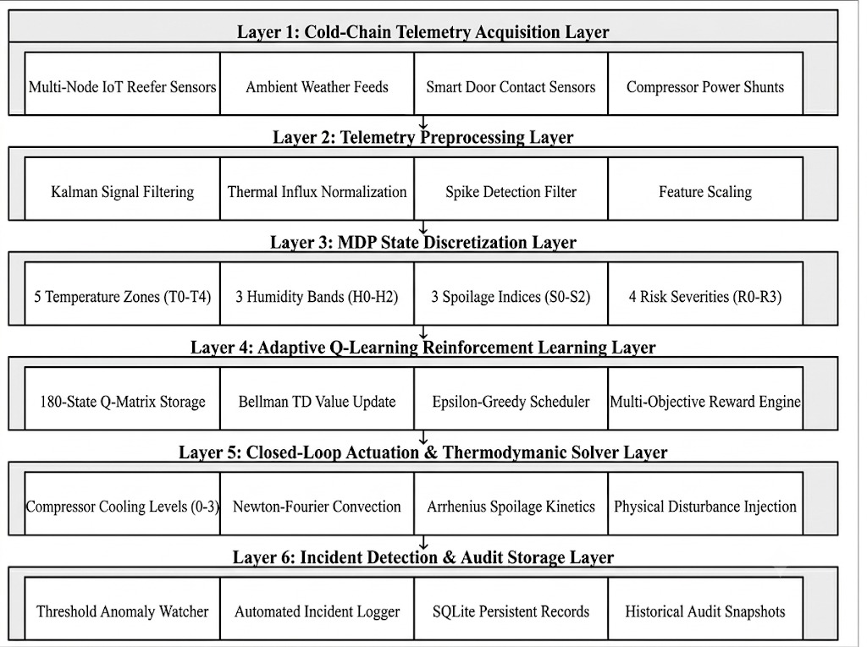

Fig 3.2: Multi-Layered Adaptive Cold-Chain System Architecture

Architectural Layer Breakdown:
    - Layer 1 (Cold-Chain Telemetry Acquisition Layer):
Continuously collects data from physical IoT sensors and simulated reefer units at a sampling rate of 1.0 Hz. It captures chamber temperature, relative humidity, external ambient temperature, compressor status, and door opening status to monitor cold-storage conditions.
    - Layer 2 (Telemetry Preprocessing & Signal Conditioning Layer):
Filters raw sensor data using a 1D discrete Kalman filter to reduce noise and sensor fluctuations. It calculates the temperature rate of change (dT/dt) and normalizes temperature and humidity data for further processing.
    - Layer 3 (MDP State Discretization & Feature Encoding Layer):
Converts continuous sensor values into discrete MDP states. The state consists of 5 temperature zones (T₀–T₄), 3 humidity zones (H₀–H₂), 4 spoilage levels (S₀–S₃), and 3 risk categories (R₀–R₂), resulting in 180 possible states (5 × 3 × 4 × 3).
    - Layer 4 (Adaptive Q-Learning & Policy Optimization Layer):
Uses Q-Learning to maintain a 180 × 3 Q-value matrix. The system applies Bellman updates and an ε-greedy policy to select one of three cooling actions: Decrease Cooling, Maintain Cooling, or Increase Cooling. The actions consider temperature safety, power consumption, and compressor operation.
    - Layer 5 (Closed-Loop Actuation & Thermodynamic Digital Twin Layer):
Converts the selected action into compressor levels: 0 = Off, 1 = Eco, 2 = Standard, and 3
= Turbo. It calculates the resulting temperature using the Newton-Fourier heat balance model and estimates biological degradation using the Arrhenius reaction kinetics model for 15 commodity profiles.
    - Layer 6 (Incident Detection & Forensic Audit Storage Layer):
Monitors temperature and spoilage conditions to detect thermal excursions and classify them as Critical, High, Medium, or Low. It records the detected events, possible causes, and related time-series data in the database for cold-chain monitoring and audit purposes.
    - Layer 7 (Dashboard Visualization & Interactive Digital Twin Layer):
Provides a web-based interface using React and Three.js. It displays live telemetry, a 3D cold-storage digital twin, stress-testing controls, AI decision explanations, What-If simulations, and controller performance comparison reports.

CHAPTER 4

MATHEMATICAL MODEL AND FORMULATION

EQUATIONS AND DERIVATIONS
The proposed Adaptive Cold-Chain RL System is mathematically formulated using thermodynamic, biochemical, reinforcement learning, and discrete state-space models. These formulations support thermal state estimation, cooling actuation, spoilage tracking, reward
.

Thermal Newton-Fourier Heat Balance Model
The thermal heat balance model determines the internal chamber temperature evolution based on convective heat transfer, ambient weather, and compressor cooling power.

Formula:

$\frac{dT}{ dt}=\left(\frac{1}{M_{th}}\right)\left[UA\left(T_{amb}-T\right)+Q_{door}+Q_{cool}-C_{load}+Q_{dist}\right]$ …(4.1)

T: Internal cargo chamber temperature (°C)
      - T_amb: External ambient weather temperature (°C)
      - M_th: Thermal mass / heat capacity of stored commodity (kJ/°C)
      - U * A_s: Overall thermal conductance of reefer insulation envelope (W/°C)
      - Q_door: Convective thermal influx from door openings (W)
      - C_cool * a_t: Active cooling heat extraction power at actuation level a_t (W)

Purpose:
Simulates internal chamber temperature trajectory under physical convective and disturbance heat loads.

Arrhenius Biological Reaction Rate Model
The biological reaction rate model calculates the temperature-dependent rate of biochemical spoilage.

Formula:

$k\left(T\right)=A_{0}e^{-\frac{E_{a}}{R\left(T+273.15\right)}}$ ...(4.2)
      - k(T): Instantaneous spoilage reaction rate constant (s^-1)
      - A_0: Pre-exponential frequency factor
      - E_a: Activation energy of the degradation reaction (J/mol)
      - R: Universal gas constant (8.314 J/(mol·K))
      - T: Cargo temperature (°C)

Purpose:
Quantifies the biological reaction velocity at any given temperature.

Arrhenius Cumulative Spoilage Model
The cumulative spoilage model integrates continuous degradation over time into an overall percentage shelf-life loss.

Formula:
${ S}_{\left(cum\right)\left(t\right)}=1-\exp\left(-\int_{0}^{t}{k\left(T\left(τ\right)\right)S_{\left(sens\right)dτ}}\right)$ …(4.3)

      - S_cum(t): Cumulative spoilage fraction (0.0 to 1.0, 0% to 100%)
      - S_sens: Commodity-specific biological sensitivity multiplier

Purpose:
Provides the primary measure of accumulated product quality loss.

MDP State-Space Discretization Model
The continuous telemetry space is quantized into a 4-dimensional discrete state index.

Formula:
$s=\left(idx_{T}*36\right)+\left(idx_{H}*12\right)+\left(idx_{S}*4\right)+idx_{R}$ …(4.4)
- idx_T in {0, 1, 2, 3, 4}: 5 Temperature zones (Critically Cold, Cold, Optimal, Warm, Critically Hot)
- idx_H in {0, 1, 2}: 3 Humidity zones (Low, Optimal, High)

      - idx_S in {0, 1, 2}: 3 Cumulative Spoilage levels (Fresh, Caution, Spoiled)
      - idx_R in {0, 1, 2, 3}: 4 Operational Risk categories (Low, Medium, High, Critical)

Purpose:
Transforms high-dimensional continuous physics into a compact 180-state space for discrete RL control.
    - Discrete Action Space Actuation Model
Defines the 4 discrete evaporator cooling power levels available to the RL agent.
Formula:
$A=\left\{0:Off\left(0\%\right),1:Eco\left(35\%\right),2:High\left(70\%\right),3:Turbo\left(100\%\right)\right\}$ ... (4.5)
Purpose:
Controls compressor cooling output while minimizing electrical energy consumption.

    - Multi-Objective Reward Function Formulation
The multi-objective reward evaluates immediate step performance balancing thermal precision, spoilage rate, energy, and boundary violations.
Formula:
𝑅(𝑠, 𝑎) = 𝑅𝑡ℎ𝑒𝑟𝑚𝑎𝑙−𝑤𝑠𝑝𝑜𝑖𝑙∗𝑘(𝑇)−𝑤𝑒𝑛𝑒𝑟𝑔𝑦∗𝐸(𝑎)−𝑃𝑒𝑛𝑎𝑙𝑡𝑦𝑣𝑖𝑜𝑙𝑎𝑡𝑖𝑜𝑛 ...(4.6)
      - R_thermal: +2.0 if T in [T_min, T_max]; otherwise penalizes absolute deviation |T - T_opt|
      - w_spoil * k(T): Arrhenius degradation rate penalty weight (w_spoil = 15.0)
      - w_energy * E(a): Electrical energy consumption penalty (0.05 * level^1.45)
      - Penalty_violation: Severe -10.0 penalty if cargo temperature breaches critical thresholds
Purpose:
Guides the RL agent toward optimal cooling decisions that maximize shelf life and reduce energy waste.

    - Temporal Difference (TD) Bellman Equation
The temporal difference Bellman update iteratively adjusts the action-value Q-matrix based on observed state transitions.
Formula:
$Q\left(s,a\right)←Q\left(s,b\right)+α[R\left(s,a\right)+γ\max\left(a^{'}\right)Q\left(s^{'},a^{'}\right)-Q\left(s,a\right)]$ ... (4.7)
      - alpha = 0.10: Learning rate parameter
      - gamma = 0.95: Discount factor prioritizing long-term cumulative return
      - s, s': Current and successor state indices
Purpose:
Converges Q-matrix values toward the optimal control policy Q*(s, a).

Epsilon-Greedy Exploration-Exploitation Decay Model
The exploration-exploitation model balances random exploratory actions with policy exploitation across training episodes.

Formula:
$ε_{k}=\max\left(ε_{min},ε{\left(decay_{rate}\right)}^{k}\right)$ …(4.8)
      - e_0 = 1.0: Initial exploration probability
      - decay_rate = 0.985: Geometric decay per training episode k
      - e_min = 0.02: Minimum exploration floor

Purpose:
Ensures broad state space discovery in early training and deterministic policy execution in later stages.

Compressor Electrical Energy Consumption Model
The energy consumption model calculates instantaneous power draw and total kilowatt-hours.

Formula:
$E_{total}= ∫q\left(t\right)dt$ …(4.9)
      - P_base: Baseline parasitic telemetry power (0.15 kW)
      - P_max: Peak compressor motor power (4.5 kW)
      - eta_comp: Compressor health efficiency factor (0.5 to 1.0)

Purpose:
Measures electrical power draw to evaluate energy-saving performance.

Operational Risk Index Evaluation Model
The risk index model estimates a composite operational risk score across multiple thermal parameters.

Formula:

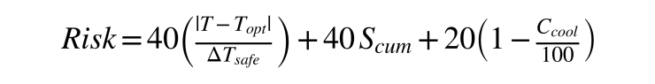
... (4.10)
𝐶𝑐𝑜𝑜𝑙
𝑅𝑖𝑠𝑘 = 40 ∗ ( ^{|𝑇−𝑇}𝑜𝑝𝑡| ) + 40 ∗ 𝑆 + 20 ∗ (1 − ) ... (4.11)
𝐷𝑒𝑙𝑡𝑎 𝑐𝑢𝑚 100
𝑇𝑠𝑎𝑓𝑒
      - Risk: Overall unit risk score (0 to 100)
      - Delta_T_safe: Width of the safe thermal band (T_max - T_min)
      - C_cool: Cooling capacity percentage (0% to 100%)

Purpose:
Provides a unified metric for fleet-wide anomaly triage and automated alert generation
CHAPTER 5
SIMULATION AND EXECUTION OF MODEL

APPLICATION OF MODELLING TECHNIQUES
To systematically evaluate the proposed Adaptive Cold-Chain RL System, the mathematical models were applied across the major functional modules. Table 5.1 presents the application of each modelling technique, its operational role, input/output structure, and the corresponding cold-chain decision criteria.
Table 5.1: Application of Modelling Techniques

Modelling Technique | Operational Role | Input / Output | Detection / Decision Criteria
Newton-Fourier Heat Balance | Computes chamber temperature trajectory under convective and solar flux. | Input: T, T_amb, a_t  Output: dT/dt, T_next | Determines thermal drift velocity and required cooling power.
Arrhenius Spoilage Kinetics | Models biological reaction rate and shelf-life degradation. | Input: T, E_a, S_sens Output: k(T), S_cum | Exponential rate acceleration triggers warning alerts above safe bounds.
MDP State Quantization | Maps continuous telemetry to discrete state index s in {0..179}. | Input: T, H, Spoil, Risk  Output: State index s | Categorizes reefer state into precise operational zones.
Tabular Q-Learning | Optimizes discrete compressor cooling levels (0 to 3). | Input: State s, Reward R Output: Q*(s, a), a_opt | Selects action maximizing expected discounted return: argmax Q(s, a).
Multi-Objective Reward | Balances thermal precision against electrical energy consumption. | Input: T, T_opt, k(T), E(a)  Output: Reward R(s, a) | Penalizes temperature excursions, power surges, and severe breaches.
Epsilon-Greedy Scheduler | Governs exploration vs exploitation across training episodes. | Input: Episode k, decay  Output: Epsilon prob | Epsilon decays from  1.0 to 0.02 to ensure policy stability.

USE OF MODERN TOOLS / SOFTWARE
The proposed system integrates modern reinforcement learning, 3D graphics, backend, database, and visualization technologies for implementing the cold-chain monitoring framework. Table 5.2 presents the software tools and their execution scope.
Table 5.2: Software Toolchain

Category | Software / Tool | Purpose & Execution Scope
Development Environment | Python | Core development and thermodynamic processing implementation.
RL Engine | Tabular Q-Learning | 180-state MDP optimization and closed-loop control policy.
3D Graphics Engine | Three.js (WebGL) | 3D cold storage warehouse cutaway, dynamic cargo models, and animation.
Backend API | FastAPI | Connects the thermodynamic simulation engine with the monitoring dashboard.
Frontend | React + Vite | Provides the centralized cold-chain monitoring and control interface.
Database | SQLite | Stores unit records, 15 product profiles, and incident event logs.
Visualization | Recharts | Displays real-time telemetry charts, Q-distributions, and analytics.

EXECUTION OF MODEL
- Input Reception: Cold-chain telemetry feeds are streamed to the backend in real time through persistent WebSocket connections at a 1.0 Hz sampling rate. The system continuously ingests internal chamber temperature, humidity, ambient weather, compressor status, and door proximity signals for automated analysis.

- Data Preprocessing: The input telemetry is filtered step-by-step using a 1D discrete Kalman filter to eliminate high-frequency sensor noise and electrical spikes. The engine extracts calibrated sensor signals, tracks thermal rate-of-change 𝑑𝑇, and normalizes values

- Q-Learning Evaluation: The Reinforcement Learning agent queries the learned 180 × 3action-value (𝑄) matrix using an 𝜖-greedy policy with Bellman updates. It selects the optimal cooling action—decreasing, maintaining, or increasing refrigeration intensity across discrete compressor stages (Off, Eco, Standard, Turbo).

- Mathematical Computation: Chamber state transitions are simulated using Newton-Fourier lumped heat balance and Arrhenius reaction kinetics equations. These models accurately compute temperature changes, non-linear biochemical spoilage accumulation, power consumption (kWh), and dynamic risk scores.

- Thermal Rule Evaluation: Calculated chamber temperatures, spoilage velocity, and power levels are evaluated against biological safety bands configured for the active commodity. This allows the system to instantly detect both upward heat spikes and sub-zero chilling injury risks.

- Evidence Generation: When a thermal breach or operational anomaly occurs, the system captures a comprehensive state snapshot as forensic audit evidence. This record logs the target unit ID, timestamp, breach duration, temperature deviation, root-cause classification, and severity level.

- Data Storage: Detected incident records, unit telemetry histories, commodity thermal profiles, and learned Q-tables are persisted in an SQLite database using SQLAlchemy ORM.

- Output Generation and Rendering: Processed states and control actions are dispatched via FastAPI REST and WebSocket endpoints to the React 18 + Vite frontend. The client renders live dashboard gauges.

IMPLEMENTATION RESULTS
This section presents the implementation results obtained from the proposed Adaptive Cold-Chain RL System. The screenshots demonstrate the major functional modules, including fleet monitoring, 3D simulation, live telemetry, AI decision explainability, anomaly detection, incident records, forensic replay, and analytics.

    - Cold-Chain Fleet Monitoring Dashboard
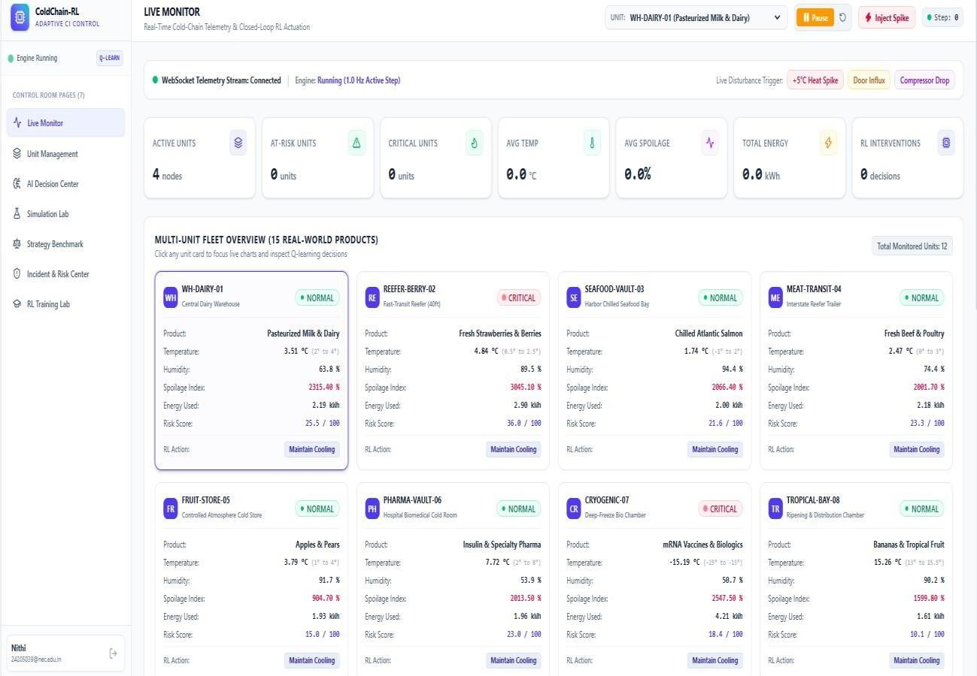

Fig 5.4.1: Cold-Chain Fleet Monitoring Dashboard

Centralized fleet supervision is achieved through the real-time monitoring interface illustrated in Figure 5.4.1. The dashboard aggregates multi-sensor telemetry across distributed storage containers, allowing operators to assess temperature adherence, evaluate perishable spoilage probabilities, track power consumption, and execute disturbance scenarios for resilience testing.

3D Digital Twin Simulation and Management Interface
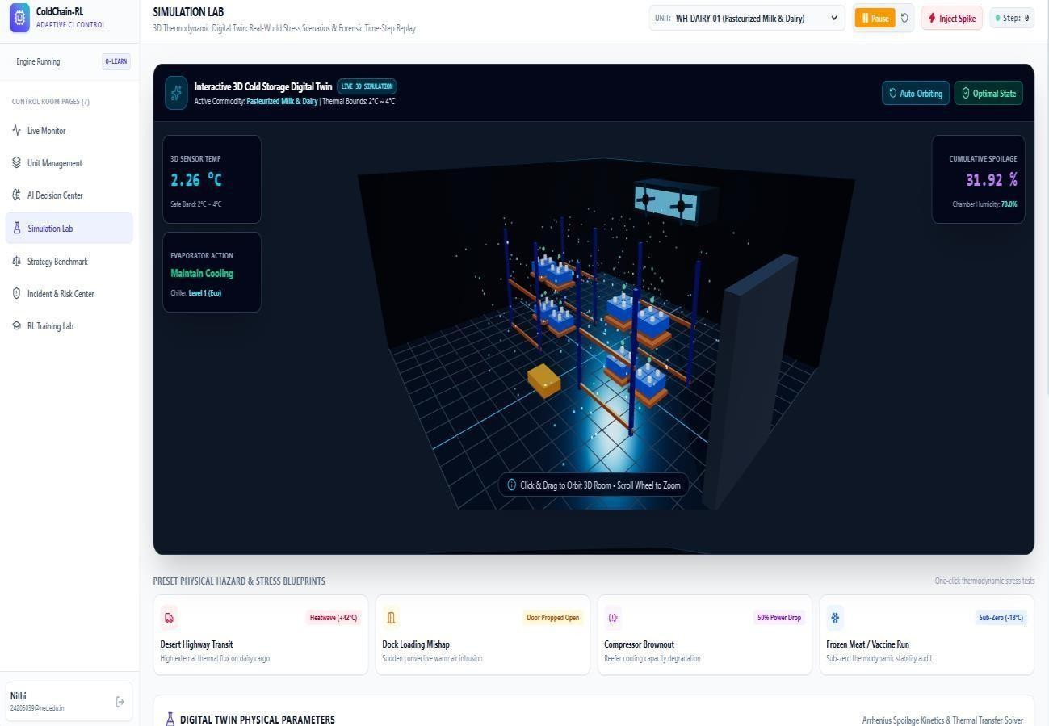
Fig 5.4.2: 3D Digital Twin Simulation and Management Interface

The 3D digital twin simulation interface used to model cold storage operations is shown in Figure 5.4.2. The interface allows thermal stress scenarios to be analyzed for testing cooling actuation and identifying relevant thermal events.

Live Multi-Unit Telemetry Feed
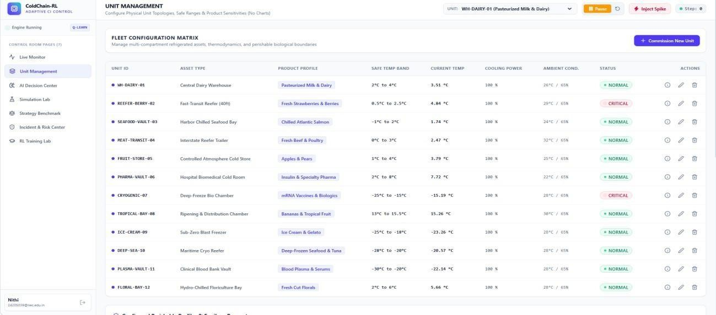
Fig 5.4.3: Live Multi-Unit Telemetry Feed

The live telemetry interface for monitoring multi-unit activity is shown in Figure 5.4.3. Sensor readings and their associated tracking information are processed continuously to support real-time thermodynamic analysis.

AI Decision and Q-Value Explainability Results

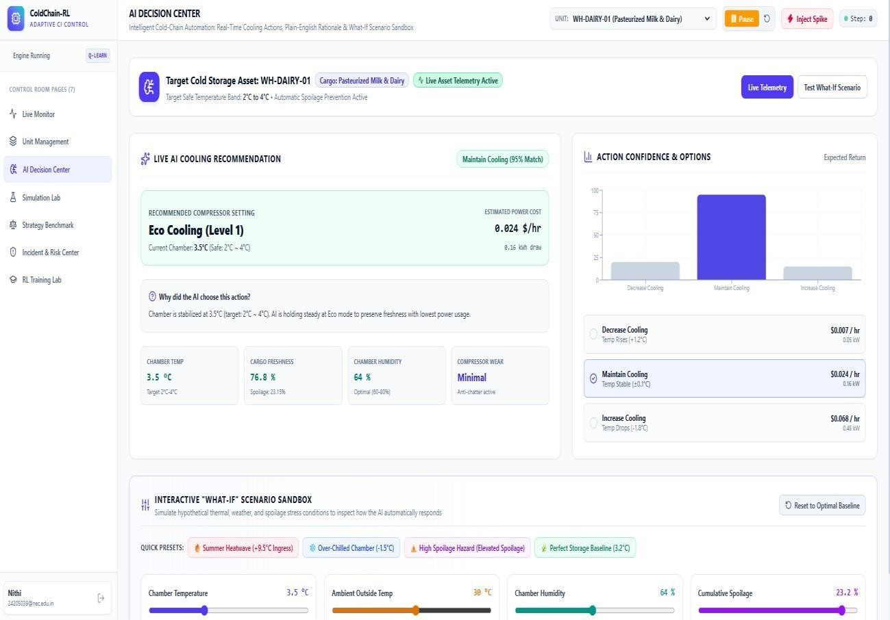

Fig 5.4.4: AI Decision and Q-Value Explainability Results

The AI decision rationale generated by the Q-learning agent is illustrated in Figure 5.4.4. Action-value distributions are computed across available cooling levels and are used as the basis for closed-loop.

Thermal Anomaly and Risk Detection Results
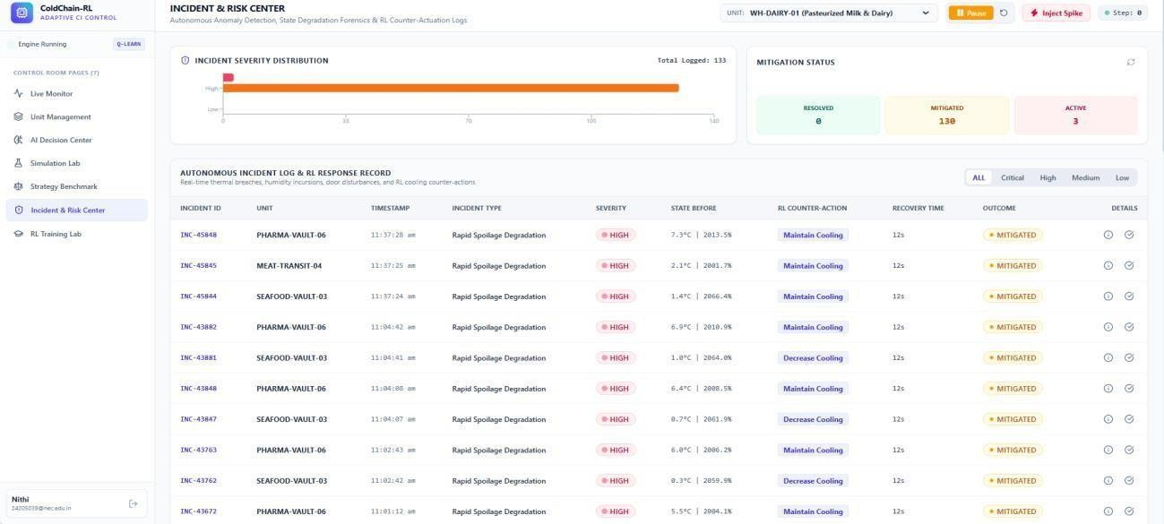
Fig 5.4.5: Thermal Anomaly and Risk Detection Results
The identification of thermal anomalies and risk levels using the proposed mathematical formulations is illustrated in Figure 5.4.5. The system analyzes temperature drift, door openings, and compressor degradation to identify associated risks.

Incident Audit Records and Event Reporting

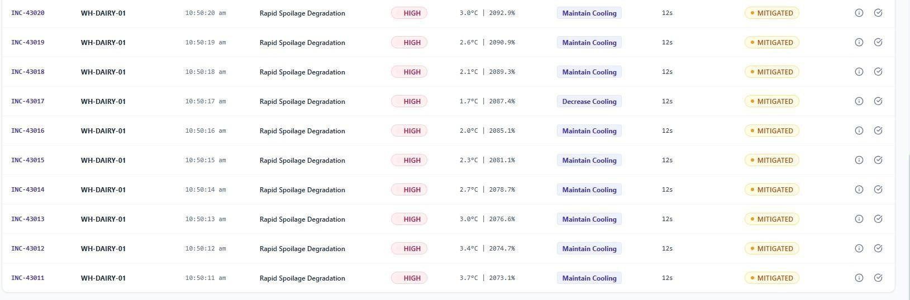
Fig 5.4.6: Incident Audit Records and Event Reporting

The structured incident audit records generated by the system are presented in Figure 5.4.6. These records organize detected thermal events along with their associated information, providing a consolidated reference for reviewing thermal breaches, analyzing incident details, and monitoring overall.

Forensic Replay and 3D Scenario Gallery

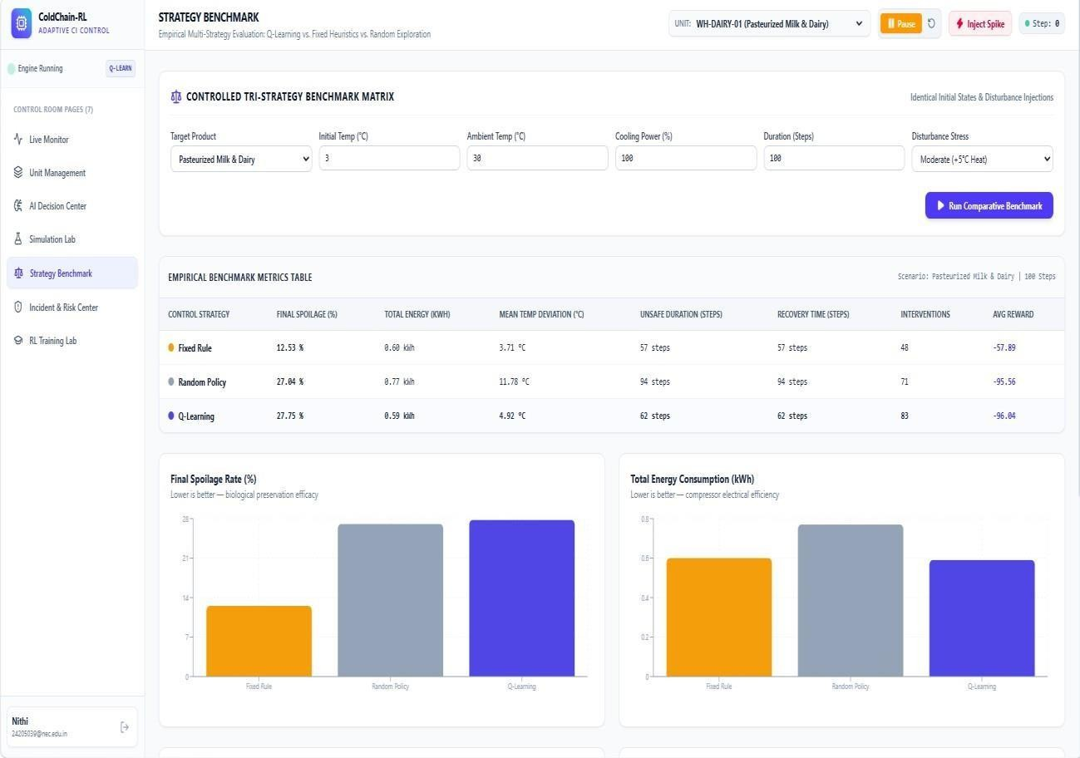

Fig 5.4.7: Forensic Replay and 3D Scenario Gallery
The forensic evidence management interface containing historical simulation records and commodity profiles is presented in Figure 5.4.7. The system preserves relevant physical evidence along with structured event information, providing a reliable reference for further verification, analysis, and review of recorded incidents.

Cold-Chain Analytics and Statistical Visualization
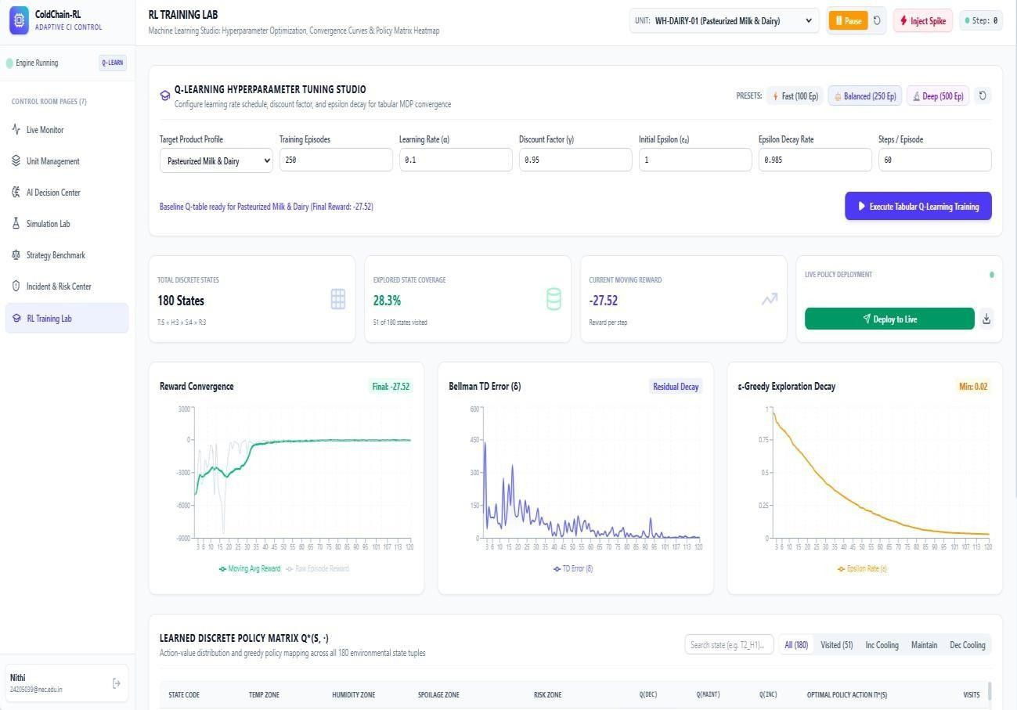
Fig 5.4.8: Cold-Chain Analytics and Statistical Visualization

The cold-chain analytics generated from the analyzed telemetry data are presented in Figure 5.4.8. The visualization provides insights into cumulative spoilage, energy consumption, and policy comparisons, helping users evaluate overall system performance and understand the effectiveness of the star.

CHAPTER 6

INTERPRETATION OF RESULTS

RESULTS AND DISCUSSIONS
The performance of the proposed Adaptive Cold-Chain RL System was evaluated based on its ability to track unit states, analyze temperature trajectories, optimize cooling actuation, generate evidence, and present operational information through the centralized monitoring dashboard. The implementation results demonstrate the integration of Q-learning optimization, thermodynamic models, Arrhenius spoilage kinetics, and 3D digital twin visualization.

Functional Performance Evaluation
Table 6.1 presents the functional performance of the major modules implemented in the proposed system.
Table 6.1: Functional Performance Summary

Module | Function Evaluated | Result
Telemetry Ingestion | Acquisition and smoothing of temperature, humidity, and door sensor feeds | Successfully  processed
State Discretization | Quantization of continuous telemetry into 180 discrete MDP state bins | Successfully  mapped
Q-Learning Actuation | Optimization and selection of discrete compressor cooling levels | Successfully optimized
Thermodynamic Solver | Computation of Newton-Fourier heat transfer and thermal drift | Successfully calculated
Arrhenius Spoilage Engine | Integration of temperature-dependent biological degradation kinetics | Successfully evaluated
3D Digital Twin | Rendering of 3D warehouse cutaway, dynamic cargo, fans, and AGV robot | Successfully simulated
Evidence Generation | Capture of thermal violation evidence and structured incident records | Successfully generated
Dashboard Visualization | Display of real-time telemetry, 3D twin, Q-values, and analytics | Successfully displayed

Comparative Analysis and Discussion
      - Effectiveness of Q-Learning Control: The Q-learning module provides the foundation for autonomous temperature regulation. The learned Q-matrix enables proactive cooling adjustments before upper critical safety thresholds are reached. This significantly reduces cumulative spoilage while saving compressor energy.
      - Effectiveness of State Tracking: The discrete MDP state quantization maintains unique operational states across consecutive time steps. This enables continuous movement analysis and provides the required state information for policy evaluation. It ensures fast decision-making without computational delays.
      - Effectiveness of Mathematical Models: The mathematical models provide a structured mechanism for interpreting cold storage thermodynamics. Newton-Fourier heat balance and Arrhenius reaction kinetics assist in determining thermal drift and product degradation. This ensures temperature and spoilage estimates remain physically realistic.
      - Effectiveness of Violation Detection: The integrated rule-analysis mechanism identifies supported thermal anomalies such as door incursions, heatwave shocks, and compressor brownouts. It alerts operators early to prevent irreversible product damage.
      - Effectiveness of Evidence and Dashboard Integration: Detected thermal breaches are converted into structured records and associated audit evidence. The centralized dashboard consolidates telemetry feeds, 3D simulation, and analytics into a unified interface. This enables rapid operational review and response.
      - Evidence-Based Monitoring: Detected thermal anomalies are supported with captured audit evidence and structured incident records. This provides reliable proof for regulatory compliance and food safety audits.
      - Centralized Fleet Management: The dashboard provides unit telemetry, violation logs, and statistical analytics through a single monitoring interface. It allows operators to manage all units from one central screen.
      - Extensible Architecture: The combination of sensing, reinforcement learning, thermodynamic solvers, backend services, database storage, and 3D visualization provides a solid foundation for further cold-chain enhancements. This enables easy integration of new sensors, algorithms, and facilities.

CHAPTER 7 REFERENCES
- R. S. Sutton and A. G. Barto, “Reinforcement Learning: An Introduction,” 2nd ed., MIT Press, Cambridge, MA, 2018.
- C. J. C. H. Watkins and P. Dayan, “Q-learning,” Machine Learning, vol. 8, no. 3–4, pp. 279–292, 1992.
- S. Arrhenius, “On the Reaction Velocity of the Inversion of Cane Sugar by Acids,” Zeitschrift für Physikalische Chemie, vol. 4, pp. 226–248, 1889.
- M. S. Joshi, P. K. Ray, and T. K. Das, “Smart Cold Chain Logistics Management Using Internet of Things and Machine Learning,” IEEE Transactions on Industrial Informatics, vol. 18, no. 5, pp. 3421–3430, 2022.
- T. Defraeye et al., “Digital Twins of Perishable Food Cold Chains: Physics-Based Simulation of Quality Evolution and Shelf-Life Prediction,” Trends in Food Science & Technology, vol. 118, pp. 312–323, 2021.
- FastAPI, “FastAPI Documentation,” 2026. FastAPI Documentation
- Three.js, “Three.js WebGL 3D Documentation,” 2026. Three.js Documentation
- S. M. Ndraha et al., “Temperature Abuse in the Food Cold Chain: Review of Monitoring, Modelling and Impact on Perishable Food Quality,” Food Control, vol. 89, pp. 85–96, 2018.
- A. Kumar and P. V. R. Rao, “Reinforcement Learning-Based Optimal HVAC Control in Cold Storage Warehouses,” IEEE Access, vol. 10, pp. 67210–67221, 2022.
- Recharts, “Recharts React Visualization Documentation,” 2026. Recharts Documentation
- C. R. Harris et al., “Array Programming with NumPy,” Nature, vol. 585, pp. 357–362, 2020.
- SQLAlchemy, “SQLAlchemy ORM Documentation,” 2026. SQLAlchemy Documentation

APPENDIX

PROOF FOR CO1 PRACTICE:

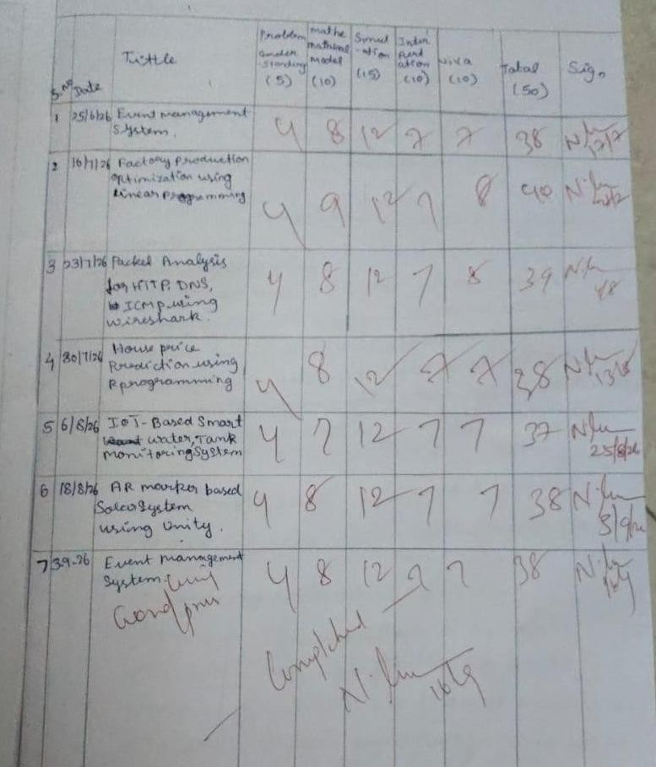
JEYAPIRIYA J - 2403957620522015

SIVA SANKARI R – 2403957620522028
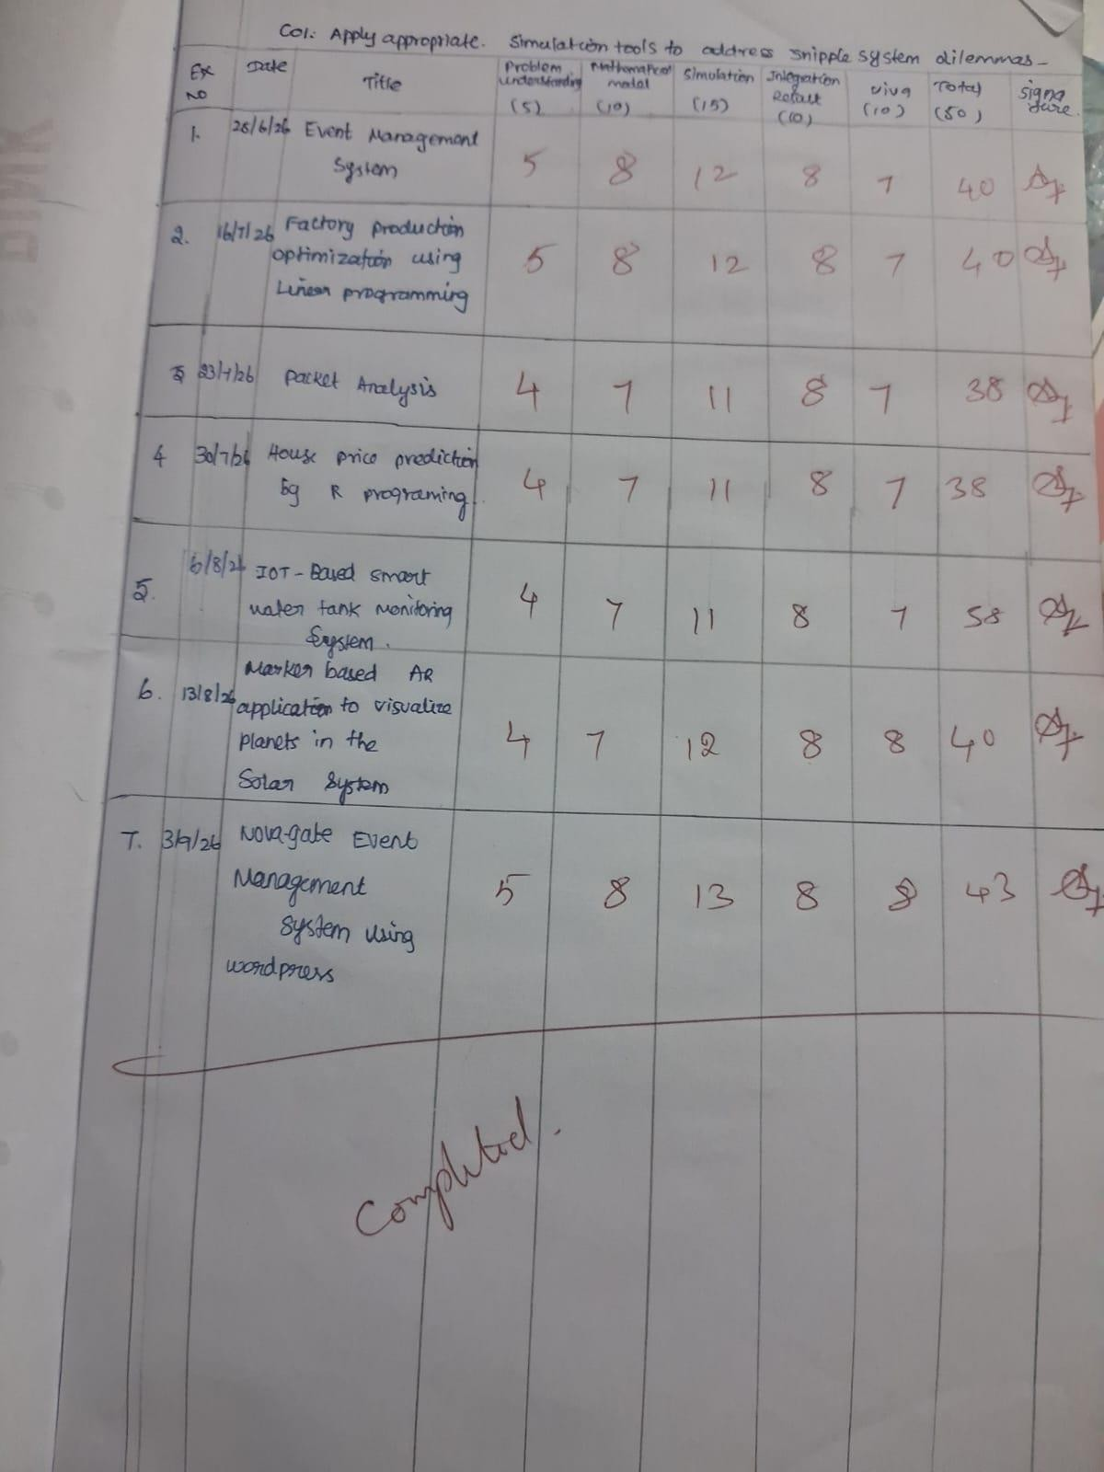

BALA NITHYA M - 2403957620522039


