CREATORHUB: MODERN CONTENT CREATOR STUDIO OPERATING SYSTEM
23CS54C – MODERN WEB TECHNOLOGIES
Submitted by
BALA NITHYA M 24104085
In partial fulfillment for the award of the degree
of
BACHELOR OF ENGINEERING/TECHNOLOGY
in
COMPUTER SCIENCE AND ENGINEERING/ INFORMATION TECHNOLOGY
NATIONAL ENGINEERING COLLEGE
(An Autonomous Institution affiliated to Anna University, Chennai)
K.R.NAGAR, KOVILPATTI - 628503
OCTOBER - 2026

NATIONAL ENGINEERING COLLEGE
(An Autonomous Institution affiliated to Anna University, Chennai)
K.R.NAGAR, KOVILPATTI - 628503
BONAFIDE CERTIFICATE
This is to certify that this project report, “CreatorHub: Modern Content Creator Studio Operating System”, is the bonafide work of BALA NITHYA M(24104085) who carried out the project work under my supervision.
Course Instructor/Guide
Submitted to the 23CS54C – MODERN WEB TECHNOLOGIES Viva-Voce examination held at National Engineering College, K.R.Nagar, Kovilpatti on ____________
Internal Examiner Co Examiner

TABLE OF CONTENTS
CH NO TITLE.....................................................................................................PAGE NO
1 INTRODUCTION .............................................................. 3
2 OBJECTIVES ................................................................ 4
3 DESCRIPTION ............................................................... 5
4 CLASS DIAGRAM ............................................................. 6
5 TABLE STRUCTURES .......................................................... 7
6 ER DIAGRAM ................................................................ 16
7 TECH STACK ................................................................ 18
8 MODULES ................................................................... 19
9 CONCLUSION ................................................................ 35

CHAPTER 1
INTRODUCTION

In the modern digital environment, the efficient management of multi-format content creation operations plays a vital role in ensuring the smooth functioning of independent media production teams, digital creator studios, and individual creators. Handling conceptual ideation, narrative scriptwriting, teleprompter pacing, frame-by-frame video review, thumbnail design, and brand sponsorship calculations through manual, disconnected, or paper-based methods is time-consuming, error-prone, and lacks operational transparency. There is an urgent need for a reliable, full-stack digital solution that brings all these production activities under one unified studio operating platform.
The CreatorHub Studio Operating System is a comprehensive, full-stack web application designed to digitize and automate the complete lifecycle of digital content creation from initial topic ideation to post-production delivery and brand monetization. The system was developed to meet the real-world operational requirements of modern multi-platform video creators producing long-form horizontal videos for YouTube alongside short-form vertical assets for TikTok, Instagram Reels, and YouTube Shorts.
The application is organized into three major functional domains: Master Data & Ideation Management, which covers foundational creator workspaces, multi-format derivative planning, and structured narrative scripts; Production & Review Pipeline, which handles 5-stage visual Kanban tracking, synchronized teleprompter recording, and timestamped video review feedback; and Monetization & Analytics, which provides creators with automated brand sponsorship rate valuations, invoice generation, and real-time cross-platform revenue projections.
The system is built on modern web standards utilizing React 19, Tailwind CSS, Node.js, Express, and MongoDB, delivering sub-100ms UI responsiveness, high-contrast dark mode ergonomics, and stateless JWT authentication. This report documents the design, development, and implementation of the CreatorHub Studio Operating System, providing a complete technical overview of its architecture, features, and functionality.

CHAPTER 2
OBJECTIVES

• To Digitize Creator Studio Operations: Replace disconnected spreadsheets, note apps, and manual documents with a centralized web operating system to improve workflow efficiency, data accessibility, and production speed.
• To Automate Pillar-to-Derivative Content Planning: Decompose a single master video idea into structured derivative formats (YouTube Longs, Shorts, Reels, and Carousels) to maximize audience reach without manual reformatting.
• To Streamline Script Blueprinting and Pacing: Implement a structured 5-section narrative script editor with real-time Words-Per-Minute (WPM) duration calculators and an integrated 60-FPS teleprompter.
• To Automate the Production Kanban Pipeline: Track video deliverables through 5 sequential stages (Ideation, Scripting, Filming, Editing, Completed) with automated checklist validations and stage transitions.
• To Enable Timestamped Collaborative Review: Allow creators and video editors to pin feedback comments to exact video timestamps, eliminating revision ambiguity.
• To Provide Heuristic A/B Thumbnail Testing: Deliver a multi-layer HTML5 composite canvas editor with side-by-side feed previews and rule-based Click-Through Rate (CTR) contrast scoring.
• To Standardize Brand Sponsorship Monetization: Eliminate arbitrary pricing through a mathematical valuation engine using niche baseline CPM rates and automated commercial invoice generation.
• To Enforce User Authentication and Role-Based Access: Secure the application using BCrypt password hashing, stateless JWT session tokens, and protected workspace routes.
• To Deliver Centralized Channel Analytics: Provide real-time visibility into views, watch time duration, and multi-tier revenue projections across conservative, expected, and bullish models.
• To Deploy a Scalable, Maintainable Architecture: Use a decoupled client-server architecture with React 19, Express REST APIs, and MongoDB document persistence.

CHAPTER 3
DESCRIPTION

The CreatorHub Studio Operating System is a full-stack web application developed to manage, streamline, and automate digital content creation and monetization operations. The system consists of five major functional areas:
1. Master Workspace & Ideation Management
This module maintains foundational creator profiles, channel niches, subscriber metrics, and master pillar content ideas. The built-in Derivative Planning Engine automatically transforms a primary video topic into synchronized child formats for YouTube, TikTok, Reels, and LinkedIn carousels, ensuring consistent multi-platform publishing schedules.
2. Script Blueprinting & Teleprompter Workflow
This module manages narrative script authoring across 5 structured sections: 3-Second Hook Variations, Problem Statement, Core Substance, Climax, and Call to Action (CTA). Spoken duration is calculated in real time using the creator's target reading speed (default: 145 WPM). The integrated fullscreen teleprompter provides smooth, hardware-accelerated auto-scrolling via requestAnimationFrame.
3. Visual Kanban Production Pipeline & Video Review
This module manages day-to-day video production across five sequential stages: Ideation, Scripting, Filming, Editing, and Completed. Each content item includes task checklists, assigned team members, and timestamped video review pins that allow creators and editors to leave actionable feedback on specific video frames.
4. A/B Thumbnail Testing & Sponsorship Valuation
This module provides a dual-canvas visual testing workbench that simulates how thumbnails appear in YouTube feeds, paired with a heuristic CTR evaluator. Additionally, the Sponsorship Engine calculates transparent brand rates based on niche CPMs (e.g., Tech $38, Finance $45) and generates downloadable commercial invoices.
5. Security, Analytics, and Architecture
The application uses BCrypt for salted password encryption and JSON Web Tokens (JWT) for stateless session authorization. The reactive React 19 frontend communicates with an Express.js backend and MongoDB database, delivering sub-100ms API response times and comprehensive revenue analytics.

CHAPTER 4
CLASS DIAGRAM

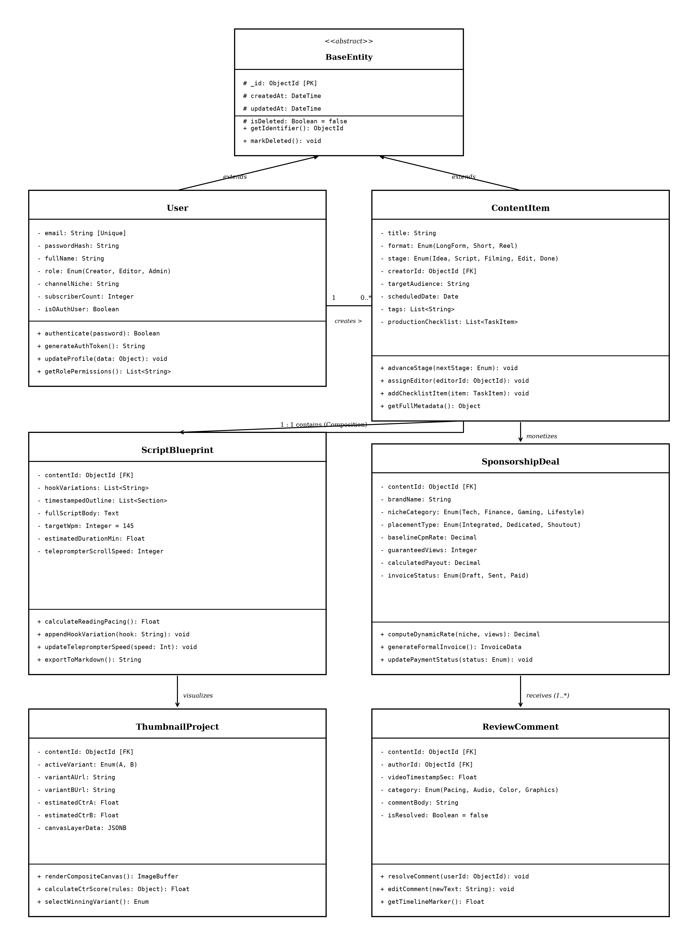
Figure 4.1: Class Diagram of CreatorHub Studio System

CHAPTER 5
TABLE STRUCTURES

Users :
Field | Type | Null | Key | Default | Extra
id | int | NO | PRI | NULL | auto_increment
username | varchar(100) | NO | UNI | NULL
password | varchar(255) | NO |  | NULL
full_name | varchar(150) | YES |  | NULL
email | varchar(150) | YES |  | NULL
role | enum('creator','editor','admin') | NO |  | creator
channel_niche | varchar(50) | YES |  | Technology
subscriber_count | int | NO |  | 0
status | enum('active','inactive') | NO |  | active
last_login | datetime | YES |  | NULL
createdAt | datetime | NO |  | NULL
updatedAt | datetime | NO |  | NULL
Content_Items :
Field | Type | Null | Key | Default | Extra
id | int | NO | PRI | NULL | auto_increment
creator_id | int | NO | MUL | NULL
title | varchar(255) | NO |  | NULL
format | enum('LongForm','Short','Reel','Carousel') | NO |  | LongForm
stage | enum('Ideation','Scripting','Filming','Editing','Completed') | NO |  | Ideation
target_niche | varchar(50) | YES |  | Technology
scheduled_date | date | YES |  | NULL
tasks_json | text | YES |  | NULL
createdAt | datetime | NO |  | NULL
updatedAt | datetime | NO |  | NULL

Scripts :
Field | Type | Null | Key | Default | Extra
id | int | NO | PRI | NULL | auto_increment
content_id | int | NO | UNI | NULL
hook_variations | text | YES |  | NULL
outline_json | text | YES |  | NULL
full_script_body | longtext | YES |  | NULL
target_wpm | int | NO |  | 145
estimated_duration | decimal(5,2) | NO |  | 0.00
teleprompter_speed | int | NO |  | 145
createdAt | datetime | NO |  | NULL
updatedAt | datetime | NO |  | NULL
Sponsorship_Deals :
Field | Type | Null | Key | Default | Extra
id | int | NO | PRI | NULL | auto_increment
content_id | int | NO | MUL | NULL
brand_name | varchar(150) | NO |  | NULL
niche_category | varchar(50) | NO |  | Technology
placement_type | varchar(50) | NO |  | Integrated_MidRoll
baseline_cpm | decimal(8,2) | NO |  | 38.00
projected_views | int | NO |  | 10000
total_payout | decimal(10,2) | NO |  | 0.00
invoice_number | varchar(50) | YES | UNI | NULL
status | enum('Draft','Sent','Paid') | NO |  | Draft
createdAt | datetime | NO |  | NULL
updatedAt | datetime | NO |  | NULL

Thumbnail_Projects :
Field | Type | Null | Key | Default | Extra
id | int | NO | PRI | NULL | auto_increment
content_id | int | NO | UNI | NULL
active_variant | enum('A','B') | NO |  | A
variant_a_url | text | YES |  | NULL
variant_b_url | text | YES |  | NULL
ctr_score_a | decimal(4,2) | NO |  | 0.00
ctr_score_b | decimal(4,2) | NO |  | 0.00
canvas_layers | text | YES |  | NULL
createdAt | datetime | NO |  | NULL
updatedAt | datetime | NO |  | NULL
Review_Comments :
Field | Type | Null | Key | Default | Extra
id | int | NO | PRI | NULL | auto_increment
content_id | int | NO | MUL | NULL
author_id | int | NO | MUL | NULL
timestamp_sec | decimal(6,2) | NO |  | 0.00
category | varchar(50) | NO |  | Pacing
comment_text | text | NO |  | NULL
is_resolved | tinyint(1) | NO |  | 0
createdAt | datetime | NO |  | NULL
updatedAt | datetime | NO |  | NULL

Audit_Logs :
Field | Type | Null | Key | Default | Extra
id | int | NO | PRI | NULL | auto_increment
user_id | int | NO | MUL | NULL
action | varchar(50) | NO |  | NULL
resource | varchar(50) | NO |  | NULL
resource_id | int | YES |  | NULL
ip_address | varchar(45) | YES |  | NULL
createdAt | datetime | NO |  | NULL
Analytics_Records :
Field | Type | Null | Key | Default | Extra
id | int | NO | PRI | NULL | auto_increment
creator_id | int | NO | MUL | NULL
month_year | varchar(7) | NO |  | NULL
total_views | bigint | NO |  | 0
avg_duration_sec | int | NO |  | 0
avg_ctr | decimal(4,2) | NO |  | 0.00
estimated_revenue | decimal(10,2) | NO |  | 0.00
createdAt | datetime | NO |  | NULL

CHAPTER 6
ER DIAGRAM

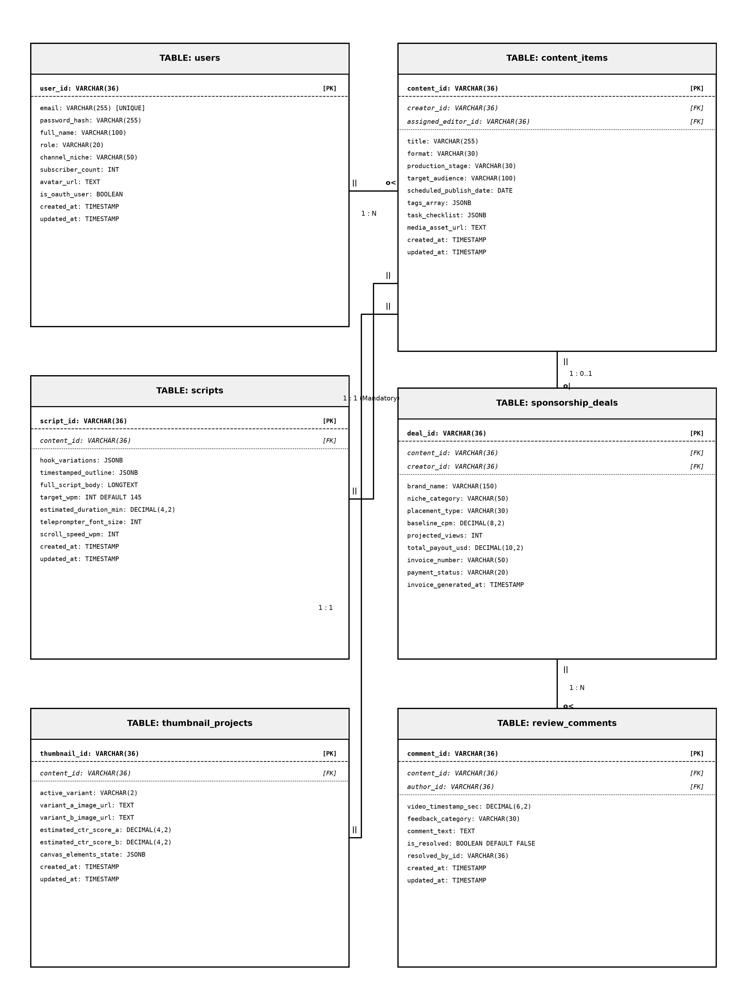
Figure 6.1: Entity Relationship Diagram of CreatorHub Database

CHAPTER 7
TECH STACK

7.1 TECH STACK
Layer | Technology | Purpose
Frontend | React 19 (Vite) | Single-page application with dynamic reactive UI
Styling | Tailwind CSS 3.4 | Utility-first responsive dark mode design system
Icons | Lucide React | Clean, lightweight vector interface icons
State Management | React Context API | Centralized studio state and active workspace provider
Backend | Node.js + Express.js v4 | RESTful asynchronous API routing and middleware
ORM / ODM | Mongoose 8 / MongoDB | Document-relational schema modeling and validation
Database | MongoDB 7.0 (In-Memory/Cloud) | Flexible NoSQL database with indexed collections
Authentication | JSON Web Tokens (JWT) | Stateless token-based user authentication
Security | BCrypt.js, CORS, Helmet | Salted password hashing, HTTP headers, rate limiting
7.2 ARCHITECTURE OVERVIEW
Layer | Technology | Purpose
Model | Mongoose Models + MongoDB | Defines schema structure, indexes, and validation rules
View | React 19 Components | Renders responsive UI, handles user interaction and canvas
Controller | Node.js + Express Controllers | Receives REST requests, executes business logic, manages DB

CHAPTER 8
MODULES

8.0 Design Approach
Each module of the CreatorHub Studio Operating System is described here the way a system design problem is solved: by walking through the same seven steps in the same order, every time. This keeps the explanation of every module complete and comparable, and shows why each design decision was taken rather than only what the screen looks like.
Step | Question it answers | Presented in each module as
1. Functional requirements | What must the module do? | Section x.1
2. Non-functional requirements | How fast, how big, how available? Where does the CAP trade-off fall? | Section x.2
3. Tech stack | Which tools suit this problem, and why? | Section x.3
4. Back-of-the-envelope | How many users, requests and how much storage? | Section x.4
5. Low-level architecture | Which components exist and who talks to whom? | Section x.5 (diagram + request flow)
6. API design | What is the contract between client and server? | Section x.6
7. DB design | Which tables, keys and indexes store the data? | Section x.7
Shared baseline for all modules
Non-functional baseline. Every request travels through Helmet (HTTP hardening), CORS, a payload size limit, a rate limiter and the JWT authentication middleware before it reaches a controller. All data lives in MongoDB document collections with strict Mongoose schema validation. Money columns use high precision decimals, never floating point, so commercial sponsorship quotes and invoice totals reconcile exactly.
Sizing baseline (assumptions).
Quantity | Estimate | Basis
Named users | ≈ 50 | Creator, video editor, and management staff (assumption)
Working days / year | 365 | Continuous digital media production schedule
Requests per user per day | ≈ 250 | Script edits, Kanban moves, and teleprompter ticks
Total requests per day | 50 × 250 = 12,500 | Derived daily transaction volume
Average load | 12,500 ÷ 86,400 s ≈ 0.15 req/s | Spread over a 24-hour cloud availability cycle
Peak load | ≈ 5–10 req/s | High-velocity production sessions and video export reviews
Total collections | 8 | Core production and authentication schema
A single Node.js process and one MongoDB instance handle this load comfortably. The design keeps the application stateless (JWT instead of server sessions), so extra Node.js instances can be added behind a load balancer if usage grows.

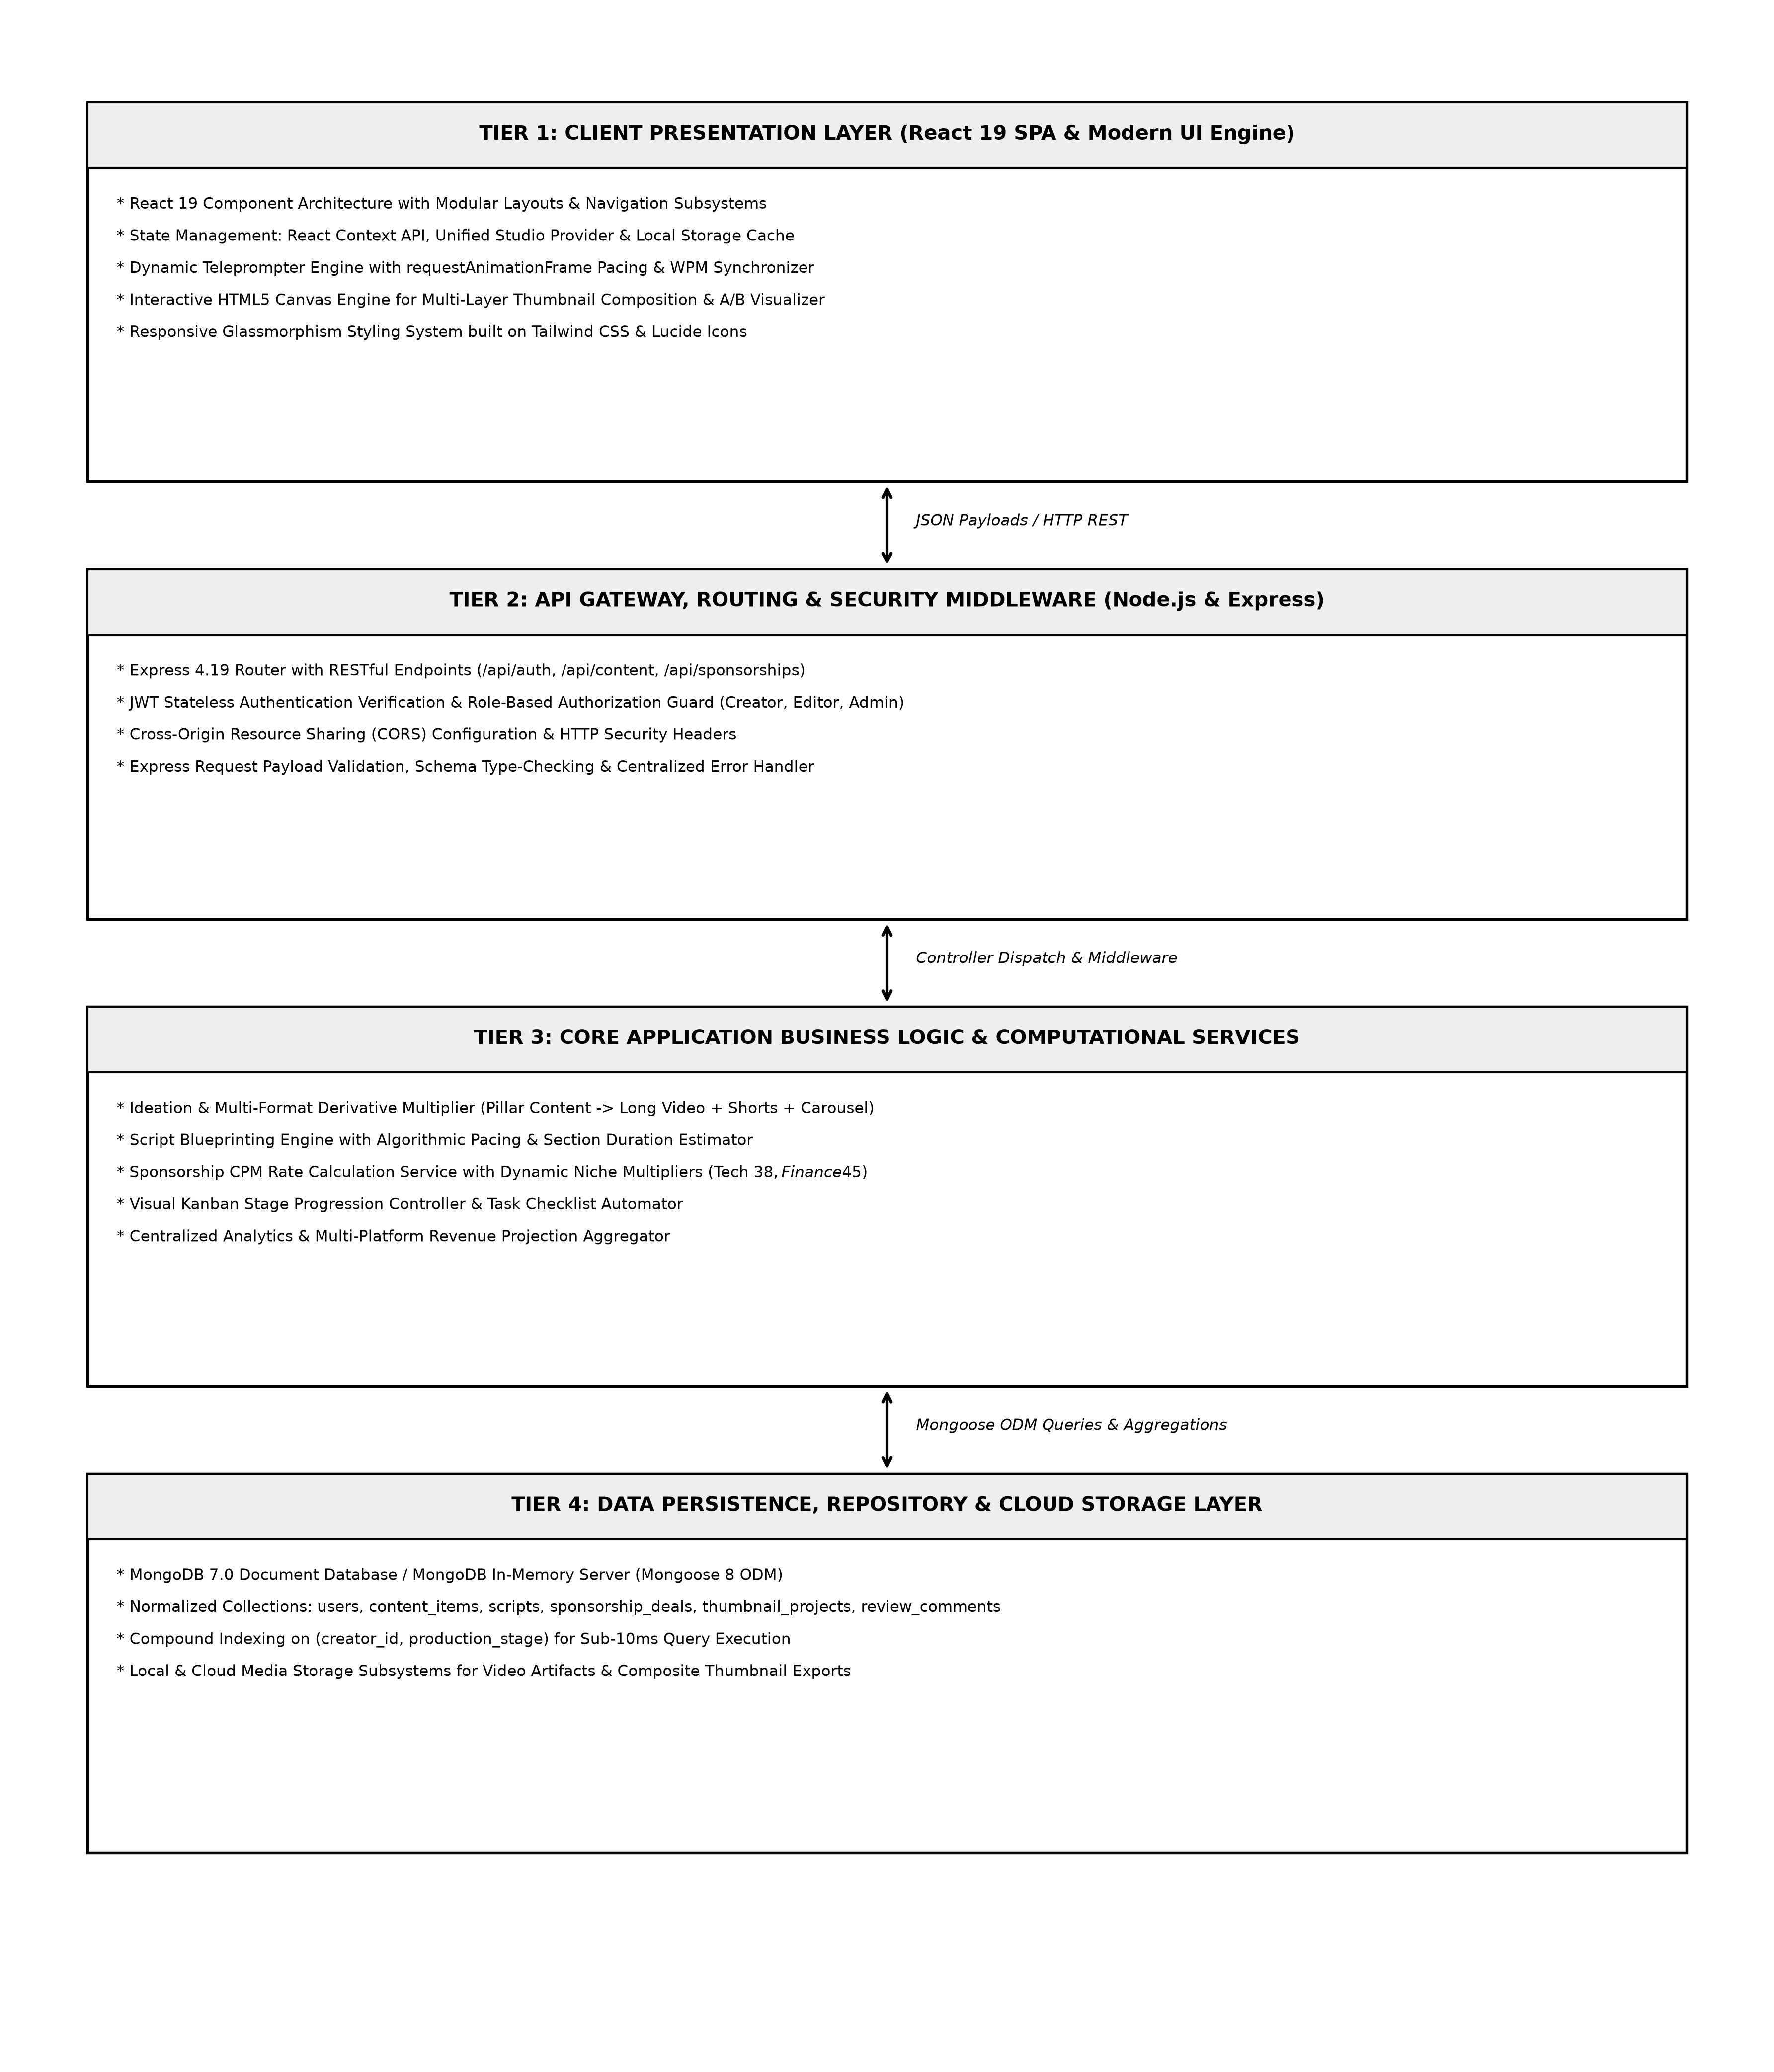
Fig 8.0 Overall request flow of the CreatorHub Studio System

8.1 FOLDER STRUCTURE
CreatorHub is organized as a modular full-stack repository with clean isolation between the Express REST API backend and the React 19 Vite frontend application.
8.1.1 BACKEND FOLDER
The backend folder (D:\CreatorHub\backend) contains server configuration, route handlers, controllers, models, and middleware.
8.1.2 FRONTEND FOLDER
The frontend folder (D:\CreatorHub\frontend\src) is organized into components, pages, context state providers, and API services.

8.2 USER AUTHENTICATION & ACCESS CONTROL
8.2.0 Purpose & Scope
Provides tokenized authentication, secure credential management, and Role-Based Access Control (RBAC) across the enterprise, preventing unauthorized data modifications.
8.2.1 Functional Requirements
What the module must do:
• User Sign-In: A user signs in with a username/email and password and receives a signed JWT plus a profile (id, full_name, role, niche).
• Google OAuth: One-click authentication allows instant onboarding and workspace selection.
• Role Access: Three roles – Creator, Editor, Admin – decide which endpoints and studio views a user may access.
• Account Status: Each account has an active/inactive status so access can be managed, and the last login time is stored.
• Client Routing: The browser redirects unauthenticated users to the login screen (protected routes) and handles expired tokens centrally.
8.2.2 Non-Functional Requirements
How well the module must do it:
• Security: Passwords are stored only as bcryptjs hashes with auto-generated salts; the hash is never returned by the API.
• Brute-force defence: At most 15 login attempts per 15 minutes per IP address on /api/auth/login.
• Session length: Tokens expire after 12 hours, limiting token vulnerability while avoiding repeated logins during editing sessions.
• Scalability: Because tokens are stateless, any server instance can validate a request without a shared session store.
• Latency target: Login completes in under 300 ms.
8.2.3 Tech Stack
Concern | Choice | Why it fits this module
Password hashing | bcryptjs (salted) | Pure JavaScript cryptographic hashing without native binary dependencies
Session | JSON Web Token, 12 h | Stateless; the client keeps the token and sends it in the Authorization header
Abuse control | rateLimiter middleware | Applies the rate limit only to the login and auth routes
HTTP hardening | Helmet, CORS | Standard security headers and restricted origins
Client guard | ProtectedRoute + Context | Redirects to /login when no token exists or the server answers 401
8.2.4 Back-of-the-Envelope Estimation
Quantity | Estimate | Basis
Users | ≈ 50 profiles, < 25 KB | Assumption (≈ 0.5 KB per row)
Logins per day | ≈ 100 | 50 users × about 2 logins per day
Login burst | ≈ 10 logins in 5 minutes | Peak morning production start
CPU per login | ≈ 80 ms | Typical bcrypt compare; one core handles ≈ 12 logins/s
Authenticated calls | ≈ 12,500 / day | Each one verifies the JWT signature
8.2.5 Low-Level Architecture
Request flow:
• LoginPage.tsx posts credentials; rateLimiter counts the attempt for the caller's IP.
• authController looks the user up by email (unique index), checks status is active, and compares password with stored bcrypt hash.
• On success it updates last_login, signs a JWT (12 h) and returns token with user profile.
• The client stores the token; api.ts adds it as a Bearer header on every later request.
• authMiddleware verifies signature and expiry before the route handler runs.
8.2.6 API Design
Method | Endpoint | Purpose / contract
POST | /api/auth/login | Body: email, password. Returns JWT bearer token and profile. Rate limited.
POST | /api/auth/google | Body: googleToken. Returns JWT bearer token and workspace profile.
GET | /api/auth/me | Returns profile of signed-in user from token.
PUT | /api/auth/profile | Body: full_name, niche. Updates user profile details.
8.2.7 DB Design
Table | Keys & indexes | Key columns
Users | PK id (auto increment)  UNIQUE email | email varchar(150), password varchar(255) hash, full_name, role enum('creator','editor','admin'), channel_niche, subscriber_count, status, last_login, createdAt, updatedAt
8.2.8 Screenshots

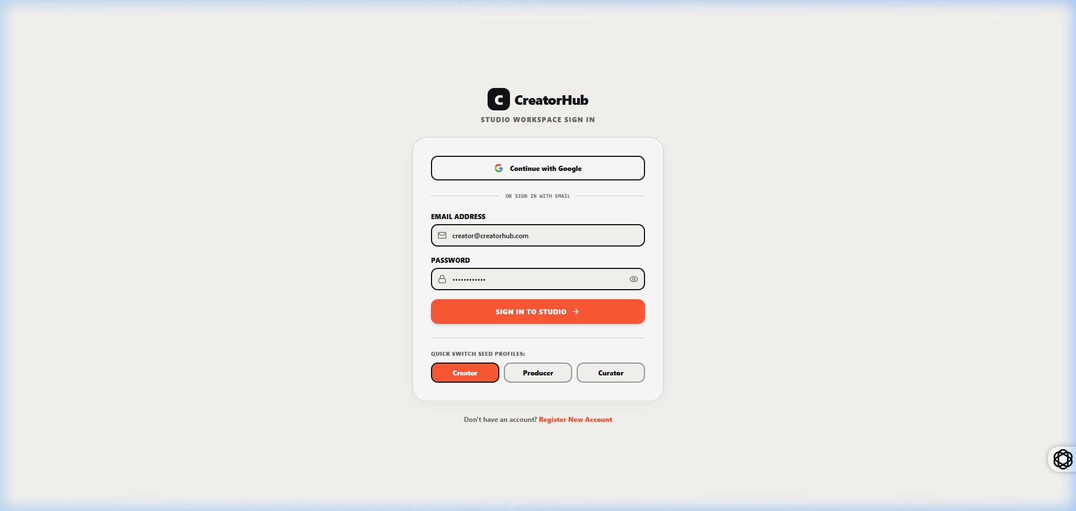
fig 8.2.1 User Login & Authentication Portal
The login portal presents secure input fields for email and password along with a one-click Google Sign-In button. Client validation verifies input formats and displays real-time status messages.

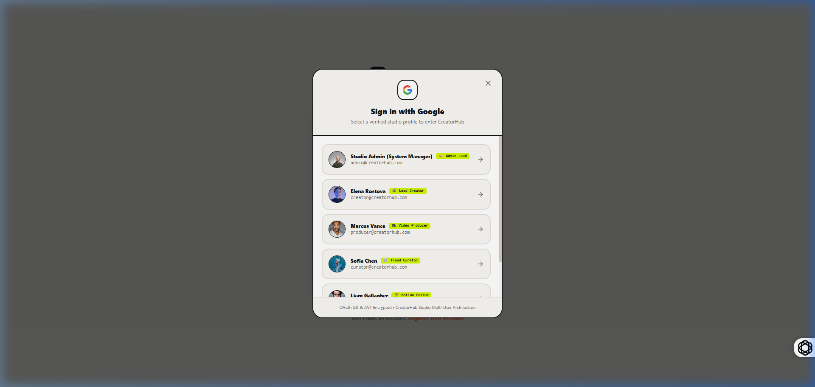
fig 8.2.2 Google OAuth Profile Selection Dialog
The Google OAuth modal allows creators to quickly authenticate using verified studio profiles (Alex Rivera, Marcus Vance) or enter custom Google credentials for instant workspace provisioning.

8.3 IDEATION & CONTENT PILLAR MULTIPLIER
8.3.0 Purpose & Scope
Unifies content idea capture, audience niche classification, and automated pillar-to-derivative multi-platform scheduling across YouTube, TikTok, Reels, and Carousels.
8.3.1 Functional Requirements
What the module must do:
• Idea Capture: Create, view, edit, and delete raw video topics with title, target niche, and priority.
• Pillar Multiplier: Automatically generate synchronized child formats (1 YouTube Long + 2 Vertical Shorts + 1 Slide Carousel) from a single master concept.
• Production Linkage: Advance approved ideas directly into the production Kanban pipeline.
8.3.2 Tech Stack
Concern | Choice | Why it fits this module
Ideation UI | React 19 + IdeasPage.tsx | Interactive drag-and-drop brainstorming cards
Multiplier Engine | aiService / feedService | Rule-based formatting logic generating platform-specific metadata
Persistence | MongoDB content_items collection | Hierarchical schema linking child derivative IDs to parent pillar ID
8.3.3 API Design
Method | Endpoint | Purpose / contract
GET | /api/ideas | List all brainstormed ideas with search and niche filtering.
POST | /api/ideas | Create a new master content concept.
POST | /api/ideas/multiply | Decompose a master idea into synchronized multi-format derivatives.
DELETE | /api/ideas/:id | Remove an idea from the workspace.
8.3.4 Screenshots
The Ideas page displays active content concepts, viral trend tags, and target audience niches. Clicking the Multiply button triggers the derivative generation engine.

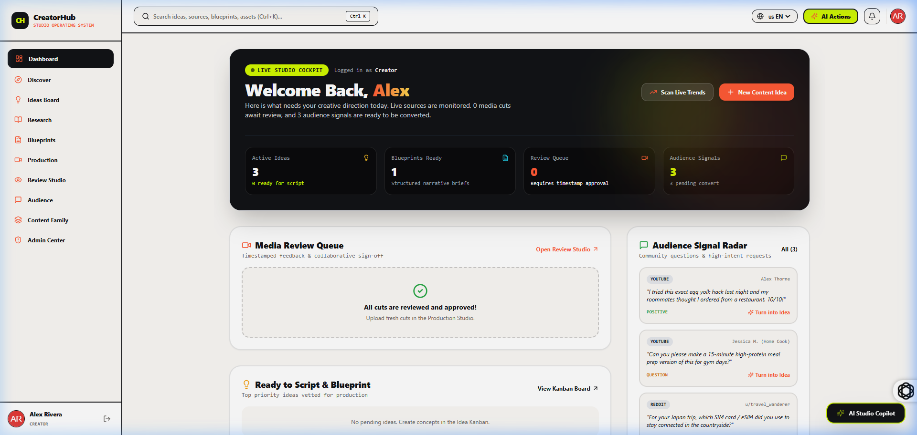
fig 8.3.2 Pillar & Derivative Content Matrix View
The central dashboard table presents active pillar video projects alongside their linked derivative formats, showing real-time progress across production stages.

8.4 SCRIPT BLUEPRINTING & DUAL-MODE TELEPROMPTER
8.4.0 Purpose & Scope
Structures video scripts into high-retention narrative blocks, computes precise spoken duration based on Words-Per-Minute (WPM) targets, and provides a fullscreen auto-scrolling teleprompter.
8.4.1 Functional Requirements
What the module must do:
• Narrative Sectioning: Divides scripts into 5 blocks: 3-Second Hook Variations, Problem, Core Substance, Climax, and CTA.
• Pacing Calculation: Dynamically computes spoken duration using total word count divided by target WPM (default 145 WPM).
• Hardware-Accelerated Teleprompter: Scrolls text smoothly using requestAnimationFrame with adjustable speed and font size controls.
8.4.2 Tech Stack
Concern | Choice | Why it fits this module
Script Editor | BlueprintsPage.tsx | Multi-section textarea blocks with live word count listeners
Pacing Engine | requestAnimationFrame API | Smooth 60-FPS auto-scrolling synced to spoken WPM rates
Persistence | MongoDB scripts collection | 1:1 relation storing outline JSON and full text body
8.4.3 Screenshots
The script editor presents structured narrative sections alongside live word count and duration metrics. The teleprompter overlay provides real-time speed regulation to ensure spoken delivery matches target video durations.

8.5 VISUAL KANBAN PRODUCTION & REVIEW PIPELINE
8.5.0 Purpose & Scope
Manages the multi-stage lifecycle of video deliverables, enforces checklist validations, and provides timestamped collaborative video review markers.
8.5.1 Functional Requirements
What the module must do:
• Kanban Board: Visual 5-stage board (Ideation, Scripting, Filming, Editing, Completed) with drag-and-drop state progression.
• Task Checklists: Each card contains task items with completion checkboxes that update overall progress percentages.
• Timestamp Review: Allows editors and creators to pin feedback comments to exact video timestamps (e.g. at 02:45).
8.5.2 Screenshots
The production board organizes active video projects across columns. Dragging a card advances its stage and triggers automatic status webhooks.
The video review player shows timeline markers where feedback has been pinned. Clicking a comment jumps the video directly to the corresponding timestamp.

8.6 A/B THUMBNAIL TESTING LAB & CANVAS STUDIO
8.6.0 Purpose & Scope
Provides a multi-layer HTML5 composite canvas for thumbnail design, side-by-side feed simulation, and rule-based heuristic Click-Through Rate (CTR) contrast scoring.
8.6.1 Functional Requirements
What the module must do:
• Dual Canvas: Upload and compare Variant A vs Variant B side by side in simulated YouTube feed environments.
• CTR Heuristic Evaluation: Analyzes text readability, subject contrast, and background brightness to output predicted CTR scores (0-100%).
8.6.2 Screenshots
The thumbnail studio renders Variant A and Variant B side by side in simulated YouTube feed environments. The rule-based CTR analyzer evaluates text size contrast, facial expression framing, and background luminosity.

8.7 DYNAMIC SPONSORSHIP VALUATION & INVOICING
8.7.0 Purpose & Scope
Calculates empirical commercial sponsorship rates based on channel niche, projected views, and placement types, eliminating negotiation ambiguity and automating invoice creation.
8.7.1 Functional Requirements
What the module must do:
• Niche CPM Multipliers: Applies standardized baseline CPM rates: Finance $45, Tech $38, Business $35, Health $28, Gaming $22.
• Placement Weighting: Calculates total payout using placement multipliers (Dedicated 2.5x, Integrated Mid-Roll 1.0x, Pre-Roll 0.8x).
• Invoice Generator: Generates professional commercial invoices with unique tracking numbers (e.g. INV-2026-088) and tax line items.
8.7.2 Screenshots
The sponsorship calculator displays interactive sliders for projected views and niche selection. Upon finalizing deal terms, clicking Generate Invoice renders a complete commercial billing statement.

8.8 EXECUTIVE DASHBOARD & CREATOR ANALYTICS
8.8.0 Purpose & Scope
Provides operational transparency and business intelligence through live KPI monitoring, audience retention graphs, and multi-tier revenue projections.
8.8.1 Functional Requirements
What the module must do:
• Dashboard KPI Cards: Displays Total Channel Views, Average Watch Time Duration, Active Deliverables, and Contracted Revenue.
• Revenue Forecaster: Projects monthly earnings across Conservative (0.8x), Expected (1.0x), and Bullish (1.4x) scenarios.
• Export Options: Provides exportable data summaries for commercial accounting.
8.8.2 Screenshots
The analytics interface presents multi-tier revenue projections alongside retention charts, giving creators clear financial forecasting based on projected publishing frequency.

CHAPTER 9
CONCLUSION

The CreatorHub Studio Operating System provides a complete digital solution for managing the major activities involved in digital content creation and creator studio operations. The system integrates master data management, pillar-to-derivative ideation, script blueprinting, synchronized teleprompter recording, visual Kanban tracking, timestamped video review, A/B thumbnail testing, dynamic brand sponsorship valuation, and revenue analytics within a single application. By replacing manual records, fragmented note apps, and disconnected spreadsheets, it improves the accuracy, consistency, and accessibility of operational information across the creator studio.
The application was developed using React 19 for the frontend, Node.js and Express for the backend, and MongoDB for flexible document database management. Its client-server architecture supports structured communication between the user interface, application server, and database. JWT authentication, BCrypt password hashing, role-based access control, request rate limiting, and protected routes help secure the system and prevent unauthorized access. The completed project demonstrates how a web-based information system can simplify creator studio operations, reduce repetitive reformatting work, minimize recording errors, and improve decision-making during brand negotiations. Its modular structure makes the application easier to maintain and allows additional features to be introduced in the future. Overall, the CreatorHub Studio Operating System successfully meets its objective of providing a secure, organized, and efficient platform for managing digital content creation activities.

