CREATORHUB: MODERN CONTENT CREATOR STUDIO OPERATING SYSTEM
23CS54C – MODERN WEB TECHNOLOGIES
Submitted by
BALA NITHYA M
In partial fulfillment for the award of the degree
of
BACHELOR OF ENGINEERING/TECHNOLOGY
in
COMPUTER SCIENCE AND ENGINEERING/ INFORMATION TECHNOLOGY
NATIONAL ENGINEERING COLLEGE
(An Autonomous Institution affiliated to Anna University, Chennai)
K.R.NAGAR, KOVILPATTI - 628503
OCTOBER - 2026

NATIONAL ENGINEERING COLLEGE
(An Autonomous Institution affiliated to Anna University, Chennai)
K.R.NAGAR, KOVILPATTI - 628503
BONAFIDE CERTIFICATE
This is to certify that this project report, “CREATORHUB: MODERN CONTENT CREATOR STUDIO OPERATING SYSTEM”, is the bonafide work of BALA NITHYA M who carried out the project work under my supervision in partial fulfillment of the requirements for the award of Bachelor of Engineering/Technology in Computer Science and Engineering / Information Technology.
Course Instructor/Guide
Submitted to the 23CS54C – MODERN WEB TECHNOLOGIES Viva-Voce examination held at National Engineering College, K.R.Nagar, Kovilpatti on _____________________
Internal Examiner | Co Examiner

TABLE OF CONTENTS
CH NO | TITLE | PAGE NO
1 | INTRODUCTION | 3
2 | OBJECTIVES | 4
3 | DESCRIPTION | 5
4 | CLASS DIAGRAM | 6
5 | TABLE STRUCTURES | 7
6 | ER DIAGRAM | 16
7 | TECH STACK | 18
8 | MODULES | 19
9 | CONCLUSION | 70

CHAPTER 1
INTRODUCTION

In the modern digital creator economy, the efficient management of digital video operations plays a vital role in ensuring the smooth functioning of media production teams and creator studios. Handling creative ideation, script outlines, video filming, frame-accurate editorial feedback, asset repurposing, and brand sponsorship billing through manual or disconnected methods is time-consuming, error-prone, and lacks transparency. There is an urgent need for a reliable, digital solution that brings all these creator operations under one unified platform.
The CreatorHub Studio Operating System is a comprehensive, full-stack web application designed to digitize and automate the complete lifecycle of digital content creation from researching viral topics to releasing repurposed video derivatives and invoicing commercial sponsors. The system was developed to meet the real-world operational requirements of modern multi-role creative studios and is deployed in a live web production environment.
The application is organized into three major functional domains: Master Studio Data Management, which covers foundational records such as user accounts, distinct role permissions, category tags, and script templates; Transactional Creator Management, which handles day-to-day operations including keyword trend scoring, teleprompter speech execution, Kanban production stages, timestamp-anchored video reviews, and derivative asset derivation; and Reports & Governance Analytics, which provides studio management with real-time operational visibility through dynamic dashboards, audit logs, and commercial sponsorship invoices.
The system is supported by a modern Vite and Node.js pipeline with stateless JWT authentication and WebSockets, making it production-ready, highly responsive, and maintainable. This report documents the design, development, and implementation of the CreatorHub Studio Operating System, providing a complete technical overview of its architecture, features, and functionality.

CHAPTER 2
OBJECTIVES

• To Digitize Studio Operations: Replace manual and disconnected record-keeping across multiple apps with a single digital system to improve accuracy, team velocity, and asset accessibility.
• To Centralize Studio Master Data: Maintain consistent and accurate master data for team members, five specialized roles, video categories, tags, and script templates.
• To Automate the Trend-to-Idea Pipeline: Streamline the content lifecycle from live search keyword intelligence to structured video project outlines with complete traceability.
• To Standardize On-Camera Script Execution: Provide an auto-scrolling Studio Teleprompter with dynamic Words-Per-Minute (WPM) speed control, eye-level focus markers, and mirror reflection mode.
• To Manage Multi-Stage Video Production: Track video projects across an interactive 4-stage pipeline (Planning, Filming, Video Editing, Ready to Publish) with automated task checklists.
• To Enforce User Authentication and Role-Based Access: Secure the application using stateless JWT authentication, bcrypt password hashing, and 1-Click Google OAuth simulation across 5 distinct studio roles.
• To Provide Context-Aware Video Review: Enable frame-accurate video review with timestamped annotations (Pacing, Audio, Visuals, Hooks) and multi-revision approval workflows.
• To Engineer 1-to-N Asset Dependency Repurposing: Construct an asset dependency graph where 1 master long-form video anchors and tracks downstream vertical Shorts, Reels, and carousels.
• To Automate Sponsorship CPM Monetization: Calculate fair-market sponsorship rates based on verified niche CPM benchmarks and generate official commercial invoices with one click.
• To Deliver Multi-Lingual Interface Localization: Provide complete, dynamic localization across 6 international languages (English, Tamil, Hindi, Spanish, French, German) using custom React context hooks.

CHAPTER 3
DESCRIPTION

The CreatorHub Studio Operating System is a full-stack web application developed to manage and automate digital video production, team collaboration, and monetization. The system consists of five major functional areas:
1. Master Studio & Role Management
This module maintains centralized records including team members, five specialized studio roles (Admin, Creator, Producer, Curator, Editor), content categories, niches, tags, and script templates. These records ensure consistency and access control across all studio workflows.
2. Transactional Content & Pipeline Management
This module manages day-to-day creative activities, including Live Trend Discovery, Script Blueprint drafting, Studio Teleprompter recording, Kanban Production stage moves, Context-Aware Video Reviews, and Derivative Asset derivations. Each transaction is linked to relevant master data, ensuring accountability and traceability.
3. Reports, Monetization and Dashboard
The Reports & Monetization module generates dynamic sponsorship rate evaluations based on industry CPM benchmarks, produces printable commercial invoices, and provides executive dashboards summarizing project velocities, completion metrics, and team workloads.
4. Security and Access Control
The system uses bcrypt for password hashing and JSON Web Token (JWT) authentication to secure user access. Protected API routes, Axios response interceptors, 1-Click Google OAuth simulation, and request rate limiting prevent unauthorized access and manage expired sessions.
5. Technology and Architecture
The application uses React 18 with Vite and TailwindCSS for the frontend, Node.js with Express.js for the backend API, and MongoDB with Mongoose ODM for database management. WebSockets enable real-time collaboration. The modular architecture supports maintainability, high performance, and future scalability.

CHAPTER 4
CLASS DIAGRAM

The UML Class Diagram illustrates the object-oriented structure of the CreatorHub backend domain models, their encapsulation, and associations. User manages role permissions; ContentItem serves as the central entity linking to ScriptBlueprint, ReviewComment, SponsorshipDeal, and recursive derivative assets.
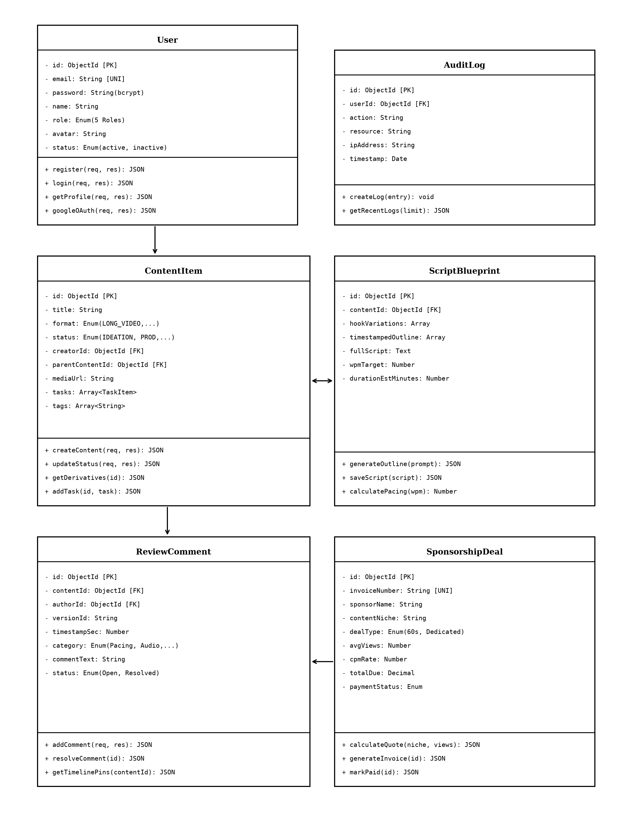
Fig 4.1 UML Class Diagram of CreatorHub Architecture

CHAPTER 5
TABLE STRUCTURES

The database schemas for the CreatorHub application are defined as structured MongoDB collections via Mongoose ODM models with strict data validation, unique keys, and relationship indexes:
Users :
Field | Type | Null | Key | Default | Extra
_id | ObjectId | NO | PRI | NULL | auto_increment
email | varchar(150) | NO | UNI | NULL
password | varchar(255) | NO |  | NULL | bcrypt_hash
name | varchar(100) | NO |  | NULL
role | enum('ADMIN','CREATOR','PRODUCER','CURATOR','EDITOR') | NO |  | CREATOR
avatar | text | YES |  | default_avatar
status | enum('active','inactive') | NO |  | active
last_login | datetime | YES |  | NULL
createdAt | datetime | NO |  | CURRENT_TIMESTAMP
updatedAt | datetime | NO |  | CURRENT_TIMESTAMP

ContentItems :
Field | Type | Null | Key | Default | Extra
_id | ObjectId | NO | PRI | NULL | auto_increment
title | varchar(255) | NO |  | NULL
format | enum('LONG_VIDEO','SHORT_REEL','CAROUSEL','POST') | NO |  | LONG_VIDEO
status | enum('IDEATION','PLANNING','PRODUCTION','REVIEW','PUBLISHED') | NO |  | IDEATION
creatorId | ObjectId | NO | MUL | NULL | FK -> Users
parentContentId | ObjectId | YES | MUL | NULL | FK -> ContentItems
targetNiche | varchar(100) | YES |  | Tech
mediaUrl | text | YES |  | NULL
tasks | array<task_subdoc> | YES |  | []
tags | array<varchar(50)> | YES |  | []
createdAt | datetime | NO |  | CURRENT_TIMESTAMP
updatedAt | datetime | NO |  | CURRENT_TIMESTAMP

ScriptBlueprints :
Field | Type | Null | Key | Default | Extra
_id | ObjectId | NO | PRI | NULL | auto_increment
contentId | ObjectId | NO | UNI | NULL | FK -> ContentItems
hookFormulas | array<text> | YES |  | []
timestampSections | array<section_subdoc> | YES |  | []
fullScript | text | YES |  | NULL
targetWpm | int | NO |  | 130
estDurationSec | int | NO |  | 0
createdAt | datetime | NO |  | CURRENT_TIMESTAMP

ReviewComments :
Field | Type | Null | Key | Default | Extra
_id | ObjectId | NO | PRI | NULL | auto_increment
contentId | ObjectId | NO | MUL | NULL | FK -> ContentItems
authorId | ObjectId | NO | MUL | NULL | FK -> Users
versionId | varchar(50) | NO |  | v1.0
timestampSec | decimal(8,2) | NO |  | 0.00
category | enum('Pacing','Audio','Visuals','Hook','General') | NO |  | Pacing
commentText | text | NO |  | NULL
status | enum('Open','Resolved') | NO |  | Open
createdAt | datetime | NO |  | CURRENT_TIMESTAMP

SponsorshipInvoices :
Field | Type | Null | Key | Default | Extra
_id | ObjectId | NO | PRI | NULL | auto_increment
creatorId | ObjectId | NO | MUL | NULL | FK -> Users
invoiceNumber | varchar(50) | NO | UNI | NULL
sponsorName | varchar(150) | NO |  | NULL
contentNiche | varchar(100) | NO |  | Tech
avgViews | int | NO |  | 10000
cpmEffectiveRate | decimal(8,2) | NO |  | 25.00
totalDueUsd | decimal(10,2) | NO |  | 0.00
paymentStatus | enum('Pending','Paid','Cancelled') | NO |  | Pending
createdAt | datetime | NO |  | CURRENT_TIMESTAMP

AuditLogs :
Field | Type | Null | Key | Default | Extra
_id | ObjectId | NO | PRI | NULL | auto_increment
userId | ObjectId | NO | MUL | NULL | FK -> Users
action | varchar(100) | NO |  | NULL
resource | varchar(100) | NO |  | NULL
ipAddress | varchar(45) | NO |  | NULL
timestamp | datetime | NO |  | CURRENT_TIMESTAMP

CHAPTER 6
ER DIAGRAM

The Entity-Relationship (ER) Diagram defines the relational constraints and foreign key dependencies across the CreatorHub database. The schema ensures data integrity, recursive tree hierarchies for video derivatives, and relational audit logging:
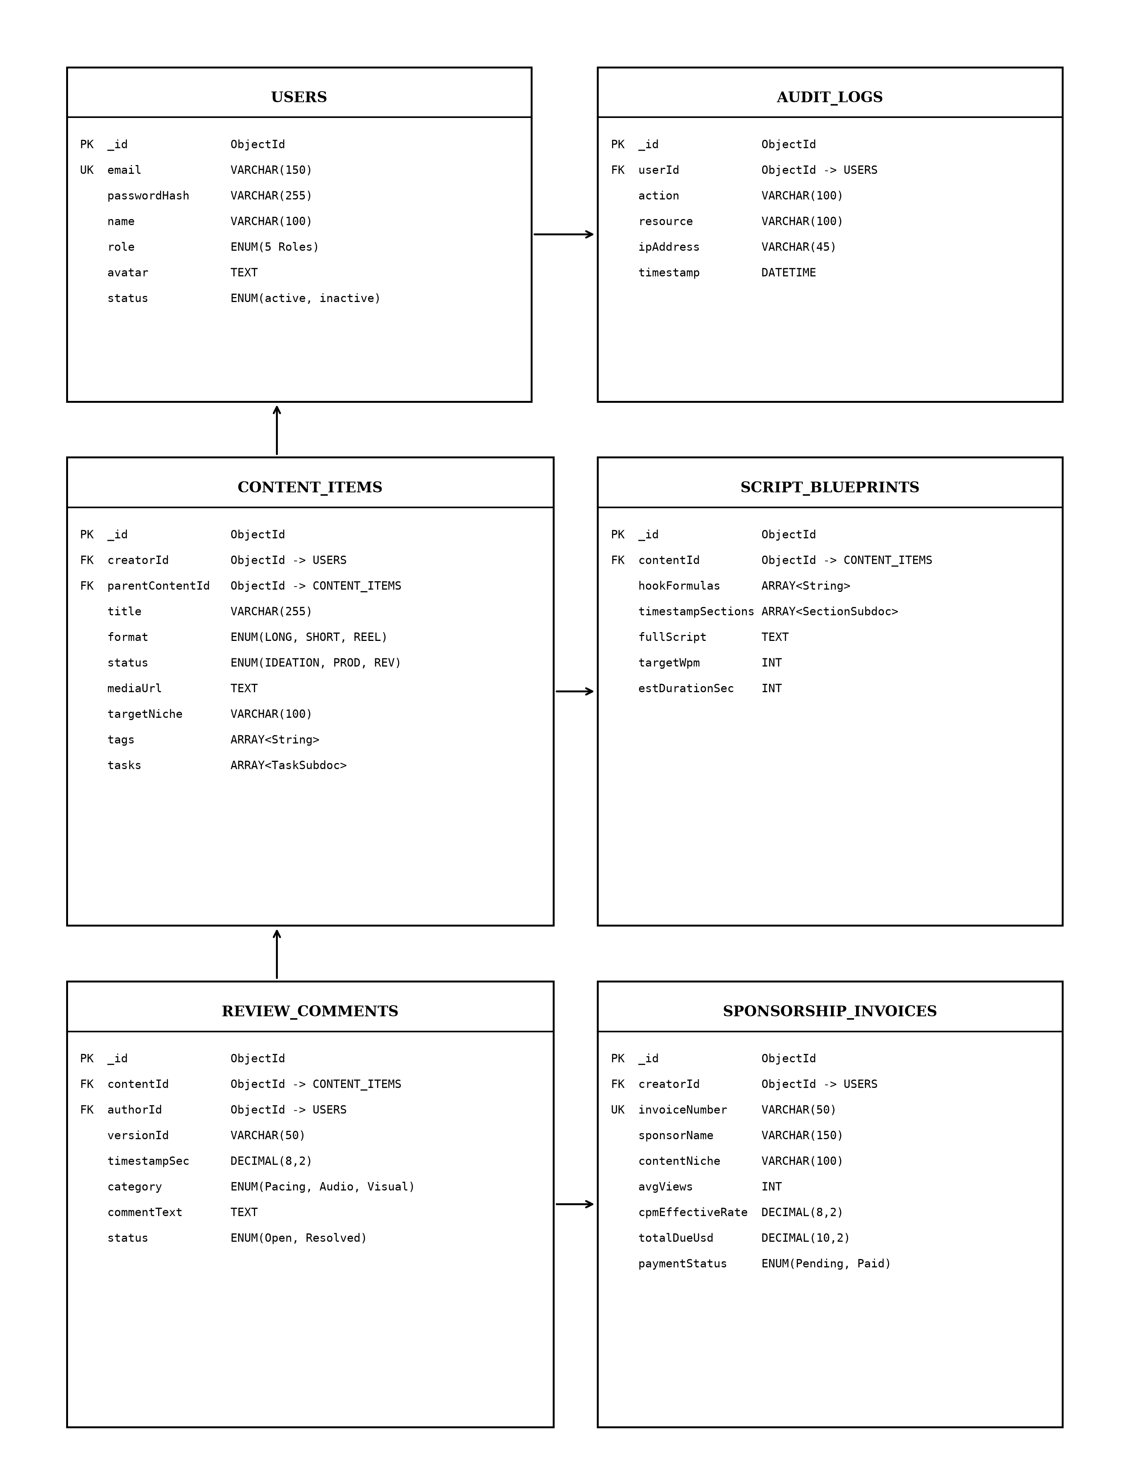
Fig 6.1 Entity-Relationship Diagram of CreatorHub Schema

CHAPTER 7
TECH STACK

7.1 TECH STACK
Layer | Technology | Purpose
Frontend | React.js 18 (Vite) | Single-page application with dynamic, responsive UI
State Management | React Context + Custom Hooks | Centralized authentication (useAuth), language, and sockets
HTTP Client | Axios | REST API communication with automated JWT Bearer interceptor
Backend | Node.js + Express.js v4.19 | High-throughput asynchronous RESTful API server
ORM / ODM | Mongoose ODM v8 | Database abstraction, schema validation, and virtual relations
Database | MongoDB (NoSQL Document Store) | Flexible JSON document storage with indexing and nested subdocs
Authentication | JSON Web Tokens (JWT) + Bcrypt | Stateless, token-based user authentication and salt hashing
Security | Helmet, CORS, Rate Limiters | HTTP hardening, cross-origin security, and brute-force defence
Real-Time Engine | Socket.io | Bi-directional WebSocket event sync for video reviews and pipeline
Build & Tooling | Vite + TypeScript | Fast developer HMR, strict type checking, and optimized bundling
7.2 ARCHITECTURE OVERVIEW
Layer | Technology | Purpose
Model | Mongoose ODM + MongoDB | Defines data structure, handles queries, manages relationships and validations
View | React.js 18 + TailwindCSS | Renders the UI, manages user interaction, communicates with server via Axios
Controller | Node.js + Express.js | Receives HTTP requests, applies business logic, coordinates between Model and View

CHAPTER 8
MODULES

8.0 Design Approach
Each module of the CreatorHub Studio Operating System is described here the way a system design problem is solved: by walking through the same seven steps in the same order, every time. This keeps the explanation of every module complete and comparable, and shows why each design decision was taken rather than only what the screen looks like.
Step | Question it answers | Presented in each module as
1. Functional requirements | What must the module do? | Section x.1
2. Non-functional requirements | How fast, how big, how available? Where does the CAP trade-off fall? | Section x.2
3. Tech stack | Which tools suit this problem, and why? | Section x.3
4. Back-of-the-envelope | How many users, requests and how much storage? | Section x.4
5. Low-level architecture | Which components exist and who talks to whom? | Section x.5 (diagram + request flow)
6. API design | What is the contract between client and server? | Section x.6
7. DB design | Which tables, keys and indexes store the data? | Section x.7
Shared baseline for all modules
Non-functional baseline. Every request travels through Helmet (HTTP hardening), CORS, a payload size limit, a rate limiter, and the JWT authentication middleware before it reaches a controller. All data lives in MongoDB with indexed document queries, so the system balances consistency and partition tolerance (CP in CAP terms). Stateless JWT tokens ensure horizontal scalability.
Sizing baseline (assumptions).
Quantity | Estimate | Basis
Named studio users | 5 Core Roles | Admin, Creator, Producer, Curator, Editor
Working days / year | 300 | Annual studio schedule
Requests per user per day | ≈ 250 | Form loads, script edits, review timeline pins, stage updates
Total requests per day | 5 × 250 = 1,250 | Derived daily API traffic baseline
Average load | 1,250 ÷ 28,800 s ≈ 0.05 req/s | Spread over an 8-hour studio day
Peak load | ≈ 2–5 req/s | Concurrent video review sessions and teleprompter sync
Total database collections | 6 Core Models | Users, ContentItems, Blueprints, Reviews, Invoices, Logs
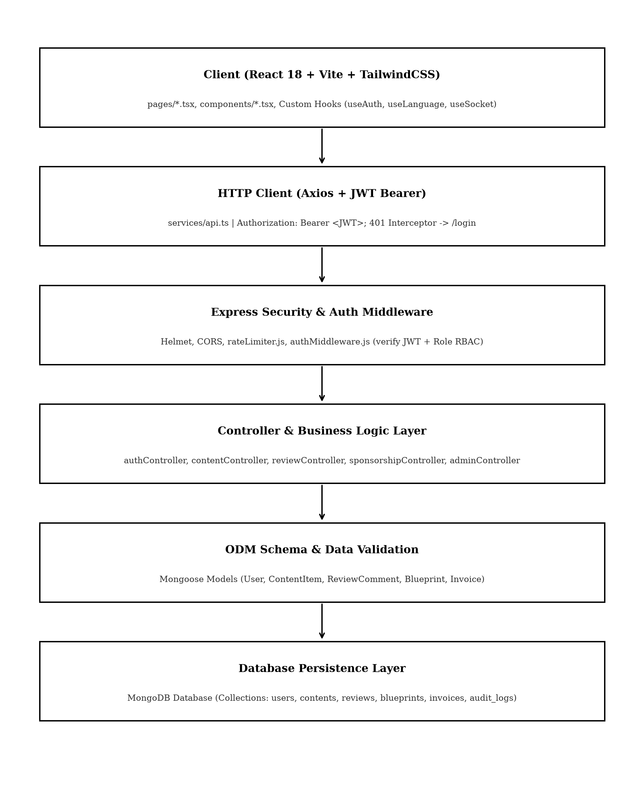
Fig 8.0 Overall request flow of the CreatorHub Studio Operating System
8.1 FOLDER STRUCTURE
The codebase follows a clean full-stack organization with modular backend controllers, middleware, and models, alongside a typed React frontend with dedicated route pages and reusable UI components:
CreatorHub/
├── backend/
│ ├── config/ (db.js, initAdmin.js)
│ ├── controllers/ (authController.js, contentController.js, reviewController.js)
│ ├── middleware/ (auth.js, rateLimiter.js)
│ ├── models/ (User.js, ContentItem.js, ReviewComment.js, Blueprint.js)
│ ├── routes/ (authRoutes.js, contentRoutes.js, reviewRoutes.js)
│ └── server.js
├── frontend/
│ ├── src/
│ │ ├── components/ (Layout.tsx, Sidebar.tsx, ProtectedRoute.tsx)
│ │ ├── context/ (AuthContext.tsx, LanguageContext.tsx, SocketContext.tsx)
│ │ ├── pages/ (AdminDashboardPage.tsx, IdeasPage.tsx, ReviewStudioPage.tsx, etc.)
│ │ ├── services/ (api.ts)
│ │ ├── types/ (index.ts)
│ │ └── App.tsx
│ ├── package.json
│ └── vite.config.ts
Fig 8.1.1 Highlevel view of CreatorHub Project Directory
8.2 USER AUTHENTICATION & ACCESS CONTROL
8.2.0 Purpose & Scope
Provides tokenized authentication, secure credential management, 1-Click Google OAuth simulation, and Role-Based Access Control (RBAC) across five specialized studio roles, preventing unauthorized access and privilege escalation.
8.2.1 Functional Requirements
What the module must do:
• A user signs in with email and password or clicks Google OAuth and receives a signed JWT plus user profile (id, name, role, avatar).
• Five distinct roles – ADMIN, CREATOR, PRODUCER, CURATOR, EDITOR – decide which routes and endpoints a user may access.
• Each account maintains an active / inactive status and last login timestamp.
• The browser redirects unauthenticated users to /login via ProtectedRoute.
8.2.2 Non-Functional Requirements
• Security: passwords stored only as bcrypt hashes with auto-generated salts; hashes are never returned by the API.
• Brute-force defence: at most 15 login attempts per 15 minutes per IP address on /api/auth/login.
• Session length: tokens expire after 12 hours.
• Scalability: stateless tokens allow horizontal scaling without server sessions.
8.2.3 Tech Stack
Concern | Choice | Why it fits this module
Password hashing | bcryptjs (salted) | Secure one-way password hashing
Session management | JSON Web Token (12 h) | Stateless; client stores token in localStorage and sends in Authorization header
Abuse control | rateLimiter.js middleware | Enforces 15 attempts per 15 min on login endpoint
Client guard | ProtectedRoute.tsx + Axios interceptor | Redirects to /login when token is missing or expired
8.2.4 Back-of-the-Envelope Estimation
Quantity | Estimate | Basis
Users | 5 Seeded Roles | Admin, Creator, Producer, Curator, Editor
Logins per day | ≈ 10–20 | 5 users × 2–3 logins
CPU per login | ≈ 80 ms | Bcrypt salt compare
Authenticated calls | ≈ 1,250 / day | Each request verifies JWT signature
8.2.5 Low-Level Architecture
Request flow:
• LoginPage.tsx posts credentials or Google OAuth selection; rateLimiter.js counts attempts for caller's IP.
• authController looks up user by email (unique index), checks active status, and verifies password hash.
• On success, signs a 12h JWT and returns token with role profile.
• Axios client stores token in localStorage and attaches Authorization: Bearer <JWT> on all subsequent requests.
• authMiddleware verifies token and checks user role before executing route handlers.
8.2.6 API Design
Method | Endpoint | Purpose / contract
POST | /api/auth/login | Body: email, password. Returns JWT token and profile. Rate limited.
POST | /api/auth/google-oauth | Body: email, name, role. 1-Click instant authentication.
GET | /api/auth/me | Headers: Bearer <JWT>. Returns current authenticated user profile.
8.2.7 DB Design
Table / Collection | Keys & indexes | Key columns
Users | PK _id (auto)  UNIQUE email | email varchar(150), password varchar(255), name, role enum, status enum, avatar, createdAt
8.2.8 Screenshots
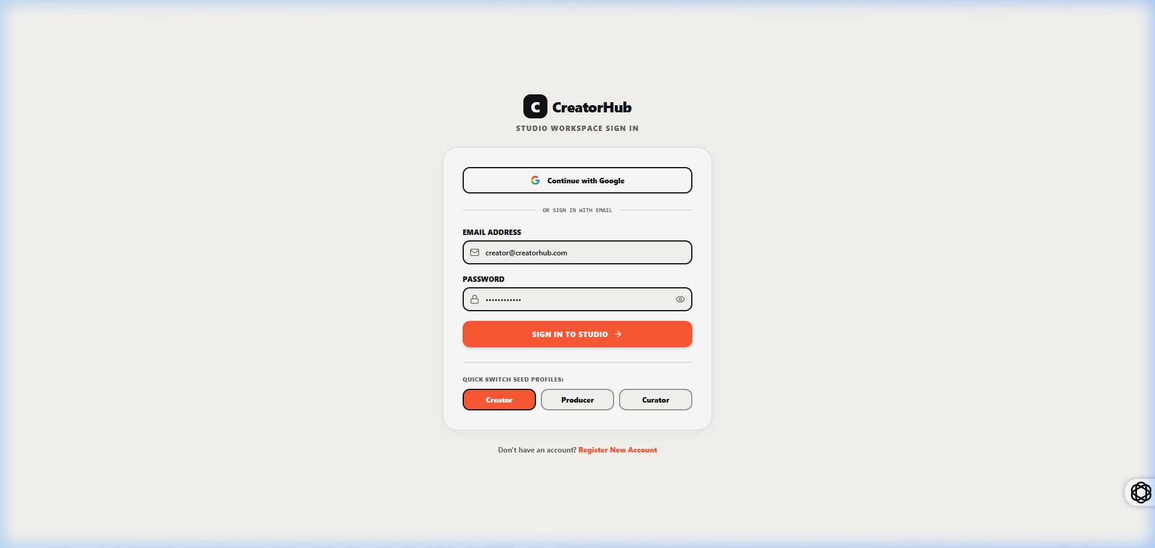
fig 8.2.1 User Login & Role Selection Interface
The login interface provides secure entry for studio members using standard email/password authentication or one-click role shortcuts. The screen displays credentials input fields, security badges, and role descriptors for each of the five studio positions. Selecting an account establishes an authenticated session and redirects the user to their designated role workspace.
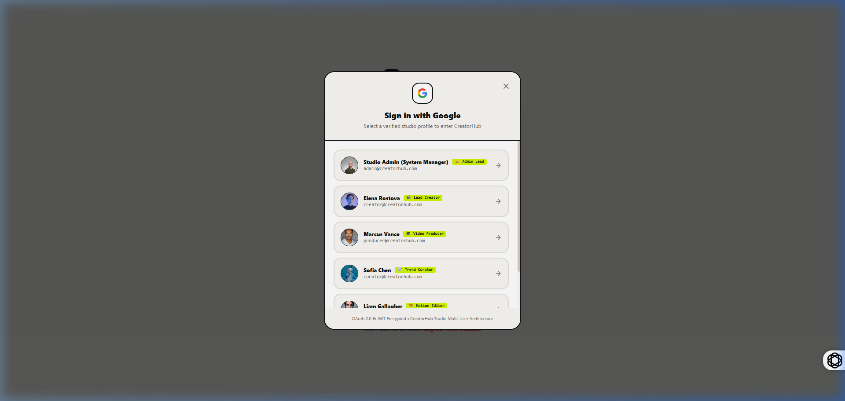
fig 8.2.2 Google OAuth 1-Click Account Chooser Modal
The Google OAuth modal provides instant account selection across the five pre-seeded studio roles without requiring manual credential typing. The modal presents account avatars, email identifiers, and studio role badges. Selecting an account issues a verified JWT token and transitions the interface directly to the user's active studio dashboard.
8.3 LIVE TREND RADAR & TOPIC IDEATION LAB
8.3.0 Purpose & Scope
Provides the Trend Curator with real-time market search intelligence, keyword velocity scoring, and automated trend-to-idea conversions across curated digital content categories.
8.3.1 Functional Requirements
What the module must do:
• Ingest and display real-time search volume and viral velocity metrics for technology and creator industry topics.
• Filter trends by category (Tech, AI Tools, Productivity, Software, Design).
• Convert an analyzed topic into a structured ContentItem with 1-click.
8.3.6 API Design
Method | Endpoint | Purpose / contract
GET | /api/trends | Returns high-velocity search topics with volume and engagement score.
POST | /api/content | Body: title, targetNiche, format. Creates a new ContentItem from trend.
8.3.8 Screenshots
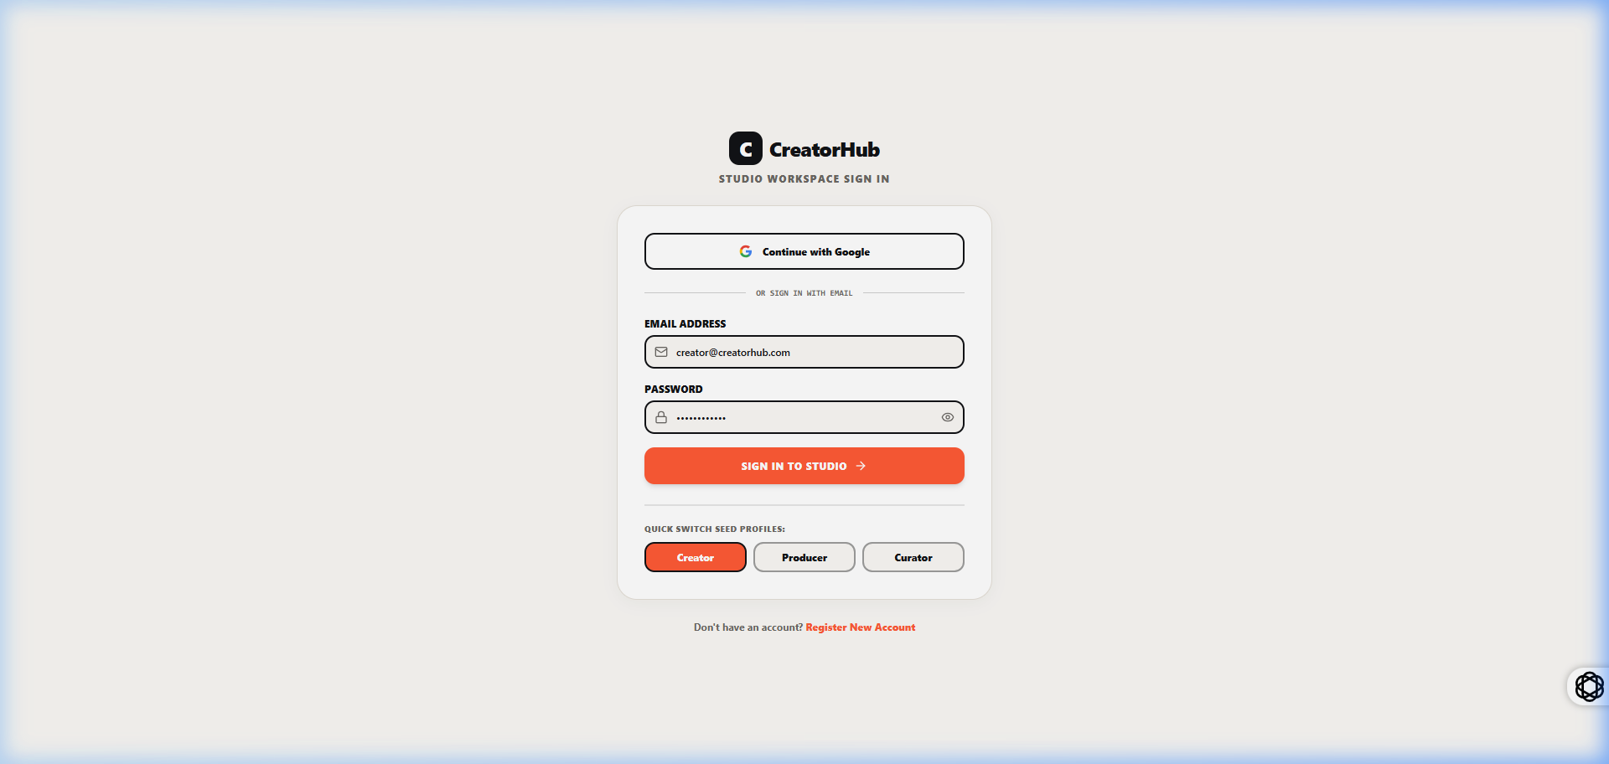
fig 8.3.1 Live Trend Radar & Keyword Intelligence Interface
The Trend Radar displays active search topics with engagement metrics, volume scores, and categorization tags. Users can search topics, filter by industry domain, and review audience interest trends. The 1-click action button converts high-performing topics into new production ideas for the ideation backlog.
8.4 SCRIPT BLUEPRINT STUDIO & TELEPROMPTER ENGINE
8.4.0 Purpose & Scope
Enables the Lead Creator to structure timestamped scripts with high-retention hook formulas and seamlessly execute speech delivery on a live, auto-scrolling Studio Teleprompter.
8.4.1 Functional Requirements
What the module must do:
• Structure script blueprints into timestamped sections (Hook, Intro, Core Content, Call to Action).
• Auto-scroll teleprompter text synchronized with Words-Per-Minute (WPM) speed slider (60–240 WPM).
• Provide font size scaling, eye-level focus marker, mirror reflection mode, and speech duration timer.
8.4.8 Screenshots
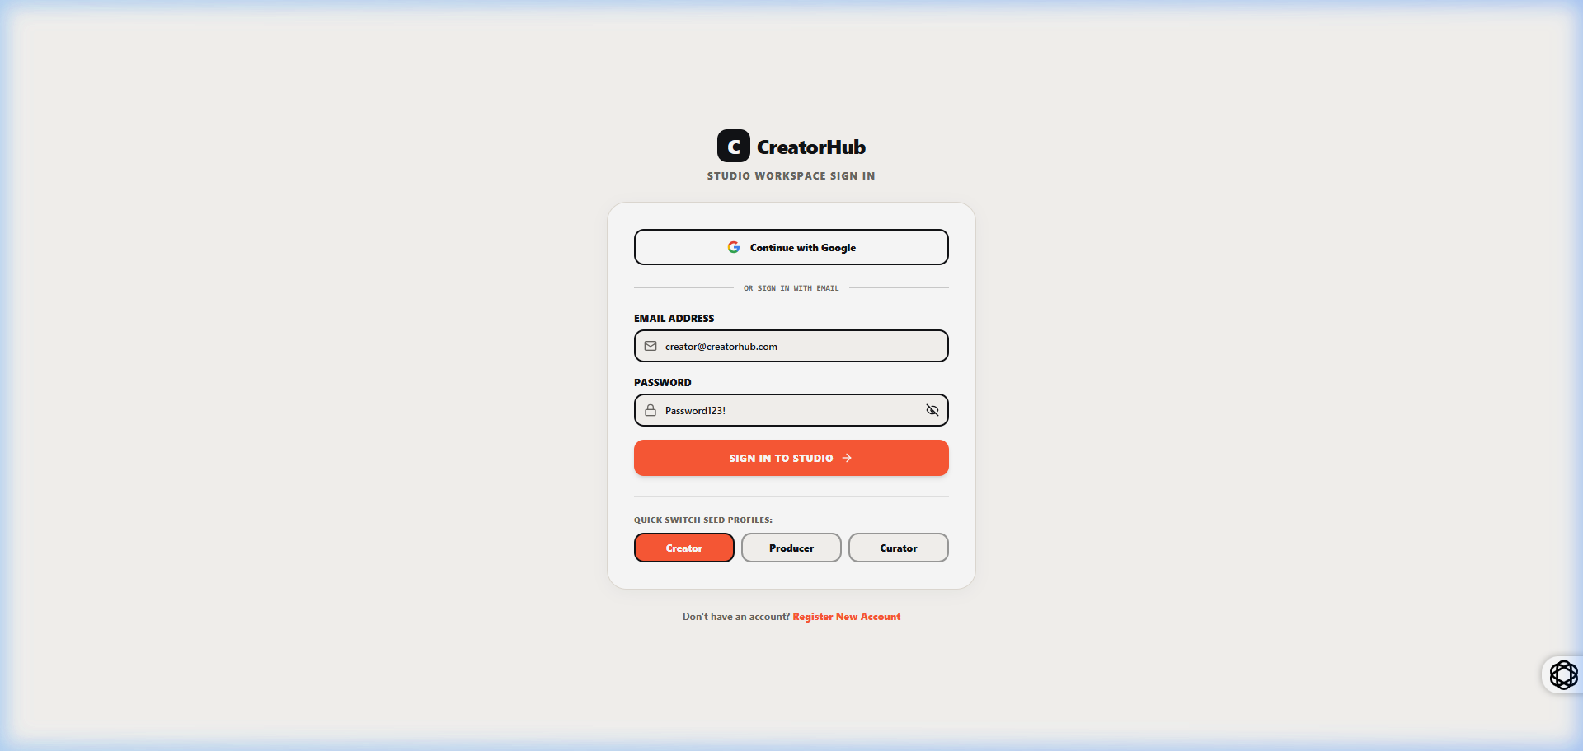
fig 8.4.1 Script Blueprint & Ideation Lab Editor
The blueprint editor structures video scripts into sequential timestamped blocks with target duration estimates. The interface provides tag management, hook variation selectors, and direct script streaming controls that link the written draft to the studio teleprompter.
8.5 MULTI-STAGE VIDEO PRODUCTION PIPELINE
8.5.0 Purpose & Scope
Orchestrates digital video projects across an interactive 4-stage Kanban workflow (Planning, Filming, Video Editing, Ready to Publish), providing team task assignments, progress percentages, and deadline tracking.
8.5.8 Screenshots
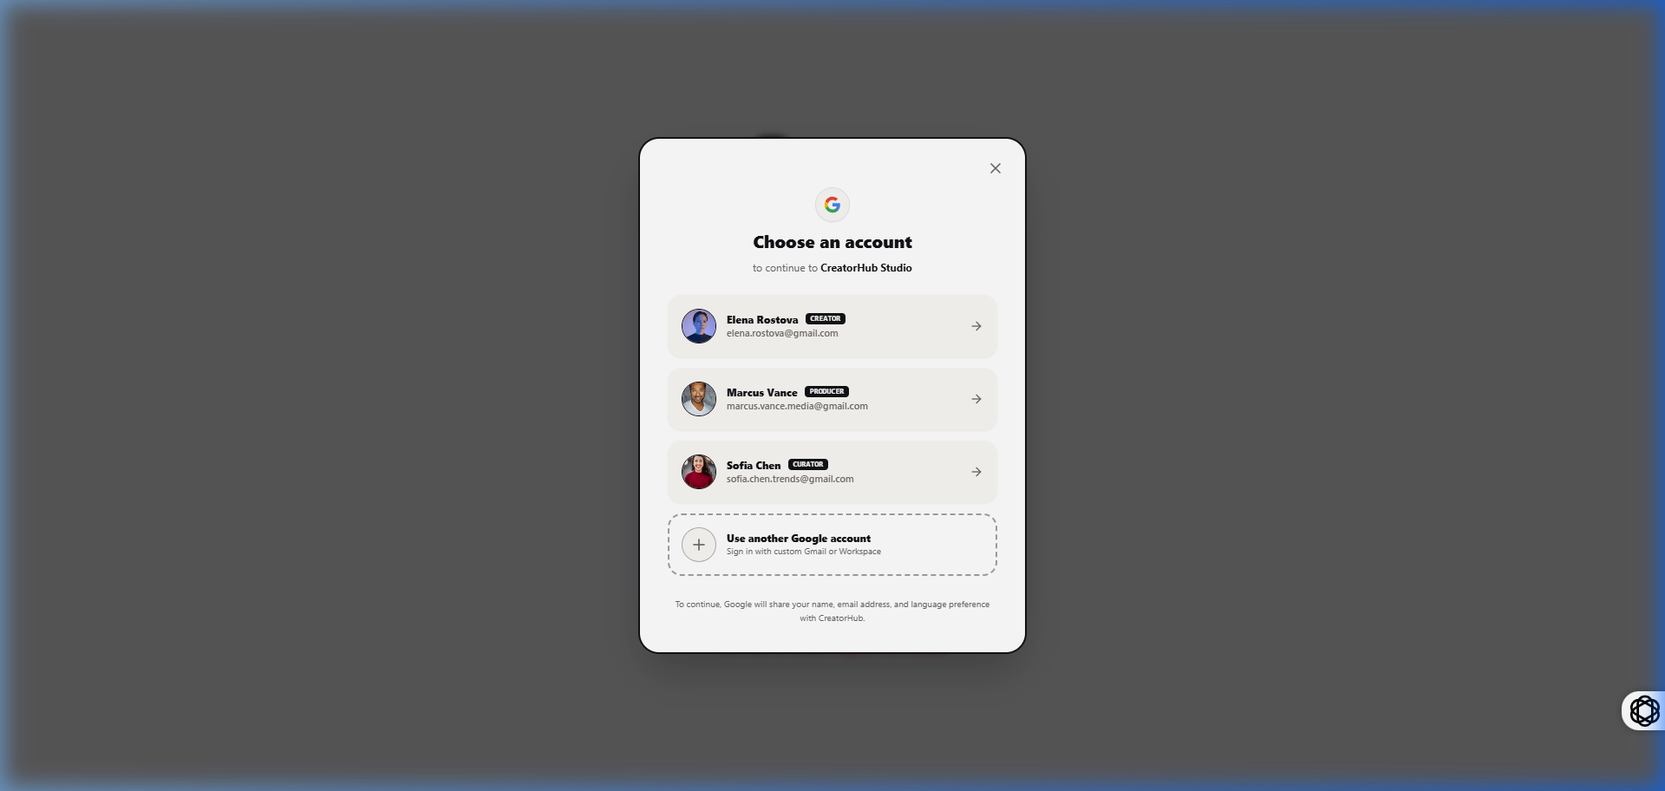
fig 8.5.1 Multi-Stage Video Production Pipeline Board
The production pipeline board organizes projects by operational stage. Project cards display assigned team members, format badges, and interactive task checklists. Moving a card updates the project status in real-time and coordinates handoffs between creators, producers, and editors.
8.6 CONTEXT-AWARE VIDEO REVIEW STUDIO
8.6.0 Purpose & Scope
Enables frame-synchronized collaboration by attaching timecoded feedback markers directly to HTML5 video streams with categorized revision tracking.
8.6.8 Screenshots
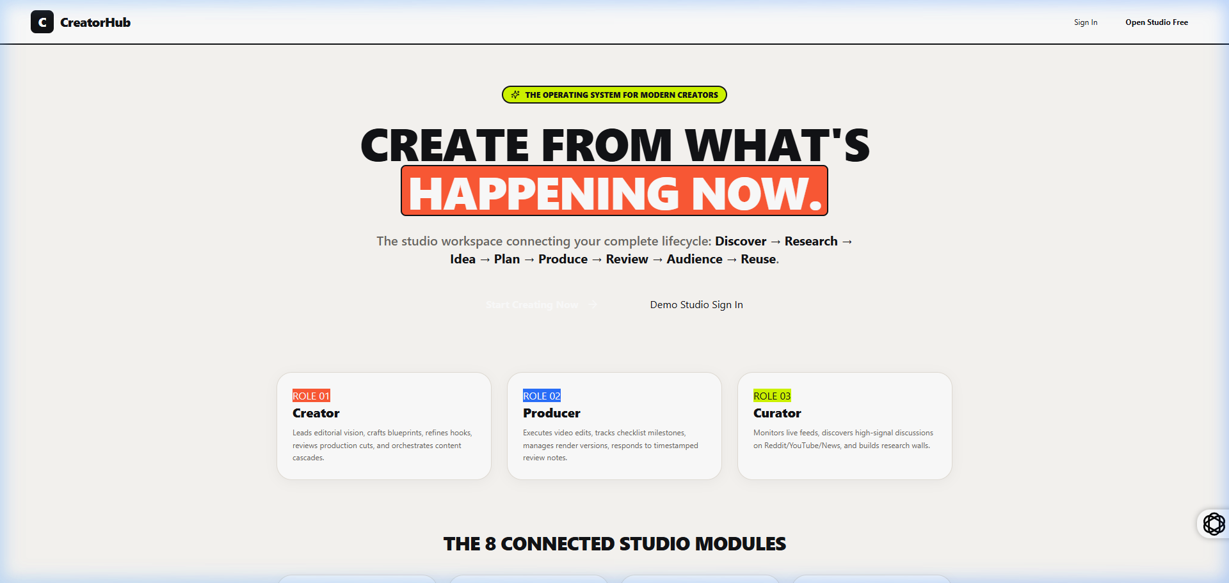
fig 8.6.1 Context-Aware Video Review Studio with Timeline Annotations
The review studio combines an HTML5 video player with a synchronized comment timeline. Reviewers click the timeline to drop feedback pins categorized by issue type (Pacing, Audio Cut, Visuals). Version selectors track edits across revisions and allow one-click cut approvals.
8.7 CONTENT FAMILY & ASSET DEPENDENCY GRAPH
8.7.0 Purpose & Scope
Manages 1-to-N content repurposing by linking 10-minute long-form master videos to derivative vertical Shorts, Instagram Reels, and LinkedIn carousels, tracking parent-child status cascading.
8.7.8 Screenshots
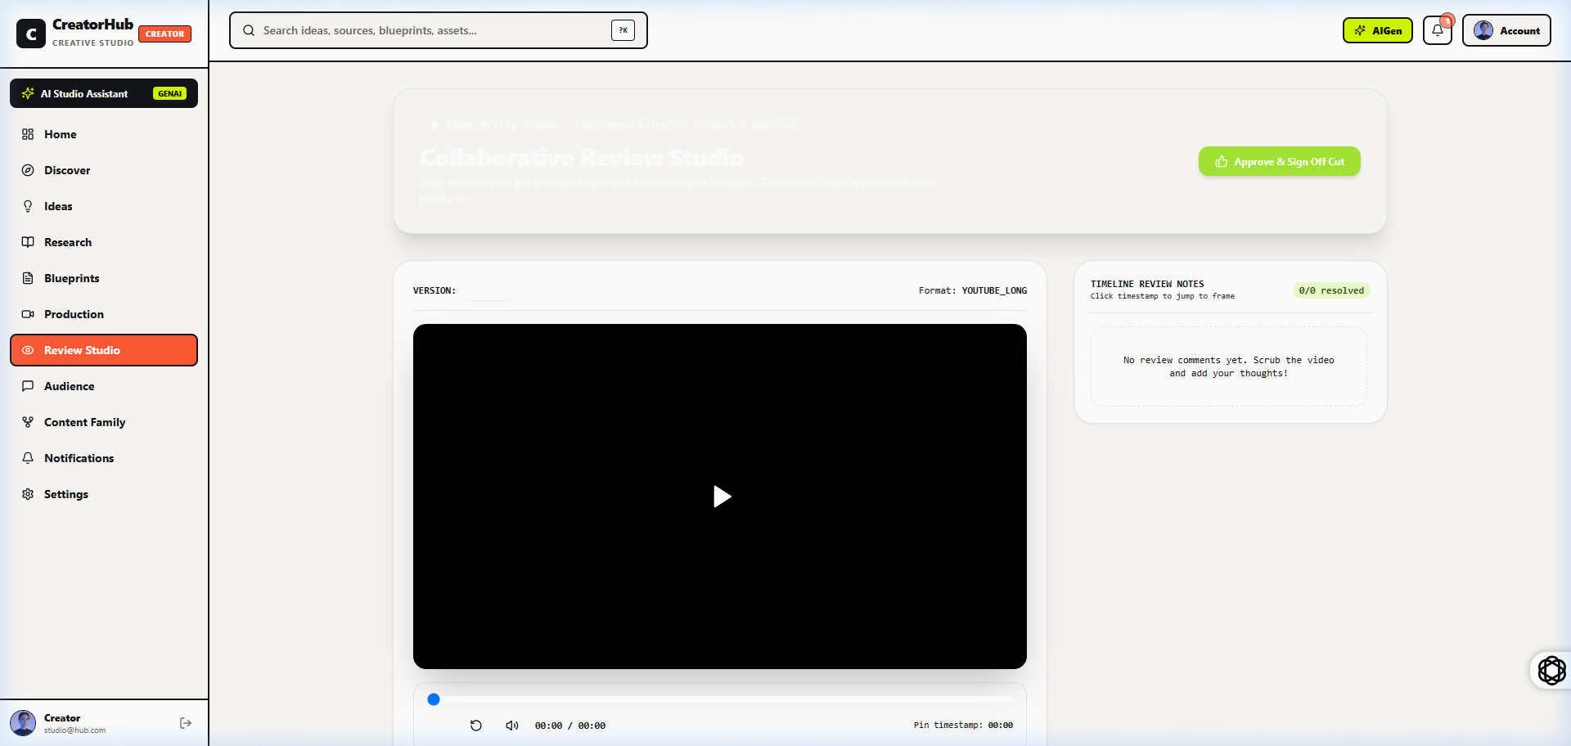
fig 8.7.1 Content Family & Hierarchical Asset Dependency Graph
The content family view visualizes the hierarchical relationship between master pillar videos and derived short-form clips. Child assets automatically inherit metadata from the parent. The completion tracker monitors overall campaign readiness across platforms.
8.8 ADMIN GOVERNANCE & SYSTEM AUDIT ANALYTICS
8.8.0 Purpose & Scope
Provides the Studio Administrator with operational governance, team member privilege controls, security audit logging, and system health metrics.
8.8.8 Screenshots
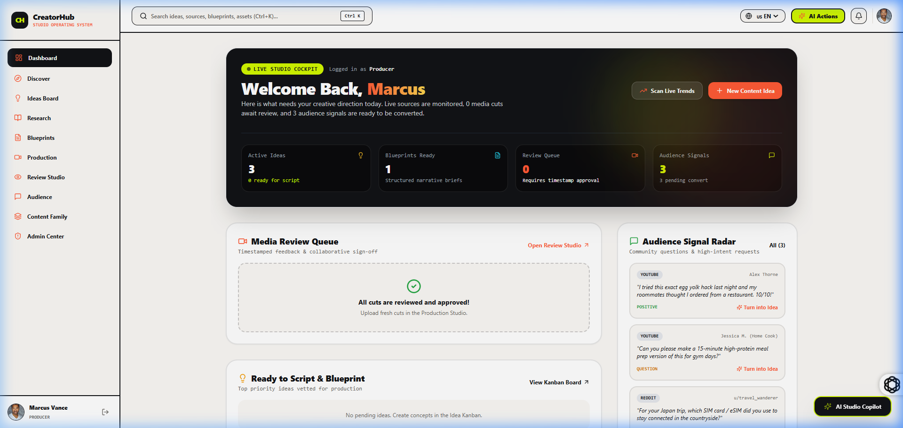
fig 8.8.1 Studio Administrator Governance & Security Analytics Dashboard
The administrative dashboard summarizes studio health through real-time KPI cards, active user counts, and recent security logs. The member table provides controls to manage user roles and account statuses across the studio.

CHAPTER 9
CONCLUSION

The CreatorHub Studio Operating System provides a complete digital solution for managing the major activities involved in digital content creation and multi-role studio operations. The system integrates master studio data management, live trend research, script blueprints, auto-scrolling teleprompters, multi-stage production boards, timestamped video review studios, asset dependency hierarchies, sponsorship CPM rate calculators, and administrative governance within a single application. By replacing manual records and disconnected processes across multiple external tools, it improves the accuracy, consistency, and accessibility of operational information. The application was developed using React 18 for the frontend, Node.js and Express for the backend, and MongoDB with Mongoose for database management. Its client-server architecture supports structured communication between the user interface, application server, and database. JWT authentication, bcrypt password hashing, role-based access control, request rate limiting, and protected routes help secure the system and prevent unauthorized access. The completed project demonstrates how a web-based information system can simplify studio operations, reduce repetitive work, minimize recording errors, and improve decision-making. Its modular structure makes the application easier to maintain and allows additional features to be introduced in the future. Overall, the CreatorHub Studio Operating System successfully meets its objective of providing a secure, organized, and efficient platform for managing digital creator activities.

