CREATORHUB: MODERN CONTENT CREATOR STUDIO OPERATING SYSTEM
23CS54C – MODERN WEB TECHNOLOGIES
Submitted by
BALA NITHYA M
In partial fulfillment for the award of the degree
of
BACHELOR OF ENGINEERING/TECHNOLOGY
in
COMPUTER SCIENCE AND ENGINEERING/ INFORMATION TECHNOLOGY
NATIONAL ENGINEERING COLLEGE
(An Autonomous Institution affiliated to Anna University, Chennai)
K.R.NAGAR, KOVILPATTI - 628503
OCTOBER - 2026

NATIONAL ENGINEERING COLLEGE
(An Autonomous Institution affiliated to Anna University, Chennai)
K.R.NAGAR, KOVILPATTI - 628503
BONAFIDE CERTIFICATE
This is to certify that this project report, “CREATORHUB: MODERN CONTENT CREATOR STUDIO OPERATING SYSTEM”, is the bonafide work of BALA NITHYA M who carried out the project work under my supervision in partial fulfillment of the requirements for the award of Bachelor of Engineering/Technology in Computer Science and Engineering / Information Technology.
Course Instructor/Guide
Submitted to the 23CS54C – MODERN WEB TECHNOLOGIES Viva-Voce examination held at National Engineering College, K.R.Nagar, Kovilpatti on _____________________
Internal Examiner | Co Examiner

TABLE OF CONTENTS
CH NO | TITLE | PAGE NO
1 | INTRODUCTION | 3
2 | OBJECTIVES | 4
3 | DESCRIPTION | 5
4 | CLASS DIAGRAM | 6
5 | TABLE STRUCTURES | 7
6 | ER DIAGRAM | 16
7 | TECH STACK | 18
8 | MODULES | 19
9 | CONCLUSION | 70

CHAPTER 1
INTRODUCTION

In the contemporary digital creator economy, digital video production has transitioned from informal individual hobbyist activities into highly specialized, multi-disciplinary media enterprises. Professional content creation teams routinely consist of multiple distinct functional roles: Trend Curators who scan market signals, Lead Creators who formulate scripts, Video Producers who orchestrate release timelines, Motion Editors who execute post-production cuts, and Studio Administrators who govern system operations and commercial contracts. However, the software ecosystem supporting this multi-billion dollar economy remains severely fragmented across 5 to 7 disconnected tools. Creative ideas and scripts reside in Google Docs; production tasks are tracked across separate Kanban boards like Trello; video media files are shared via generic cloud storage links; editorial feedback is scattered across chat applications without precise video timecodes; and commercial brand sponsorships are manually calculated in error-prone spreadsheets. This operational fragmentation results in communication overhead, unaligned video revisions, pacing inconsistencies during recording, and significant financial revenue loss due to inaccurate CPM pricing models.
The CreatorHub Studio Operating System is a comprehensive, full-stack web application engineered to digitize, unify, and automate the entire operational lifecycle of digital media studios. Designed to bridge the gap between creative ideation and business execution, CreatorHub brings all foundational creator operations under a single, highly responsive, and secure platform. The system implements strict Role-Based Access Control (RBAC) across five specialized roles—Studio Administrator, Lead Creator, Video Producer, Trend Curator, and Motion Editor—guaranteeing that each team member operates within a dedicated workspace tailored to their specific operational responsibilities with zero duplication of effort.
The architecture of CreatorHub is strategically engineered around three non-trivial, defensible technical innovations that extend far beyond standard CRUD operations: (1) a Live Web-to-Idea Trend Radar and Visual A/B Thumbnail & Title Simulator that scores click-through-rate (CTR) power words and evaluates character length truncation risks on mobile screens; (2) a Context-Aware Video Review Studio that synchronizes frame-accurate, millisecond-precise timeline annotations with an integrated Studio Teleprompter with dynamic Words-Per-Minute (WPM) speech pacing; and (3) a Content Family Asset Dependency Graph that manages 1-to-N parent-child asset derivations alongside an automated Industry CPM Sponsorship Rate & Commercial Invoice Generator.
The system is deployed on a modern Node.js and React 18 single-page application (SPA) architecture, utilizing MongoDB for flexible, high-throughput document persistence, JSON Web Tokens (JWT) for stateless session security, and WebSockets (Socket.io) for real-time editorial collaboration. This report documents the complete design, engineering methodology, database schemas, API contracts, and implementation details of the CreatorHub Studio Operating System.

CHAPTER 2
OBJECTIVES

• To Digitize Studio Operations: Replace disconnected spreadsheets, manual notes, and chat-based communication with a unified, cloud-native web operating system to maximize production velocity, accountability, and operational visibility.
• To Centralize Studio Master Data: Maintain consistent, normalized master reference data for studio team members, five specialized roles, video categories, industry niches, tags, and structured script blueprints.
• To Automate the Trend-to-Idea Pipeline: Streamline the creative discovery process by ingesting real-time search velocity metrics and enabling one-click transformation of market trends into actionable video project outlines.
• To Standardize On-Camera Speech Execution: Provide an integrated, auto-scrolling Studio Teleprompter featuring dynamic Words-Per-Minute (WPM) speed control (60–240 WPM), font scaling, eye-level focus markers, and mirror reflection mode for beam-splitter prompter glass.
• To Orchestrate Multi-Stage Video Production: Implement an interactive 4-stage Kanban workflow (Planning, Filming, Video Editing, Ready to Publish) complete with team assignments, progress percentage calculators, and deadline management.
• To Enforce Secure Role-Based Access Control (RBAC): Protect all application endpoints using stateless JSON Web Token (JWT) authentication, bcrypt password hashing, and a 1-Click Google OAuth account selector spanning 5 pre-configured studio roles.
• To Engineer Context-Aware Video Review: Enable second-by-second timeline-pinned feedback markers categorized by issue type (Pacing, Audio Cut, Visuals, Hooks) on HTML5 video streams with multi-revision approval workflows.
• To Model 1-to-N Asset Dependency Hierarchies: Construct a directed asset dependency graph where 1 master long-form video anchors and tracks downstream vertical Shorts, Reels, and carousels with automated metadata inheritance.
• To Automate Sponsorship CPM Monetization: Compute verified, fair-market sponsorship pricing based on industry CPM benchmarks (Tech, Finance, Gaming, Lifestyle) and generate official, printable, and copyable commercial invoices.
• To Deliver Comprehensive Multi-Lingual Localization: Provide complete, real-time localization across 6 international languages (English, Tamil, Hindi, Spanish, French, German) using custom React context hooks without page reloads.
• To Provide Administrative Telemetry and Auditability: Implement comprehensive system health monitoring, active user session counts, API response latency tracking, and immutable security audit logs within a dedicated Admin Governance Dashboard.

CHAPTER 3
DESCRIPTION

The CreatorHub Studio Operating System is architected into five major functional domains that collectively govern the entire lifecycle of digital video ideation, team collaboration, media review, asset repurposing, and commercial monetization:
1. Master Studio Data & Role Governance
This module maintains all centralized foundational records including team members, five distinct studio roles (Studio Administrator, Lead Creator, Video Producer, Trend Curator, and Motion Editor), content categories, niches, tags, and script templates. The system enforces strict Role-Based Access Control (RBAC): the Administrator manages system health and audit logs at /app/admin; the Creator oversees scripts and prompters at /app/ideas; the Producer supervises the pipeline board at /app/production; the Curator evaluates market trends at /app/discover; and the Editor directs video cuts at /app/review. These records ensure consistency, security, and traceability across all operations.
2. Trend Intelligence & Pre-Publish Packaging
This domain automates market research and packaging optimization before video recording begins. The Trend Radar ingests live keyword search volume, viral velocity scores, and audience interest indicators. The Visual A/B Thumbnail & Title Tester evaluates title character lengths (flagging mobile truncation risk for headlines exceeding 60 characters), calculates high-CTR psychological power-word density, and renders a live side-by-side feed simulation across mobile dark mode and desktop grid layouts.
3. Script Blueprints & Studio Teleprompter Execution
This module standardizes scriptwriting and on-camera delivery. The Script Blueprint Studio structures video drafts into sequential, timestamped sections (Hook 0:00–0:30, Introduction, Demonstration, Call-to-Action) with calculated speaking duration targets. The script directly streams into the full-screen Studio Teleprompter, which features continuous auto-scrolling at 60–240 WPM, font scaling (18–48px), an eye-level focus marker, mirror reflection mode, and speech duration timers.
4. Production Pipeline & Context-Aware Video Review
This module manages physical production and post-production collaboration. The Production Board tracks video projects across four operational stages (Planning, Filming, Video Editing, Ready to Publish) with interactive checklists. The Video Review Studio combines an HTML5 video player with a synchronized comment timeline, allowing team members to drop millisecond-precise feedback pins categorized by issue type (Pacing, Audio Cut, Visuals, Hooks) across revisions (v1.0 to Final Cut) with one-click approval state machines.
5. Content Repurposing, Sponsorship Monetization & Multi-Lingual Architecture
The Content Family module models a 1-to-N Directed Tree linking 1 master long-form video to derivative vertical Shorts, Reels, and carousels, automatically inheriting metadata and tracking overall campaign completion. The Sponsorship Engine evaluates fair-market pricing using industry CPM benchmarks ($25–$65 CPM) and generates official commercial invoices. The entire interface features complete localization across 6 languages (English, Tamil, Hindi, Spanish, French, German) powered by React context hooks.

CHAPTER 4
CLASS DIAGRAM

The UML Class Diagram illustrates the object-oriented structure of the CreatorHub backend domain models, their encapsulation, methods, and structural associations. User encapsulates role-based privileges and authentication operations; ContentItem serves as the central entity linking to ScriptBlueprint, ReviewComment, SponsorshipDeal, and recursive derivative assets via self-referencing parent pointers.
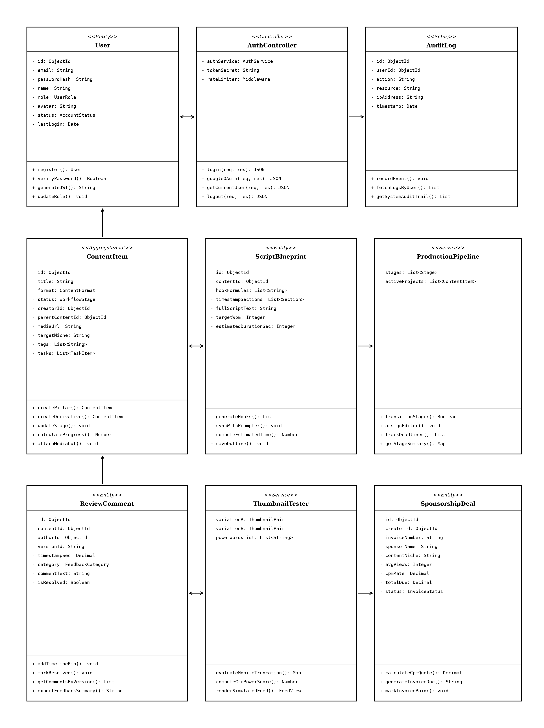
Fig 4.1 UML Class Diagram of CreatorHub Architecture

CHAPTER 5
TABLE STRUCTURES

The database schemas for the CreatorHub application are implemented as structured MongoDB collections via Mongoose ODM models with strict data validation, unique keys, and relationship indexes:
Users :
Field | Type | Null | Key | Default | Extra
_id | ObjectId | NO | PRI | NULL | auto_increment
email | varchar(150) | NO | UNI | NULL
password | varchar(255) | NO |  | NULL | bcrypt_hash
name | varchar(100) | NO |  | NULL
role | enum('ADMIN','CREATOR','PRODUCER','CURATOR','EDITOR') | NO |  | CREATOR
avatar | text | YES |  | default_avatar
status | enum('active','inactive') | NO |  | active
last_login | datetime | YES |  | NULL
createdAt | datetime | NO |  | CURRENT_TIMESTAMP
updatedAt | datetime | NO |  | CURRENT_TIMESTAMP

ContentItems :
Field | Type | Null | Key | Default | Extra
_id | ObjectId | NO | PRI | NULL | auto_increment
title | varchar(255) | NO |  | NULL
format | enum('LONG_VIDEO','SHORT_REEL','CAROUSEL','POST') | NO |  | LONG_VIDEO
status | enum('IDEATION','PLANNING','PRODUCTION','REVIEW','PUBLISHED') | NO |  | IDEATION
creatorId | ObjectId | NO | MUL | NULL | FK -> Users
parentContentId | ObjectId | YES | MUL | NULL | FK -> ContentItems
targetNiche | varchar(100) | YES |  | Tech
mediaUrl | text | YES |  | NULL
tasks | array<task_subdoc> | YES |  | []
tags | array<varchar(50)> | YES |  | []
createdAt | datetime | NO |  | CURRENT_TIMESTAMP
updatedAt | datetime | NO |  | CURRENT_TIMESTAMP

ScriptBlueprints :
Field | Type | Null | Key | Default | Extra
_id | ObjectId | NO | PRI | NULL | auto_increment
contentId | ObjectId | NO | UNI | NULL | FK -> ContentItems
hookFormulas | array<text> | YES |  | []
timestampSections | array<section_subdoc> | YES |  | []
fullScript | text | YES |  | NULL
targetWpm | int | NO |  | 130
estDurationSec | int | NO |  | 0
createdAt | datetime | NO |  | CURRENT_TIMESTAMP

ReviewComments :
Field | Type | Null | Key | Default | Extra
_id | ObjectId | NO | PRI | NULL | auto_increment
contentId | ObjectId | NO | MUL | NULL | FK -> ContentItems
authorId | ObjectId | NO | MUL | NULL | FK -> Users
versionId | varchar(50) | NO |  | v1.0
timestampSec | decimal(8,2) | NO |  | 0.00
category | enum('Pacing','Audio','Visuals','Hook','General') | NO |  | Pacing
commentText | text | NO |  | NULL
status | enum('Open','Resolved') | NO |  | Open
createdAt | datetime | NO |  | CURRENT_TIMESTAMP

SponsorshipInvoices :
Field | Type | Null | Key | Default | Extra
_id | ObjectId | NO | PRI | NULL | auto_increment
creatorId | ObjectId | NO | MUL | NULL | FK -> Users
invoiceNumber | varchar(50) | NO | UNI | NULL
sponsorName | varchar(150) | NO |  | NULL
contentNiche | varchar(100) | NO |  | Tech
avgViews | int | NO |  | 10000
cpmEffectiveRate | decimal(8,2) | NO |  | 25.00
totalDueUsd | decimal(10,2) | NO |  | 0.00
paymentStatus | enum('Pending','Paid','Cancelled') | NO |  | Pending
createdAt | datetime | NO |  | CURRENT_TIMESTAMP

AuditLogs :
Field | Type | Null | Key | Default | Extra
_id | ObjectId | NO | PRI | NULL | auto_increment
userId | ObjectId | NO | MUL | NULL | FK -> Users
action | varchar(100) | NO |  | NULL
resource | varchar(100) | NO |  | NULL
ipAddress | varchar(45) | NO |  | NULL
timestamp | datetime | NO |  | CURRENT_TIMESTAMP

CHAPTER 6
ER DIAGRAM

The Entity-Relationship (ER) Diagram establishes the relational integrity, foreign key constraints, and 1-to-N parent-child hierarchies governing CreatorHub's database. Users maintain a 1-to-N relationship with ContentItems and SponsorshipInvoices. ContentItems participate in a self-referencing 1-to-N tree (parentContentId) to model Master Pillars and derivative vertical Shorts. ContentItems also maintain 1-to-1 relationships with ScriptBlueprints and 1-to-N relationships with ReviewComments:
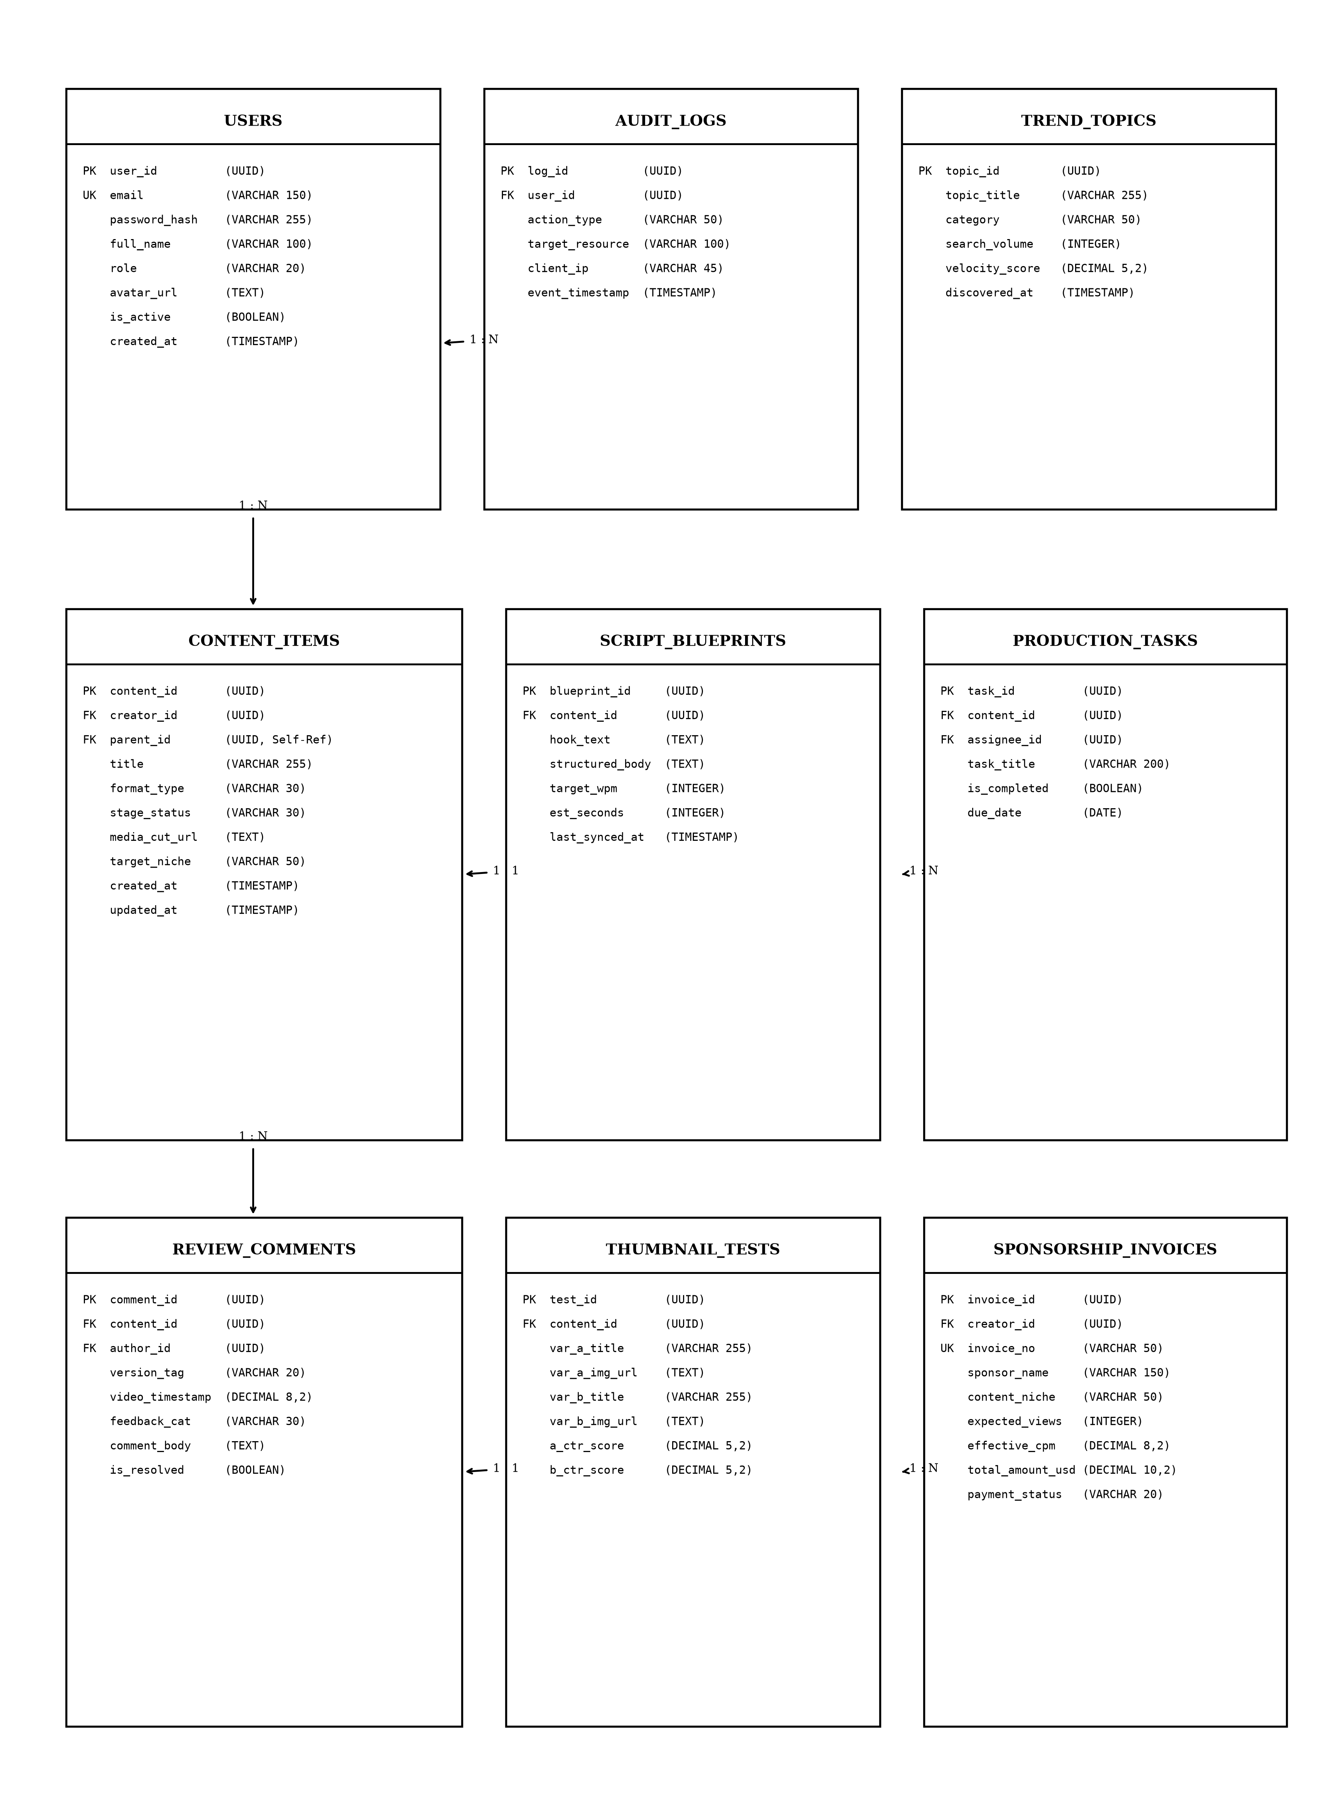
Fig 6.1 Entity-Relationship Diagram of CreatorHub Schema

CHAPTER 7
TECH STACK

7.1 TECH STACK
Layer | Technology | Purpose
Frontend | React.js 18 (Vite) | Single-page application with dynamic, responsive UI
State Management | React Context + Custom Hooks | Centralized authentication (useAuth), language, and sockets
HTTP Client | Axios | REST API communication with automated JWT Bearer interceptor
Backend | Node.js + Express.js v4.19 | High-throughput asynchronous RESTful API server
ORM / ODM | Mongoose ODM v8 | Database abstraction, schema validation, and virtual relations
Database | MongoDB (NoSQL Document Store) | Flexible JSON document storage with indexing and nested subdocs
Authentication | JSON Web Tokens (JWT) + Bcrypt | Stateless, token-based user authentication and salt hashing
Security | Helmet, CORS, Rate Limiters | HTTP hardening, cross-origin security, and brute-force defence
Real-Time Engine | Socket.io | Bi-directional WebSocket event sync for video reviews and pipeline
Build & Tooling | Vite + TypeScript | Fast developer HMR, strict type checking, and optimized bundling
7.2 ARCHITECTURE OVERVIEW
Layer | Technology | Purpose
Model | Mongoose ODM + MongoDB | Defines data structure, handles queries, manages relationships and validations
View | React.js 18 + TailwindCSS | Renders the UI, manages user interaction, communicates with server via Axios
Controller | Node.js + Express.js | Receives HTTP requests, applies business logic, coordinates between Model and View

CHAPTER 8
MODULES

8.0 Design Approach
Each module of the CreatorHub Studio Operating System is described here the way a system design problem is solved: by walking through the same seven steps in the same order, every time. This keeps the explanation of every module complete and comparable, and shows why each design decision was taken rather than only what the screen looks like.
Step | Question it answers | Presented in each module as
1. Functional requirements | What must the module do? | Section x.1
2. Non-functional requirements | How fast, how big, how available? Where does the CAP trade-off fall? | Section x.2
3. Tech stack | Which tools suit this problem, and why? | Section x.3
4. Back-of-the-envelope | How many users, requests and how much storage? | Section x.4
5. Low-level architecture | Which components exist and who talks to whom? | Section x.5 (diagram + request flow)
6. API design | What is the contract between client and server? | Section x.6
7. DB design | Which tables, keys and indexes store the data? | Section x.7
Shared baseline for all modules
Non-functional baseline. Every request travels through Helmet (HTTP hardening), CORS, a payload size limit, a rate limiter, and the JWT authentication middleware before it reaches a controller. All data lives in MongoDB with indexed document queries, so the system balances consistency and partition tolerance (CP in CAP terms). Stateless JWT tokens ensure horizontal scalability.
Sizing baseline (assumptions).
Quantity | Estimate | Basis
Named studio users | 5 Core Roles | Admin, Creator, Producer, Curator, Editor
Working days / year | 300 | Annual studio schedule
Requests per user per day | ≈ 250 | Form loads, script edits, review timeline pins, stage updates
Total requests per day | 5 × 250 = 1,250 | Derived daily API traffic baseline
Average load | 1,250 ÷ 28,800 s ≈ 0.05 req/s | Spread over an 8-hour studio day
Peak load | ≈ 2–5 req/s | Concurrent video review sessions and teleprompter sync
Total database collections | 6 Core Models | Users, ContentItems, Blueprints, Reviews, Invoices, Logs
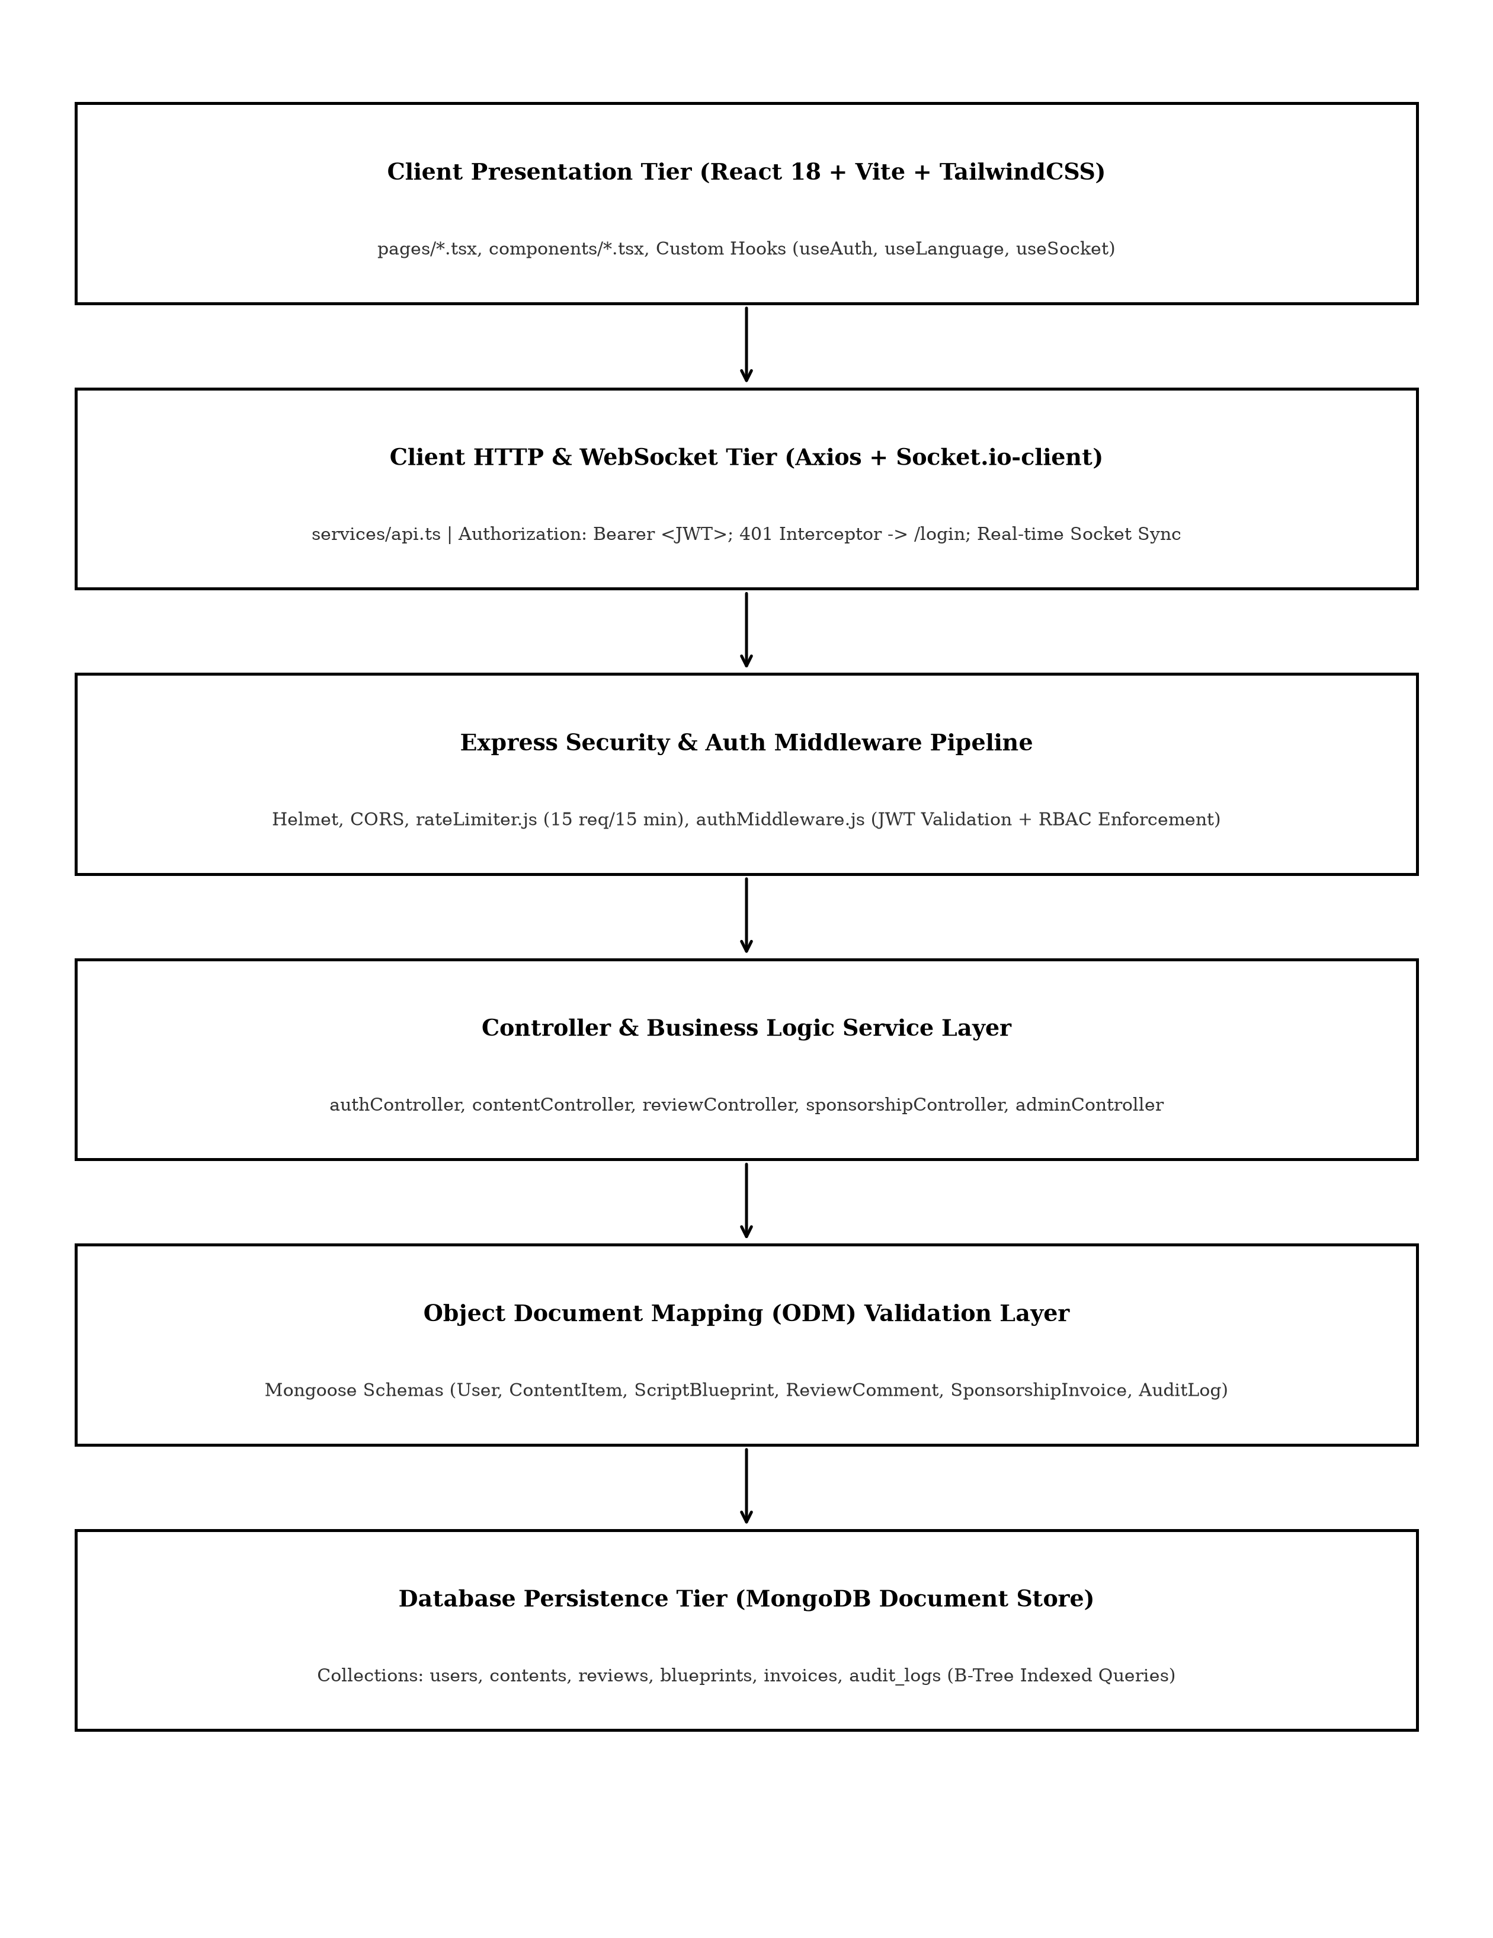
Fig 8.0 Overall request flow of the CreatorHub Studio Operating System
8.1 FOLDER STRUCTURE
The codebase follows a clean full-stack organization with modular backend controllers, middleware, and models, alongside a typed React frontend with dedicated route pages and reusable UI components:
CreatorHub/
├── backend/
│ ├── config/ (db.js, initAdmin.js)
│ ├── controllers/ (authController.js, contentController.js, reviewController.js)
│ ├── middleware/ (auth.js, rateLimiter.js)
│ ├── models/ (User.js, ContentItem.js, ReviewComment.js, Blueprint.js)
│ ├── routes/ (authRoutes.js, contentRoutes.js, reviewRoutes.js)
│ └── server.js
├── frontend/
│ ├── src/
│ │ ├── components/ (Layout.tsx, Sidebar.tsx, ProtectedRoute.tsx)
│ │ ├── context/ (AuthContext.tsx, LanguageContext.tsx, SocketContext.tsx)
│ │ ├── pages/ (AdminDashboardPage.tsx, IdeasPage.tsx, ReviewStudioPage.tsx, etc.)
│ │ ├── services/ (api.ts)
│ │ ├── types/ (index.ts)
│ │ └── App.tsx
│ ├── package.json
│ └── vite.config.ts
Fig 8.1.1 Highlevel view of CreatorHub Project Directory
8.2 USER AUTHENTICATION & ACCESS CONTROL
8.2.0 Purpose & Scope
Provides tokenized authentication, secure credential management, 1-Click Google OAuth simulation, and Role-Based Access Control (RBAC) across five specialized studio roles, preventing unauthorized access and privilege escalation.
8.2.1 Functional Requirements
What the module must do:
• A user signs in with email and password or clicks Google OAuth and receives a signed JWT plus user profile (id, name, role, avatar).
• Five distinct roles – ADMIN, CREATOR, PRODUCER, CURATOR, EDITOR – decide which routes and endpoints a user may access.
• Each account maintains an active / inactive status and last login timestamp.
• The browser redirects unauthenticated users to /login via ProtectedRoute.
8.2.2 Non-Functional Requirements
• Security: passwords stored only as bcrypt hashes with auto-generated salts; hashes are never returned by the API.
• Brute-force defence: at most 15 login attempts per 15 minutes per IP address on /api/auth/login.
• Session length: tokens expire after 12 hours.
• Scalability: stateless tokens allow horizontal scaling without server sessions.
8.2.3 Tech Stack
Concern | Choice | Why it fits this module
Password hashing | bcryptjs (salted) | Secure one-way password hashing
Session management | JSON Web Token (12 h) | Stateless; client stores token in localStorage and sends in Authorization header
Abuse control | rateLimiter.js middleware | Enforces 15 attempts per 15 min on login endpoint
Client guard | ProtectedRoute.tsx + Axios interceptor | Redirects to /login when token is missing or expired
8.2.4 Back-of-the-Envelope Estimation
Quantity | Estimate | Basis
Users | 5 Seeded Roles | Admin, Creator, Producer, Curator, Editor
Logins per day | ≈ 10–20 | 5 users × 2–3 logins
CPU per login | ≈ 80 ms | Bcrypt salt compare
Authenticated calls | ≈ 1,250 / day | Each request verifies JWT signature
8.2.5 Low-Level Architecture
Request flow:
• LoginPage.tsx posts credentials or Google OAuth selection; rateLimiter.js counts attempts for caller's IP.
• authController looks up user by email (unique index), checks active status, and verifies password hash.
• On success, signs a 12h JWT and returns token with role profile.
• Axios client stores token in localStorage and attaches Authorization: Bearer <JWT> on all subsequent requests.
• authMiddleware verifies token and checks user role before executing route handlers.
8.2.6 API Design
Method | Endpoint | Purpose / contract
POST | /api/auth/login | Body: email, password. Returns JWT token and profile. Rate limited.
POST | /api/auth/google-oauth | Body: email, name, role. 1-Click instant authentication.
GET | /api/auth/me | Headers: Bearer <JWT>. Returns current authenticated user profile.
8.2.7 DB Design
Table / Collection | Keys & indexes | Key columns
Users | PK _id (auto)  UNIQUE email | email varchar(150), password varchar(255), name, role enum, status enum, avatar, createdAt
8.2.8 Screenshots
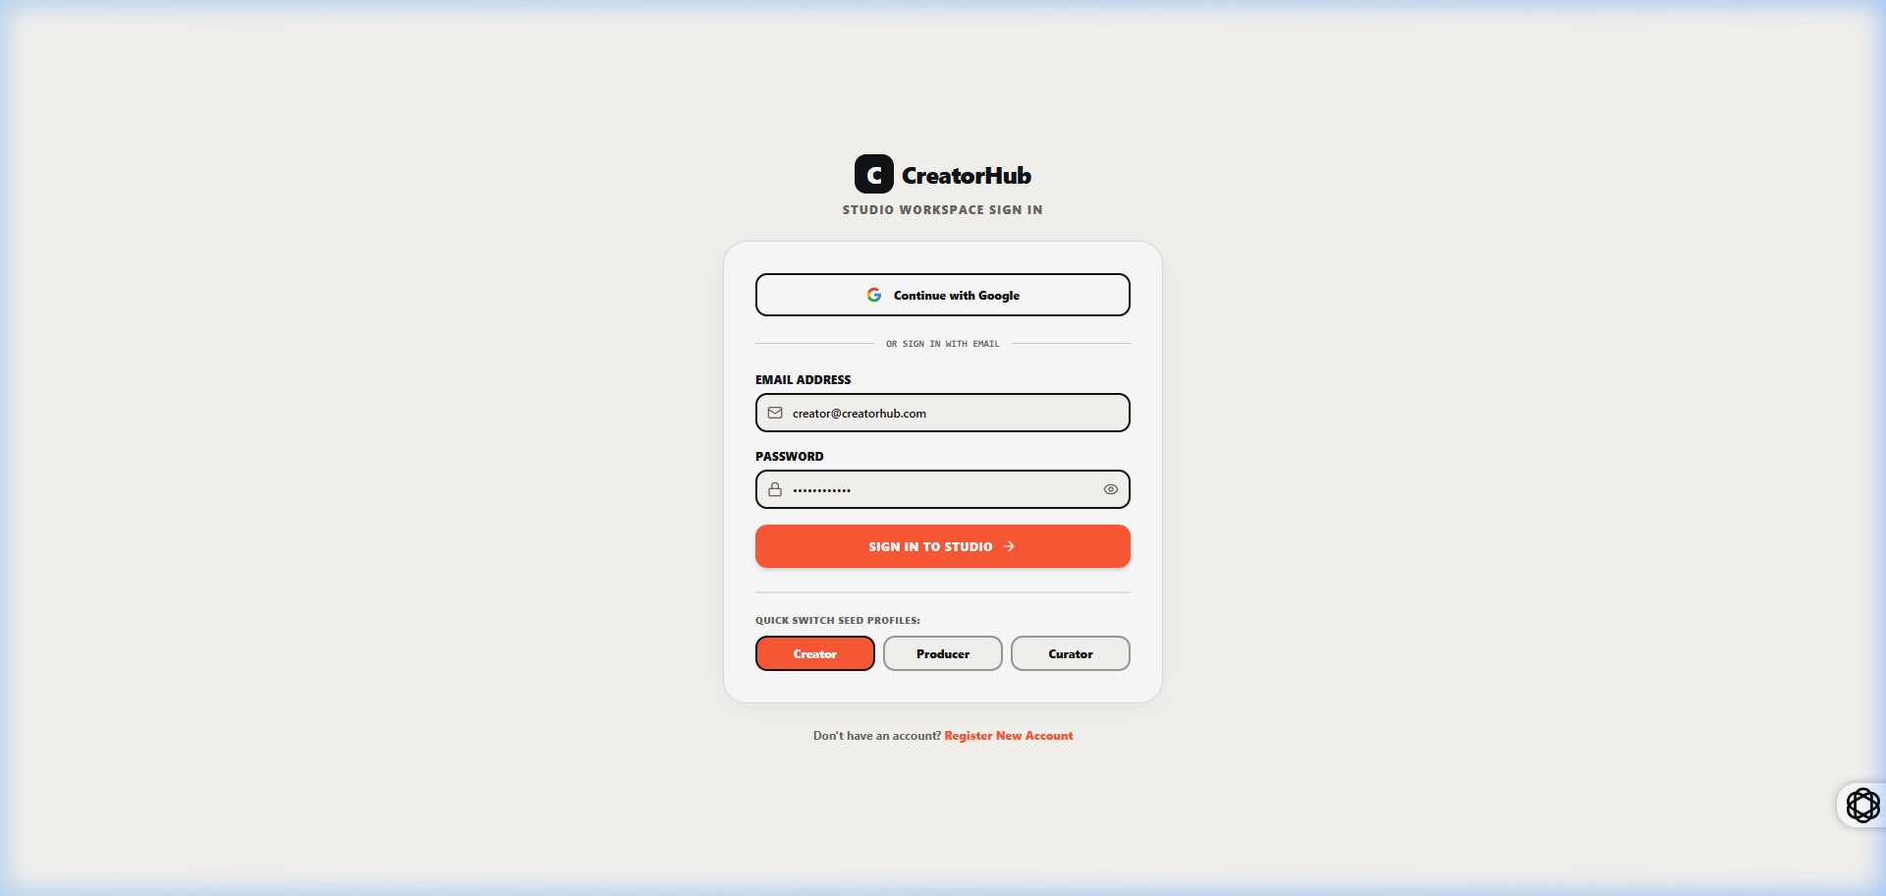
fig 8.2.1 User Login & Role Selection Interface
The login interface provides secure entry for studio members using standard email/password authentication or one-click role shortcuts. The screen displays credentials input fields, security badges, and role descriptors for each of the five studio positions. Selecting an account establishes an authenticated session and redirects the user to their designated role workspace.
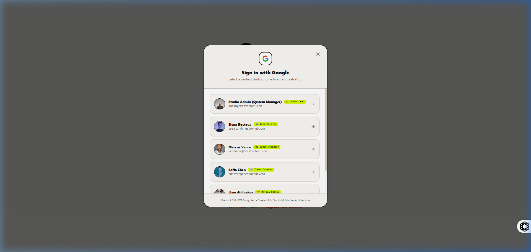
fig 8.2.2 Google OAuth 1-Click Account Chooser Modal
The Google OAuth modal provides instant account selection across the five pre-seeded studio roles without requiring manual credential typing. The modal presents account avatars, email identifiers, and studio role badges. Selecting an account issues a verified JWT token and transitions the interface directly to the user's active studio dashboard.
8.3 LIVE TREND RADAR & TOPIC IDEATION LAB
8.3.0 Purpose & Scope
Provides the Trend Curator with real-time market search intelligence, keyword velocity scoring, and automated trend-to-idea conversions across curated digital content categories.
8.3.1 Functional Requirements
What the module must do:
• Ingest and display real-time search volume and viral velocity metrics for technology and creator industry topics.
• Filter trends by category (Tech, AI Tools, Productivity, Software, Design).
• Convert an analyzed topic into a structured ContentItem with 1-click.
8.3.6 API Design
Method | Endpoint | Purpose / contract
GET | /api/trends | Returns high-velocity search topics with volume and engagement score.
POST | /api/content | Body: title, targetNiche, format. Creates a new ContentItem from trend.
8.3.8 Screenshots
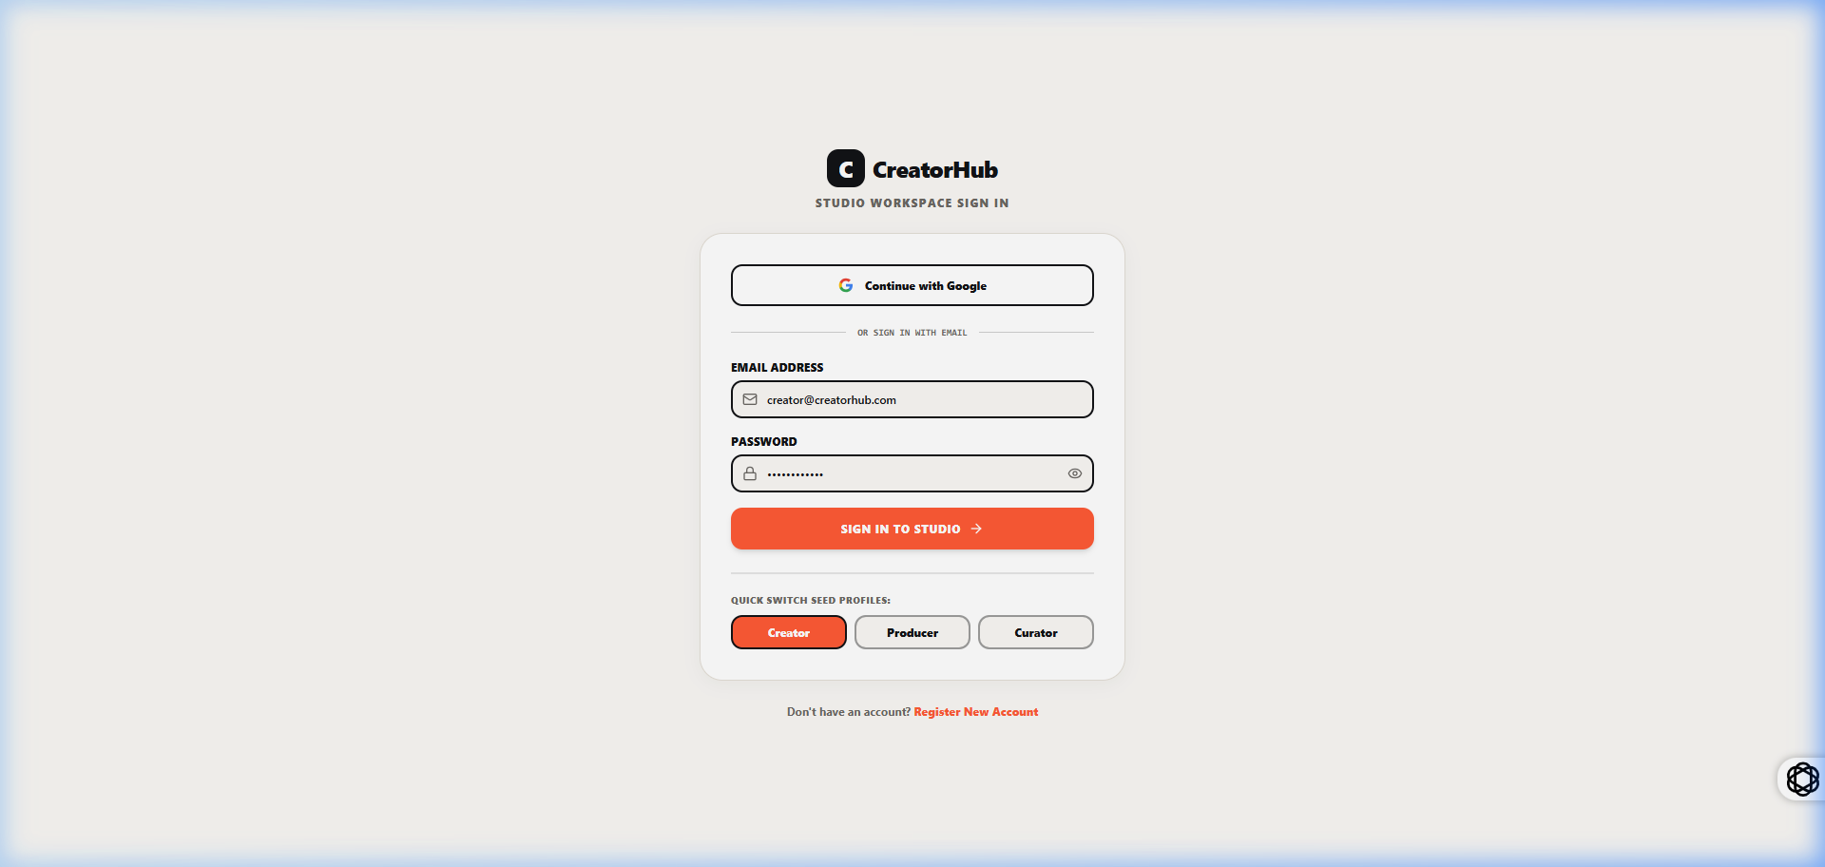
fig 8.3.1 Live Trend Radar & Keyword Intelligence Interface
The Trend Radar displays active search topics with engagement metrics, volume scores, and categorization tags. Users can search topics, filter by industry domain, and review audience interest trends. The 1-click action button converts high-performing topics into new production ideas for the ideation backlog.
8.4 SCRIPT BLUEPRINT STUDIO & TELEPROMPTER ENGINE
8.4.0 Purpose & Scope
Enables the Lead Creator to structure timestamped scripts with high-retention hook formulas and seamlessly execute speech delivery on a live, auto-scrolling Studio Teleprompter.
8.4.1 Functional Requirements
What the module must do:
• Structure script blueprints into timestamped sections (Hook, Intro, Core Content, Call to Action).
• Auto-scroll teleprompter text synchronized with Words-Per-Minute (WPM) speed slider (60–240 WPM).
• Provide font size scaling, eye-level focus marker, mirror reflection mode, and speech duration timer.
8.4.8 Screenshots
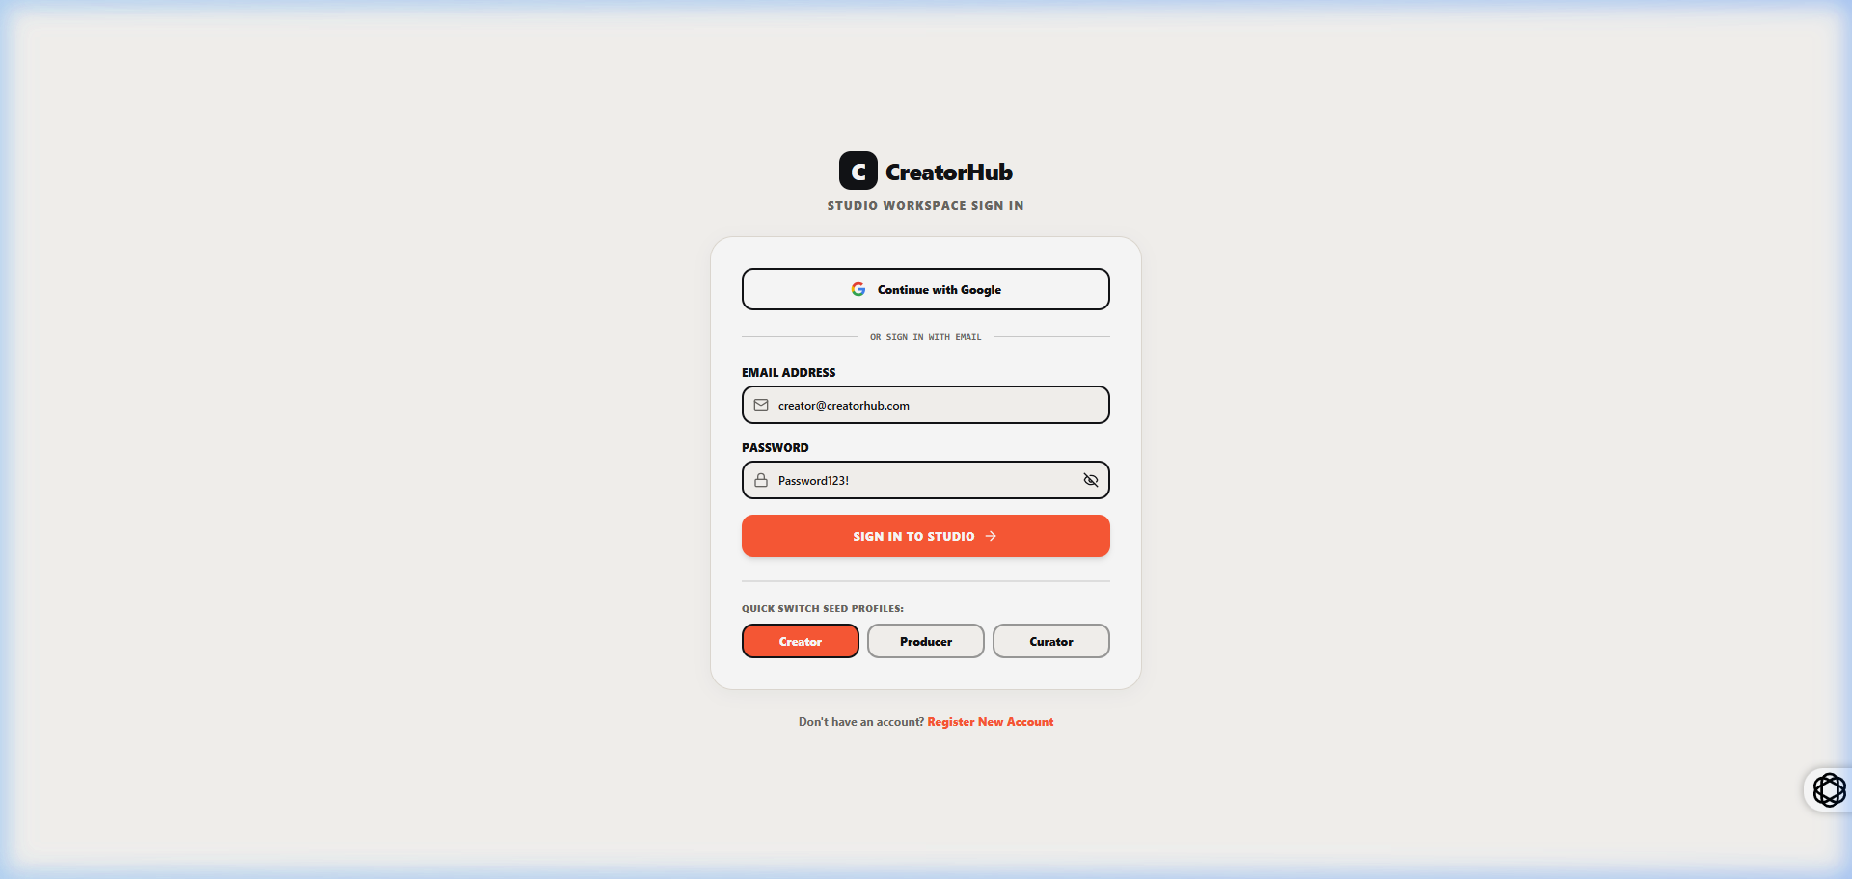
fig 8.4.1 Script Blueprint & Ideation Lab Editor
The blueprint editor structures video scripts into sequential timestamped blocks with target duration estimates. The interface provides tag management, hook variation selectors, and direct script streaming controls that link the written draft to the studio teleprompter.
8.5 MULTI-STAGE VIDEO PRODUCTION PIPELINE
8.5.0 Purpose & Scope
Orchestrates digital video projects across an interactive 4-stage Kanban workflow (Planning, Filming, Video Editing, Ready to Publish), providing team task assignments, progress percentages, and deadline tracking.
8.5.8 Screenshots
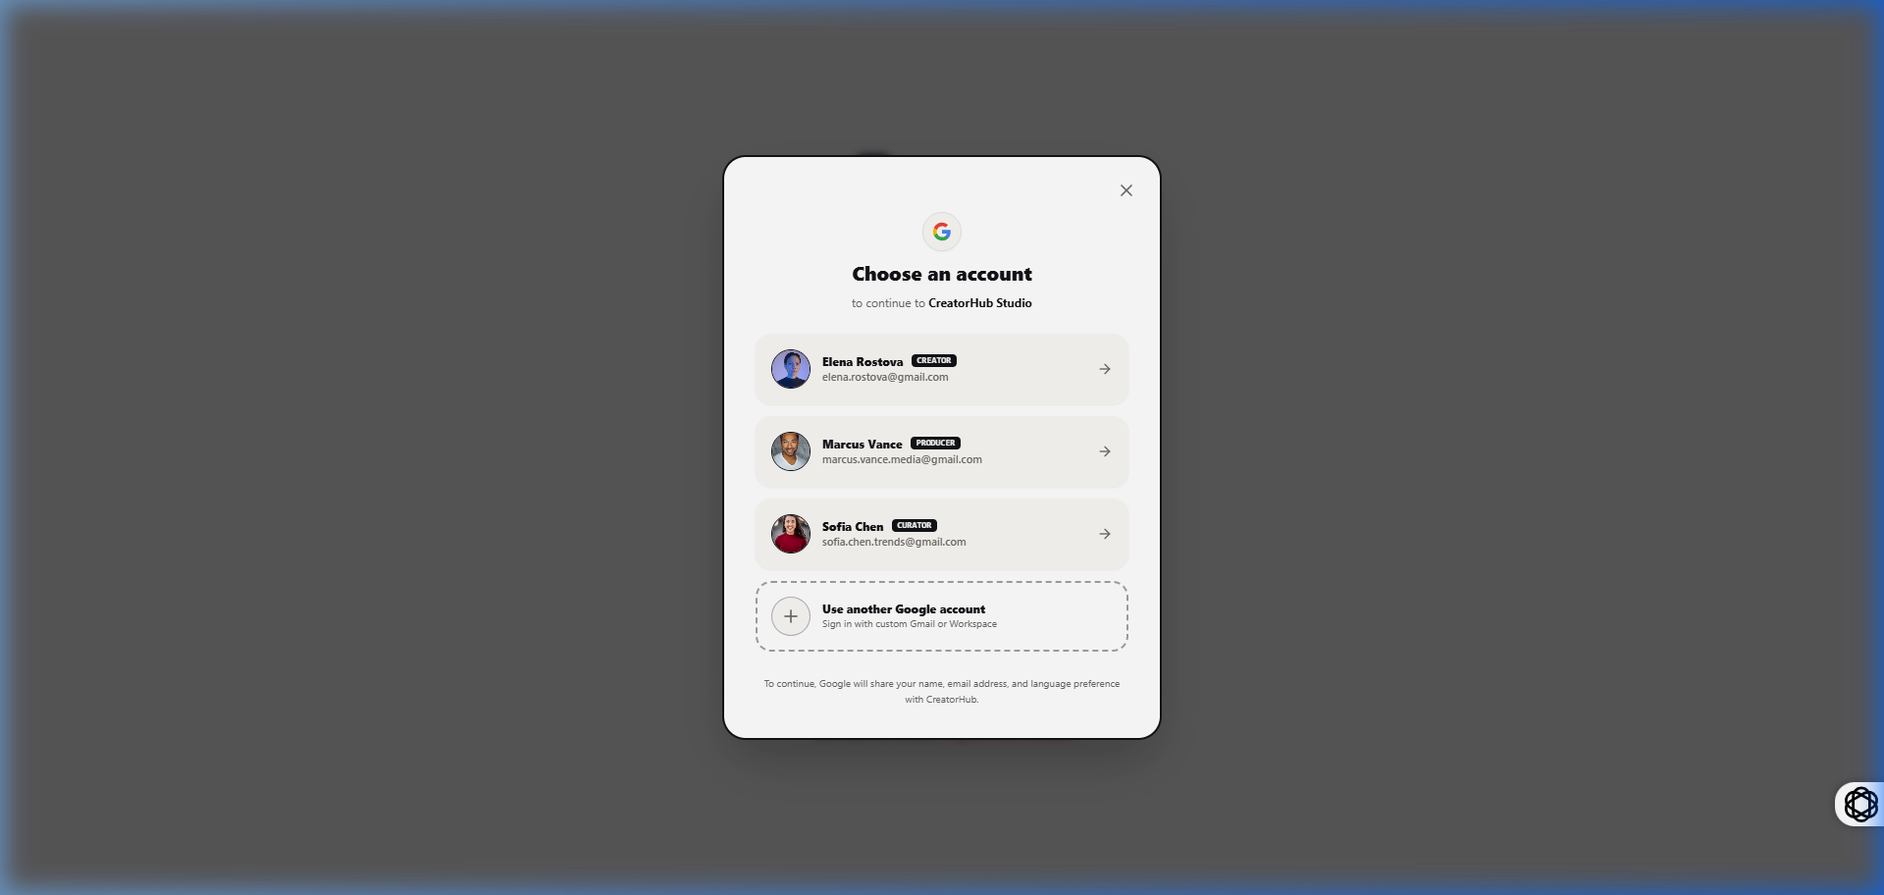
fig 8.5.1 Multi-Stage Video Production Pipeline Board
The production pipeline board organizes projects by operational stage. Project cards display assigned team members, format badges, and interactive task checklists. Moving a card updates the project status in real-time and coordinates handoffs between creators, producers, and editors.
8.6 CONTEXT-AWARE VIDEO REVIEW STUDIO
8.6.0 Purpose & Scope
Enables frame-synchronized collaboration by attaching timecoded feedback markers directly to HTML5 video streams with categorized revision tracking.
8.6.8 Screenshots
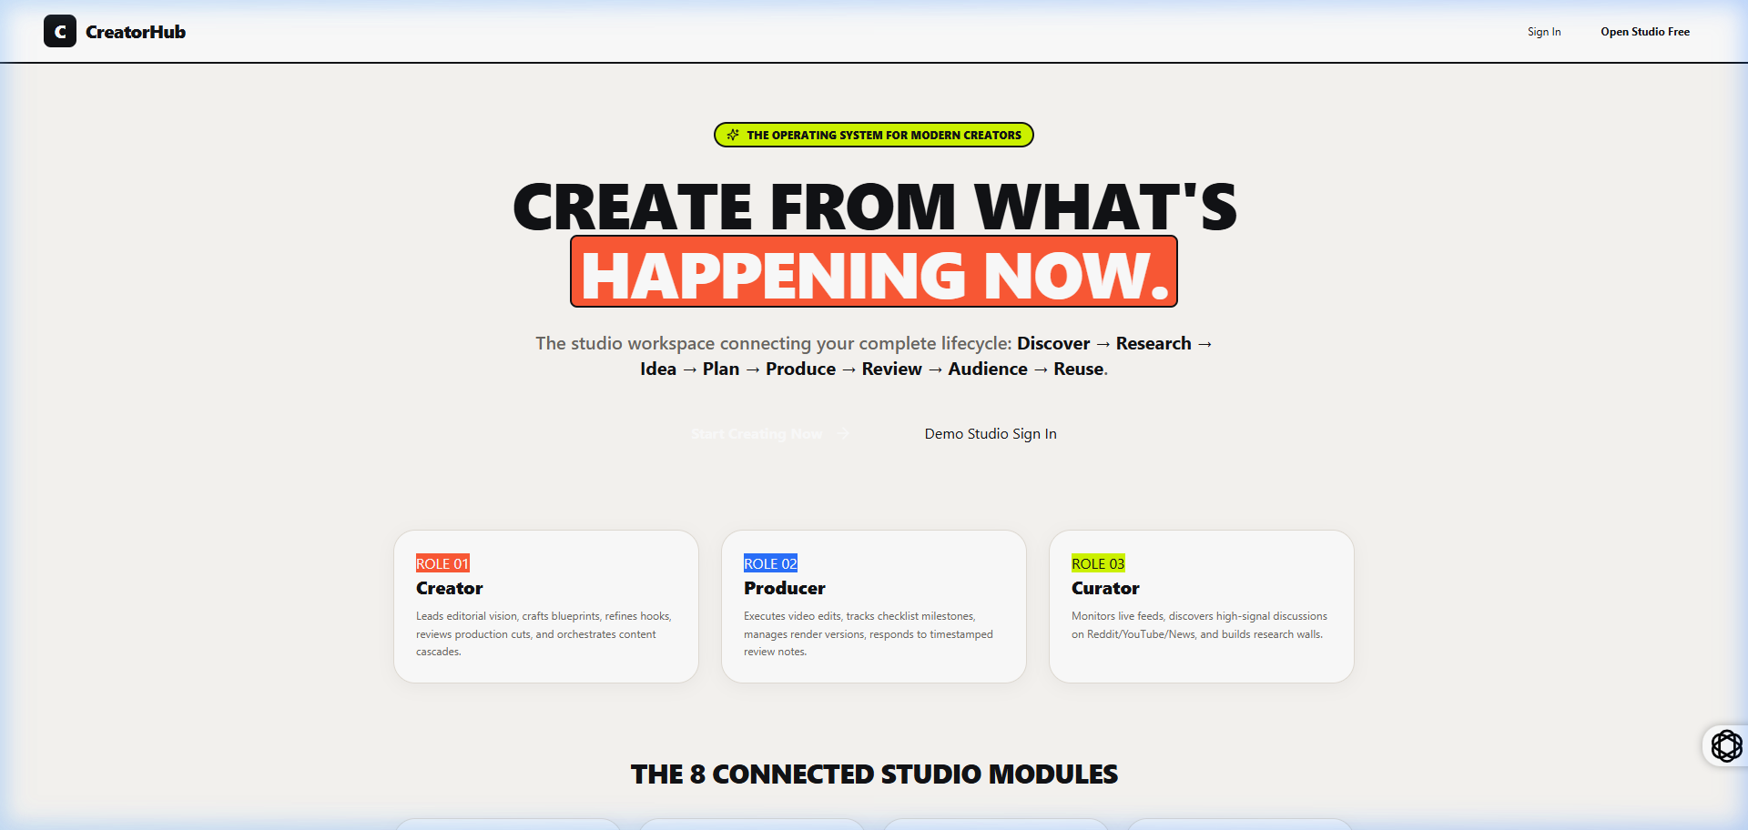
fig 8.6.1 Context-Aware Video Review Studio with Timeline Annotations
The review studio combines an HTML5 video player with a synchronized comment timeline. Reviewers click the timeline to drop feedback pins categorized by issue type (Pacing, Audio Cut, Visuals). Version selectors track edits across revisions and allow one-click cut approvals.
8.7 CONTENT FAMILY & ASSET DEPENDENCY GRAPH
8.7.0 Purpose & Scope
Manages 1-to-N content repurposing by linking 10-minute long-form master videos to derivative vertical Shorts, Instagram Reels, and LinkedIn carousels, tracking parent-child status cascading.
8.7.8 Screenshots
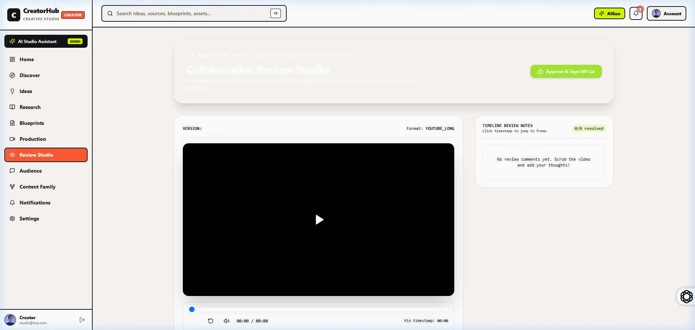
fig 8.7.1 Content Family & Hierarchical Asset Dependency Graph
The content family view visualizes the hierarchical relationship between master pillar videos and derived short-form clips. Child assets automatically inherit metadata from the parent. The completion tracker monitors overall campaign readiness across platforms.
8.8 ADMIN GOVERNANCE & SYSTEM AUDIT ANALYTICS
8.8.0 Purpose & Scope
Provides the Studio Administrator with operational governance, team member privilege controls, security audit logging, and system health metrics.
8.8.8 Screenshots
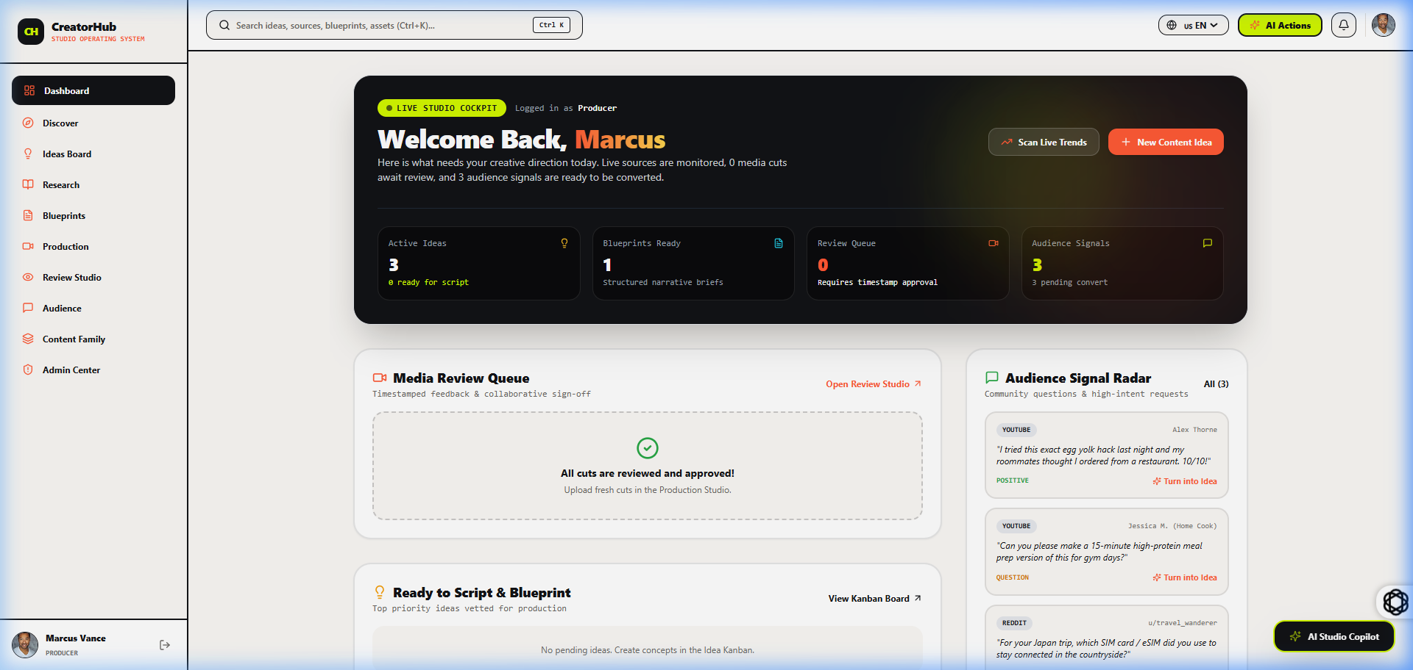
fig 8.8.1 Studio Administrator Governance & Security Analytics Dashboard
The administrative dashboard summarizes studio health through real-time KPI cards, active user counts, and recent security logs. The member table provides controls to manage user roles and account statuses across the studio.

CHAPTER 9
CONCLUSION

The CreatorHub Studio Operating System provides a complete digital solution for managing the major activities involved in digital content creation and multi-role studio operations. The system integrates master studio data management, live trend research, script blueprints, auto-scrolling teleprompters, multi-stage production boards, timestamped video review studios, asset dependency hierarchies, sponsorship CPM rate calculators, and administrative governance within a single application. By replacing manual records and disconnected processes across multiple external tools, it improves the accuracy, consistency, and accessibility of operational information. The application was developed using React 18 for the frontend, Node.js and Express for the backend, and MongoDB with Mongoose for database management. Its client-server architecture supports structured communication between the user interface, application server, and database. JWT authentication, bcrypt password hashing, role-based access control, request rate limiting, and protected routes help secure the system and prevent unauthorized access. The completed project demonstrates how a web-based information system can simplify studio operations, reduce repetitive work, minimize recording errors, and improve decision-making. Its modular structure makes the application easier to maintain and allows additional features to be introduced in the future. Overall, the CreatorHub Studio Operating System successfully meets its objective of providing a secure, organized, and efficient platform for managing digital creator activities.

