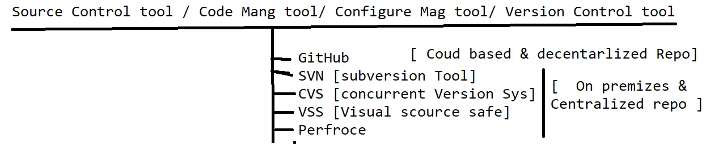

**What is GitHub**

It’s a distributed cloud decentralized repository where we can maintain our sourceCode / Automation Framework source code/ CRS doc /build of the application in one place

There are 2 Software in Git-Community

1. Git HUB : Cloud based repository(software) , which is used maintain the source code in one place , in order to use it just create an account with https://github.com
2. Git [Git client] : it’s a software should installed in client machine , which is used to communicate to GITHUB

EG : Git client Software EGit , GitDeskTop , GitBash

**Advantages of GitHud Cloud**

1. Since its cloud based repository , no need have maintenance team to maintain the Software / HardWare
2. Cloud means pay rent for what you use
3. Cloud software always access via internet
4. Cloud System / sever physically not present within the Organization, but present virtually
5. Initial investment is not required for Software/ Physical location
6. Scale UP / Scale Down is easy
7. File Share between the team members is easier
8. It provides remote access, it means anywhere contributors can access via internet
9. Provide History for changes made by users & backup facility
10. GitHub also provide platform to review [pull request] the Code of Automaton test scripts
11. GitHub Also handle the conflict’s
12. Jenkins Always get the latest framework from the Git for batch Execution

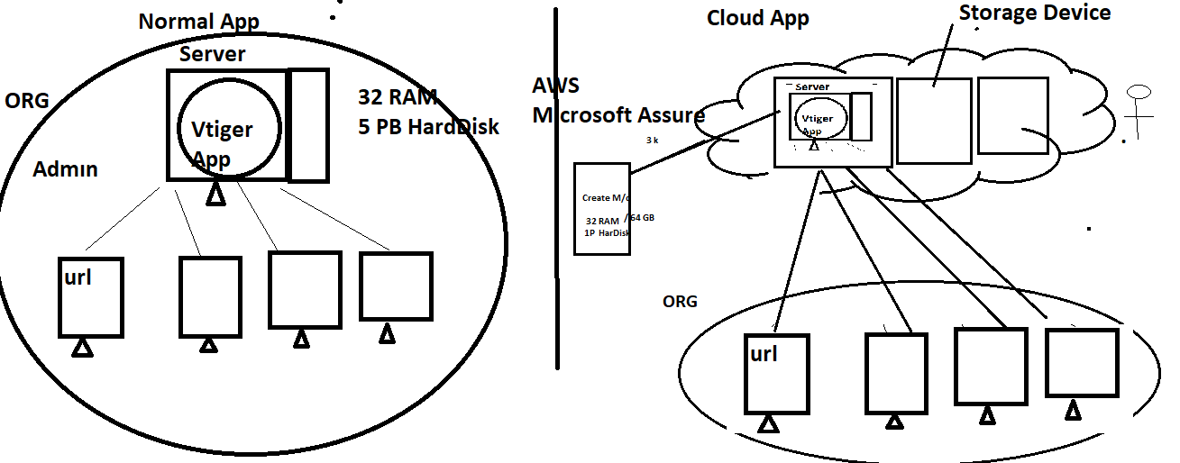

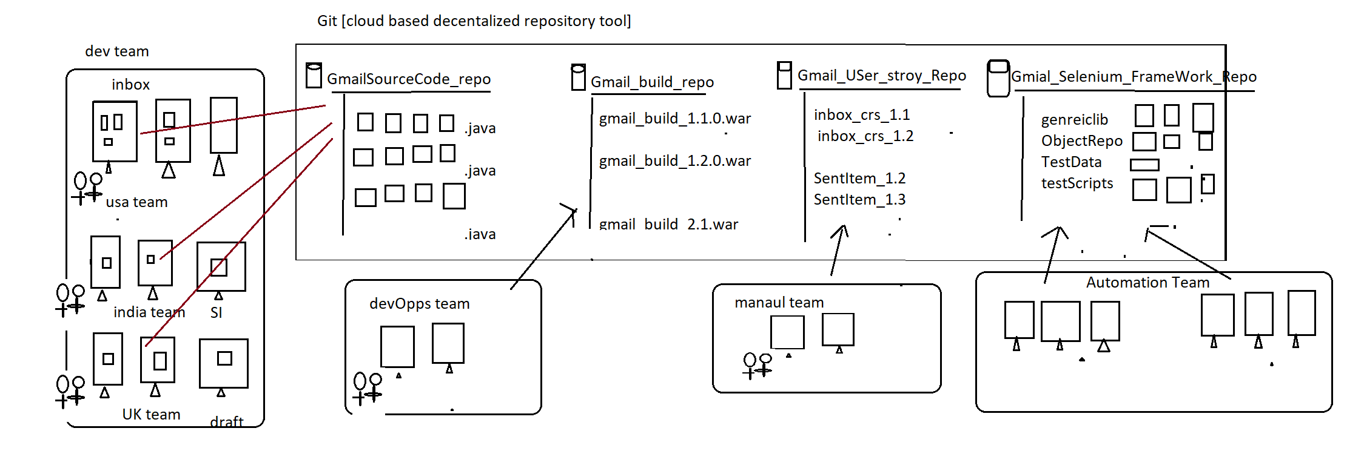

Developer Usage of Git : used to maintain the Source of the Application in one place

Automation Usage of Git : used to maintain the entire Automation framework in one place

DevOps Usage of Git : used to maintain the multiple application build version(like .exe, .war , .tar , .jar etc) in one place

Manual team Usage of Git : used to maintain the entire CRS / use case of the application

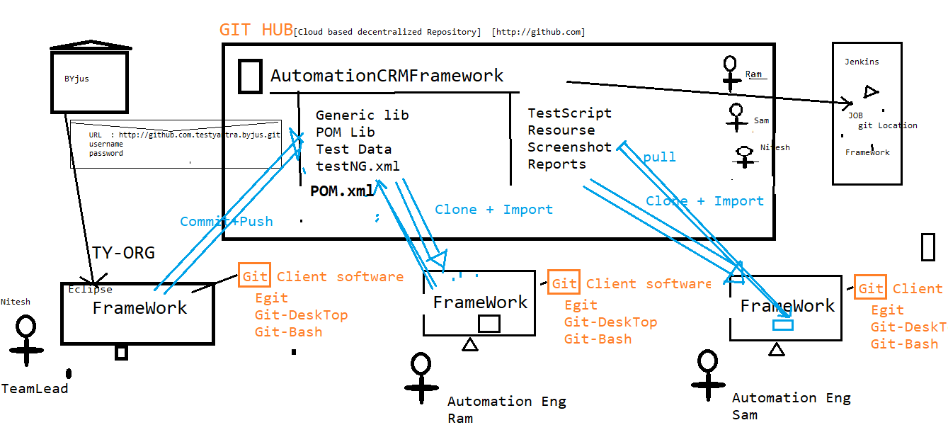

**Git Architecture**

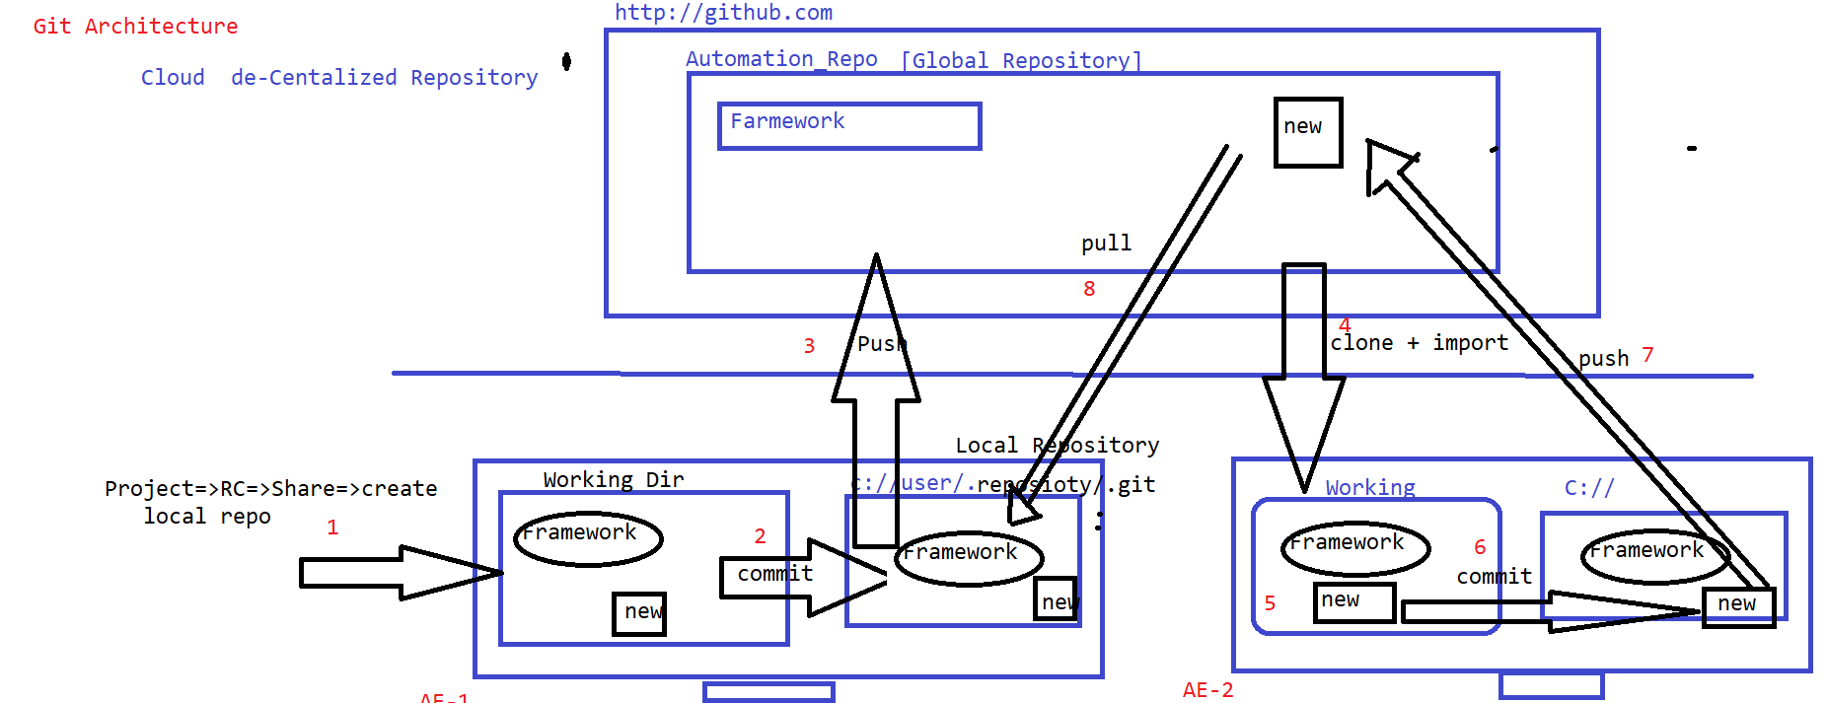

**Why Git is Decentralized Repository?**

Git is Decentralized Repository because, in Git before pushing any Code to git Hub, we have to commit the code to local repository first, make sure code is working in Local Repository then push Code to GITHUB(Global Repo)

* There are Three stages in Git , start with “Working Diretory”🡺Local Repo🡺Global Repo

**What is Git Conflicts**

When two or more engineers modified the same file , when Eng-1 one push the file to GitHub will not get any conflicts , but Eng-2 try to push the same file to GitHub , will get git

Conflicts (because that file already modified by Eng-1)

Solution: Before push any file to GitHub, we should mandatorily Pull the Project & select merge option , then[eclipse automatically merge the Code with comments]& remove comments manually & analyse the code then push it

**What is Pull Request & git branching ?** 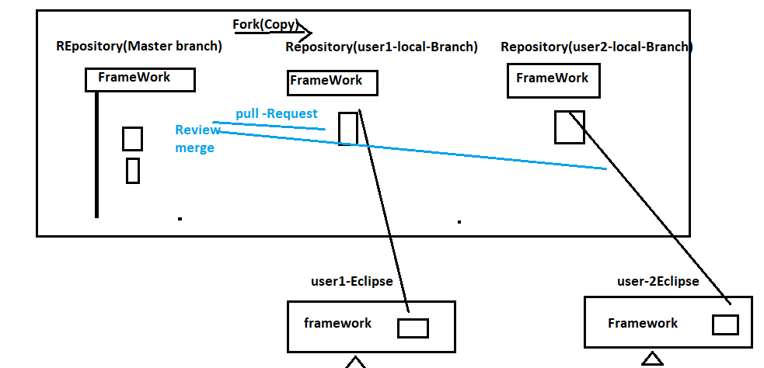

Whenever user made changes in the Programs , some Organization will not have access to push your changes to Master-Branch , in such case we supposed to create a local branch using “fork” option , than push the changes to local branch & than create “Pull Request” to Team lead asking for “REVIEW & MERGE” my program to master branch

Can u explain Git Commands?

Commit

Pull

Push

merge

Clone

Fork

How to create account with Git-Hub

1. Go to [www.github.com](http://www.github.com)
2. Click on sign Up
3. Create an account [capture username/password]

How to create Repository in Git-Hub

1. Login to github
2. click on “new Button ” or click on “+”=>new Repository
3. enter all the details & click on “CREATE” BUTTON
4. COPY Git URL 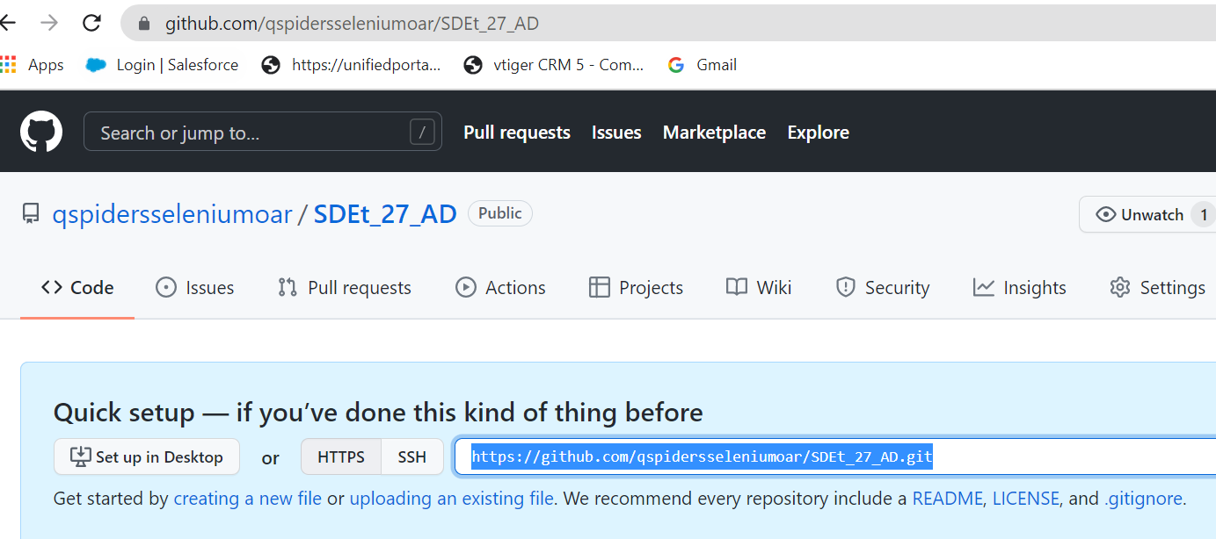

How to create Token ID for Git-Hub instead of password

1. login to GitHub
2. Go to “Profile Image” Icon
3. Click on Settings
4. Click on “Devlopers settings”
5. Click on “Personal Access Token”
6. Click on “Generate new Token” button
7. Enter the TokenID name & select repo “CheckBox”
8. Click on “generate token” button
9. Copy the Token ID

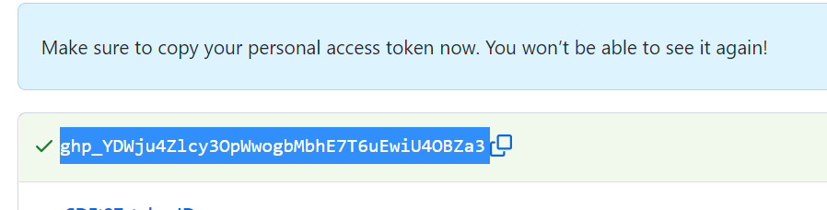

How to share the Eclipse Project to Git

1. Select the Project 🡺Right click 🡺 Team🡺 Share Project
2. Click on Finish

How to push your framework from Working_Dir to Local Repository?

1. Select the Project 🡺Right click 🡺 Team🡺 Commit
2. Drag the Files from upstaged area to Staged-Area
3. With comment
4. Click on “Commit”

How to push your framework from Local_Repo to GitHub [Global Repository]?

1. Select the Project 🡺Right click 🡺 Team🡺 Commit
2. Drag the Files from upstaged area to Staged-Area
3. With comment
4. Click on “Commit-Push”

How to get Framework from GitHub to local System very first Time

1. Go to Eclipse
2. Click on “File”
3. Click on import
4. Expand “Git” folder
5. Click on “Project from git”
6. Click on “Clone URL”
7. Enter “Git URL” username/TokenID
8. Click on finish
9. Enter framework will be loaded from Global Repo to Local Repo

How to push newly created file from Local to Global[GitHub]

1. Select the “new File” in side the package
2. Right Click 🡺 team
3. Click on commit
4. Drag the “new File” from upstaged area 🡺 staged area
5. Click on “Commit & Bpush”

How to get newly created file from Global[GitHub] to local

1. Select the project
2. Right Click🡺 Team
3. Click on “pull” => merge
4. Click on finish