CAREER PAGE API DOCUMENTATION

Organization Name : Elements HR
{YOUR_API_KEY}* : A731C86A-0D9F-45AB-8ABB-67A15543AE9E
*Please DO NOT share the API with anyone

Please find the api to fetch career page jobs information.
Api : api.turbohire.co/careerpagejobs
(Header) X-Api-Key : {A731C86A-0D9F-45AB-8ABB-67A15543AE9E }

Here is a quick curl request to use in postman to test the api.
POST /api/careerpagejobs HTTP/1.1
Host: api.turbohire.co
X-Api-Key: {A731C86A-0D9F-45AB-8ABB-67A15543AE9E}
Accept: */*
Cache-Control: no-cache
Swagger Information about API:
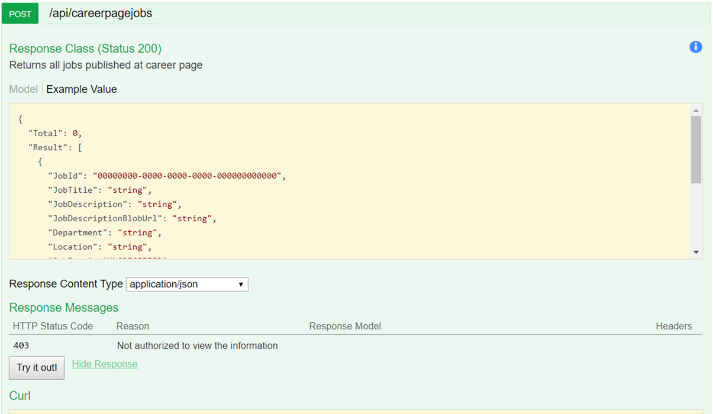
Response Model:
{
"Total": 0,
"Result": [
{
"JobId": "00000000-0000-0000-0000-000000000000",
"JobTitle": "string",
"JobDescription": "string",
"JobDescriptionBlobUrl": "string",
"JobDescriptionVideoUrl": "string",
"JobCode": "string",
"RolesAndResponsibilities": "string",
"Eligibility": "string",
"Department": "string",
"Location": "string",
"Experience": {
"MinExp": 0,
"MaxExp": 0
},
"JobType": "UNSPECIFIED",
"NumberOfVacancy": 0,
"CreatedByName": "string",
"CreatedByEmail": "string",
"CreatedDate": "2020-02-19T06:37:33.479Z",
"UpdatedDate": "2020-02-19T06:37:33.479Z",
"ApplyUrl": "string"
}
]
}

SAMPLE CODE:

HTML:
<html>

<head>
<title>Jobs Page</title>
</head>
<body>
<div id="jobs">

</div>
</body>

<script src="https://ajax.googleapis.com/ajax/libs/jquery/3.4.1/jquery.min.js"></script>
<script>
var settings = {
"async": true,
"crossDomain": true,
"url": "https://api.turbohire.co/api/careerpagejobs",
"method": "POST",
"headers": {
"X-Api-Key": "{A731C86A-0D9F-45AB-8ABB-67A15543AE9E}",
"Accept": "*/*",
"Cache-Control": "no-cache",
"Host": "api.turbohire.co",
"Accept-Encoding": "gzip, deflate",
"Content-Length": "0",
"Connection": "keep-alive",
"cache-control": "no-cache"
}
}

$(document).ready(function () {
$.ajax(settings).done(function (response) {
response.Result.forEach(function (job) {
$("#jobs").append($(`<div style="display: flex;flex-direction: column;width: 20%;">
<h1>${job.JobTitle}</h1>
<div>${job.JobDescription}</div>
<button><a href="${job.ApplyUrl}"> Apply </a></button>
</div>`));
})
});
})
</script>

</html>

REFERENCE:

Please see the below websites as Reference:
- ByteRidge
- Avanse
- StellApps
- Wingify

