To :
TECH GURU PLUS
Logo

Mr. Nazim Khan www.TechGuruPlus.com Najibabad
 +91 9999999999


test@yahoo.com
Najibabad, District Bijnor
September 11, 2023


Nazim Khan
19999-999-999
test@gmail.com
Najibabad, Bijnor
www.techguruplus.com

Get this template from TechGuruPlus.com, where we have lots of other templates too. To see more templates-
Go to our website page: https://techguruplus.com/letterhead-templates/ If you can't find the template you want, just leave a comment in the comment box on our website, and we'll make new templates for you. You can then download these new templates for free after a week.

Sincerely,
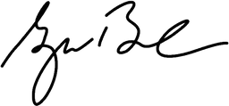
General Manager

