**Type Script**

Typescript is superset of JavaScript

add static types to JS

both dynamic and static languages depend of types (Def of data structure and their behaviors)

dynamic language - validates data structure during runtime, errors caught during runtime not during development time

static - catch dev errors before code executes.

JavaScript - dynamic

typescript - static typing capabilities 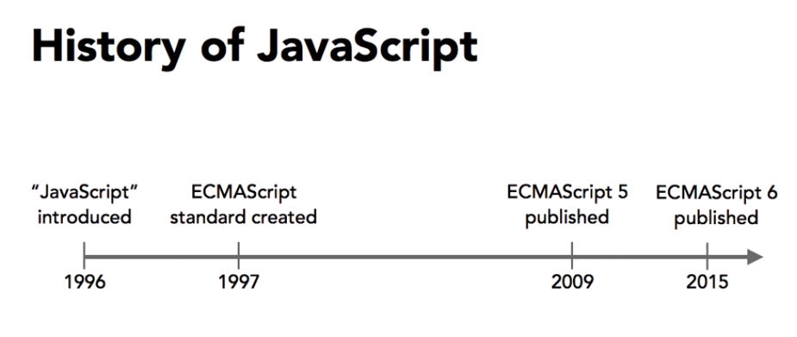

Transpilers - Tool that translate code from one language to another langauge , Typescript to ECMAscript 5

Type Script - <https://www.typescriptlang.org/>

Document - <https://www.typescriptlang.org/docs/home.html>

ECMAScript compatibility table - <https://kangax.github.io/compat-table/es6/>