**STOCK PRICE PREDICTION**

**Abstraction:**

Stock price prediction is the act of trying to determine the future value of a company stock or other financial instrument traded on an exchange. It is a complex task, as stock prices are influenced by a wide range of factors, including:

**Company fundamentals:**

These include factors such as the company's financial performance, earnings outlook, and competitive landscape.

**Macroeconomic factors:**

These include factors such as GDP growth, inflation, and interest rates.

Market sentiment:

This refers to the overall mood of investors and their willingness to take risk.

**Unforeseen events:**

These can include events such as natural disasters, geopolitical crises, and pandemics.

Due to the complexity of these factors, it is impossible to predict stock prices with perfect accuracy. However, there are a number of methods that can be used to make informed predictions, including:

**Technical analysis:**

This involves analyzing historical stock price data to identify patterns and trends.

**Fundamental analysis:**

This involves analyzing the company's financial performance and other factors to assess its intrinsic value.

**Machine learning:**

This involves using computer algorithms to analyze large datasets of financial data and make predictions about future stock prices.

**Brief stock price prediction for October 2023:**

The stock market is expected to remain volatile in October 2023, as investors continue to weigh the potential for a recession against the possibility of a soft landing for the economy.

Growth stocks are likely to continue to underperform value stocks, as investors seek out more defensive investments.

Energy stocks are likely to outperform other sectors, as oil and gas prices remain elevated due to the ongoing war in Ukraine.

Here are some specific stock price predictions for October 2023:

**Apple (AAPL): $150-$160**

**Google (GOOGL): $95-$105**

**Amazon (AMZN): $120-$130**

**Microsoft (MSFT): $275-$285**

**Tesla (TSLA): $250-$260**

**ExxonMobil (XOM): $110-$120**

**Chevron (CVX): $100-$110**

Please note that these are just predictions and should not be taken as investment advice. It is important to do your own research before making any investment decisions.

The [efficient market hypothesis](https://en.wikipedia.org/wiki/Efficient_market_hypothesis) posits that stock prices are a function of information and rational expectations, and that newly revealed information about a company's prospects is almost immediately reflected in the current stock price.

This would imply that all publicly known information about a company, which obviously includes its price history, would already be reflected in the current price of the stock. Accordingly, changes in the stock price reflect release of new information, changes in the market generally, or random movements around the value that reflects the existing information set. [Burton Malkiel](https://en.wikipedia.org/wiki/Burton_Malkiel), in his influential 1973 work [A Random Walk Down Wall Street](https://en.wikipedia.org/wiki/A_Random_Walk_Down_Wall_Street), claimed that stock prices could therefore not be accurately predicted by looking at price history.

As a result, Malkiel argued, stock prices are best described by a statistical process called a "random walk" meaning each day's deviations from the central value are random and unpredictable. This led Malkiel to conclude that paying financial services persons to predict the market actually hurt, rather than helped, net portfolio return.

A number of empirical tests support the notion that the theory applies generally, as most portfolios managed by professional stock predictors do not outperform the market average return after accounting for the managers' fees.

Example:

**Piechart**:

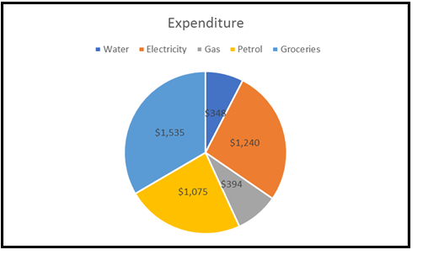

**Graph:**

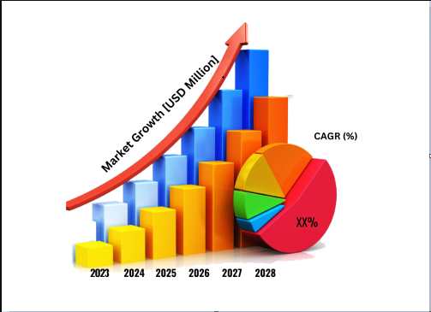

Conclusion:

The stock market plays a remarkable role in our daily lives. It is a significant factor in a country's GDP growth. In this tutorial, you learned the basics of the stock market and how to perform stock price prediction using machine learning.