MURALIKRISHNAN SRINIVASAN
Industrial & Product Design EngineerIndustrial & Product Design Engineer
Salem, Tamil Nadu, India | srinimurali121@gmail.com | +91 88701 44521

PROFESSIONAL SUMMARY
Industrial and Product Design engineer with strong experience in CAD modeling, product development, and manufacturing technologies. Experienced in SolidWorks product design, injection molding design, and prototyping. Passionate about creating innovative engineering solutions and improving product functionality through design optimization.

EDUCATION
Bachelor of Engineering in Mechanical Engineering
Sri Shanmugha College of Engineering and Technology
Expected 2026 | CGPA: 7.6

TECHNICAL SKILLS
CAD Software | SolidWorks, CATIA V5, AutoCAD, Creo
Design Capabilities | 3D Modeling, Engineering Drawings, DFM, Injection Molding Design
Manufacturing | 3D Printing, 3D Scanning, Prototyping, Product Validation
Core Strengths | Creative Problem Solving, Decision Making, Design Assembly

WORK EXPERIENCE
Product Design Intern at Tamirabot Advanced Engineering Pvt Ltd (March 2025 – May 2025)
• Worked on complete product design lifecycle from concept development to manufacturing delivery.
• Created detailed 3D models using SolidWorks.
• Designed products optimized for injection molding and cost efficiency.
• Managed prototyping and validation processes.
In Plant Training at TVS Mobility, Sankari (July 2024)
• Exposure to automotive manufacturing processes and assembly workflows.
• Learned quality control procedures and production operations.
Industrial Training at Salem Steel Plant (2023)
• Studied industrial manufacturing processes and steel production workflows.

CERTIFICATIONS
• NPTEL – Manufacturing Process Technology I & II
• Diploma in Mechatronics – Alison
• Introduction to Aircraft Design – Alison
• NPTEL – Sustainable Power Generation Systems
• AutoCAD – GUVI
• CATIA Basics – Great Learning

ENGINEERING PROJECTS
MULTIPURPOSE TILTABLE ELECTRIC TROLLEY
Design Patent No: 300578-001 | Status: Granted
Designed and developed a Multipurpose Tiltable Electric Trolley — a patented utility vehicle that combines electric mobility with a tiltable hopper mechanism and a detachable flat-bed platform, enabling versatile material handling across industrial, agricultural, and construction environments.
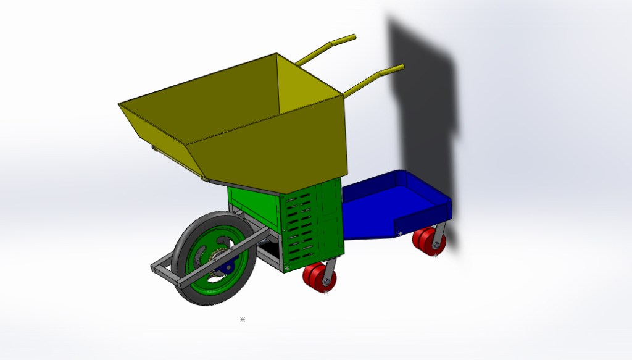
Key Contributions:
• Modeled the complete assembly in SolidWorks — including sheet metal hopper, structural chassis, and wheel sub-assemblies
• Applied sheet metal design principles (bends, flanges, clearance tolerances) for the hopper and body panels
• Designed the tilt mechanism to achieve a controlled dump angle while maintaining structural integrity under load
• Leveraged injection molding and fabrication knowledge (from Tamirabot internship) to ensure design-for-manufacturing compliance
• Conducted spatial and load path analysis to balance the center of gravity across tilt and flat-bed modes
AI BASED MULTI-CROP HEALTH MONITORING AUTONOMOUS DEVICE
Agricultural Robotics
Designed and developed a concept model of an Automated Pesticide Spraying Robot aimed at reducing human exposure to harmful pesticides in agricultural fields. The project focused on remote-controlled spraying operations using an Arduino-based control system, improving farmer safety, efficiency, and crop productivity through intelligent automation.
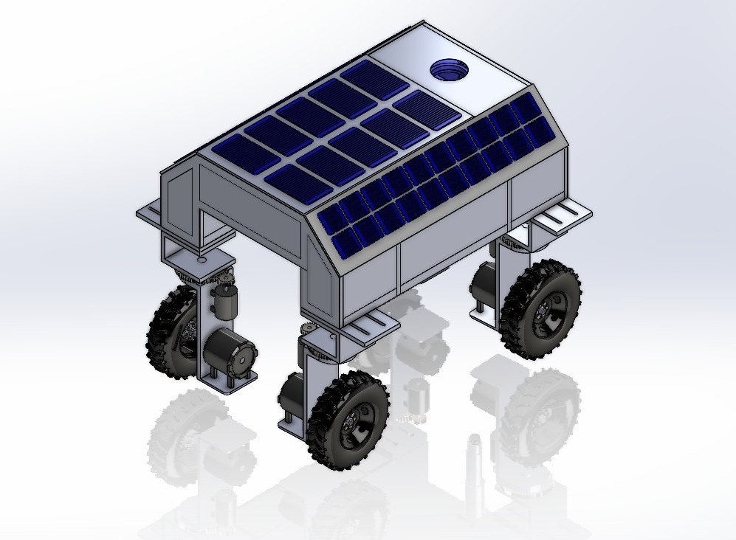
Key Contributions:
• Designed the full robot structure and body layout using SolidWorks CAD modeling
• Developed the locomotion system using DC geared motors for off-road agricultural terrain
• Designed and integrated the pesticide spraying mechanism for uniform coverage
• Implemented direction and speed control using motor drivers and servo motors
• Programmed remote operation via Bluetooth-enabled Android application
• Designed the power supply system using battery pack and DC-DC converter
• Validated the concept model against real-world agricultural use cases
MICRO INJECTION MOLDING MECHINE
Precision Tooling & Manufacturing
During my industrial training, I designed and developed a micro injection molding machine aimed at manufacturing terminal caps for electrical contact pins. The project focused on achieving precision molding for small components while understanding real-world tooling and process parameters.
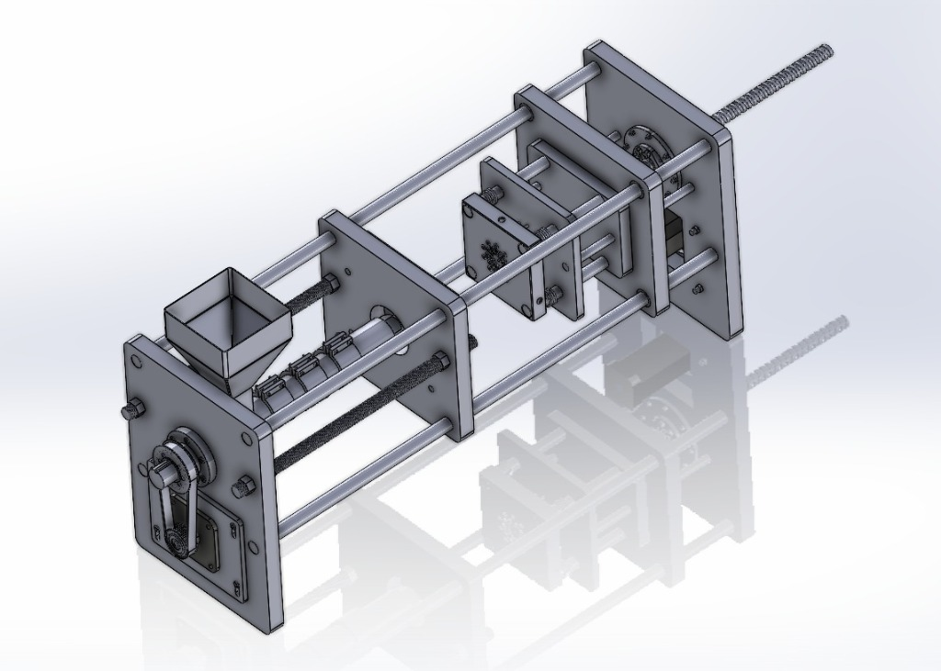
Key Contributions:
• Designed the micro injection molding machine concept and components using CAD tools
• Developed mold design including core and cavity for terminal cap geometry
• Studied and implemented runner and gate design for proper material flow
• Assisted in tooling setup and mold assembly
• Analyzed injection pressure requirements and material flow behavior
• Worked on part ejection mechanisms to ensure defect-free removal
• Collaborated with the production team during trial runs and optimization

