

Mohd. Razia Alangir Banu
MALLAVARPU BALA PRANITHA
2520030051
CSE
CO-6

Case Study Topic: Smart Event Management & Scheduling System

Workdone Summary:
The EventSphere system was developed to manage event scheduling and resource allocation efficiently. Event records were sorted using efficient sorting algorithms to organize schedules. A greedy approach was used to select the maximum number of non-overlapping events, while dynamic programming techniques were applied to optimize resource usage and scheduling decisions. The system improved event planning, reduced scheduling conflicts, and maximized resource utilization.

Implementation Details
- Event details are stored using appropriate Java classes.
- Merge Sort is used to arrange events based on start time.
- Quick Sort is used for priority-based event ranking.
- Greedy Activity Selection is applied to schedule the maximum number of non-conflicting events.
- Dynamic Programming is used to optimize resource allocation.
- The final schedule minimizes conflicts and improves resource utilization.

Result:

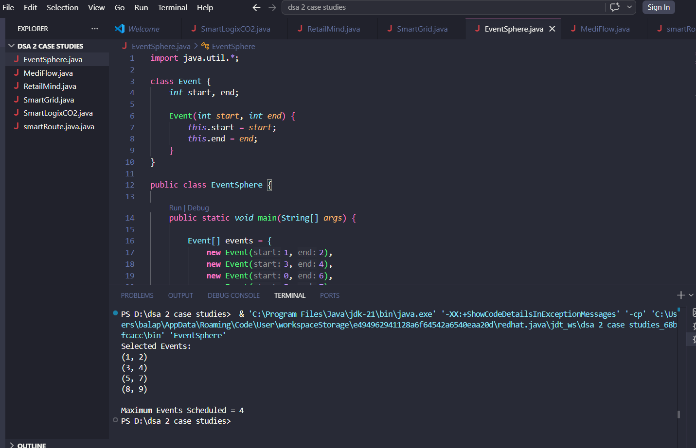

The EventSphere system uses the Greedy Activity Selection algorithm to schedule the maximum number of non-overlapping events. This improves event planning, reduces scheduling conflicts, and ensures efficient utilization of available venues and resources.

Github Link: https://github.com/balapranithamallavarapu-cmyk/DSA-II-Case-Studies

