**What is a Hub and Node?**

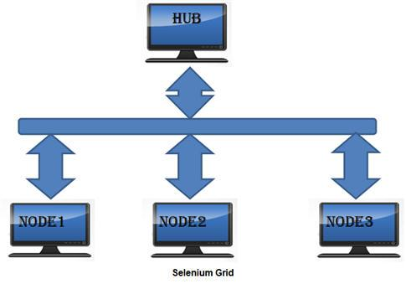

**The Hub**

* The hub is the central point where you load your tests into.
* There should only be one hub in a grid.
* The hub is launched only on a single machine, say, a computer whose O.S is Windows 7 and whose browser is IE.
* The machine containing the hub is where the tests will be run, but you will see the browser being automated on the node.

**The Nodes**

* Nodes are the Selenium instances that will execute the tests that you loaded on the hub.
* There can be one or more nodes in a grid.
* Nodes can be launched on multiple machines with different platforms and browsers.
* The machines running the nodes need not be the same platform as that of the hub.

**Hub**: Hub is central point to the entire GRID Architecture which receives all requests. There is only one hub in the selenium grid. Hub distributes the test cases across each node.

**Node**: There can be multiple nodes in Grid. Tests will run in nodes. Each node communicates with the Hub and performs test assigned to it.

### Install Selenium GRID

**Step 1**: Download Selenium Server jar file from Selenium’s official website which is formerly known as Selenium RC Server and save it at any location on the local disk.

URL of selenium HQ: <http://www.seleniumhq.org/download/>

**Step 2**: Open command prompt and navigate to folder where the server is located. Run the server by using below command

*java -jar selenium-server-standalone-2.41.0.jar -role hub*

The hub will use the port 4444 by default. This port can be changed by passing the different port number in command prompt provided the port is open and has not been assigned a task.

Status can be checked by using the web interface:*http://localhost:4444/grid/console*

**Step 3**: Go to the other machine where you intend to setup Nodes. Open the command prompt and run the below line.

|  |  |  |
| --- | --- | --- |
| 1 | java -jar selenium-server-standalone-2.41.0.jar -role node -hub | |
| 2 | http://localhost:4444/grid/register -port 5556 |

Run the selenium server in other machines to start nodes.

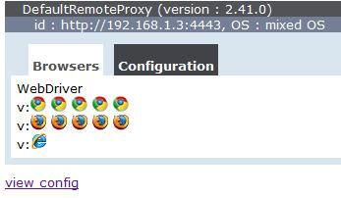

Hub

On the command prompt, type [**java**](http://www.guru99.com/java-tutorial.html)**-jar selenium-server-standalone-2.30.0.jar -role hub**

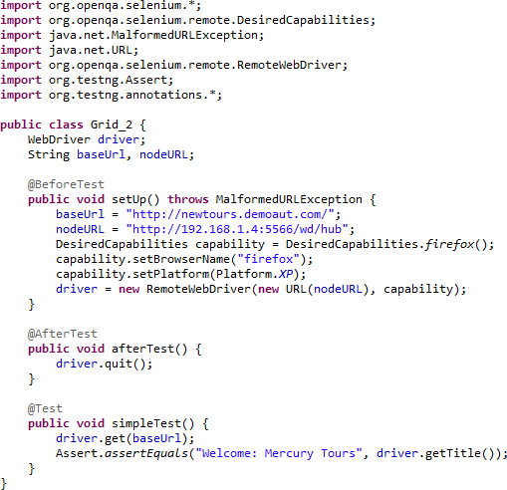

**Benefits of Selenium Grid:**

1. Selenium Grid gives the flexibility to distribute your test cases for execution.
2. Reduces batch processing time.
3. Can perform multi browser testing.
4. Can perform multi OS testing.

**Summary**

* Selenium Grid is used to run multiple tests simultaneously in different browsers and platforms.
* Grid uses the hub-node concept.
* The hub is the central point wherein you load your tests.
* Nodes are the Selenium instances that will execute the tests that you loaded on the hub.
* To install Selenium Grid, you only need to download the Selenium Server jar file - the same file used in running Selenium RC tests.
* There are 2 ways to verify if the hub is running: one was through the command prompt, and the other was through a browser
* To run test scripts on the Grid, you should use the DesiredCapabilities and the RemoteWebDriver objects.
* DesiredCapabilites is used to set the type of browser and OS that we will automate
* RemoteWebDriver is used to set which node (or machine) that our test will run against.