**COMMON ELEMENT**

**CODE:**

**package** test;

**public** **class** Ce {

**public** **static** **void** main(String args[])

{

**int**[] array1={4,5,8,1,87,45,3,2};

**int**[] array2={12,56,89,3,2,7,1,4,25};

**for**(**int** i=0;i<array1.length;i++)

{

**for**(**int** j=0;j<array2.length;j++)

{

**if**(array1[i]==array2[j])

{System.***out***.println("common element is:"+array1[i]);

}

}

}

}

}

**OUTPUT:** 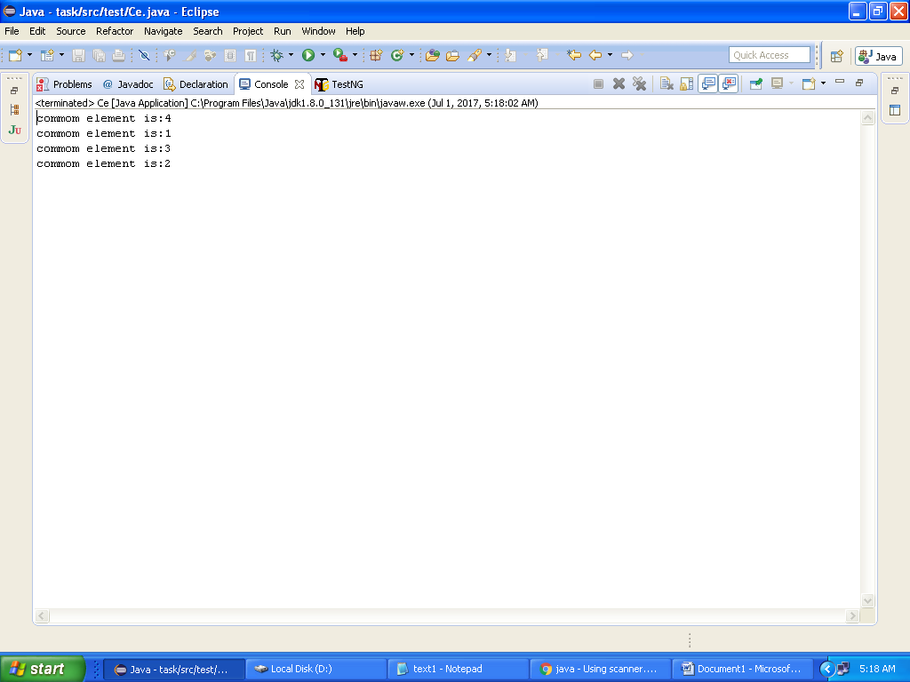

**STORE CONTENT LINE BY LINE IN A FILE**

**CODE:**

package test;

import java.io.BufferedWriter;

import java.io.File;

import java.io.FileWriter;

import java.io.IOException;

import java.io.Writer;

public class Stf {

public static void main(String[] args) {

BufferedWriter bufferedWriter = null;

try {

String strContent = "Objectives of defects:"+System.*lineSeparator*()+"Finding defects which may get created by the programmer while developing the software."+System.*lineSeparator*()+"To prevent defects."+System.*lineSeparator*()+"To gain confidence of the customer by providing them a quality product.";

File myFile = new File("d:/text1.txt");

System.*out*.println("Content successfully written.");

if (!myFile.exists()) {

myFile.createNewFile();

}

Writer writer = new FileWriter(myFile);

bufferedWriter = new BufferedWriter(writer);

bufferedWriter.write(strContent);

} catch (IOException e) {

e.printStackTrace();

} finally{

try{

if(bufferedWriter != null) bufferedWriter.close();

} catch(Exception ex){

}

}

}

}

**OUTPUT:**

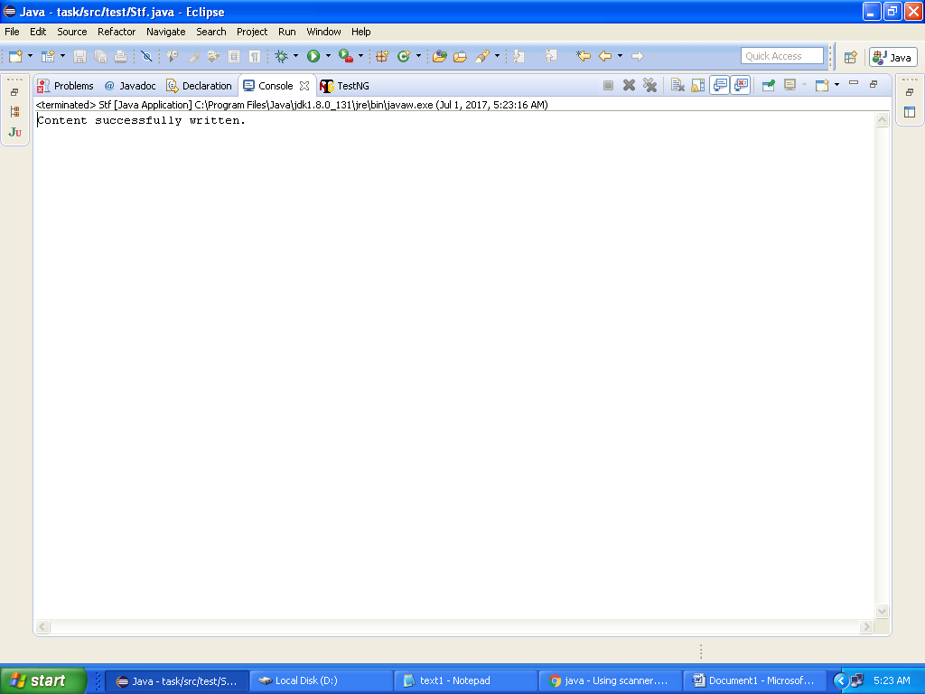

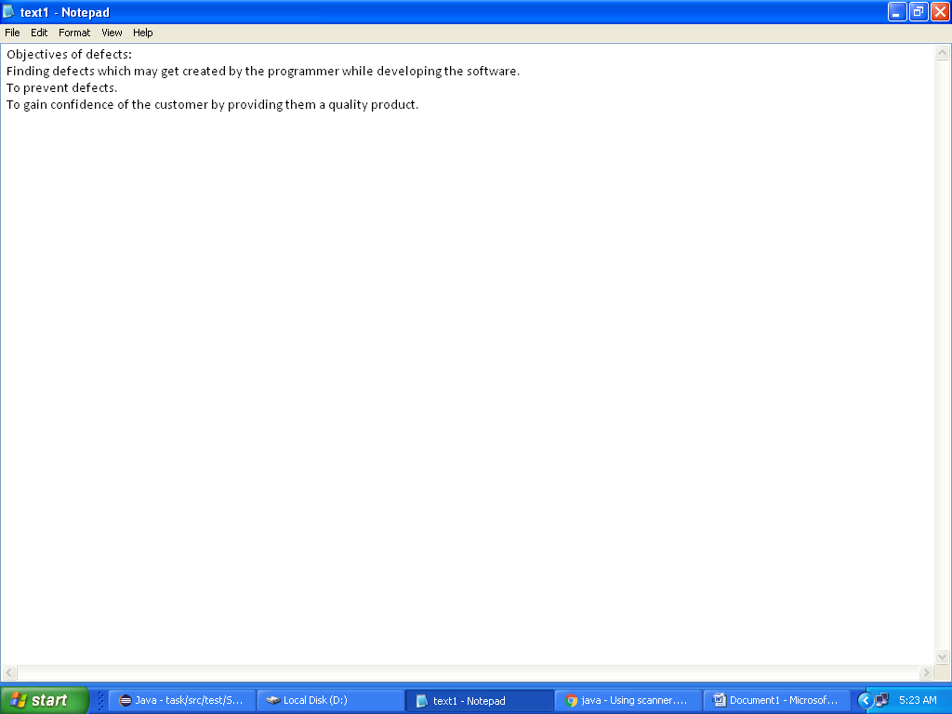

Screenshot for text file