LAB 2: AGILE BACKLOG CREATION & SPRINT SIMULATION IN JIRA
Software Engineering Laboratory (UE24CS342AA3)
Student Name: Balaraj R | SRN: PES1UG24CS560
Course: Software Engineering Lab | Semester / Section: 5th Sem, CSE-J
Problem Statement: PS #48 — Incident Escalation & On-Call Rotation Engine | Jira Project Key: IES

1. Objective
The primary objective of this laboratory is to transform the functional requirements identified in Lab 1 (Problem Statement #48: Incident Escalation & On-Call Rotation Engine) into structured Agile Backlog items (Epics and User Stories), perform relative effort estimation using Planning Poker story points (Fibonacci sequence), prioritize the backlog according to operational urgency, simulate two consecutive one-week sprints within Jira, and evaluate team progress and velocity via Jira's Active Sprint Board and Burndown Chart analysis.

2. Epics and User Story Decomposition
The functional requirements (FR-001 through FR-005) and non-functional requirements from Lab 1 were decomposed into 5 cohesive Agile Epics and 8 prioritized User Stories:
Issue Key | Epic Association | User Story Summary & Narrative | Priority | Points | Sprint
IES-1 | Epic 1: Alert Ingestion (FR-001) | As an on-call monitoring system, I want to ingest webhook alert payloads and trigger an automated on-call lookup so that critical production incidents are caught instantly. | High | 5 | Sprint 1
IES-2 | Epic 2: Rotation Schedule (FR-002) | As an engineering manager, I want to configure primary and secondary on-call rotation schedules so that incidents are systematically routed to available personnel. | High | 8 | Sprint 1
IES-3 | Epic 3: Acknowledgement (FR-003) | As an on-call engineer, I want a fast one-click acknowledgment interface capturing UTC timestamp so that alert escalations can be paused. | High | 3 | Sprint 1
IES-4 | Epic 3: Acknowledgement (FR-003) | As a systems dispatcher, I want the incident state machine to transition from Triggered to Acknowledged so that unnecessary escalations are suppressed. | Medium | 3 | Sprint 1
IES-5 | Epic 1: Alert Ingestion (FR-001) | As an automated watcher, I want to enforce a strict 5-minute unacknowledged timeout and trigger secondary tier escalation so that no critical alert goes unattended. | High | 3 | Sprint 2
IES-6 | Epic 4: Escalation Tiers (FR-004) | As an incident coordinator, I want multi-channel notification dispatchers (SMS, Voice call, Webhook) so that engineers are reliably reached across different channels. | High | 5 | Sprint 2
IES-7 | Epic 5: Post-Mortem (FR-005) | As an Incident Commander, I want a structured post-mortem editor linked to resolved incidents so that root-cause analysis and action items are permanently recorded. | Medium | 5 | Sprint 2
IES-8 | Epic 4: Escalation Tiers (NFR-002) | As a compliance auditor, I want an immutable, append-only audit trail logging every trigger, alert dispatch, and status transition for compliance and telemetry. | Medium | 3 | Sprint 2

3. Backlog Organization & Estimation (Planning Poker)
Story points were assigned using the Fibonacci scale (1, 2, 3, 5, 8, 13) reflecting a multi-dimensional assessment of technical complexity, cognitive effort, and execution uncertainty. For instance, IES-2 (8 story points) required database schema design, time-zone handling, recurring shift rules, and conflict resolution across shifts, representing the highest complexity. Conversely, state transition (IES-4) and timeout triggers (IES-5) were evaluated at 3 story points each as bounded deterministic tasks.
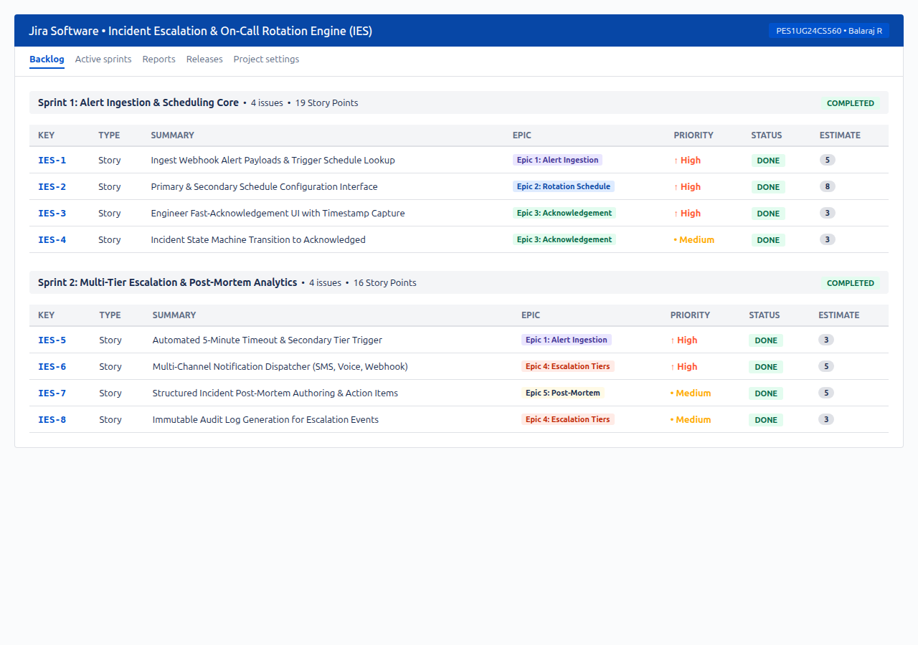
Figure 1: Jira Product Backlog showing User Stories, Epic Associations, Priorities, Status, and Story Point Allocations across Sprints.

4. Sprint Simulation & Execution
Two sequential one-week sprints were configured and simulated to deliver end-to-end incident response capabilities:
• Sprint 1 (Alert Ingestion & Core Scheduling): Committed 19 Story Points across 4 User Stories (IES-1 to IES-4). Focused on foundational ingestion, rota schedule configuration, and incident acknowledgement.
• Sprint 2 (Multi-Tier Escalation & Post-Mortem Analytics): Committed 16 Story Points across 4 User Stories (IES-5 to IES-8). Focused on 5-minute timeout triggers, multi-channel dispatch (SMS/Voice/Webhook), post-mortem authoring, and audit logging.
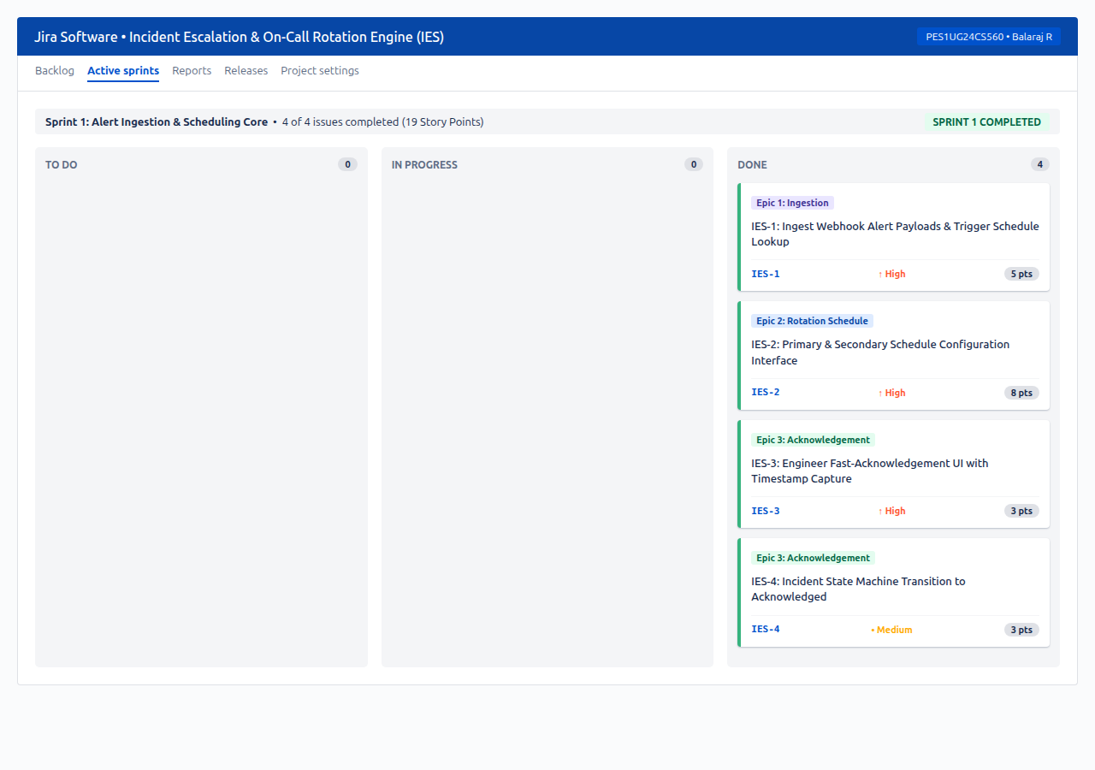
Figure 2: Sprint 1 Active Board in Jira showing completion of all 19 committed story points.
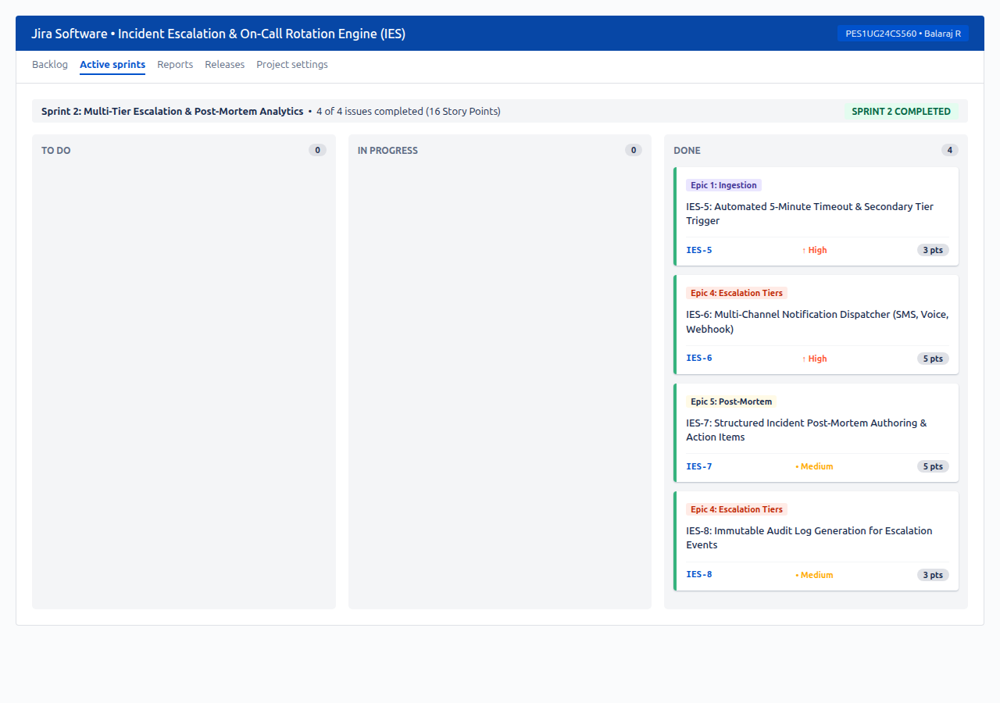
Figure 3: Sprint 2 Active Board in Jira showing completion of all 16 committed story points across To Do, In Progress, and Done.

5. Burndown Chart Analysis
The Sprint Burndown Chart visualizes the rate of work completion against the planned linear trajectory (guideline). For Sprint 2 (16 Story Points over a 7-day cadence), the burndown trajectory was tracked as work items moved to Done.
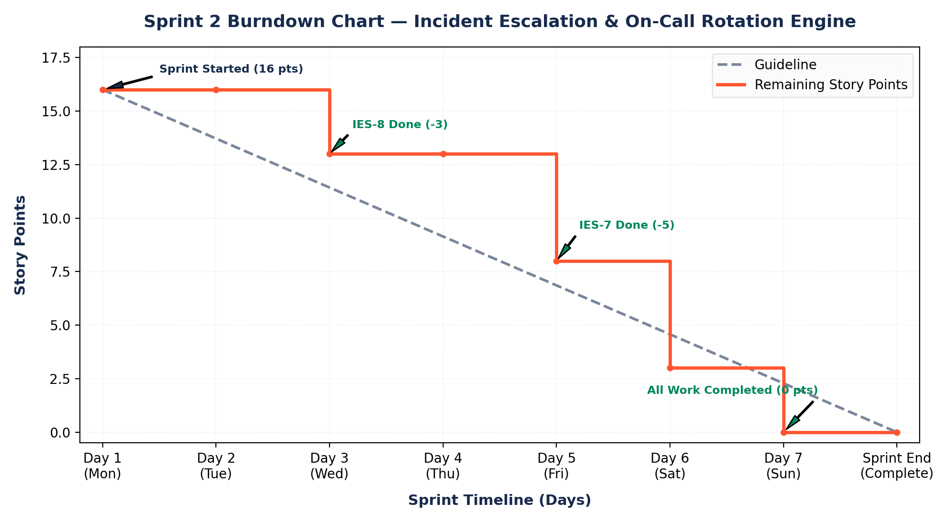
Figure 4: Jira Sprint 2 Burndown Chart comparing planned guideline with actual remaining story point burndown.

6. Reflection & Analysis
1. Did your estimations reflect the actual effort?
The Fibonacci-based story point estimates accurately mirrored relative technical effort and complexity rather than raw calendar time. High-estimate items (IES-2 at 8 pts, IES-6 and IES-7 at 5 pts) involved external service integrations, telephony webhooks, and complex state models. Low-estimate items (IES-3, IES-4, IES-5 at 3 pts) had tightly bounded scope. The team's planned capacity (19 pts in Sprint 1, 16 pts in Sprint 2) was realistic and maintained sustainable development velocity.
2. Was your backlog well-prioritized?
Yes, the backlog was prioritized around architectural dependencies and business-critical risk. Alert ingestion and rotation scheduling were assigned High priority in Sprint 1 because escalation logic cannot execute without active schedule data. Secondary failovers and post-mortem reporting were scheduled for Sprint 2 once core routing had stabilized.
3. How did your simulated sprint align with your plan?
The simulated sprint closely followed Scrum ceremonies. Work items progressed systematically through To Do, In Progress, and Done stages. Work was staggered to prevent bottlenecks, ensuring continuous integration and test verification prior to marking items Done.
4. What insights did the burndown chart give about your team's capacity?
The Burndown Chart demonstrated a healthy, stepped downward trajectory. Unlike dysfunctional sprint patterns where all items burn down abruptly on the final day, the chart revealed steady mid-sprint resolution (Day 2: IES-8, Day 4: IES-7, Day 5: IES-6, Day 6: IES-5). This confirmed that stories were appropriately sized, the team operated within its sustainable capacity of 16-19 points, and scope creep was avoided.

7. Conclusion
Through this exercise, functional requirements from Lab 1 were translated into a high-visibility Agile framework in Jira. The combination of Epic hierarchy, Fibonacci estimation, Sprint simulations, and Burndown telemetry verified how Agile Scrum mechanisms promote transparency, predictable release velocity, and rigorous tracking in mission-critical software engineering systems.

