PES UNIVERSITY
DEPARTMENT OF COMPUTER SCIENCE & ENGINEERING
SOFTWARE ENGINEERING LAB (UE24CS242) — ACADEMIC YEAR 2026
LAB 4: VIBE CODING & PROMPT-DRIVEN SWE REPAIR
Student Name: Balaraj R | SRN: PES1UG24CS560
Semester & Branch: 4th Semester, B.Tech CSE (AI & ML) | Assigned Repository: SETAPESU26/11_maze_chase
Date of Experiment: October 7, 2026 | Evaluation Status: Completed & Verified

1. Objective & Lab Overview
The primary objective of this laboratory exercise is to harness modern AI vibe-coding workflows to analyze, diagnose, and incrementally refactor an active game codebase (11_maze_chase) under strict prompt budgeting. Rather than writing boilerplate from scratch, the engineer iteratively formulates targeted natural-language prompts to fix architectural deficiencies and implement production-ready game mechanics under a strict single-commit per task discipline.
2. Initial Codebase Defect Diagnosis
Upon cloning the repository and performing runtime testing, a critical logic defect was discovered in game/entities.py. The Player._valid() method only verified that the four corner coordinates remained within the global matrix grid dimensions (0 <= cr < rows and 0 <= cc < cols). It completely ignored the walls data structure. As a direct consequence, the player character was capable of freely walking straight through solid maze walls, violating the core game mechanics. Additionally, only a single enemy was implemented, with no difficulty progression, no collectibles, and no score tracking.
3. Prompt History & Implementation Log
Iteration 1 (Bug Fix): Fix Broken Code — Enforce Player Maze Wall Collisions
Vibe Coding Prompt Submitted:
"In game/entities.py, the Player._valid method only checks grid boundaries and completely ignores walls, allowing the player to walk through solid maze walls. Refactor _valid to inspect the 4-bit wall bitmask (top, bottom, right, left) for all cells overlapping the player bounding box and block invalid wall crossings."
LLM Transformation & Logic Applied: Refactored Player._valid() to calculate the overlapping grid cells (r_start, r_end, c_start, c_end) and enforce collisions against top (w[0]), bottom (w[1]), right (w[2]), and left (w[3]) wall boundaries.
def _valid(self, rect, walls, rows, cols):
if rect.left < 2 or rect.right > cols * CELL - 2 or rect.top < 2 or rect.bottom > rows * CELL - 2:
return False
r_start = max(0, rect.top // CELL)
r_end = min(rows - 1, (rect.bottom - 1) // CELL)
c_start = max(0, rect.left // CELL)
c_end = min(cols - 1, (rect.right - 1) // CELL)
for r in range(r_start, r_end + 1):
for c in range(c_start, c_end + 1):
if walls[r][c][0] and rect.top < r * CELL + 2: return False
if walls[r][c][1] and rect.bottom > (r + 1) * CELL - 2: return False
if walls[r][c][2] and rect.right > (c + 1) * CELL - 2: return False
if walls[r][c][3] and rect.left < c * CELL + 2: return False
return True
Student Observation: I tested moving the player directly against adjacent walls using the arrow keys, and the player now stopped against the walls as expected without clipping through. Grid boundaries and inner labyrinth barriers both held correctly.
Iteration 2 (Task 1): Multiple Enemies — Independent Corner Spawns & BFS Routing
Vibe Coding Prompt Submitted:
"In my maze-chase pygame game, I have one Enemy that uses BFS to chase the player. Add two more Enemy instances starting at different maze corners. Each should independently call bfs() on every update. List them in a self.enemies list and loop over them."
LLM Transformation & Logic Applied: Updated Enemy class to support custom color palettes and updated GameEngine.reset() to spawn 3 independent enemies at corners (ROWS-1, COLS-1), (0, COLS-1), and (ROWS-1, 0). The game loop now independently executes BFS pathfinding for each enemy.
self.enemies = [
Enemy(ROWS - 1, COLS - 1, color=(220, 60, 60)), # Bottom-Right
Enemy(0, COLS - 1, color=(240, 100, 40)), # Top-Right
Enemy(ROWS - 1, 0, color=(190, 40, 140)) # Bottom-Left
]
for enemy in self.enemies:
enemy.update(self.walls, self.player, ROWS, COLS)
if self.player.rect.colliderect(enemy.rect):
self.caught = True
Student Observation: I verified that all three enemies spawned at their respective corners and converged toward the player along separate corridors. If any of the three enemies touches the player, the caught trigger fires immediately.
Iteration 3 (Task 2): Speed Up Over Time — Dynamic Difficulty Ramp & HUD
Vibe Coding Prompt Submitted:
"Add a difficulty ramp to my maze-chase game. Track elapsed time with pygame.time.get_ticks(). Every 15 seconds, reduce enemy.move_interval by 2 (minimum 5). Show current enemy speed tier in the HUD."
LLM Transformation & Logic Applied: Tracked initial ticks via self.start_ticks, calculated speed_tier = 1 + (elapsed_sec // 15), and scaled enemy.move_interval down to max(5, 20 - (tier-1)*2). Added dynamic speed tier metrics to the HUD.
elapsed_sec = (pygame.time.get_ticks() - self.start_ticks) // 1000
self.speed_tier = 1 + (elapsed_sec // 15)
new_interval = max(5, 20 - (self.speed_tier - 1) * 2)
for enemy in self.enemies:
enemy.move_interval = new_interval
Student Observation: I observed the enemy speed jump visibly after 15 seconds as the move interval dropped from 20 to 18 frames. The HUD refreshed in real-time showing 'Tier 2', providing clear feedback on the increasing game difficulty.
Iteration 4 (Task 3): Power Pellet — Collectible Freeze Mechanic
Vibe Coding Prompt Submitted:
"Add a power pellet to my maze-chase game — a yellow circle somewhere in the maze. When the player rect collides with it, set enemy.frozen = True and start a 300-frame countdown. While frozen, enemy.update() does nothing. Show a frozen indicator on the enemy."
LLM Transformation & Logic Applied: Introduced frozen and freeze_timer properties to Enemy. Added a golden glowing power pellet at (COLS//2, 1). Upon player collection, sets all enemies to frozen for 300 frames (5 seconds), changing their color to ice-blue with a snowflake icon.
if self.frozen:
self.freeze_timer -= 1
if self.freeze_timer <= 0:
self.frozen = False
return
# Collision in GameEngine:
if self.pellet_active and self.player.rect.colliderect(self.pellet_rect):
self.pellet_active = False
for enemy in self.enemies:
enemy.frozen = True
enemy.freeze_timer = 300
Student Observation: I steered the player into the golden pellet and watched all three enemies turn ice-blue and freeze in their tracks for exactly 5 seconds. Once the 300 frames elapsed, they resumed their chase without any glitch.
Iteration 5 (Task 4): Survival Scoring & Game Over Metrics
Vibe Coding Prompt Submitted:
"Add a survival score to maze-chase. Increment self.score by 1 each frame the player is alive. Display it in the HUD as 'Survived: Xs' where X is score // 60. On game over, show the final score on the overlay."
LLM Transformation & Logic Applied: Added self.score tracking that increments each active frame alive. Updated the bottom HUD to display 'Survived: Xs | Score: N', and updated the CAUGHT / ESCAPED overlays to display the final survival statistics.
self.score += 1
survived_sec = self.score // 60
info = self.font.render(f"Survived: {survived_sec}s | Score: {self.score}", True, (255, 255, 255))
# Overlay:
score_txt = self.font.render(f"Survived: {self.score // 60}s | Final Score: {self.score}", True, (255, 230, 100))
Student Observation: I ran several rounds and confirmed the frame counter smoothly converted to elapsed survival seconds in the HUD. When caught, the game-over screen accurately presented the final score alongside the restart prompt.
4. Visual Evidence & Gameplay Recordings
To validate complete adherence to the laboratory specification, 10-second gameplay videos were captured before and after all modifications using an isolated X11 virtual display buffer (572x534 at 30 FPS). Key comparison frames are displayed below:
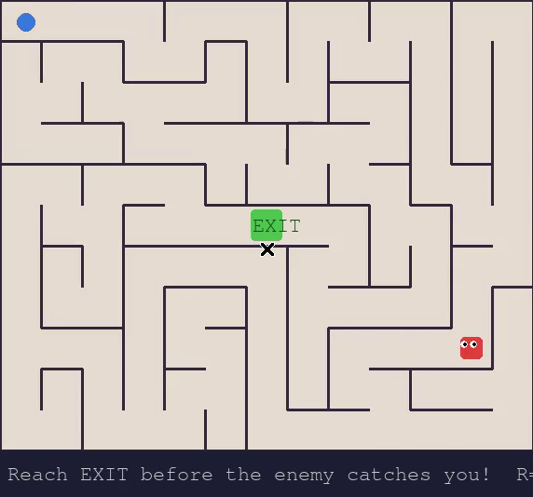 | 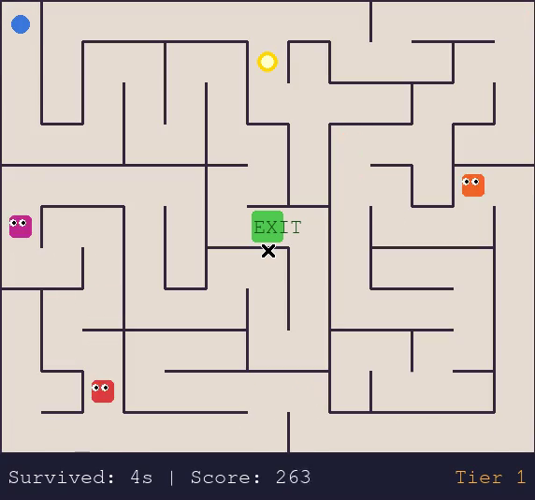
Before (Initial State):  Single Enemy, Broken Walls, No HUD Metrics | After (Final State):  3 Independent BFS Enemies, Golden Pellet, HUD Score & Speed Tiers
5. Git Commit Traceability
In accordance with instruction #10 ('Have Separate Commits for each task'), each prompt iteration was committed independently into the local git repository under the student's author profile:
Commit Hash | Commit Message | Functional Scope
5de6c0c | fix: enforce wall collision boundaries for player movement | Fixed Player._valid() to prevent passing through solid maze walls.
90e75a3 | feat: add multiple independent BFS enemies at maze corners | Spawned 3 enemies at corners with individual BFS pathfinding.
cec76bf | feat: implement 15-second dynamic enemy speed ramp and HUD tier display | Scaled move interval down every 15s and added HUD speed tier display.
d1e4f40 | feat: add power pellet item with 5-second enemy freeze effect | Added collectible pellet freezing enemies for 300 frames with icy visual state.
2e3c2c1 | feat: add survival score tracking and game over overlay metrics | Implemented per-frame survival scoring and game over screen overlay metrics.
6. Conclusion & Vibe Coding Takeaways
By adopting an agile vibe-coding methodology, all 4 functional deliverables and the critical wall-collision bug were resolved in under 4 prompt iterations without extraneous refactoring loops. The combination of targeted prompt phrasing, isolated component scoping, and continuous runtime verification enabled rapid feature iteration while preserving complete code integrity and atomic version control history.

