Full Stack Development with MERN
OrderOnTheGo: On-Demand Food Ordering Solution

- Introduction:

- Project Title: OrderOnTheGo: On-Demand Food Ordering Solution
- Team Members:
Team Leader: Muramalla Balaram
Team Member: Ganji Harika
Team Member: Kammila Sudheer Raja
Team Member: Pusarla Tharun Veer

- Project Overview:

- Purpose:
The purpose of this project is to develop a full-stack web application that allows users to browse food items, add them to cart, and place orders online. The system also includes an admin panel for managing food items and orders.

- Features:
- User Registration and Login
- Browse Food Items
- Add to Cart
- Place Order
- Order Confirmation
- Admin Dashboard
- Manage Products (Add/Edit/Delete)
- User Authentication using JWT

- Architecture:

- Frontend:
The frontend is developed using React.js. It provides a responsive and interactive user interface. Components include:
- Login & Register Pages
- Home Page
- Food Listing Page
- Cart Page
- Profile Page
- Admin Dashboard
- Axios is used to communicate with backend APIs.
- Backend:
The backend is built using Node.js and Express.js. It handles:
- User authentication
- API endpoints for users, products, cart, and orders
- Business logic processing
- Admin operations

- Database:
The database used is MongoDB. Collections include:
Users
Admin
Products
Cart
Orders
Mongoose is used to define schemas and interact with MongoDB.

- Setup Instructions:

  - Prerequisites:
This section lists the software and tools required before running the project.
- Node.js and npm – To run backend server and install packages
- MongoDB – To store application data
- Express.js – For backend framework
- React.js – For frontend user interface
- Mongoose – For database connectivity
- Git – For cloning and version control
- Code Editor (Visual Studio Code recommended)
- Basic knowledge of HTML, CSS, and JavaScript

  - Installation:
This section explains how to install and set up the project.
Step 1: Clone the Repository
git clone https://github.com/harsha-vardhan-reddy-07/Food-Ordering-App-MERN
cd Food-Ordering-App-MERN
Step 2: Install Dependencies
npm install
Step 3: Start the Application
npm run dev
OR
npm start
Step 4: Run in Browser Open browser and go to:
http://localhost:3000

  - Development Tools:
Tools used for development:
- Visual Studio Code – Code editor
- Git – Version control
- MongoDB – Database
- Node.js – Runtime environment

- Folder Structure:

- Client:
The client folder contains the frontend part of the application developed using React.js. It is responsible for the user interface and user interaction.

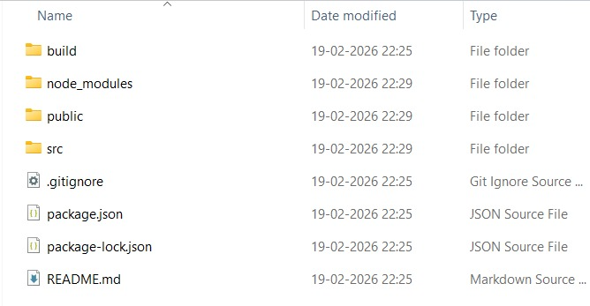
- public/ – Contains static files like index.html
- src/ – Main source folder
- components/ – Reusable UI components (Navbar, Product Card, etc.)
- pages/ – Application pages (Login, Home, Cart, etc.)
- services/ – API calls to communicate with backend
- App.js – Main React component
- index.js – Entry point of React application
- package.json – Contains project dependencies and scripts

- Server:
The server folder contains the backend part of the application developed using Node.js and Express.js. It handles business logic, API requests, and database connection.

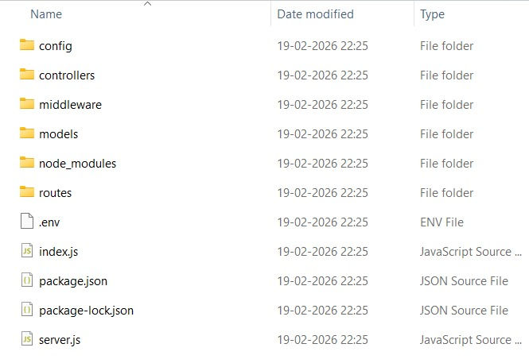
• models/ – Contains database schemas (User, Product, Orders, Cart, etc.)
• routes/ – Contains API routes
• controllers/ – Contains logic for handling requests
• config/ – Database connection configuration
• middleware/ – Authentication and error handling
• server.js – Main backend entry point
• package.json – Backend dependencies and scripts

- Running the Application:

- Frontend:
- Step 1:
- Open a new terminal
- Navigate to client folder:
cd client
- Run the frontend using:
npm start
- This will start the React application.
- Backend:
Step 2: Start the Backend Server
- Open terminal
- Navigate to server folder:
cd server
- Run the backend using:
npm run dev
This will start the backend server and connect to MongoDB database.
Step 3: Open the Application
- Open web browser
- Go to:
http://localhost:3000
- The application will run successfully.

- API Documentation:

The backend APIs are organized into different route files based on functionality.

  - Admin APIs
File: adminRoutes.js

Method | Endpoint | Description
POST | /api/admin/login | Admin login
GET | /api/admin/dashboard | Get admin dashboard data
POST | /api/admin/add | Add admin details
Purpose:
Handles admin authentication and admin operations.
  - Auth APIs
File: authRoutes.js

Method | Endpoint | Description
POST | /api/auth/register | Register new user
POST | /api/auth/login | Login user
GET | /api/auth/profile | Get user profile
Purpose:
Handles user registration and login.

  - Product APIs
File: Productroutes.js

Method | Endpoint | Description
GET | /api/products | Get all products
GET | /api/products/:id | Get product by ID
POST | /api/products | Add new product
PUT | /api/products/:id | Update product
DELETE | /api/products/:id | Delete product

Purpose:
Handles product management.

  - Cart APIs
File: cartRoutes.js
Method | Endpoint | Description
POST | /api/cart/add | Add product to cart
GET | /api/cart/:userId | Get cart items
DELETE | /api/cart/remove/:id | Remove item from cart
Purpose:
Handles cart operations.
  - Order APIs
File: orderRoutes.js
Method | Endpoint | Description
POST | /api/orders | Place new order
GET | /api/orders/:userId | Get user orders
GET | /api/orders | Get all orders
Purpose:
Handles order management.

  - Restaurant APIs
File: restaurantRoutes.js
Method | Endpoint | Description
GET | /api/restaurants | Get all restaurants
POST | /api/restaurants | Add restaurant
GET | /api/restaurants/:id | Get restaurant details
Purpose:
Handles restaurant data and menu information.

- Authentication:

Authentication is the process of verifying the identity of users before allowing them to access the application. In this project, authentication is implemented using Node.js, Express.js, MongoDB, and JWT (JSON Web Token).

- User Registration
New users can create an account by providing their username, email, and password. The user details are stored securely in the MongoDB database. This allows users to access the application features such as browsing products and placing orders.

- User Login
Registered users can log in using their email and password. The system verifies the entered credentials with the database. If the credentials are valid, the user is successfully logged in and allowed to access the application.

- JWT Token Generation
After successful login, a JWT (JSON Web Token) is generated and sent to the user. This token is used to identify the user and maintain login session. It ensures secure communication between frontend and backend.

- Authorization and Access Control
The JWT token is used to protect secure routes such as placing orders, accessing cart, and viewing user profile. Only authenticated users can access these features. Unauthorized users cannot access protected resources.

- Admin Authentication
Admin users can log in using admin credentials. Admin authentication allows access to admin features such as managing products, viewing orders, and managing restaurants.

- User Interface:

The user interface of the OrderOnTheGo application is developed using React.js. It provides an interactive and user-friendly environment for users to browse food items, manage their cart, and place orders easily. The interface is designed to be simple, responsive, and easy to navigate.

- Home Page
The home page shows all available food items and restaurants. Users can browse and select the food they want to order.
- Registration Page
This page allows new users to create an account by entering their name, email, and password.
- Login Page
This page allows registered users to login using their email and password to access the application.
- Product Page
This page displays the list of food items. Users can view details and add items to the cart.
- Cart Page
This page shows the items added to the cart. Users can check their selected items and proceed to place an order.
- Order Page
This page allows users to confirm and place their order successfully.

- Home Page:

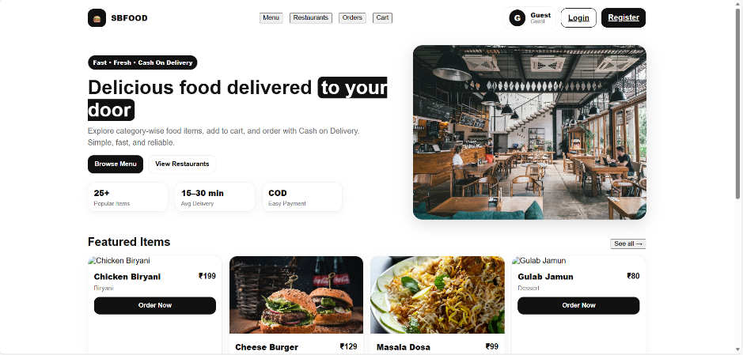

- Register Page:

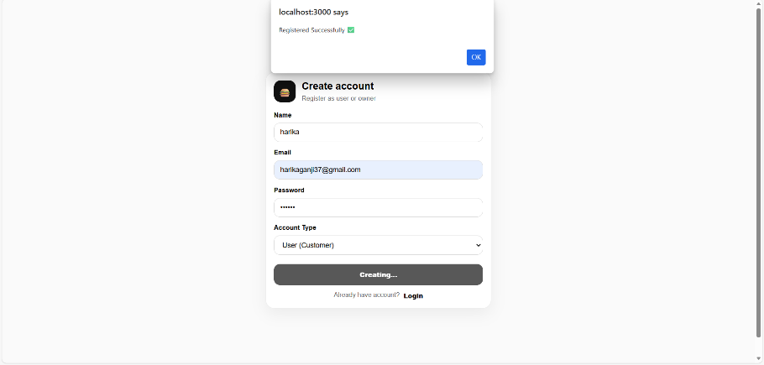

- Login Page:

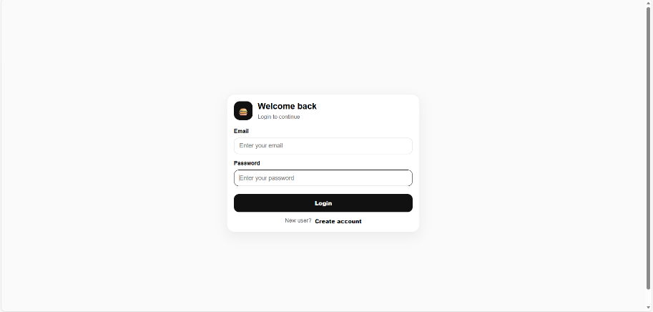

- Product Page:

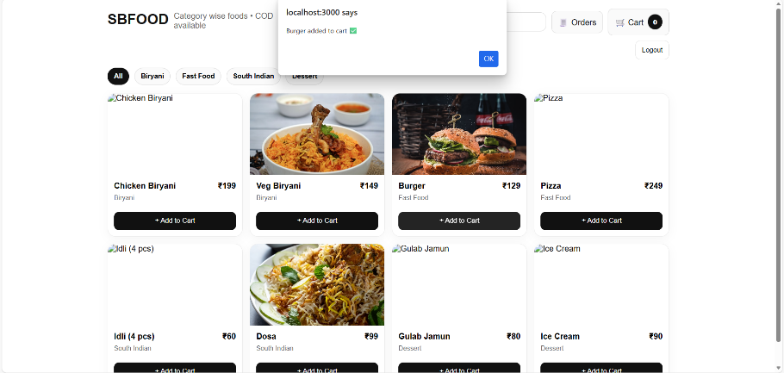

- Cart Page:

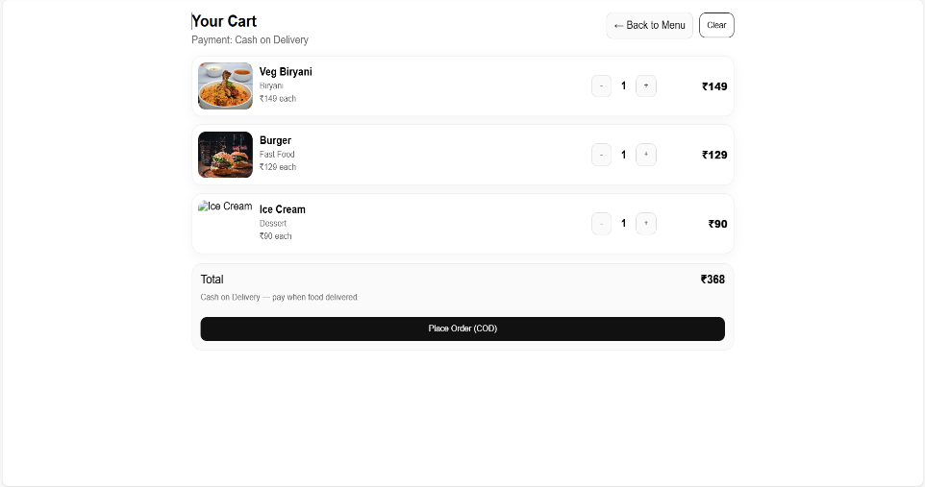

- Order Page:

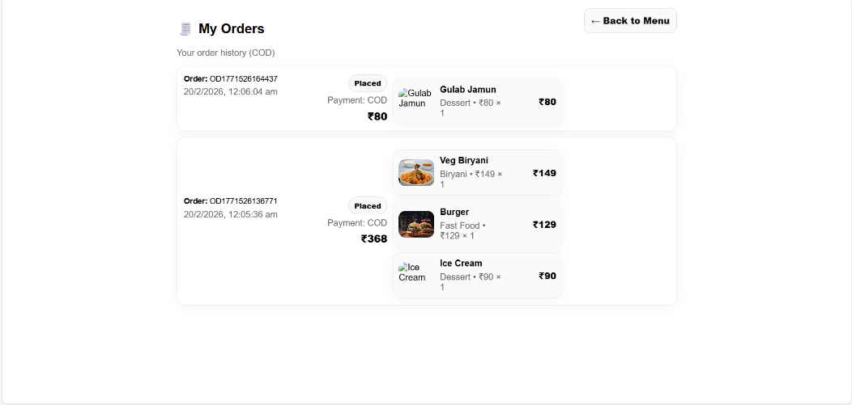

- Testing:

Testing is performed to ensure that the application works correctly and all features function as expected. It helps to identify and fix errors before deployment.
Testing Strategy
The application was tested using manual testing. Each feature was tested separately to ensure proper functionality.
The following functions were tested:
• User registration with valid and invalid inputs
• User login with correct and incorrect credentials
• Viewing food items and restaurants
• Adding items to cart
• Removing items from cart
• Placing orders successfully
• Admin login and product management
All features were tested to ensure smooth and error-free operation.

Testing Tools Used
The following tools were used for testing:
• Web Browser (Google Chrome) – to test the frontend user interface
• Postman – to test backend APIs
• MongoDB Atlas – to verify database data
• Visual Studio Code – to run and monitor the application.

- Screenshots or Demo:

The application was successfully developed and tested. The screenshots of the application, including the Home Page, Login Page, Product Page, Cart Page, and Order Page, are provided in the User Interface section.
These screenshots demonstrate the working functionality of the food ordering system, including user registration, login, browsing food items, adding items to cart, and placing orders.
The application was run locally using the development server, and all features were verified successfully.

- Demo:
The application can be demonstrated by running it locally using the following commands:
Frontend:
npm start
Backend:
npm run dev
Then open in browser:
http://localhost:3000

- Known Issues:

During the development and testing of the application, a few minor issues were identified.
• Sometimes the application takes a few seconds to load data due to server response time.
• If the backend server is not running, the frontend cannot fetch data and some features may not work.
• Incorrect login credentials show an error message, and the user needs to re-enter correct details.
• Internet connection is required for proper database connectivity with MongoDB Atlas.
• Some features may require page refresh if data is not updated immediately.

- Future Enhancements:

The following features can be added in the future to improve the application:

• Add online payment option like UPI, debit card, or credit card.
• Add order tracking feature so users can see their order status.
• Improve the user interface to make it more attractive and easier to use.
• Add search option to find food items quickly.
• Add notification feature for order confirmation.
• Allow users to update their profile details.
• Improve application speed and performance.

