**Intelligent Traffic Light Control Using Image Processing**

A Synopsis Submitted

in Partial Fulfillment of the Requirements

for the Course of

# Minor Project - I

In

Third year – Fifth Semester of

**Bachelor of Technology**

specialization

In

# DevOps

Under

**Mr. SHAMIK TIWARI**

Assistant Professor

Department of Cybernetics,

School of Computer Science

By

# 500061550 R171217014 BalaramPratap

# 500062226 R171217012 AseemGoel

# 500061565 R171217020 Harshul Malhotra 500061663 R171217047 Pratyush Pandey



DEPARTMENT OF CYBERNETICS

SCHOOL OF COMPUTER SCIENCE

UNIVERSITY OF PETROLEUM AND ENERGY STUDIES, BIDHOLI, DEHRADUN, UTTRAKHAND, INDIA

# Aug, 2019

**ABSTRACT**

In India, with the growing number of vehicles, traffic congestion at junctions has become a serious issue. The density of vehicles is increasing day by day and there is a real need of adaptive traffic signals which can monitor traffic density. We describe a system which uses image processing for regulating the traffic in an effective manner by taking images of traffic at a stop. A step by step approach of image acquisition, image processing to change the traffic light duration as per the density of vehicles on different roads at a traffic signal is followed. The number of objects in a given image is counted and priority is given to the densest road.

KEYWORDS : …………………………………!!!!!!

**TABLE OF CONTENT**

**_________________________________________**

Introduction …………………………………………………………… 3

Problem Statement ………………...………………………………… 4

Objective ……………………………………………………………… 4

Literature Review ….…….…………………………………………… 5

Methodology …………………………..……………………………8

Flow Chart……………………….…………………………………10

Pert Chart……………………….…………………………………… 11

References………………....………………………………………12

**Introduction**

In modern-day lifestyles we need to face with many issues considered one of that's traffic congestion turning into greater serious each day. It is stated that the excessive tome of vehicles, the scanty infrastructure and the irrational distribution of the development are important reasons for augmented traffic jam. The predominant cause leading to traffic jam is the high number of vehicles which was because of the high population and the development of financial system. To resolve this problem, the government must encourage humans to use public transport or vehicles with small length which includes bicycles or make tax on private/personal vehicles. Particularly, in a few Asian international locations which includes Viet Nam, the nearby authorities surpassed regulation limiting to the number of vehicles for each family. That the inadequate infrastructure cannot handle the issue of traffic is likewise a decisive reason. Besides, the main highway and roads are incapable of meeting the requirement of growing number of vehicle. Instead of working on roads to accommodate the growing traffic diverse strategies had been devised to govern the traffic on roads like embedded controllers which can be installed on the junction. These techniques are in short defined in next section.

* 1. **Standard Traffic Control Systems:**

**1.1.1 Traditional Manual Controlling**

Manual controlling the name itself defines that it requires man strength to manipulate/control the traffic. Depending on the countries and states the traffic polices are allotted for a particular area or town to control traffic. The traffic polices will carry signal light, sign board, and whistle to manipulate/control the traffic. They may be instructed to put on precise uniforms in order to manage/control the traffic.

**1.1.2 Automatic Controlling**

Automatic Traffic light is managed/controlled by means of timers and electric sensors. In traffic light each section/phase a consistent numerical value loaded within the timer. The lighting is robotically getting ON and OFF depending on the timer value changes. While the use of electric sensors it'll seize the availability of the vehicle and indicators on every section, depending at the sign the lighting fixtures robotically transfer ON and OFF.

**1.2 Drawbacks:**

In the manual controlling process, we want extra man strength. As we've poor strength of traffic

police we can't manipulate traffic manually in all region of a metropolis or city. So we need a better solution to control the traffic. On the opposite side, automated traffic controlling a traffic light uses timer for each segment/phase. Using electronic sensors is any other way in an effort to locate vehicles, and produce signal that to this approach the time is being wasted by means of a green light on an empty road. Traffic congestion also occurred while the use of the digital sensors for controlling the traffic.

All these drawbacks are alleged to be removed via the usage of Image processing.

**1.3 Image Processing in Smart Traffic Light Control**

We propose a machine for controlling the traffic light by means of image processing. The vehicles are detected by the system through images instead of using electronic sensors embedded in the pavement. A digital camera might be located alongside the traffic light. It will capture photo sequences.

Image processing is a better technique to manipulate the phase change of the traffic light. It suggests that it can lower the traffic congestion and avoids the time being wasted by using a green light on an empty street. It is likewise greater dependable in estimating car presence as it makes use of actual traffic photographs. It visualizes the practicality, so it capabilities a good deal higher than the ones structures that depend upon the detection of the vehicle’s metallic content material.

**1.4 Introduction to Image Processing**

Image Processing is a way to enhance raw photographs/images acquired from cameras/sensors placed on aircraft's and satellites or pics taken in regular day-today life for numerous applications. An Image is square graphical object. Image processing includes issues related to photograph/image illustration, compression techniques and various complicated operations, which may be achieved at the photograph/image data. The operations that come below image processing are

image enhancement operations which includes sprucing, blurring, brightening, aspect enhancement and so on. Image processing is any mode of sign processing for which the input is a photo, along with pictures or frames of video; the output of picture processing may be either a picture or a set of characteristics or parameters related to the image. Most photograph-processing strategies involve

treating the photograph as a -dimensional signal and applying popular sign-processing strategies to it. Image processing generally refers to digital picture processing, however optical and analog photo processing also are feasible.

**LITERATURE REVIEW**

**PROBLEM STATEMENT**

Traffic congestion is an increasing problem in cities and sub urban spend more of their time commuting to work, school, shopping, and social event as well as dealing with traffic light jambs and accidents.

Traffic became heavy in all directions, more to and from cities as well as between sub urban locations. Suburban business locations required huge parking lots because employees have to drive; there were few buses trains, and trolleys to carry scatter workers to their work place.

The hope of reduced congestion in the sub urban had not been realized; long commutes and traffic jams could be found everywhere

**OBJECTIVES**

By detecting the density of the vehicles, light will glow, controlling the traffic. In this process initially the system will have picture of the empty road. And the system will continuously take pictures of the road and will compare those with the empty ones which will give signal of the density of vehicles present on the road. In this system the vehicles are not being detected by sensors, rather it is detected by images. The project proposed a system for controlling the traffic light by image processing.

**METHODOLOGY**

The project follows **Iterative waterfall model.**

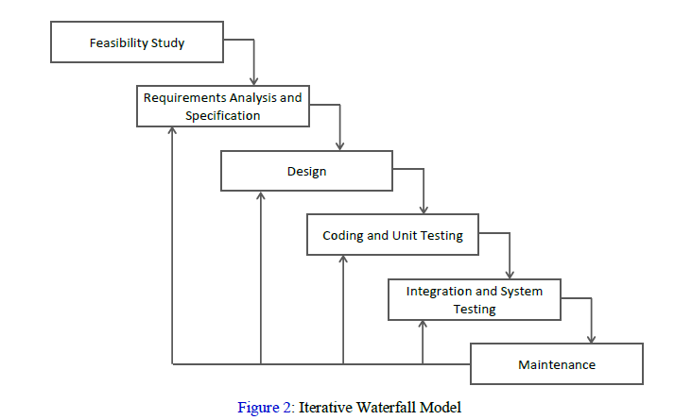

● **Requirement Analysis and Specification:** - Analyzing the requirements and specifications that are to be met.

● **Detailed design**:- Design interfaces and algorithms according to the requirements analyzed in the previous phase.

● **Implementation**:- Implement the algorithms and interfaces in the language specified in the requirement analysis and specification phase.

● **Integration and Testing**:- Integrate the interfaces and units implemented after testing them. This phase finds and errors and bugs in the units implemented.

● **Documentation**:- After successful testing and integration of software, the software is documented for maintaining code readability. This can help in maintaining the software.

**SYSTEM REQUIREMENTS**

**Software Requirements:**

* python IDE( Pycharm,/Anaconda/Jupyter notebook )
* AI algorithm modules

**Hardware Requirements:**

* 2 GHz Processor
* 4 GB RAM
* Camera

**FLOW CHART**

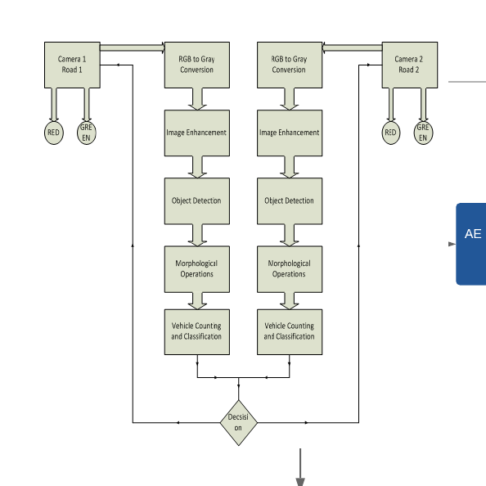

**PERT CHART**

|  |  |  |
| --- | --- | --- |
| **Start Project** | | |
| 15-8-2019 | 7 days | 22-8-2019 |

|  |  |  |
| --- | --- | --- |
| **Project Concept Development** | | |
| 23-8-2019 | 7 days | 30-8-2019 |

|  |  |  |
| --- | --- | --- |
| **Planning** | | |
| 31-8-2019 | 7 days | 7-9-2019 |

|  |  |  |
| --- | --- | --- |
| **Requirement Analysis i.e. Dataset Collection** | | |
| 8-9-2019 | 5 days | 13-9-2019 |

|  |  |  |
| --- | --- | --- |
| **Design Algorithm** | | |
| 14-9-2019 | 15 days | 29-9-2019 |

|  |  |  |
| --- | --- | --- |
| **Coding** | | |
| 30-9-2019 | 20 days | 20-10-2019 |

|  |  |  |
| --- | --- | --- |
| **Testing** | | |
| 21-10-2019 | 10 days | 31-10-2019 |

|  |  |  |
| --- | --- | --- |
| **Debugging** | | |
| 1-11-2019 | 15 days | 16-11-2019 |

**REFERENCES**

[1] In J. A. Storer and editors. M. Cohn, editors, Proc. 2000 IEEE Data Compression Conference, Los Alamitos, California, 2000. IEEE Computer Society Press.

[2]Calgary corpus 2000. ftp://ftp.cpsc.ucalgary.ca/pub/projects/text.compression.corpus.

[3] http://www.cs.wisc.edu/niagara/data/.

[4] N. Abramson. Information Theory and Coding. McGraw-Hill, 1963.

**Approved By**

**Signature Signature**

**Mr. Shamik Tiwari Dr.Monit Kapoor**

**Mentor Head of Department**