**LAB EXERCISE 1**

**Q1. Write a program in java to find the sum of two numbers and test this unit**

**with JUnit tool.**

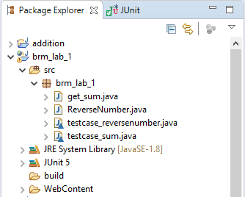

**SOURCE CODE:**

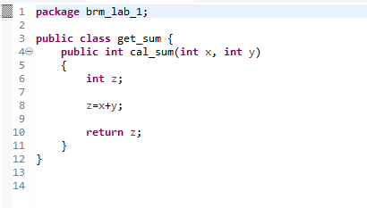

**TEST_CASE:**

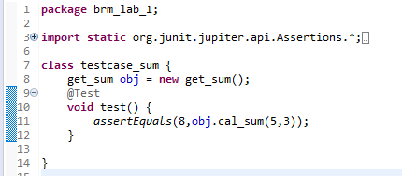

**SUCCESSFUL TEST CASE EXECUTION:**

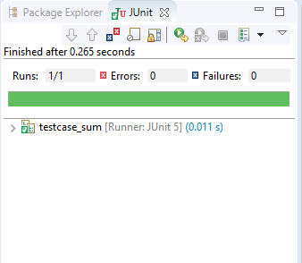

**Q2. Write a program in Java to find the reverse of a number and test it**

**using JUnit tool.**

**SOURCE CODE:**

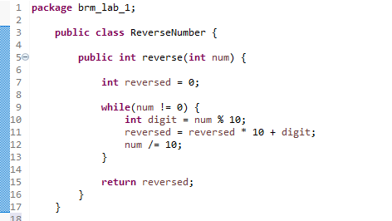

**TEST_CASE:**

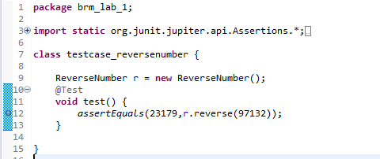

**SUCCESSFUL TEST CASE EXECUTION:**

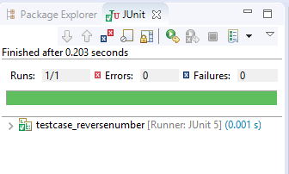

**LAB EXERCISE 2**

**Aim: Create and Install a Maven Project using Eclipse**

**1. Create a Java project using Maven.**

**SOURCE CODE:**

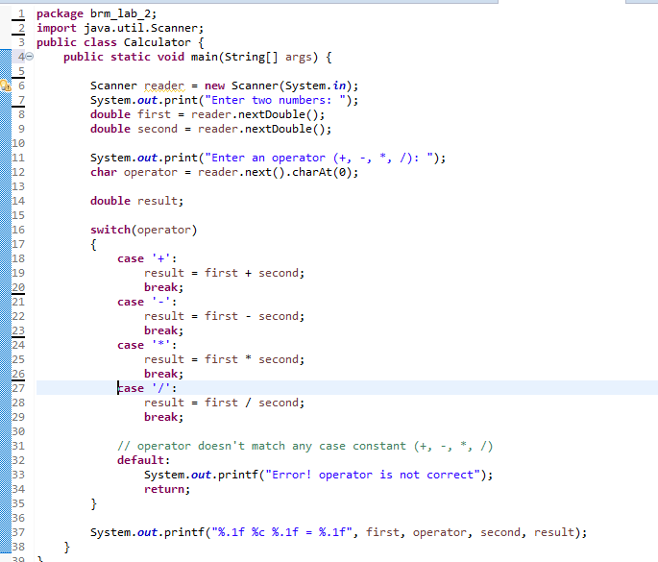

**2. Clean, Compile and Test your code.**

**Clean:**

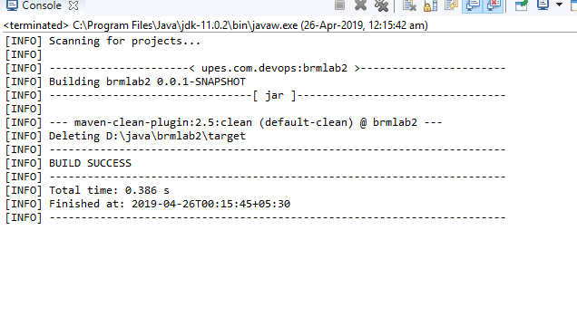

**Compile:**

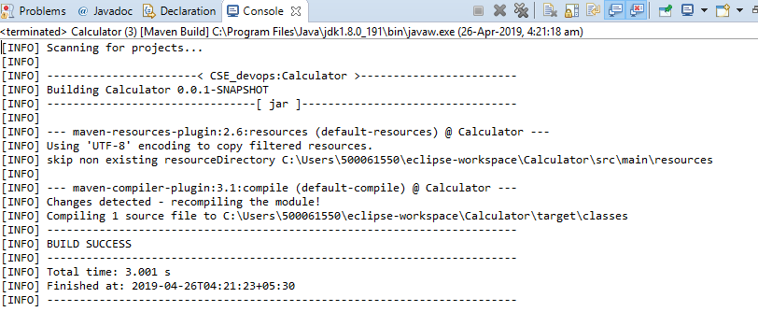

**Test:**

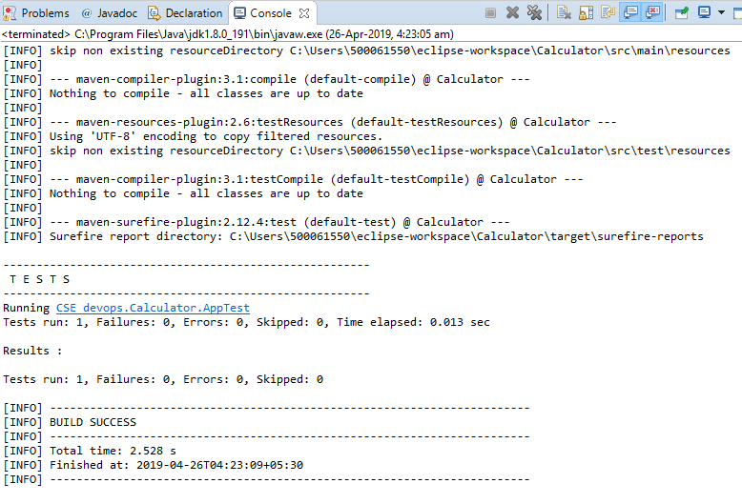

**3. Create Jar file for developed Java Project.**

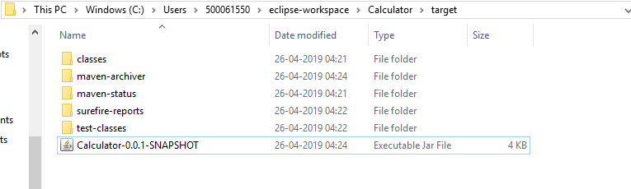

**LAB EXERCISE 3**

**Aim: Working with Maven Repository**

**1. Add Central Repository (Hibernate)**

**2. Add Remote Repository (Atlassian Mail)**

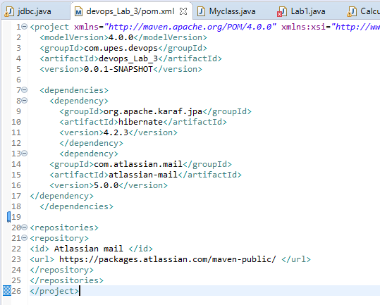

**LAB EXERCISE 4**

**Aim: Install and Manage Maven Plugin**

**Install Site Plugin and use “mvn site” command and goal for generating**

**documents for Maven Project.**

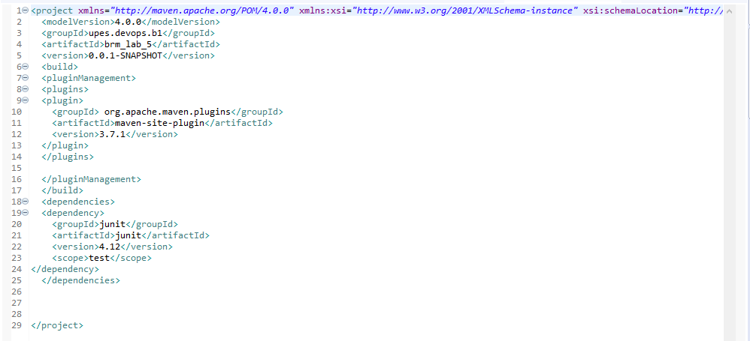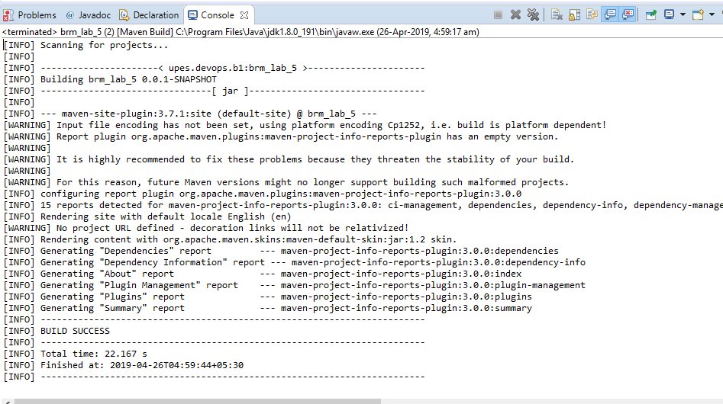

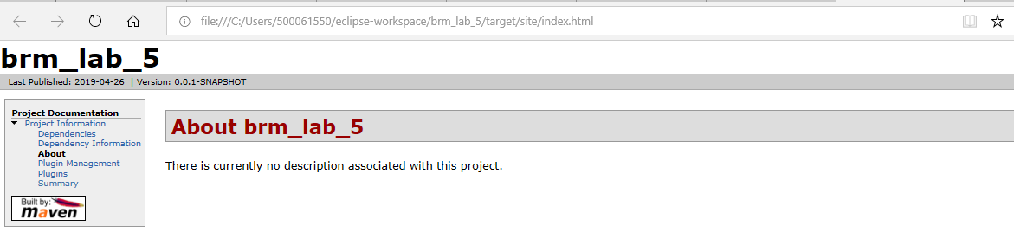

**AB EXERCISE 5**

**Aim: Installation of Eclipse and Maven Plugin**

**Install JDK and Maven 3.3.9 and set Environment Variable.**

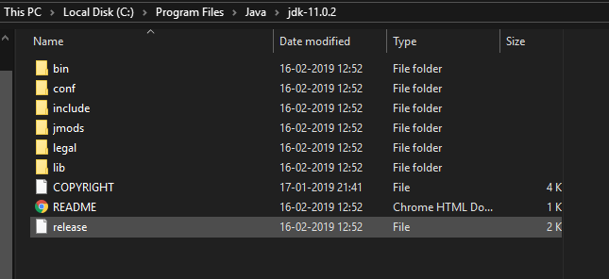

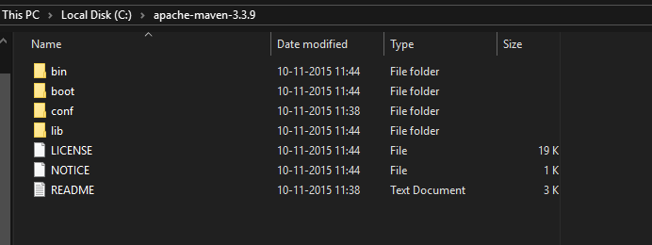

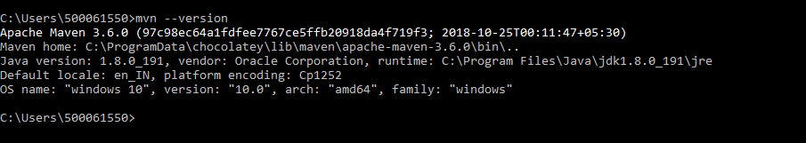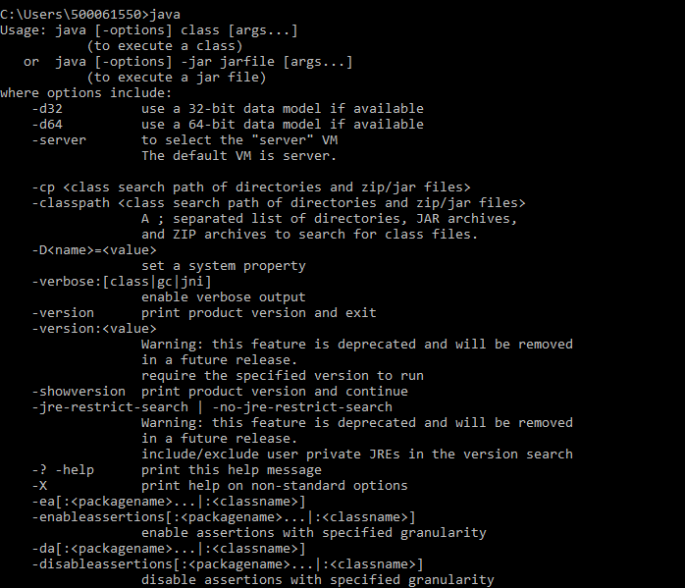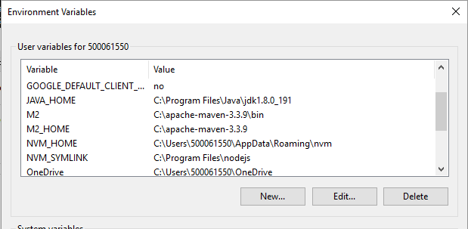

**LAB EXERCISE 6**

**Aim: Create a sample Maven Project using Eclipse and CLI**

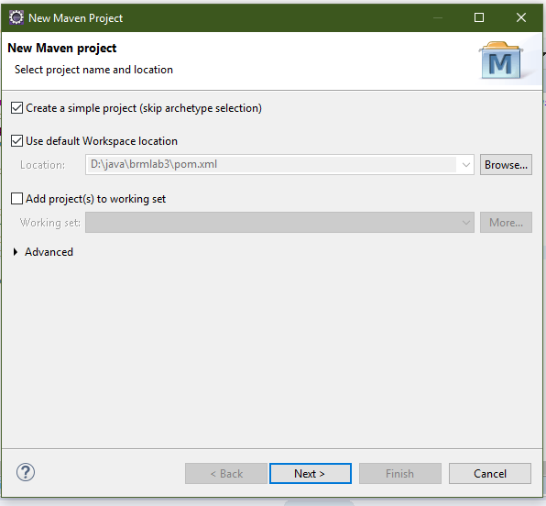

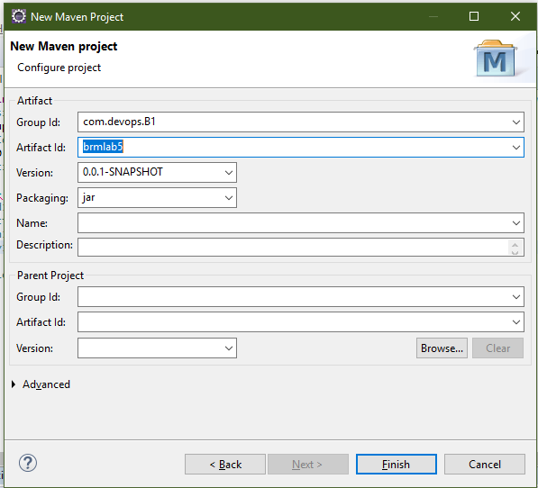

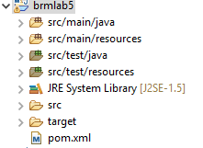

**Maven project via cmd**

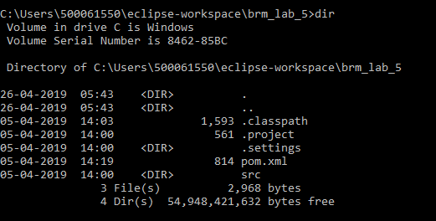

**Code:** mvn archetype:generate -DgroupId=com.devops.B1 -DartifactId=brmlab5 -DarchetypeArtifactId=maven-archetype-quickstart -DarchetypeVersion=1.4 -DinteractiveMode=false

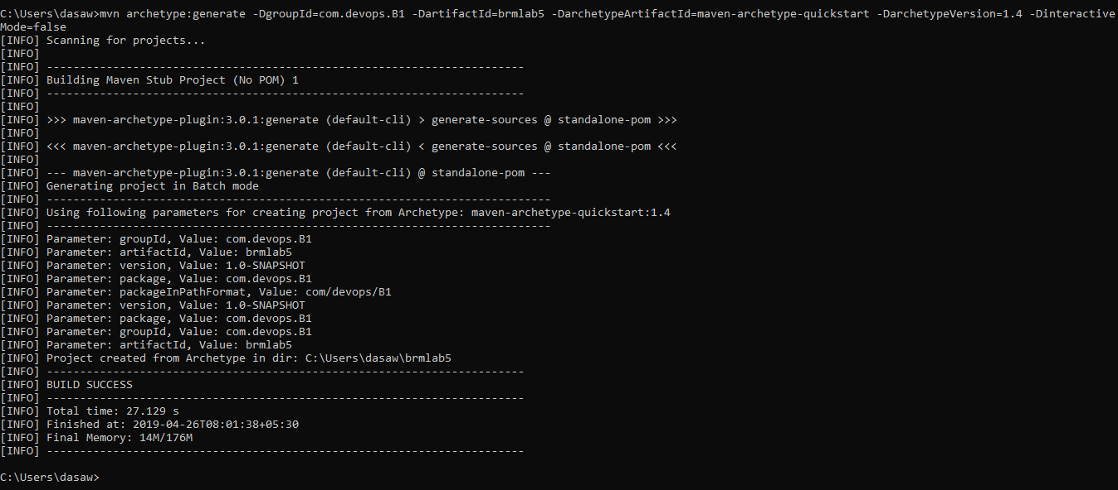

**CLEAN:**

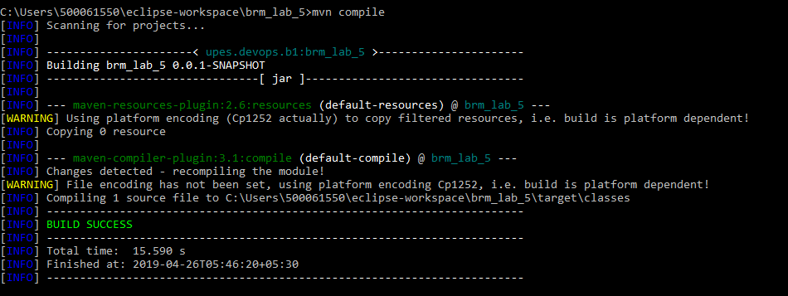

**COMPILE:**

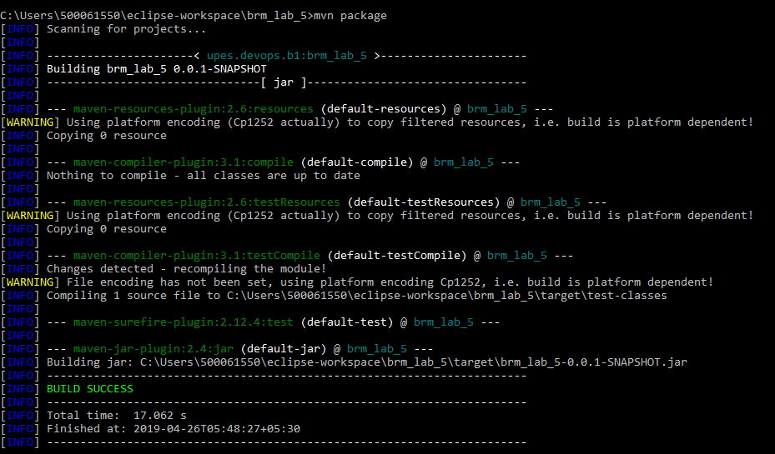

**PACKAGE:**



**LAB EXERCISE 7**

**Aim: Install and Manage Maven Plugin using CLI**

**Install Site Plugin and use “mvn site” command and goal for generating**

**documents for Maven Project using CLI.**





**LAB EXERCISE 8**

**Aim: Management of Maven Dependency using CLI**

Download Maven Dependency from Central Repository and store in

Local Repository using CLI.

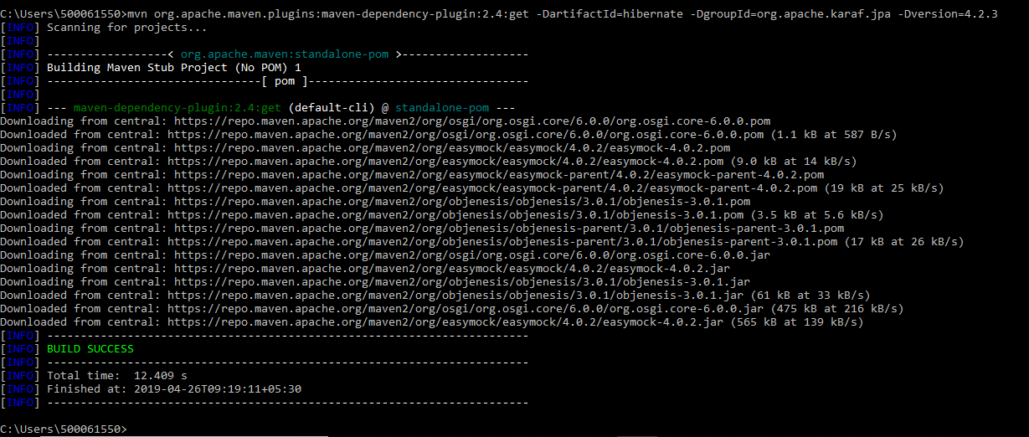

**LAB EXERCISE 10**

**Aim: Build and Deploy a sample Maven Project**

**Create a complete Maven project and use it in some other java Project.**



