

**OOPS THROUGH JAVA**

**LAB FILE**

**Submitted To: Submitted by:**

**Dr. Dhirendra Kumar Sharma Darsh Asawa**

**Assistant Professor Roll no: R171217016**

**(Cybernetics) SAP ID: 500061595**

**CSE (DEVOPS)**

**EXPERIMENT – 1**

**TITLE: Basic Java Programming**

**1) Write a program to find the largest of 3 numbers.**

**CODE:**

package java_lab1;

import java.util.Scanner;

public class Prog1 {

public static void main(String args[]) {

Scanner input = new Scanner(System.in);

System.out.println("Enter the value for x");

int x=input.nextInt();

System.out.println("Enter the value for y");

int y=input.nextInt();

System.out.println("Enter the value for z");

int z=input.nextInt();

if (x>y && x>z){

System.out.println(x + " is greatest ");

}

else if (y>z && y>x) {

System.out.println(y + " is greatest");

}

else {

System.out.println(z + " is greatest");

}

}

}

OUTPUT:

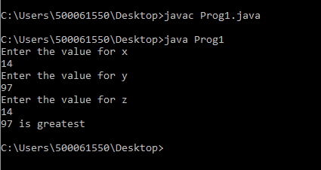

**2) Write a program to add two number using command line arguments.**

**CODE:**

package java_lab1;

public class prog2 {

public static void main(String args[])

{

int x,y,s;

x=Integer.parseInt(args[0]);

y=Integer.parseInt(args[1]);

s=x+y;

System.out.println("sum of " + x + " and " + y +" is " +s);

}

}

**OUTPUT:**

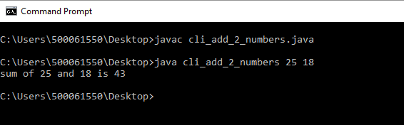

**3) Write a program to print Fibonacci series using loop.**

**CODE:**

package java_lab1;

import java.util.Scanner;

public class prog3 {

public static void main(String args[]) {

int n,first=0,second=1,add=0;

Scanner input=new Scanner(System.in);

System.out.println("enter the value : ");

n=input.nextInt();

for(int i=0;i<n;i++) {

System.out.print(add+ " ");

add=first+second;

first=second;

second=add;

}

}

}

**OUTPUT:**

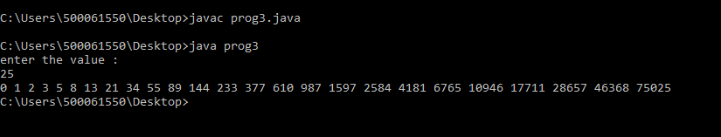

**4) Write a program to implement a command line calculator.**

**CODE:**

package java_lab1;

public class Prog4 {

public static void main(String args[]) {

int x,y,add,subt,multi,div,modulo;

x=Integer.parseInt(args[0]);

y=Integer.parseInt(args[1]);

add=x+y;

System.out.println("Addition of "+x +" & "+y+" is: "+add);

subt=x-y;

System.out.println("Subtraction of "+x +" & "+y+" is: "+subt);

multi=x*y;

System.out.println("Multipliaction of "+x +" & "+y+" is: "+multi);

div=x/y;

System.out.println("Division of "+x +" & "+y+" is: "+div);

modulo=x%y;

System.out.println("mdoulo of "+x +" &s "+y+" is: "+modulo);

}}

**OUTPUT:**

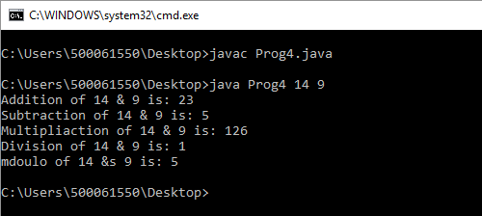

**5) Write a program using classes and object in java.**

**CODE:**

package java_lab1;

import java.util.Scanner;

public class Prog5 {

public static void main(String args[]) {

//Scanner is a class and creating an object named input as an object for this class...

Scanner input=new Scanner(System.in);

int x=input.nextInt();

System.out.println("value of x is: "+ x);

}

}

**OUTPUT:**

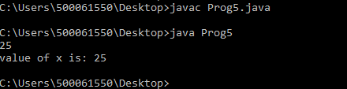

**6) Write a program to accept 10 student’s marks in an array, arrange it into ascending order,**

**convert into the following grades and print marks and grades in the tabular form.**

**Between 40 and 50: PASS**

**Between 51 and 75: MERIT**

**and above: DISTINCTION**

**CODE:**

package java_lab1;

import java.util.Scanner;

public class Prog6 {

public static void main(String args[])

{

Scanner input=new Scanner(System.in);

int i,j;

int arr[]=new int[100];

System.out.println("Enter the MARKS of 10 Students :\n");

for(i=1;i<=10;i++) {

System.out.println("Marks of student"+i+" is : ");

arr[i]=input.nextInt();

}

System.out.println("Original Marks :\n");

for(i=1;i<=10;i++)

{

System.out.print(arr[i]+" ");

}

int temp[]=new int[10];

for(i=1;i<=10;i++)

{

for(j=i+1;j<=10;j++ )

{

if(arr[i]>arr[j]) {

temp[i]=arr[i];

arr[i]=arr[j];

arr[j]=temp[i];

}

}

}

System.out.println("\nPrinting the Marks in ascending order: \n");

for(i=1;i<=10;i++)

{

System.out.print(arr[i]+" ");

}

System.out.println("\n");

int t;

System.out.print("\n\n");

for(i=1;i<=10;i++) {

t=arr[i];

if(t>=40 && t<=50 ) {

System.out.println("Marks = "+t+" Grade : Pass\n");

}

else

if(t>=51 && t<=75) {

System.out.println("Marks = "+t+" Grade : Merit\n");

}

else if(t>75){

System.out.println("Marks = "+t+" Grade : Distinction\n");

}

else

System.out.println("Marks = "+t+" Grade : Fail\n");

}

}

}

**OUTPUT:**

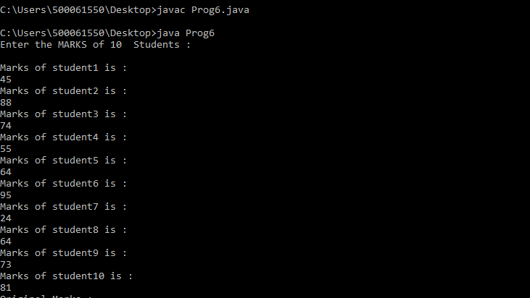

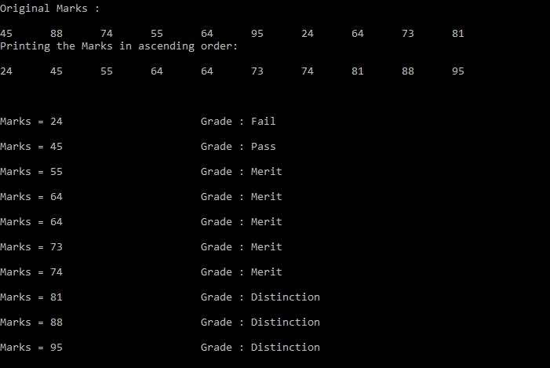

**7) Write a program to accept three digits (i.e. 0 - 9) and print all its possible combinations.**

**(For example, if the three digits are 1, 2, 3 then all possible combinations are: 123, 132,**

**213, 231, 312, 321).**

**CODE:**

package java_lab1;

import java.util.Scanner;

public class Prog7 {

public static void main(String args[]) {

System.out.print("Enter a 3-digit number: \n");

Scanner input=new Scanner(System.in);

int arr[] = new int[10];

for(int p=0;p<3;p++)

{

arr[p]=input.nextInt();

}

System.out.println("All possible combinations for the entered three digit number : \n");

for (int x = 0; x < 3; x++) {

for (int y = 0; y < 3; y++) {

for (int z = 0; z < 3; z++) {

if (x != y && y != z && z != x) {

System.out.println(arr[x] + "" + arr[y] + ""

+ arr[z]);

}

}

}

}

}

}

**OUTPUT:**

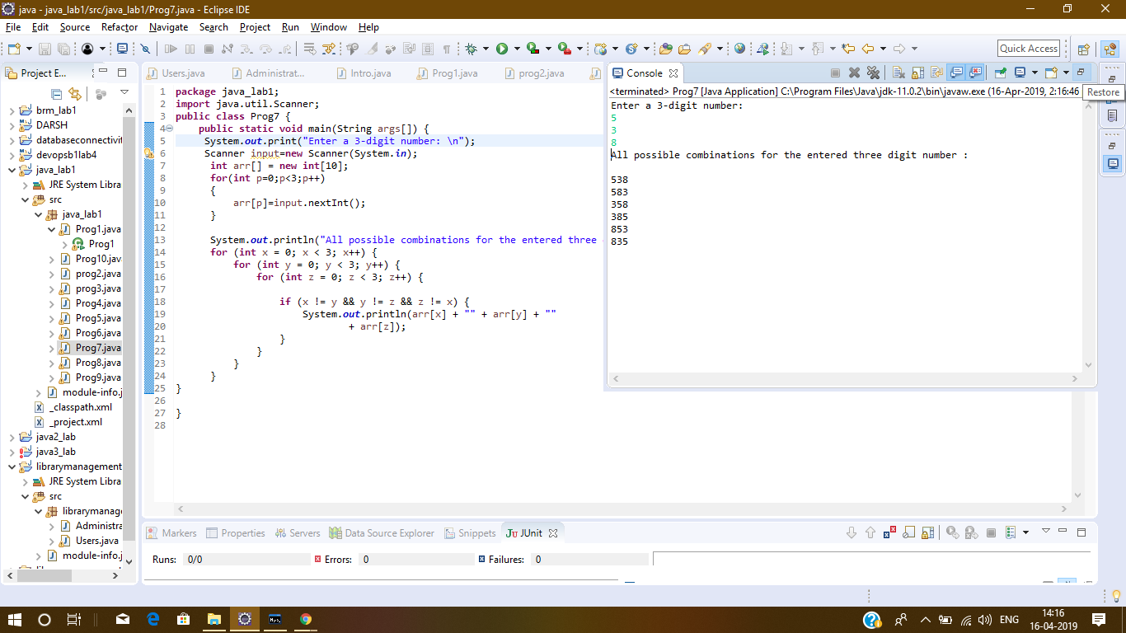

**8) Write a Java Program to accept 10 numbers in an array and compute the square of each**

**number. Print the sum of these numbers.**

**CODE:**

package java_lab1;

import java.util.Scanner;

public class Prog8 {

public static void main(String args[])

{

int arr[]=new int[10];

int temp[]=new int[1];

int i;

Scanner inp=new Scanner(System.in);

System.out.println("Enter 10 values for the array :");

for(i=0;i<10;i++) {

arr[i]=inp.nextInt();

}

System.out.println("\nThe Entered ARRAY is : ");

for(i=0;i<10;i++) {

System.out.print(arr[i]+" ");

}

for(i=0;i<10;i++) {

arr[i]=arr[i]*arr[i];

}

System.out.println("\nThe Squared ARRAY is : ");

for(i=0;i<10;i++) {

System.out.print(arr[i]+" ");

}

for(i=0;i<10;i++) {

temp[0]=temp[0]+arr[i];

}

System.out.println("\nThe Sum of all the values of Squared ARRAY is : "+temp[0]);

}

}

**OUTPUT:**

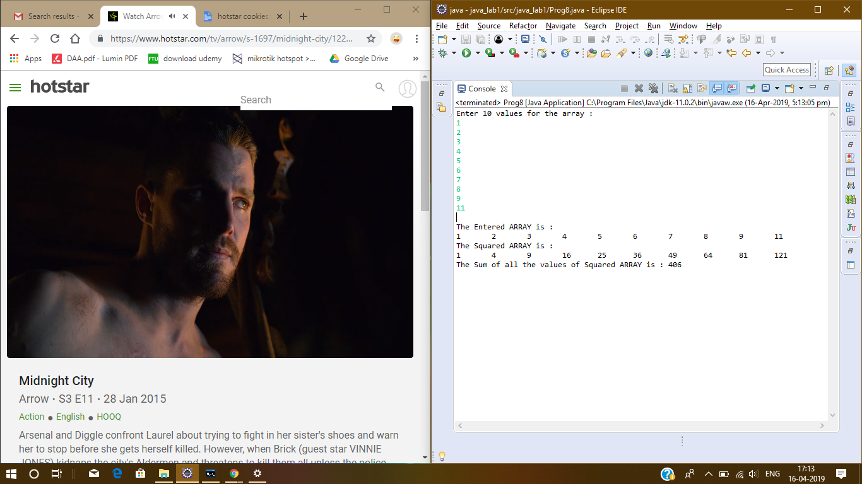

**9) Write a program to input a number of a month (1 - 12) and print its equivalent name of**

**the month. ( e.g 1 to Jan, 2 to Feb. 12 to Dec.)**

**CODE:**

package java_lab1;

import java.util.Scanner;

public class Prog9 {

public static void main(String args[]) {

int mon;

Scanner input=new Scanner(System.in);

System.out.println("Enter the number of any month(1-12): ");

mon=input.nextInt();

switch(mon) {

case 1: System.out.println("January");

break;

case 2:System.out.println("Febraury");

break;

case 3: System.out.println("March");

break;

case 4: System.out.println("April");

break;

case 5:System.out.println("May");

break;

case 6: System.out.println("June");

break;

case 7:System.out.println("July");

break;

case 8:System.out.println("August");

break;

case 9:System.out.println("September");

break;

case 10:System.out.println("October");

break;

case 11:System.out.println("November");

break;

case 12:System.out.println("December");

}

}

}

**OUTPUT:**

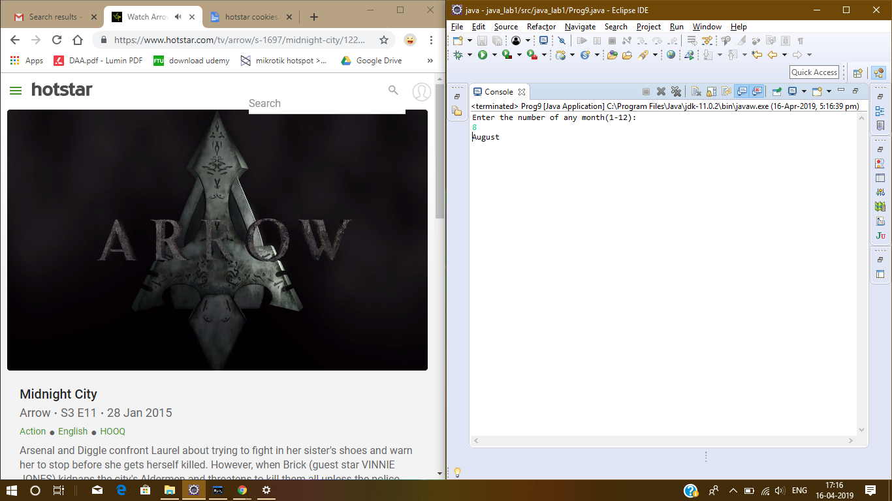

**10) Write a program to find the sum of all integers greater than 40 and less than 250 that are divisible by 5.**

**CODE:**

package java_lab1;

public class Prog10 {

public static void main(String args[])

{

int sum=0,i;

for(i=41;i<250;i++)

{

if(i%5==0){

sum+=i;

}

}

System.out.println("The sum of all intergers between 40 and 250 is "+ sum);

}

}

**OUTPUT:**

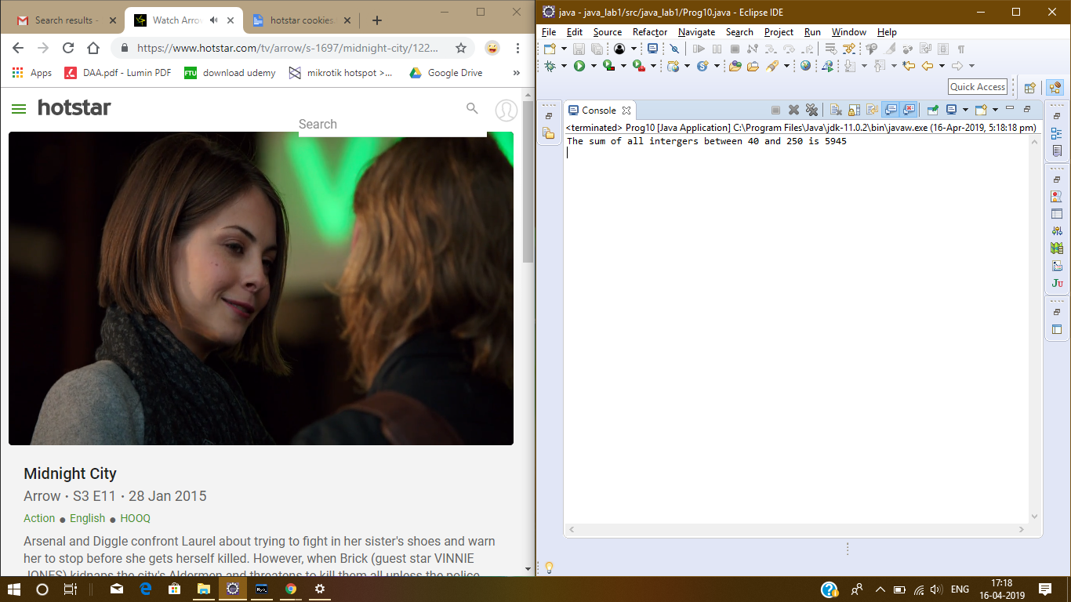

**EXPERIMENT – 2**

**TITLE- Inheritance ; Multilevel Inheritance**

**1) Write a Java program to show that private member of a superclass cannot be accessed from derived classes.**

**CODE:**

package java2_lab;

class darsh{

private int x=20;

}

public class Prog1 extends darsh {

public static void main(String[] args) {

darsh obj=new darsh();

System.out.println(obj.x);

}

}

**OUTPUT:**

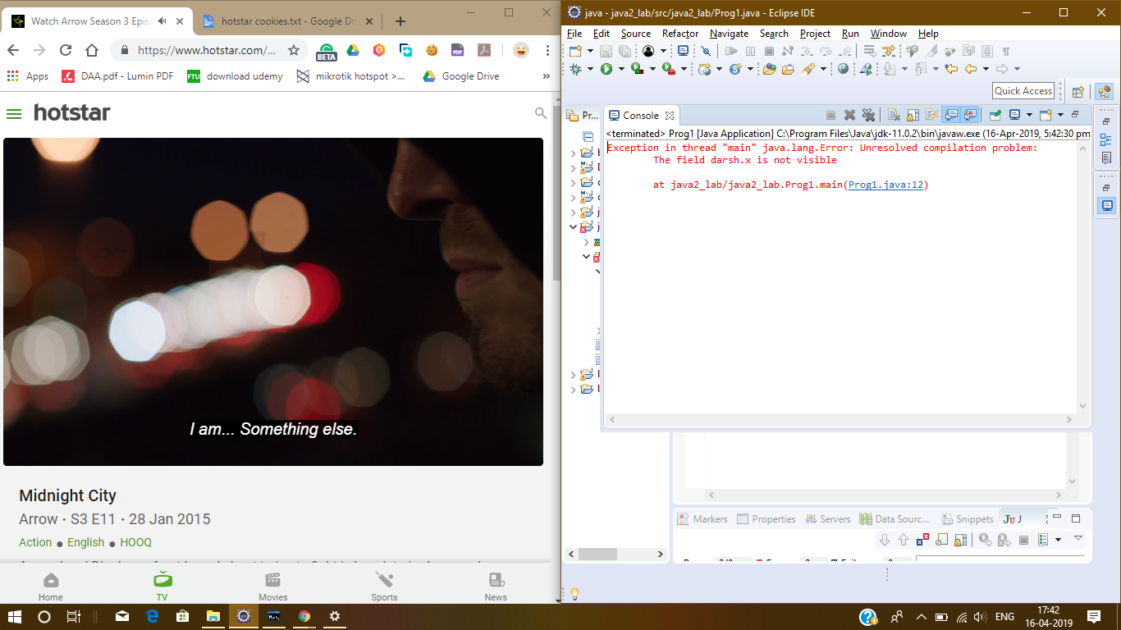

**2) Write a program in Java to create a Player class. Inherit the classes Cricket _Player, Football _Player and Hockey_ Player from Player class.**

**CODE:**

package java2_lab;

class Players{

String CricName="Virat Kohli";

String CricTeam="India";

String FootName="Messi";

String FootTeam="Barcelona";

String HockeyName="Dha";

String HockeyTeam="India";

}

class Cricket_players extends Players{

}

class Football_player extends Players{

}

class Hockey_player extends Players{

}

public class Prog2 {

public static void main(String[] args) {

Cricket_players obj1=new Cricket_players();

System.out.println("Name of cricket player is :" + obj1.CricName);

System.out.println("Name of his team is :"+ obj1.CricTeam);

Football_player obj2=new Football_player();

System.out.println("Name of Football player is :" + obj2.FootName);

System.out.println("Name of his team is :"+ obj2.FootTeam);

Hockey_player obj3=new Hockey_player();

System.out.println("Name of Hockey player is :" + obj3.HockeyName);

System.out.println("Name of his team is :"+ obj3.HockeyTeam);

}

}

**OUTPUT:**

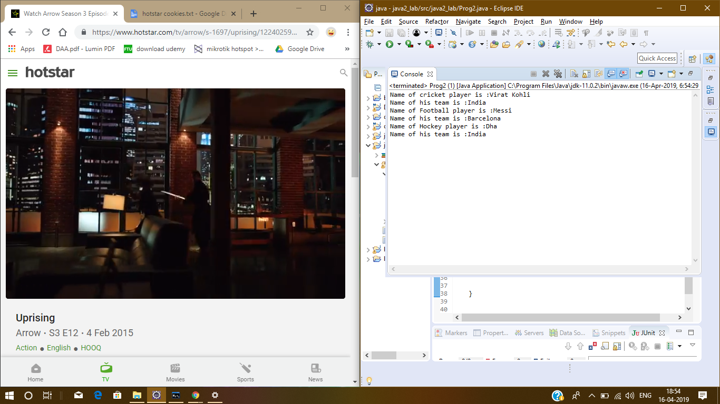

**3) Write a class Worker and derive classes DailyWorker and salaried workers from it. Every worker has a name and a salary rate. Write method Compay (int hours) to compute the week pay of every worker. A Daily Worker is paid on the basis of the number of days he/she works. The Salaried Worker gets paid the wage for 40 hours a week no matter what the actual hours are. Test this program to calculate the pay of workers. You are expected to use the concept of polymorphism to write this program.**

**CODE:**

package java2_lab;

import java.util.Scanner;

class dailyWorker{

public int company(int rate,int days) {

int a=rate;

int b=days;

return a*b;

}

}

class salariedWorker extends dailyWorker{

public int company(int rate) {

int a=rate;

return a*40;

}

}

class Worker extends salariedWorker{

int [] type_workers= new int[10];

int [] salary_rates= new int[10];

int [] Working_days=new int[10];

Scanner inp1;

dailyWorker obj1=new dailyWorker();

salariedWorker obj2=new salariedWorker();

public void workerdetail() {

System.out.println("For many workers you want to input data : ");

inp1 = new Scanner(System.in);

int n=inp1.nextInt();

int i;

for(i=0;i<n;i++) {

System.out.println("input type of the Worker : ( for DailyWorker enter '1' and for salaried worker enter '2'.) ");

int j=i+1;

type_workers[i]=inp1.nextInt();

System.out.println("the type of worker is:"+ type_workers[i]);

if(type_workers[i]==1) {

System.out.println("Enter the salary rate for worker "+ j +": ");

salary_rates[i]=inp1.nextInt();

System.out.println("Enter the number of days worker "+ j +" has worked :");

Working_days[i]=inp1.nextInt();

int x=obj1.company(salary_rates[i],Working_days[i]);

System.out.print("\nPAY OF THE WORKER IS : "+ x+"\n\n");

}

else if(type_workers[i]==2) {

System.out.println("Enter the salary rate for worker "+ j +" : ");

salary_rates[i]=inp1.nextInt();

int y=obj2.company(salary_rates[i]);

System.out.print("\nPAY OF THE WORKER IS : "+ y +"\n\n");

}

}

}

}

public class Prog3 {

public static void main(String[] args) {

Worker obj=new Worker();

obj.workerdetail();

}

}

**OUTPUT:**

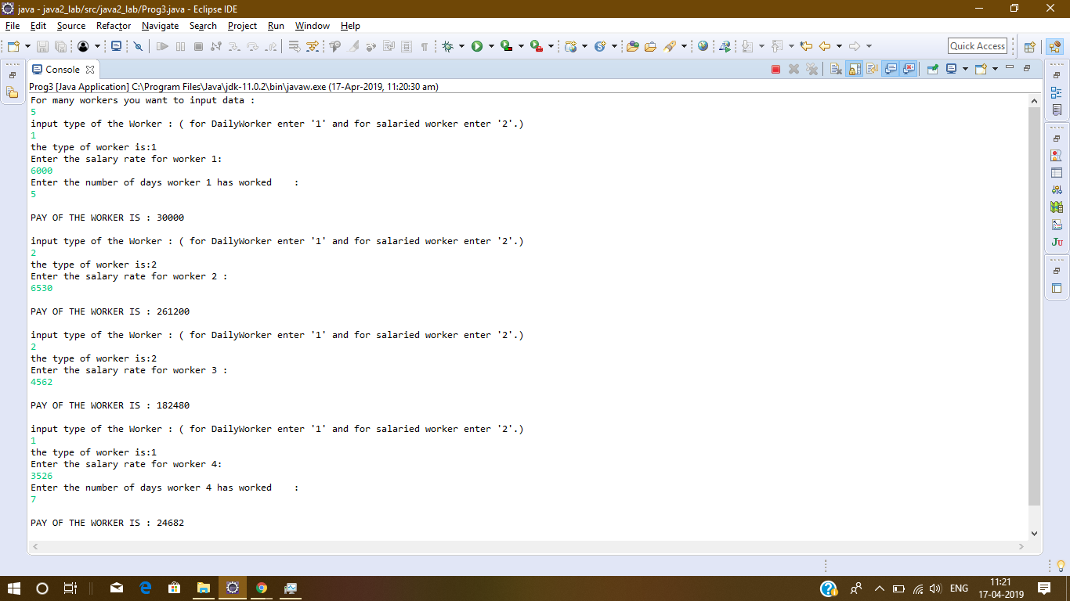

**4) Consider the trunk calls of a telephone exchange. A trunk call can be ordinary, urgent or**

**lightning. The charges depend on the duration and the type of the call. Write a program using the concept of polymorphism in Java to calculate the charges.**

**CODE:**

package java2_lab;

import java.util.Scanner;

class ordinary{

public int charges(int duration) {

int a=duration;

return a*1;

}

}

class urgent extends ordinary{

public int charges(int duration) {

int a=duration;

return a*3;

}

}

class lightning extends urgent{

public int charges(int duration) {

int a=duration;

return a*5;

}

}

public class Prog4 extends lightning {

public static void main(String[] args) {

Scanner obj=new Scanner(System.in);

ordinary ord=new ordinary();

urgent urg= new urgent();

lightning light=new lightning();

System.out.println("What kinda call u wanna do:\n\t"

+ "Press '1' for ordinary call ; '2' for urgent call ; '3' for ligtning call .");

int input=obj.nextInt();

System.out.println("Enter the duration for call (in minutes): ");

int duration=obj.nextInt();

if(input==1) {

System.out.println("You are making an ordinary call \n"

+ "Charges for your call is : "+ ord.charges(duration)+"rupees");

}

else if(input==2) {

System.out.println("You are making an urgent call \n"

+ "Charges for your call is : "+ urg.charges(duration)+"rupees");

}

else if(input==3) {

System.out.println("You are making a lightning call \n"

+ "Charges for your call is : "+ light.charges(duration)+"rupees");

}

}

}

**OUTPUT:**

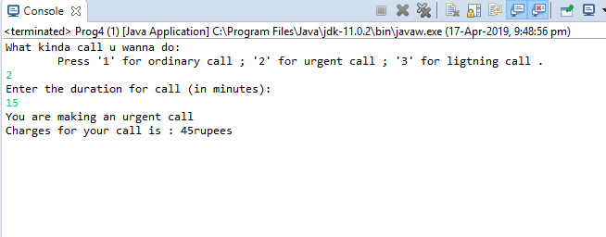

**5) Design a class employee of an organization. An employee has a name, empid, and salary.**

**Write the default constructor, a constructor with parameters (name, empid, and salary) and methods to return name and salary. Also, write a method increaseSalary that raises the**

**employee’s salary by a certain user-specified percentage. Derive a subclass Manager from**

**employee. Add an instance variable named department to the manager class. Supply a test**

**program that uses these classes and methods.**

**CODE:**

package java2_lab;

class employee{

String name;

int salary,empid;

employee(){

System.out.println("This is a default constructor\n");

}

employee(String Name,int Salary,int Empid){

name=Name;

salary=Salary;

empid=Empid;

System.out.println("Name of the employee:"+name );

System.out.println("Salary of the employee: "+salary);

System.out.println("");

}

public String name() {

return name;

}

public int salary() {

return salary;

}

public int increaseSalary(int per) {

return salary+((salary*per)/100);

}

}

public class Prog5 {

public static void main(String[] args) {

employee obj=new employee();

employee obj1=new employee("Darsh",50000,16);

System.out.println("Name of the employee is: "+ obj1.name());

System.out.println("Salary of the employee is: "+obj1.salary());

System.out.println("Salary of the employee after increament: "

+ obj1.increaseSalary(18));

}

}

**OUTPUT:**

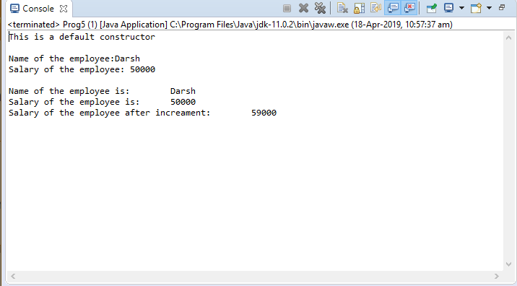

**EXPERIMENT – 3**

**TITLE: OOPs concepts**

**1) Write a program for Abstraction, Encapsulation.**

**CODE:**

package experiment5;

class student{

private String name;

public String getName() {

return name;

}

public void setName(String name) {

this.name = name;

}

}

abstract class employee{

//ABSTRACTION IS USED TO HIDE THE IMPLEMENTATION OF METHODS/...

public employee() {

System.out.println("This is the employee constructor");

}

//METHOD DECLARATION......

public abstract int sum(int x,int y);

}

class Abc extends employee{

public Abc(){

super();

System.out .println("This is contructor of Abc class");

}

//METHOD DEFINED AFTER INHERITANCE....

public int sum(int a,int b) {

return a+b;

}

}

public class Prog1 {

public static void main(String[] args) {

student obj=new student();

obj.setName("Darsh Asawa");

System.out.println("The name of the student is: "+obj.getName());

employee obj1=new Abc();

System.out.println("Sum of 5 and 6 is :"+obj1.sum(5, 6));

}

}

**OUTPUT:**

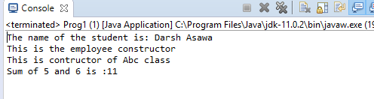

**2) Write a program for Polymorphism and Multi-level inheritance.**

**CODE:**

package experiment5;

class A{

public void run() {

System.out.println("The user is running from class A ");

}

}

class B extends A{

public void run() {

System.out.println("The user is running from class B");

}

}

public class Prog2 {

public static void main(String[] args) {

A obj=new A();

B obj1=new B();

obj1.run();

obj.run();

}

}

**OUTPUT:**

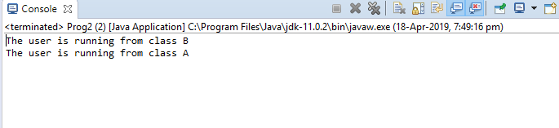

**EXPERIMENT –4**

**TITLE: Exception Handling**

**1). Area of a Triangle**

**CODE:**

import java.util.Scanner;

import java.lang.*;

class Areatriangle{

public static void main(String args[]){

int a,b,c;

Scanner input=new Scanner(System.in);

System.out.println("Enter the value for first side : ");

a=input.nextInt();

System.out.println("Enter the value for second side :");

b=input.nextInt();

System.out.println("Enter the value for third side : ");

c=input.nextInt();

double s=(a+b+c)*0.5;

double ar=s*(s-a)*(s-b)*(s-c);

if((a>=b+c)||(b>=a+c)||(c>=a+b))

{

try{ throw new ArithmeticException();}

catch(ArithmeticException e){

System.out.println("Forming this triangle is not possible");}

}

else {

System.out.println("Area of the triangle is: "+Math.pow(ar,0.5));

}

}

}

**OUTPUT:**

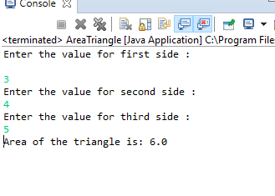

**2) Factorial of a number.**

**CODE:**

package exceptionhandling;

import java.util.Scanner;

public class Factorial{

static int factorial(int n){

if(n==0)

return 1;

else

return(n * factorial(n-1));

}

public static void main(String args[]){

Scanner input=new Scanner(System.in);

System.out.println("Enter the number :");

int number=input.nextInt();

int fact=number;

if(number<0){

try{

throw new ArithmeticException();

}

catch(ArithmeticException e){

System.out.println("Factorial cannot be found");

}

}

else {

System.out.println("Factorial of the number is :"+factorial(number));

}

}

}

**OUTPUT:**

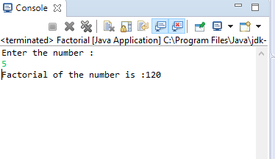

**EXPERIMENT –5**

**TITLE: Threads**

**1) Write a program to implement the concept of threading by extending Thread Class and**

**Runnable interface.**

**CODE:**

**BY EXTENDING THREAD CLASS.**

//import java.lang.Thread;

class ABC extends Thread{

public void run() {

System.out.println("thread in running.. ");

}

public int sum(int x,int y) {

return x+y;

}

}

public class Prog1 {

public static void main(String[] args) {

ABC obj=new ABC();

obj.start();

System.out.println("Sum :"+obj.sum(5, 6));

}

}

**OUTPUT:**

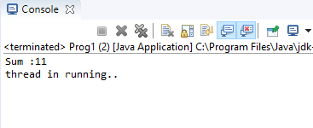

**BY IMPLEMENTING RUNNABLE INTERFACE.–––**

**CODE:**

**package** experiment6;

**class** even **implements** Runnable{

**public** **void** run(){

System.***out***.println("Even numbers:");

**for**(**int** i=0;i<11;i+=2) {

System.***out***.println(i);

}

}

}

**class** odd **implements** Runnable{

**public** **void** run(){

System.***out***.println("Odd numbers:");

**for**(**int** i=1;i<=11;i+=2) {

System.***out***.println(i);

}

}

}

**public** **class** Prog2 {

**public** **static** **void** main(String[] args) {

even r = **new** even();

Thread t = **new** Thread(r);

odd r2 = **new** odd();

Thread t2 = **new** Thread(r2);

t.start();

t2.start();

}

}

**OUTPUT:**

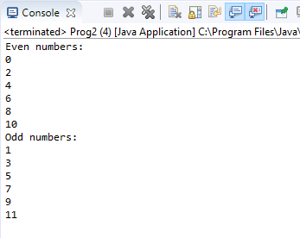

**2) Write a program for generating 2 threads, one for printing even numbers and the other for printing odd numbers.**

**CODE:**

package experiment6;

class even implements Runnable{

public void run(){

System.out.println("Even numbers:");

for(int i=0;i<11;i+=2) {

System.out.println(i);

}

}

}

class odd implements Runnable{

public void run(){

System.out.println("Odd numbers:");

for(int i=1;i<=11;i+=2) {

System.out.println(i);

}

}

}

public class Prog2 {

public static void main(String[] args) {

even r = new even();

Thread t = new Thread(r);

odd r2 = new odd();

Thread t2 = new Thread(r2);

t.start();

t2.start();

}

}

**OUTPUT:**

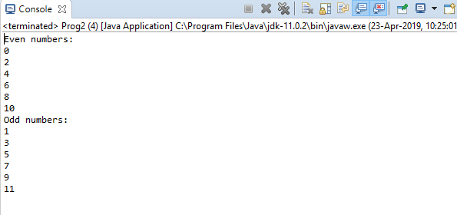

**EXPERIMENT – 6**

**TITLE: AWT Programming**

**Show button component by inheriting Frame class.**

**CODE:**

package experiment7;

import java.awt.*;

class First extends Frame{

First(){

Button b=new Button("click me");

b.setBounds(30,100,80,30);// setting button position

add(b);//adding button into frame

setSize(300,300);//frame size 300 width and 300 height

setLayout(null);//no layout manager

setVisible(true);//now frame will be visible, by default not visible

}

public static void main(String args[]){

First f=new First();

}}

**OUTPUT:**

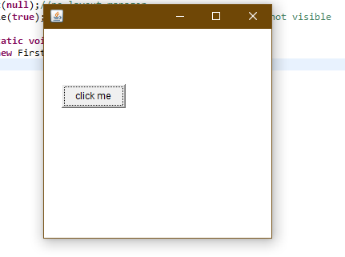

**EXPERIMENT – 7**

**TITLE: FILE I/O**

**1). Basic File handling program in java with reader/writer.**

**2). Write a program that read from a file and write to file.**

**CODE:**

**package** experiment8;

**import** java.io.*;

**public** **class** Inp_Out {

**public** **static** **void** main(String args[]) **throws** IOException {

FileReader in = **null**;

FileWriter out = **null**;

**try** {

in = **new** FileReader("input.txt");

out = **new** FileWriter("out.txt");

**int** c;

**while** ((c = in.read()) != -1) {

out.write(c);

}

}**finally** {

**if** (in != **null**) {

in.close();

}

**if** (out != **null**) {

out.close();

}

}

}

}

**OUTPUT:**

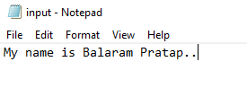 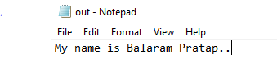

**EXPERIMENT – 8**

**TITLE: Network Programming & RMI**

**Write a RMI based for Client-Server Calculator program.**

Create a folder name RMI. In this folder create two subfolders:

1. Server: Server folder will contain three java programs:
2. MainServer.java
3. RIImplement.java
4. RemoteInterface.java
5. Client: Client folder will contain 2 java programs:
6. MainClient.java
7. RemoteInterface.java

Starting with Server folder ,

**CODE:**

1. **MainServer.java**

import java.rmi.*;

public class MainServer

{

public static void main(String args[])

{

try

{

RemoteInterface st=new RIImplement();

Naming.rebind("rmi://localhost:1020//add",st);

Naming.rebind("rmi://localhost:1020//sub",st);

Naming.rebind("rmi://localhost:1020//mult",st);

Naming.rebind("rmi://localhost:1020//div",st);

Naming.rebind("rmi://localhost:1020//mod",st);

System.out.println("SERVER IS READY");

}

catch(Exception e)

{

System.out.println("SERVER NOT READY");

}

}

}

1. **RIImplement.java**

import java.rmi.*;

import java.rmi.server.*;

public class RIImplement extends UnicastRemoteObject implements RemoteInterface

{

RIImplement() throws RemoteException

{

super();

}

public int add(int x,int y)

{

return x+y;

}

public int sub(int x,int y)

{

return (x-y);

}

public int mult(int x,int y)

{

return (x*y);

}

public int div(int x,int y)

{

return (x/y);

}

public int mod(int x,int y)

{

return (x%y);

}

}

1. **RemoteInterface.java**

import java.rmi.*;

public interface RemoteInterface extends Remote

{

public int add(int x,int y) throws RemoteException;

public int sub(int x,int y) throws RemoteException;

public int mult(int x,int y) throws RemoteException;

public int div(int x,int y) throws RemoteException;

public int mod(int x,int y) throws RemoteException;

}

Now in Client folder:

**CODE:**

1. **MainClient.java**

import java.rmi.*;

import java.util.*;

public class MainClient

{

public static void main(String args[])

{

try{

RemoteInterface st1= (RemoteInterface)Naming.lookup("rmi://localhost:1020//add");

RemoteInterface st2= (RemoteInterface)Naming.lookup("rmi://localhost:1020//sub");

RemoteInterface st3= (RemoteInterface)Naming.lookup("rmi://localhost:1020//mult");

RemoteInterface st4= (RemoteInterface)Naming.lookup("rmi://localhost:1020//div");

RemoteInterface st5= (RemoteInterface)Naming.lookup("rmi://localhost:1020//mod");

Scanner sc=new Scanner(System.in);

int x,y,c;

System.out.println("ENTER THE VALUE");

x=sc.nextInt();

y=sc.nextInt();

System.out.println("ENTER CHOICE FOR ADD,SUBTRACT,MULTIPLY,DIV,MOD");

c=sc.nextInt();

if(c==1)

System.out.println("SUM IS "+st1.add(x,y));

else if(c==2)

System.out.println("DIFF IS "+st2.sub(x,y));

else if(c==3)

System.out.println("PRODUCT IS "+st3.mult(x,y));

else if(c==4)

System.out.println("DIV IS "+st4.div(x,y));

else if(c==5)

System.out.println("MOD IS "+st5.mod(x,y));

else

System.out.println("ENTER VALID INPUT");

}

catch(Exception e){

System.out.println(e);

}

}

}

1. **RemoteInterface.java**

import java.rmi.*;

public interface RemoteInterface extends Remote

{

public int add(int x,int y) throws RemoteException;

public int sub(int x,int y) throws RemoteException;

public int mult(int x,int y) throws RemoteException;

public int div(int x,int y) throws RemoteException;

public int mod(int x,int y) throws RemoteException;

}

**OUTPUT:**

