**BalaReva.Access.Activities**

**Purpose of Activities:**

1. Execute Macro – To execute the macro in the Microsoft Access.

**Properties:**

1. File Path – Specify the access file with full path.
2. Macro Name – Macro name of the access file.
3. Password – If access file has the password, can specify it here.

**Technical Specification:**

It is developed by C#.net. It has dependency of Microsoft.Office.Interop.Access

**Screen shot of Activity:**

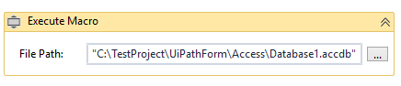

**Real-time:**

* In the Community form can also see the reviews <https://bit.ly/2Myo3X8>