**Package Installation guide**

1. Click the **Manage Package** in Uipath Studio

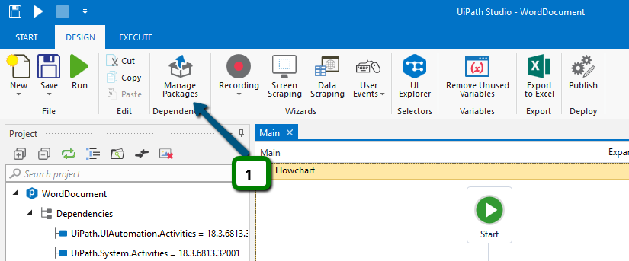

2. Click the **Community** in the Left side panel.

3. Type **BalaReva.PDF** in the Search Textbox. And you can see the package in below.

4. Click the Package. It shows the package description, version and package information URL in the right side panel.

5. Click the **Install button**.

6. Finally click **OK** button. Now the package will install in the studio.

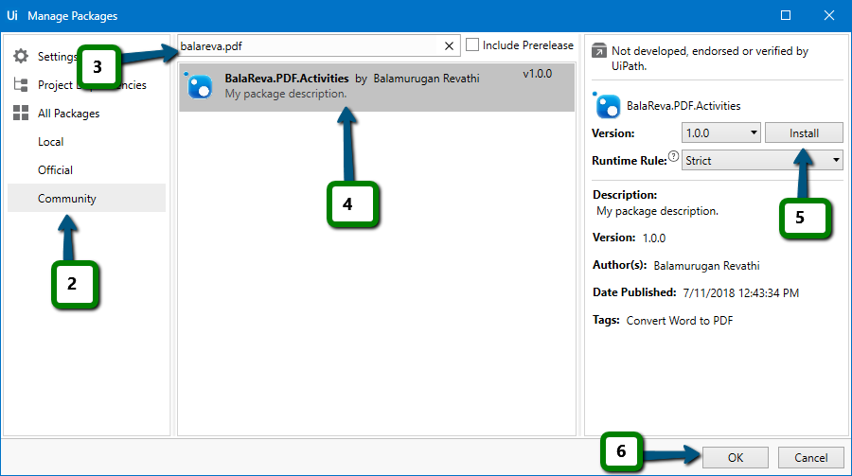

7. The custom activities available in the namespace as below

