Linux Programming

Name: Balakrishnan.P

Register number: 16MIS1159

Question 1:

#!/usr/bin/env bash

dmesg | tail -5 > demsg3.txt
grep -w "usecs" demsg3.txt
grep -i "usecs" demsg3.txt
grep -c "usecs" demsg3.txt
grep -cw "usecs" demsg3.txt

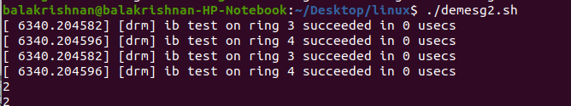

Question 2:

#!/usr/bin/env bash

file=/home/balakrishnan16mis1159/Desktop/output.txt
while IFS= read -r line
do
echo "$line" | grep "Hi"
done < "$file"
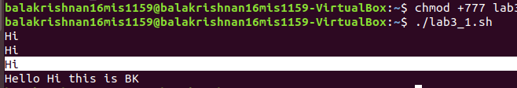

Question 3:

#!/usr/bin/env bash

dmesg > dmsg2.txt

while IFS= read -r line
#input= "dmsg.txt"
do
echo "$line" | grep -w "errors" >> dmsg3.txt
done < dmsg2.txt



Question 4:

background process:

#!/usr/bin/env bash

sleep 500

echo "hello world"

crontab process:

#!/usr/bin/env bash

top -b -n 2 -d 0.2 -p 7356 | tail -1 | awk '{print $9"\t"$10}' >> bg_output.txt

Note: here 7356 is the pid of background process

Output:

The output contains the CPU and Memory utilization of the background process mentioned above.
The performance is measured every one minute and inserted into the file named “bg_output.txt”.

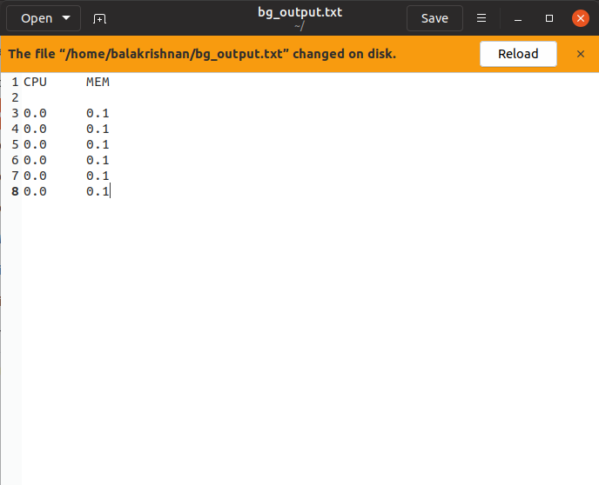

Note:The output contains same values for the utilization as the performance is measured for every one minute. It can also be measured for every minutes but since the sleep value is given only as 500 seconds I have measured for every 1 minute. And that’s why we are getting same values.

