Installation and configure Google App Engine

Laboratory Practice-II (Part-2)

## What is Google App Engine?

Google App Engine (GAE) is a fully managed platform-as-a-service (PaaS)

offering from Google Cloud Platform (GCP). It allows developers to build and deploy web applications and services without the need to manage the

underlying infrastructure. GAE abstracts away many of the complexities of managing servers, networking, and scaling, allowing developers to focus solely on writing code.

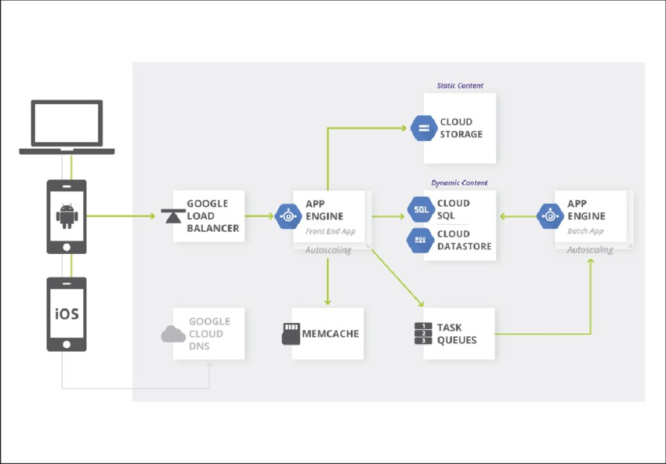

# Key features of Google App Engine include:

Automatic Scaling: GAE automatically scales your application based on

incoming traffic, ensuring that it can handle sudden spikes in demand without manual intervention.

Managed Infrastructure: Google handles the underlying infrastructure,

including servers, networking, and storage, allowing developers to focus on building and deploying their applications.

Support for Multiple Programming Languages: GAE supports several

programming languages including Python, Java, Go, and Node.js, providing flexibility for developers to choose the language they are most comfortable with.

Integrated Services: GAE integrates seamlessly with other Google Cloud Platform services such as Google Cloud Storage, Google Cloud Datastore, and Google Cloud SQL, enabling developers to leverage additional capabilities as needed.

Versioning and Traffic Splitting: GAE allows developers to deploy multiple versions of their application concurrently and perform traffic splitting to gradually roll out new features or updates.

Security and Compliance: Google App Engine offers built-in security features such as encrypted data transmission, identity and access management (IAM), and compliance certifications to ensure that applications meet industry standards and regulations.

# Create a Google Cloud Platform (GCP) Account:

If you don't have a Google Cloud Platform account, you'll need to create one. Go to the Google Cloud Platform website and sign up for an account.

Install the Google Cloud SDK:

Download and install the Google Cloud SDK, which includes the gcloud

command-line tool for interacting with Google Cloud Platform services. You can find installation instructions for various operating systems.

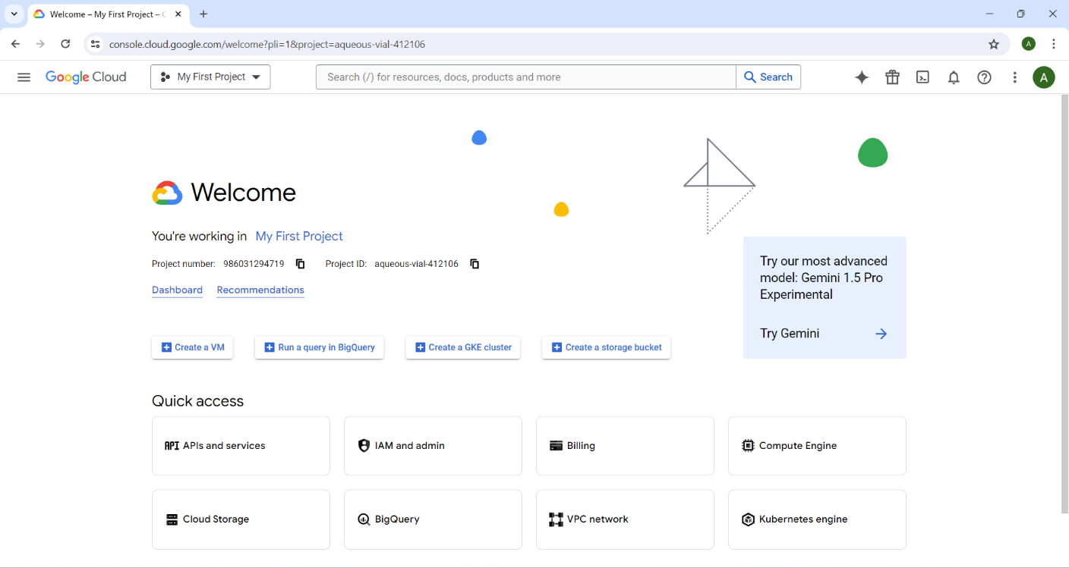

## Create a New Project:

If you haven't already created a project, click on the "Select a project" dropdown menu at the top of the page and then click on "New Project". Follow the prompts to create a new project.

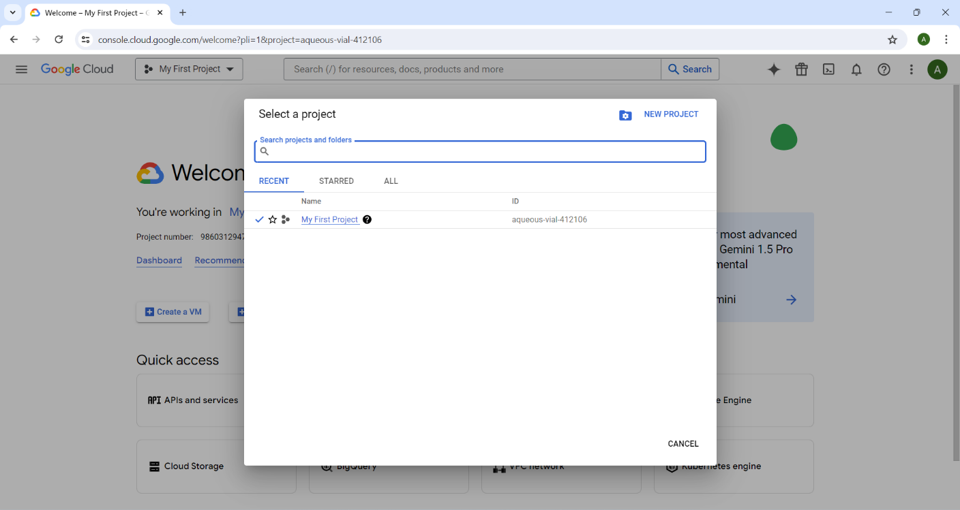

## Enable Billing:

Before you can deploy an application, you need to enable billing for your project. Click on the project name dropdown at the top of the page and select your project. Then, go to the Billing section in the left sidebar and follow the instructions to enable billing for your project.

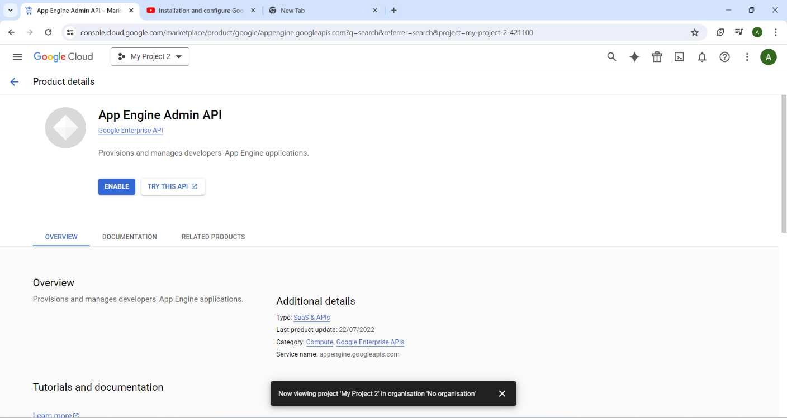

Navigate to App Engine:

In the Google Cloud Console, navigate to the "App Engine" section using the left sidebar menu.

Create an App Engine App:

Click on the "Create App" button to create a new App Engine application. Follow the prompts to select your desired region and configure your new application.

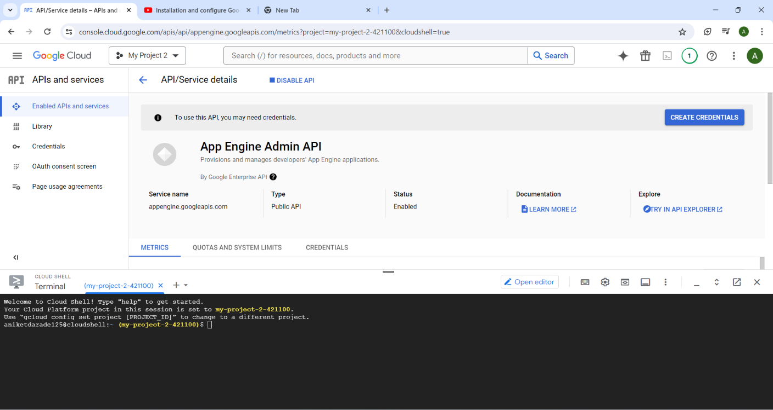

Prepare Your Application:

Ensure that your application code follows the guidelines and requirements for deploying to Google App Engine. Make any necessary changes to your code to ensure compatibility with the platform.

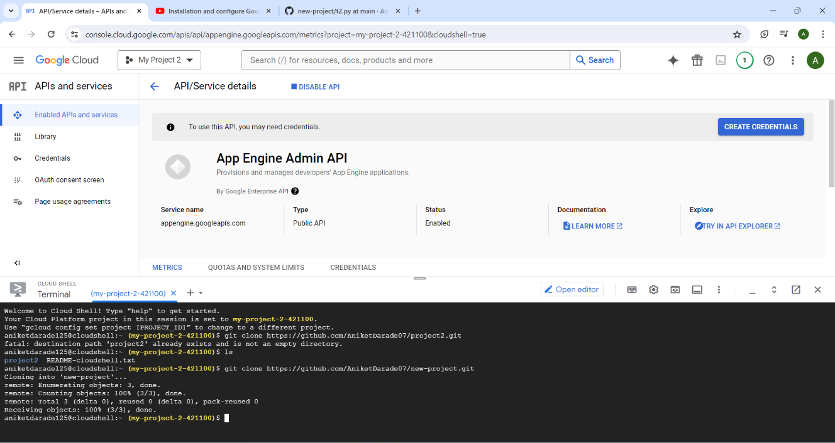

Deploy Your Application:

In the App Engine section of the Google Cloud Console, click on the "Deploy" button. Follow the prompts to select your application directory and deploy your application to Google App Engine.

Monitor Deployment:

Monitor the deployment process in the Google Cloud Console. Once the deployment is complete, you'll receive a confirmation message indicating that your application has been deployed successfully.

Access Your Application:

After deployment, you can access your application using the URL provided by Google App Engine. You can also configure custom domains and SSL certificates as needed.

