Department of Artificial Intelligence and Machine Learning Object Oriented Programming through C++
(2501CS08)

STUDENT ATTENDANCE MANAGEMENT SYSTEM
CERTIFICATE

BATCH NUMBER – 04 SUBMITTED BY
SK BALA SAIDA — 25B11AIA99
M SRI SUSWAR — 25B11AI666
N JAYA NAGA SATISH — 26B21AI087 G AJAY KUMAR — 26B21AI040

In partial fulfilment of the requirements for the award of the B.Tech. degree in Artificial intelligence and machine learning the academic year 2026-2027.

Project Guide Head of the Department
Thorati Vijaya Lakshmi, Dr. K. Naga Bhargavi, Ph.D, Assistant Professor, Associate Professor & HOD, Department of AIML. Department of AIML.

CERTIFICATE

This is to certify that the cornerstone project entitled “Student Result Management System” is submitted by [SK BALA SAIDA(25B11AIA99),M SRI SUSWAR(25B11AI666),N JAYA NAGA SATISH(26B21AI087),G AJAY
KUMAR(26B21AI040)] in partial fulfilment of the requirements for the award of the B.Tech. degree in AI&ML at ADITYA UNIVERSITY. The project work was carried out under my supervision.

Project Guide T.VIJAYALAKSHMI, M.Tech ,
Assistant Professor Department of CSE Aditya University

DECLARATION
We declare that the project entitled “Student Result Management System” is our original work, carried out as part of the requirements for the B.Tech. degree in AIML at Aditya University. This work has not been submitted, in full or in part, for another degree or diploma.

Submitted By
Sk.Balasaida 25B11AIA99
M.Suswar 25B11AI666
N.Jaya Naga Satish 25B11AI087 G.Ajay Kumar 25B11AI040
Place: Surampalem
Date:

ACKNOWLEDGEMENT
It is with immense pleasure that we express our sincere gratitude to our Cornerstone Project Guide, , T.VIJAYALAKSHMI, M.Tech ,Assistant Professor, who has guided us throughout the project. Valuable support, encouragement, and guidance have greatly contributed to the successful completion of this work.
We would like to thank our Deputy Heads of the Department, Dr. R. Suneetha, Assistant Professor, Dr.Bollu Manikyala Rao, Associate Professor ,Dr.D.Veeraswamy,Assistant Professor Department of AIML, for their support and valuable suggestions.
Our deepest thanks to our Head of the Department Dr. . K.Naga Bhargavi, Associate Professor,
for her inspiration and for providing all the necessary facilities and resources required for this project.
We also extend our sincere thanks to Dr. M.V. Rajesh, Associate Dean, School of Computing for their encouragement and support during the course of our project.
We would like to express our sincere gratitude to Dr. G. Suresh, Registrar, Dr. A Ramesh, Pro Vice-Chancellor (Engineering & Sciences), Dr.S. Rama S r e e , Pro Vice-Chancellor (Academics),
D r . M.B. Srinivas, V i c e -Chancellor, Dr. M. Sreenivasa Reddy, Deputy Pro Chancellor and Management, Aditya University for providing excellent infrastructure and state-of-the-art laboratories.
Finally, we would like to thank the faculty members, lab technicians, non-teaching staff, and our friends who have directly or indirectly supported us in completing this Cornerstone project successfully

Sk.Balasaida 25B11AIA99
M.Suswar 25B11AI666
N.Jaya Naga Satish 25B11AI087 G.Ajay Kumar 25B11AI040 Date:

ABSTRACT
The Student Result Management System is a menu-driven application developed in C++ to help organize and calculate semester results. It provides a structured way to register students, record subject details and marks, calculate grades, and display result summaries. The system is designed for academic use where student performance must be reviewed across several subjects and semesters.
For each student, the program stores a roll number, name, semester, and information for five subjects. Subject records include the subject code, subject name, credits, and marks for two internal evaluations, internal assessment, and the semester-end examination. The system validates numeric inputs and checks that values fall within the allowed ranges. For students in semesters after the first, users can also enter previously earned credits and CGPA.
After marks are entered, the program calculates the average of the two internal evaluations and combines it with the internal assessment and external examination marks to determine each subject’s total. It assigns a grade and grade point according to the project’s grading scale. A subject is considered passed when the total is at least 40 and the external examination mark is at least 24. If a student fails any subject, the semester result is shown as failed or supplementary.
The system calculates SGPA using subject credits and grade points. For later semesters, it combines the current SGPA and credits with the student’s previous CGPA and credits to calculate CGPA. It also calculates the average percentage across the five subjects. Users can search for a student by roll number, display a complete semester result, view SGPA and CGPA, identify the semester topper, list students who passed or failed, and view a class summary with result counts and average SGPA.
The project demonstrates the use of C++ classes, structures, arrays, vectors, member functions, loops, conditional statements, strings, and input validation. Student records are held in memory while the application is running; they are not saved after the program exits.

ABBREVIATIONS

Abbreviation | Meaning
OOP | Object-Oriented Programming
C++ | C++ Programming Language
SGPA | Semester Grade Point Average
CGPA | Cumulative Grade Point Average
IE | Internal Evaluation
PBL | Project Based Learning

LIST OF FIGURES

Figure 1 – Overall System Architecture Figure 2 – Student and subject class structure Figure 3 – Main menu flowchart
Figure 4 – Student registration flow
Figure 5 – Marks entry and result calculation flow Figure 6 – Result display and reporting flow Figure 7 – Student registration output
Figure 8 – Subject marks entry output Figure 9 – Student result output
Figure 10 – Topper and pass/fail report output Figure 11 – Class summary output
Figure 12 – Program exit output

LIST OF TABLES
Table 1 – Planned Modules / Functions Table 2 – Classes and responsibilities Table 3 – Grade and pass rules
Table 4 – Inputs and outputs
Table 5 – Test cases and expected results Table 6 – Team members and responsibilities

TABLE OF CONTENTS
Title Page I Certificate II Declaration III Acknowledgement IV Abstract V Abbreviations VI
List of Figures VII List of Tables VIII Table of Contents IX
- Chapter 1 — Project Planning
- 1.1 Problem Statement
- 1.2 Project Objectives
- 1.3 Planned Modules
- 1.4 System Architecture and Algorithms
- Chapter 2 — Project Implementation
- 2.1 C++ Concepts Used
- 2.2 Program Functions
- 2.3 Output Screens
- 2.4 Test Cases
- Chapter 3 — Conclusion and Future Scope
- 3.1 Conclusion
- 3.2 Future Scope
- References
- Appendix — Team Members and Responsibilities

CHAPTER 1
PROJECT PLANNING

Problem Statement
Managing semester results manually can make it difficult to organize student information, subject marks, credits, grades, and semester averages. Manual calculations of grades, SGPA, CGPA, and class summaries can also take time and lead to errors.
This project provides a console-based application for entering student and subject information, calculating results, and displaying individual or class reports. The program stores records in memory while it is running.

Project Objectives
- Register student roll number, name, and semester.
- Record marks and credits for five subjects.
- Calculate subject totals, grades, and grade points.
- Calculate percentage, SGPA, and CGPA.
- Display a student’s semester result.
- Identify the semester topper among students with entered marks.
- Display passed and failed student lists.
- Summarize result counts and average SGPA for the class.
- Validate numeric input and reject duplicate roll numbers.

Planned Modules
The system is divided into seven modules. Each module is implemented as one or more member functions of the classes described in Chapter 2.

Module | Main operations
Student Management | Add student details and check duplicate roll numbers
Subject Marks Entry | Enter subject code, name, credits, and marks
Result Calculation | Calculate subject totals, grades, SGPA, CGPA, and percentage
Student Search | Find a student using the roll number
Result Display | Display marks, grades, and semester result
Result Reports | Show topper, pass/fail lists, and class summary

Module | Main operations
Menu Control | Read a menu choice and call the selected operation

System Architecture (Algorithm & Flowchart)

Three-Layer Architecture
The program has three logical parts:
      - Menu and input: main() displays the menu and reads user choices.
      - Student and result processing: the Student class stores student details and performs marks entry and result calculations. The Subject structure stores data for each subject.
      - Reports: report functions search the student list and display topper, pass/fail, and class summary information.
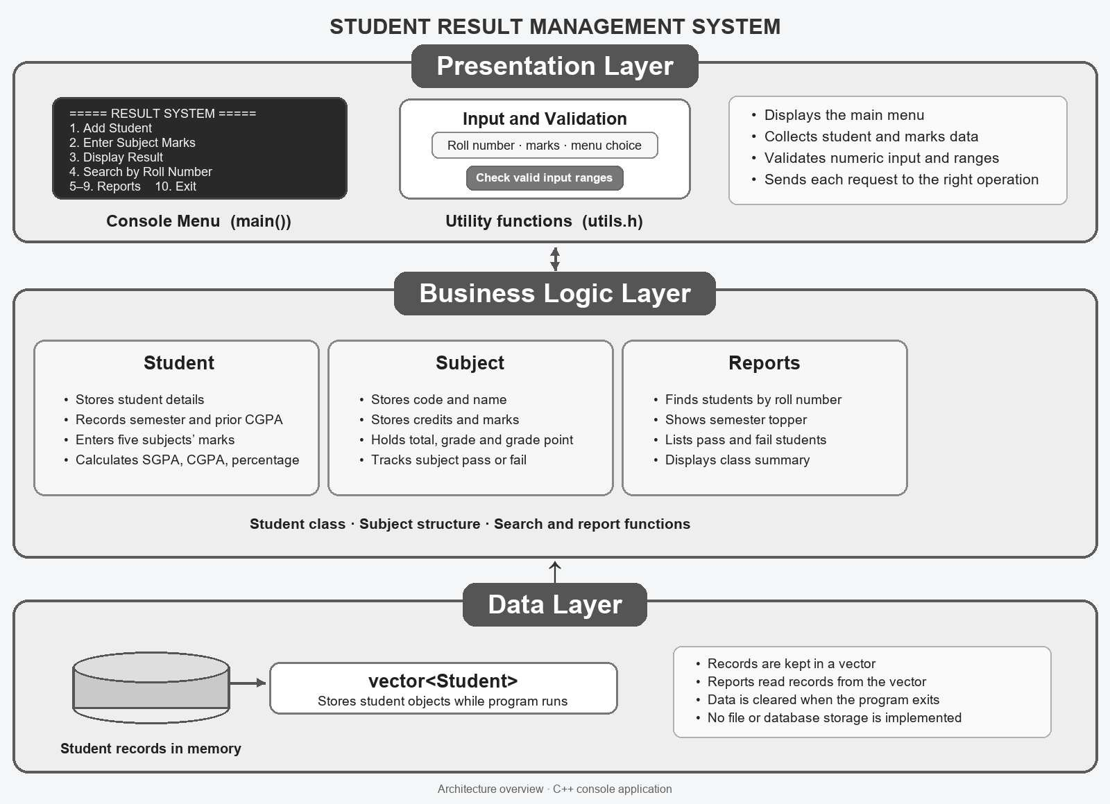
Student objects are stored in a vector<Student> while the application is running.

Figure 1 – Overall System Architecture

Overall Processing Flow
- Start the program and create an empty student list.
- Display the main menu.
- Read a choice from 1 to 10.
- Run the selected student, marks, result, or report operation.
- Return to the menu after the operation.
- End when the user selects Exit.

Student Registration Algorithm
- Read the roll number and student name.
- Read the semester number, from 1 to 8.
- If the semester is greater than 1, read previous total credits and previous CGPA.
- Search the student list for the same roll number.
- If it already exists, display a duplicate message.
- Otherwise, add the student to the list.
- 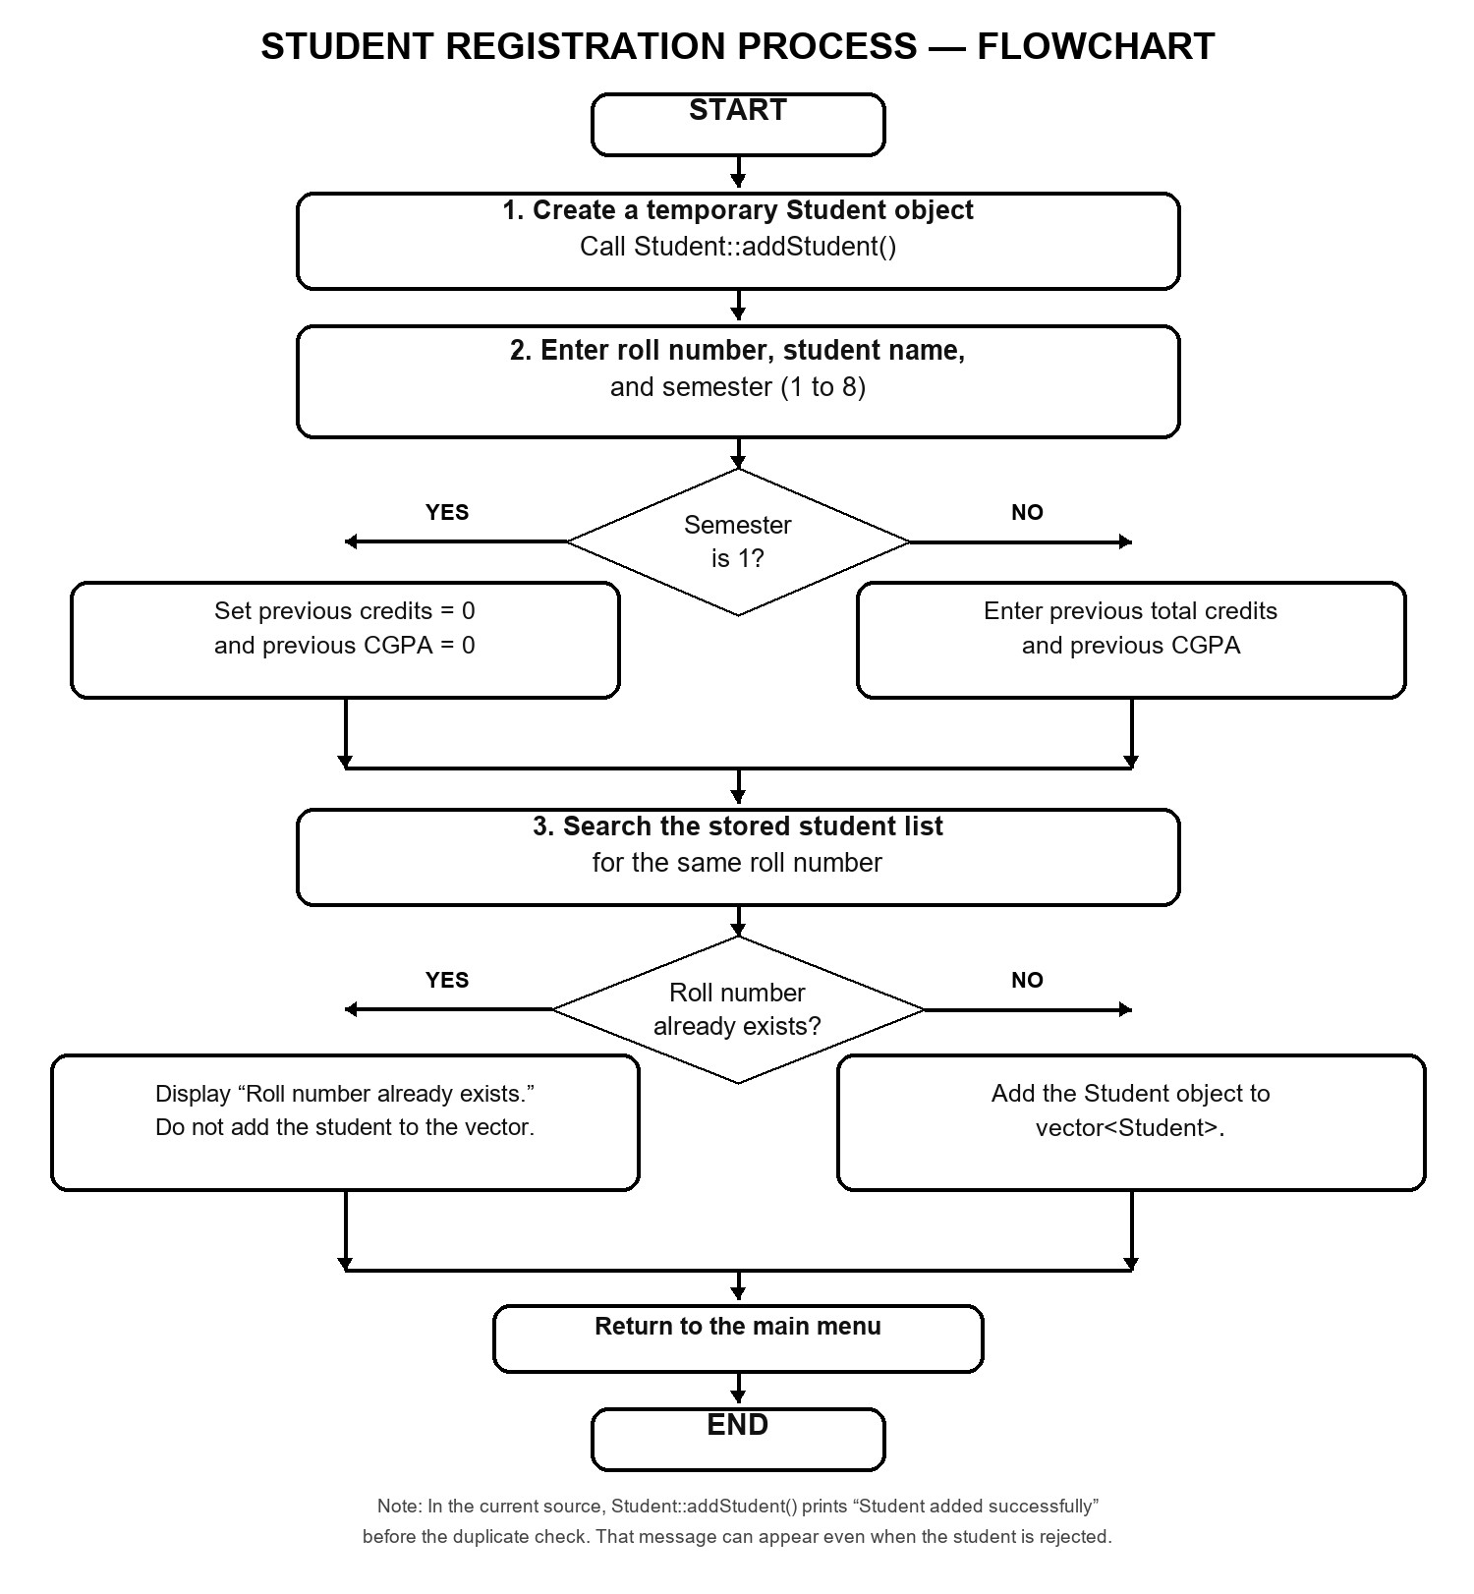

Figure 3 – Student Registration and Attendance Flow

Attendance Marking Algorithm
- Read the student’s roll number and search for the record.
- If the student is not found, display a message and return to the menu.
- For each of the five subjects, read the subject code, name, credits, and marks.
- Calculate the midterm average as (IE1 + IE2) / 2.
- Calculate the subject total as midterm average + internal marks + external marks.
- Assign a grade and grade point based on the subject total.
- Mark the subject as passed if the total is at least 40 and external marks are at least 24.
- Calculate SGPA using credit-weighted grade points.
- Calculate CGPA using the previous CGPA and credits, when provided.
- Calculate percentage as the average subject
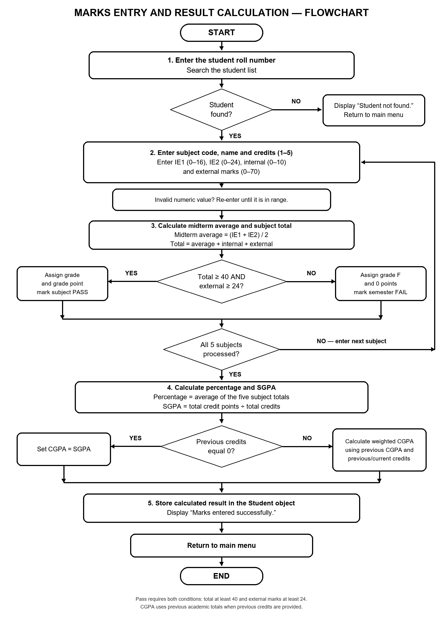 total.
Figure 4 – Student result management Flow

Attendance Percentage and Report Algorithm
- Read the roll number to search.
- Scan the student list for a matching roll number.
- If no match is found, display “Student not found.”
- If the record exists, display the result if marks have been entered; otherwise display a message that marks are unavailable.
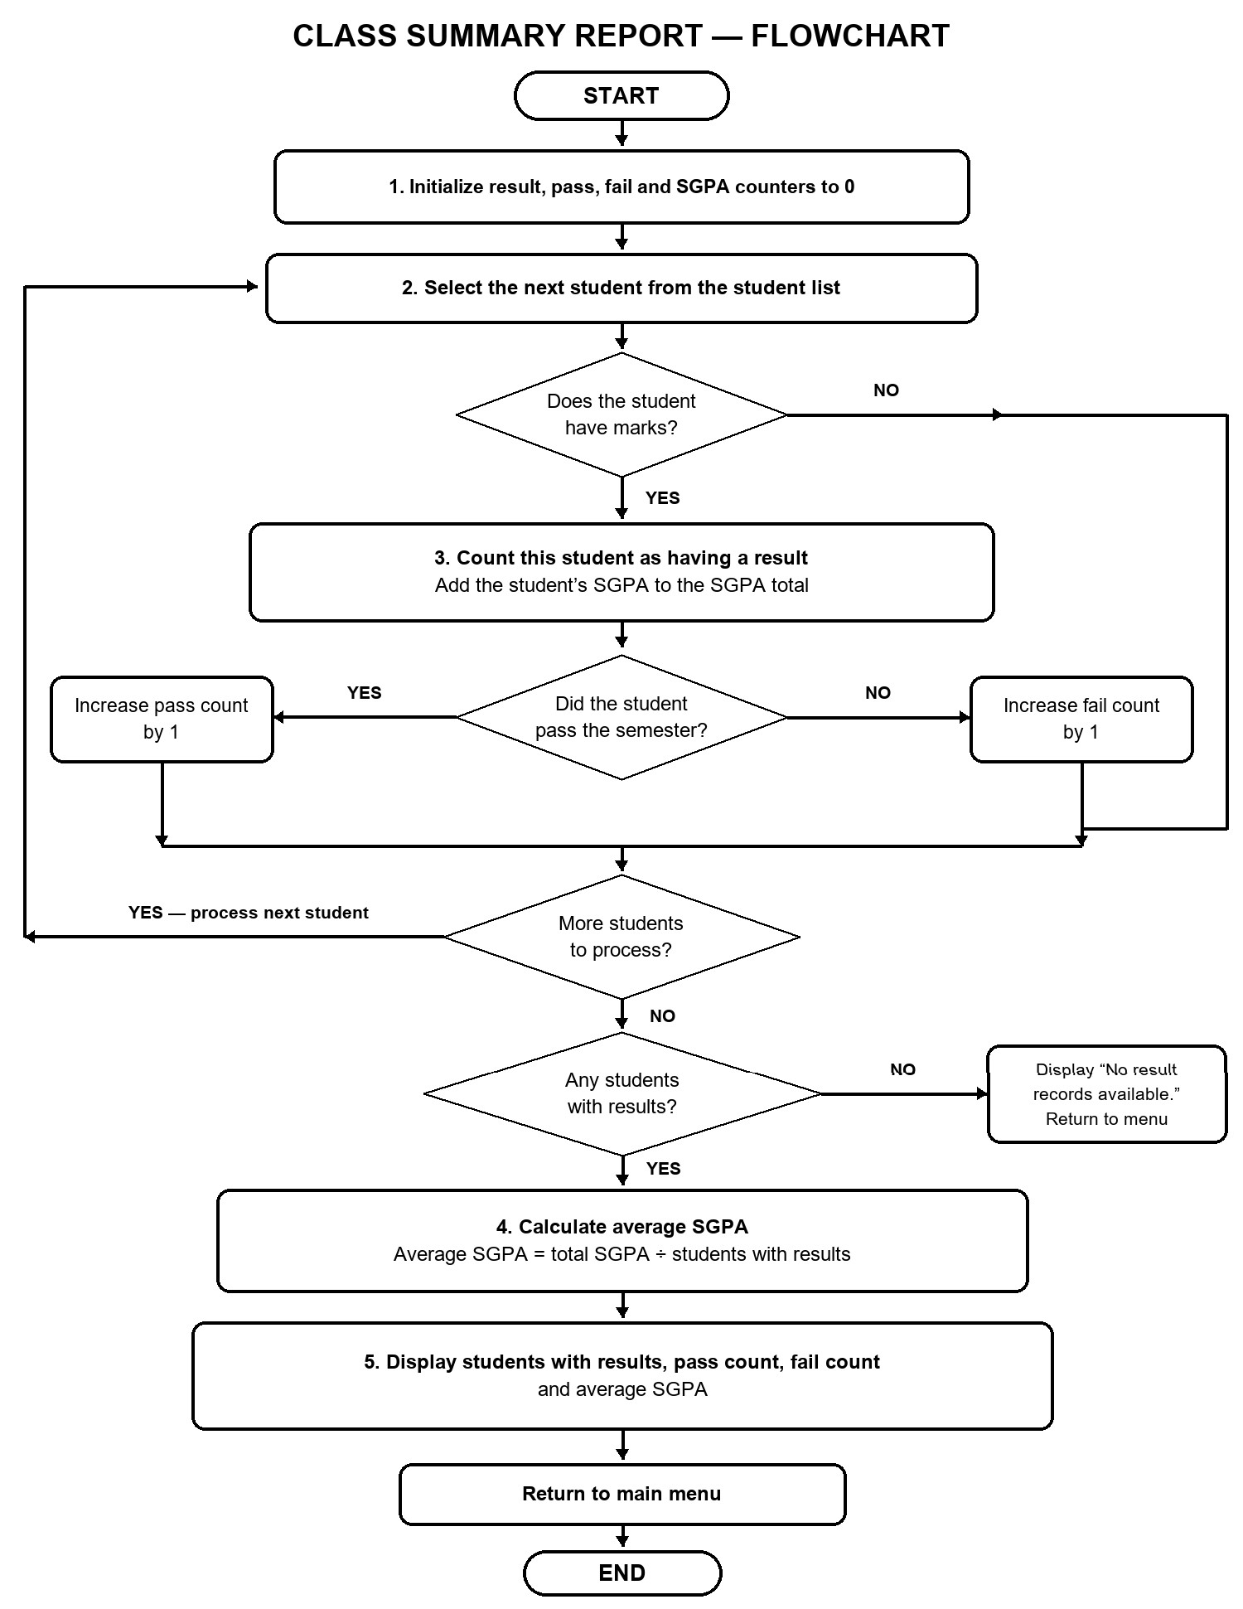
Figure 5 –Class Summary and Report Flow

Student Search Algorithm
      - Topper: compare SGPA values for students whose marks are available and display the highest.
      - Pass/fail list: check each student’s semester pass status and display the corresponding list.
      - Class summary: count students with results, count passes and failures, and calculate average SGPA.
      - Record count: display the number of student records currently in memory.

CHAPTER 2
PROJECT IMPLEMENTATION

OOP Concepts Used for Implementation

Concept Use in the project
Class and object Student represents a student record and its result operations. Structure Subject groups marks, credits, grade, and pass status.
Encapsulation Student data members are private and accessed through public member functions. Constructors The Student constructor initializes result and status fields.
Arrays Each student object stores five subject records.
Vector The program stores a variable number of student records.
Functions Separate operations handle input, calculations, display, search, and reports. Loops and conditions Process subject entries, validate values, and generate reports.
Strings Store names, roll numbers, and subject details.

Program Functions

Function Purpose
Student::addStudent() Reads student details and semester information. Student::enterMarks() Reads five subjects’ details and marks.
Student::calculateResult() Calculates totals, grades, pass status, SGPA, CGPA, and percentage. Student::displayResult() Displays a complete semester result.
Student::displaySGPACGPA() Displays SGPA and CGPA. findStudent() Finds a student by roll number.
showTopper() Displays the student with the highest SGPA among students with results. showPassFailList() Displays passed and failed students.

Function Purpose
showClassSummary() Displays result counts and average SGPA. readInteger() and readMarks() Validate numeric input against specified ranges. main() Controls the menu and calls the selected operation.

Grade and Pass Rules

Subject total Grade Grade point
90–100
80–89.99
70–79.99
60–69.99
50–59.99
40–49.99
Below 40

10
9
8
7
6
5
0

O A+ A B+ B C F
A student passes a subject when the total is at least 40 and external marks are at least 24. The semester is marked as failed if any subject does not meet both conditions.

Source Code: StudentReslutManagement.cpp
#include <iostream> #include <iomanip> #include <string> #include <vector> #include <limits> #include <cctype>
using namespace std;

const int SUBJECT_COUNT = 5;
struct Subject
{
string code; string name; int credits;
float ie1; float ie2; float internal; float external;
float midAverage; float total;
string grade; int gradePoint; bool pass;
};
// Read roll number: digits only string readRollNumber()
{
string rollNo; bool valid;

do
{
valid = true;
cout << "Enter Roll Number (digits only): "; cin >> rollNo;
for (int i = 0; i < rollNo.length(); i++)
{
if (!isdigit((unsigned char)rollNo[i]))
{
valid = false; break;
}
}
if (!valid)
cout << "Invalid roll number! Enter digits only.\n";
} while (!valid); return rollNo;
}
// Read name: letters and spaces only string readName(string message)
{
string name;

bool valid;
do
{
valid = true;
cout << message; getline(cin >> ws, name);
if (name.empty()) valid = false;
for (int i = 0; i < name.length(); i++)
{
if (!isalpha((unsigned char)name[i]) && name[i] != ' ')
{
valid = false; break;
}
}
if (!valid)
cout << "Invalid input! Use letters and spaces only.\n";
} while (!valid); return name;

}
// Read subject code: letters, digits, and hyphens string readSubjectCode()
{
string code; bool valid;
do
{
valid = true;
cout << "Enter Subject Code: "; cin >> code;
for (int i = 0; i < code.length(); i++)
{
if (!isalnum((unsigned char)code[i]) && code[i] != '-')
{
valid = false; break;
}
}
if (!valid)
cout << "Invalid code! Use letters, digits, or hyphens.\n";

} while (!valid);
return code;
}
// Read valid integer
int readInteger(string message, int minimum, int maximum)
{
int value;
while (true)
{
cout << message; cin >> value;
if (cin.fail())
{
cout << "Invalid input! Enter an integer.\n"; cin.clear(); cin.ignore(numeric_limits<streamsize>::max(), '\n');
}
else if (value < minimum || value > maximum)
{
cout << "Enter a value between "
<< minimum << " and " << maximum << ".\n";
}

return value;
}
}
}
// Read valid marks or CGPA
float readMarks(string message, float minimum, float maximum)
{
float value;
while (true)
{
cout << message; cin >> value;
if (cin.fail())
{
cout << "Invalid input! Enter a number.\n"; cin.clear(); cin.ignore(numeric_limits<streamsize>::max(), '\n');
}
else if (value < minimum || value > maximum)
{
cout << "Enter a value between "
<< minimum << " and " << maximum << ".\n";
}

return value;
}
}
}
// Grade calculation
string getGrade(float total)
{
if (total >= 90) return "O";
else if (total >= 80) return "A+"; else if (total >= 70) return "A"; else if (total >= 60) return "B+"; else if (total >= 50) return "B"; else if (total >= 40) return "C"; else return "F";
}
// Grade point calculation
int getGradePoint(string grade)
{
if (grade == "O") return 10;
else if (grade == "A+") return 9; else if (grade == "A") return 8; else if (grade == "B+") return 7; else if (grade == "B") return 6; else if (grade == "C") return 5; else return 0;
}

class Student
{
private:
string rollNo; string name; int semester;
int previousCredits; float previousCGPA;
Subject subjects[SUBJECT_COUNT];
float sgpa; float cgpa;
float percentage; int totalCredits;
bool semesterPass; bool marksEntered; bool studentAdded;
public:
Student()
{
semester = 1;
previousCredits = 0;
previousCGPA = 0;

sgpa = 0;
cgpa = 0;
percentage = 0;
totalCredits = 0;
semesterPass = false; marksEntered = false; studentAdded = false;
}
void addStudent(); void enterMarks(); void calculateResult(); void displayResult();
void displaySGPACGPA();
string getRollNo() const
{
return rollNo;
}
string getName() const
{
return name;
}
float getSGPA() const

{
return sgpa;
}
bool isPass() const
{
return semesterPass;
}
bool hasMarks() const
{
return marksEntered;
}
bool isAdded() const
{
return studentAdded;
}
};
// Add student
void Student::addStudent()
{
cout << "\n========== ADD STUDENT ==========\n";
rollNo = readRollNumber();
name = readName("Enter Student Name: ");

semester = readInteger("Enter Semester (1 to 8): ", 1, 8);
if (semester == 1)
{
previousCredits = 0;
previousCGPA = 0;
}
else
{
previousCredits = readInteger(
"Enter Previous Total Credits: ", 1, 300);
previousCGPA = readMarks(
"Enter Previous CGPA (0 to 10): ", 0, 10);
}
studentAdded = true; marksEntered = false;
cout << "\nStudent added successfully!\n";
}
// Enter subject marks
void Student::enterMarks()
{
if (!studentAdded)
{
cout << "\nPlease add student details first.\n";

return;
}
cout << "\n========== ENTER SUBJECT MARKS ==========\n";
for (int i = 0; i < SUBJECT_COUNT; i++)
{
cout << "\n---------- Subject " << i + 1 << " \n";
subjects[i].code = readSubjectCode();
subjects[i].name = readName("Enter Subject Name: ");
subjects[i].credits = readInteger( "Enter Credits (1 to 5): ", 1, 5);
subjects[i].ie1 = readMarks(
"Enter IE1 Marks (out of 16): ", 0, 16);
subjects[i].ie2 = readMarks(
"Enter IE2 Marks (out of 24): ", 0, 24);
subjects[i].internal = readMarks(
"Enter Internal Marks (out of 10): ", 0, 10);
subjects[i].external = readMarks(
"Enter Semester-End Marks (out of 70): ", 0, 70);
}

marksEntered = true; calculateResult();
cout << "\nMarks entered successfully!\n";
}
// Calculate result
void Student::calculateResult()
{
float totalMarks = 0;
float totalCreditPoints = 0;
totalCredits = 0; semesterPass = true;
for (int i = 0; i < SUBJECT_COUNT; i++)
{
subjects[i].midAverage = (subjects[i].ie1 + subjects[i].ie2) / 2.0;
subjects[i].total = subjects[i].midAverage + subjects[i].internal + subjects[i].external;
// Pass requires 40 total and at least 24 external marks if (subjects[i].total >= 40 &&
subjects[i].external >= 24)

{
subjects[i].pass = true;
subjects[i].grade = getGrade(subjects[i].total); subjects[i].gradePoint = getGradePoint(subjects[i].grade);
}
else
{
subjects[i].pass = false; subjects[i].grade = "F"; subjects[i].gradePoint = 0; semesterPass = false;
}
totalMarks += subjects[i].total; totalCredits += subjects[i].credits;
totalCreditPoints +=
subjects[i].gradePoint * subjects[i].credits;
}
percentage = totalMarks / SUBJECT_COUNT;
if (totalCredits > 0)
sgpa = totalCreditPoints / totalCredits; else
sgpa = 0;

if (previousCredits == 0)
{
cgpa = sgpa;
}
else
{
cgpa =
((previousCGPA * previousCredits) + (sgpa * totalCredits)) / (previousCredits + totalCredits);
}
}
// Display full result
void Student::displayResult()
{
if (!studentAdded)
{
cout << "\nPlease add student details first.\n"; return;
}
if (!marksEntered)
{
cout << "\nMarks have not been entered for this student.\n"; return;
}

cout << "\n===============================================================\n"; cout << " UNIVERSITY SEMESTER RESULT\n";
cout << "===============================================================\n";
cout << "Roll Number : " << rollNo << endl; cout << "Name : " << name << endl; cout << "Semester : " << semester << endl;
cout << "\n \n";
cout << left
<< setw(10) << "Code"
<< setw(17) << "Subject"
<< setw(6) << "IE1"
<< setw(6) << "IE2"
<< setw(9) << "Internal"
<< setw(9) << "External"
<< setw(8) << "Total"
<< setw(7) << "Grade"
<< setw(7) << "Point"
<< "Result\n";
cout << " \n";
for (int i = 0; i < SUBJECT_COUNT; i++)
{
cout << left
<< setw(10) << subjects[i].code

<< setw(17) << subjects[i].name
<< setw(6) << subjects[i].ie1
<< setw(6) << subjects[i].ie2
<< setw(9) << subjects[i].internal
<< setw(9) << subjects[i].external
<< setw(8) << fixed << setprecision(2)
<< subjects[i].total
<< setw(7) << subjects[i].grade
<< setw(7) << subjects[i].gradePoint;
if (subjects[i].pass) cout << "PASS\n"; else
cout << "FAIL\n";
}
cout << " \n";
cout << "Average Percentage : "
<< fixed << setprecision(2) << percentage << "%\n";
cout << "SGPA : "
<< fixed << setprecision(2) << sgpa << endl;
cout << "CGPA : "
<< fixed << setprecision(2) << cgpa << endl;
if (semesterPass)

cout << "Semester Result : PASS\n"; else
cout << "Semester Result : FAIL / SUPPLEMENTARY\n";
cout << "===============================================================\n";
}
// Display SGPA and CGPA
void Student::displaySGPACGPA()
{
if (!studentAdded || !marksEntered)
{
cout << "\nStudent details or marks are not available.\n"; return;
}
cout << "\n========== SGPA AND CGPA ==========\n";
cout << "Roll Number : " << rollNo << endl; cout << "Name : " << name << endl;
cout << "SGPA : " << fixed << setprecision(2) << sgpa << endl; cout << "CGPA : " << fixed << setprecision(2) << cgpa << endl;
}
// Find student using roll number
int findStudent(vector<Student>& students, string rollNo)
{
for (int i = 0; i < (int)students.size(); i++)
{

if (students[i].getRollNo() == rollNo) return i;
}
return -1;
}
// Show topper
void showTopper(vector<Student>& students)
{
int topperIndex = -1;
for (int i = 0; i < (int)students.size(); i++)
{
if (students[i].hasMarks())
{
if (topperIndex == -1 || students[i].getSGPA() > students[topperIndex].getSGPA())
{
topperIndex = i;
}
}
}
if (topperIndex == -1)
cout << "\nNo result records available.\n"; else

{
cout << "\n========== SEMESTER TOPPER ==========\n";
students[topperIndex].displayResult();
}
}
// Show passed and failed students
void showPassFailList(vector<Student>& students)
{
cout << "\n========== PASSED STUDENTS ==========\n";
for (int i = 0; i < (int)students.size(); i++)
{
if (students[i].hasMarks() && students[i].isPass())
{
cout << students[i].getRollNo()
<< " - " << students[i].getName() << endl;
}
}
cout << "\n========== FAILED STUDENTS ==========\n";
for (int i = 0; i < (int)students.size(); i++)
{
if (students[i].hasMarks() && !students[i].isPass())
{
cout << students[i].getRollNo()
<< " - " << students[i].getName() << endl;

}
}
}
// Show class summary
void showClassSummary(vector<Student>& students)
{
int resultCount = 0; int passCount = 0; int failCount = 0; float sgpaSum = 0;
for (int i = 0; i < (int)students.size(); i++)
{
if (students[i].hasMarks())
{
resultCount++;
sgpaSum += students[i].getSGPA();
if (students[i].isPass()) passCount++;
else
failCount++;
}
}
if (resultCount == 0)
{

cout << "\nNo result records available.\n"; return;
}
cout << "\n========== CLASS SUMMARY ==========\n";
cout << "Students with Results : " << resultCount << endl; cout << "Passed Students : " << passCount << endl; cout << "Failed Students : " << failCount << endl; cout << "Average SGPA : "
<< fixed << setprecision(2)
<< sgpaSum / resultCount << endl;
}
// Main program int main()
{
vector<Student> students;
int choice; string rollNo; int index;
do
{
cout << "\n=================================================\n"; cout << " UNIVERSITY SEMESTER RESULT MANAGEMENT SYSTEM\n"; cout << "=================================================\n";
cout << "1. Add Student Semester Result\n";

cout << "2. Enter Subject Marks\n";
cout << "3. Display Student Semester Result\n"; cout << "4. Search Student by Roll Number\n"; cout << "5. Show Semester Topper\n";
cout << "6. Show Pass/Fail Student List\n"; cout << "7. Show Class Summary\n";
cout << "8. Show SGPA and CGPA\n"; cout << "9. Show Total Student Records\n"; cout << "10. Exit\n";
choice = readInteger("Enter your choice: ", 1, 10); switch (choice)
{
case 1:
{
Student student; student.addStudent();
if (findStudent(students, student.getRollNo()) != -1)
{
cout << "Roll number already exists. Student not added.\n";
}
else
{
students.push_back(student);
}

break;
}
case 2:
rollNo = readRollNumber();
index = findStudent(students, rollNo);
if (index == -1)
cout << "Student not found. Add student first.\n"; else
students[index].enterMarks(); break;
case 3:
case 4:
rollNo = readRollNumber();
index = findStudent(students, rollNo);
if (index == -1)
cout << "Student not found.\n"; else
students[index].displayResult(); break;
case 5:
showTopper(students);

break;
case 6:
showPassFailList(students); break;
case 7:
showClassSummary(students); break;
case 8:
rollNo = readRollNumber();
index = findStudent(students, rollNo);
if (index == -1)
cout << "Student not found.\n"; else
students[index].displaySGPACGPA(); break;
case 9:
cout << "\nTotal Student Records: "
<< students.size() << endl; break;
case 10:
cout << "\nThank you for your using the system.\n";

break;
}
} while (choice != 10); return 0;
}

Output Screens
    - Main menu
    - Student registration
    - Duplicate roll number message
    - Subject marks entry
    - Complete student result
    - Student search when found and when not found
    - Semester topper
    - Passed and failed student lists
    - Class summary
    - SGPA and CGPA display
    - Total student records
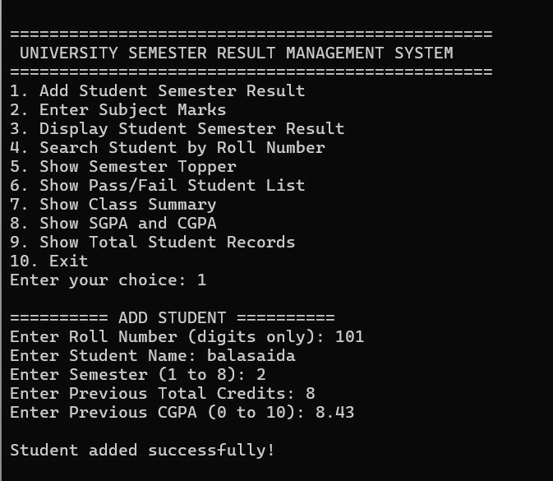
    - Exit message

Figure 7 –Add Student

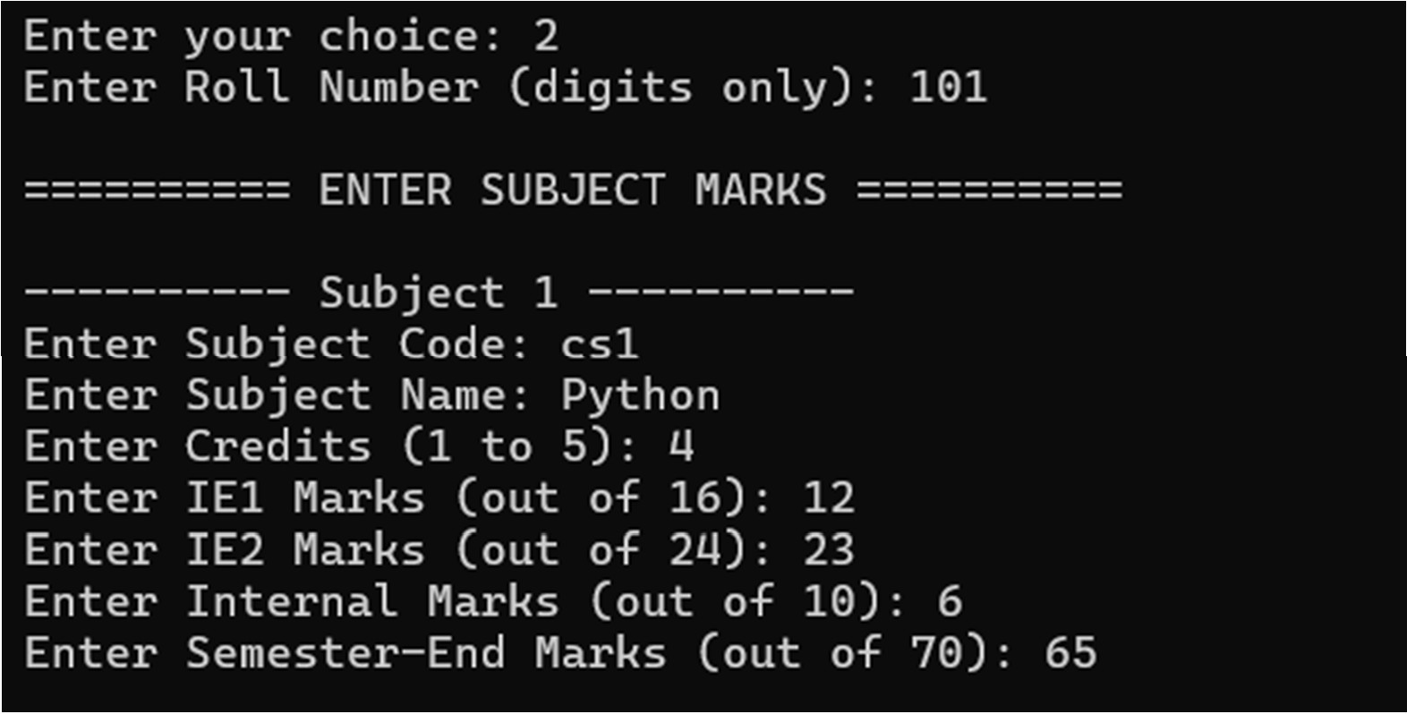

Figure 8 – Enter Subject Marks

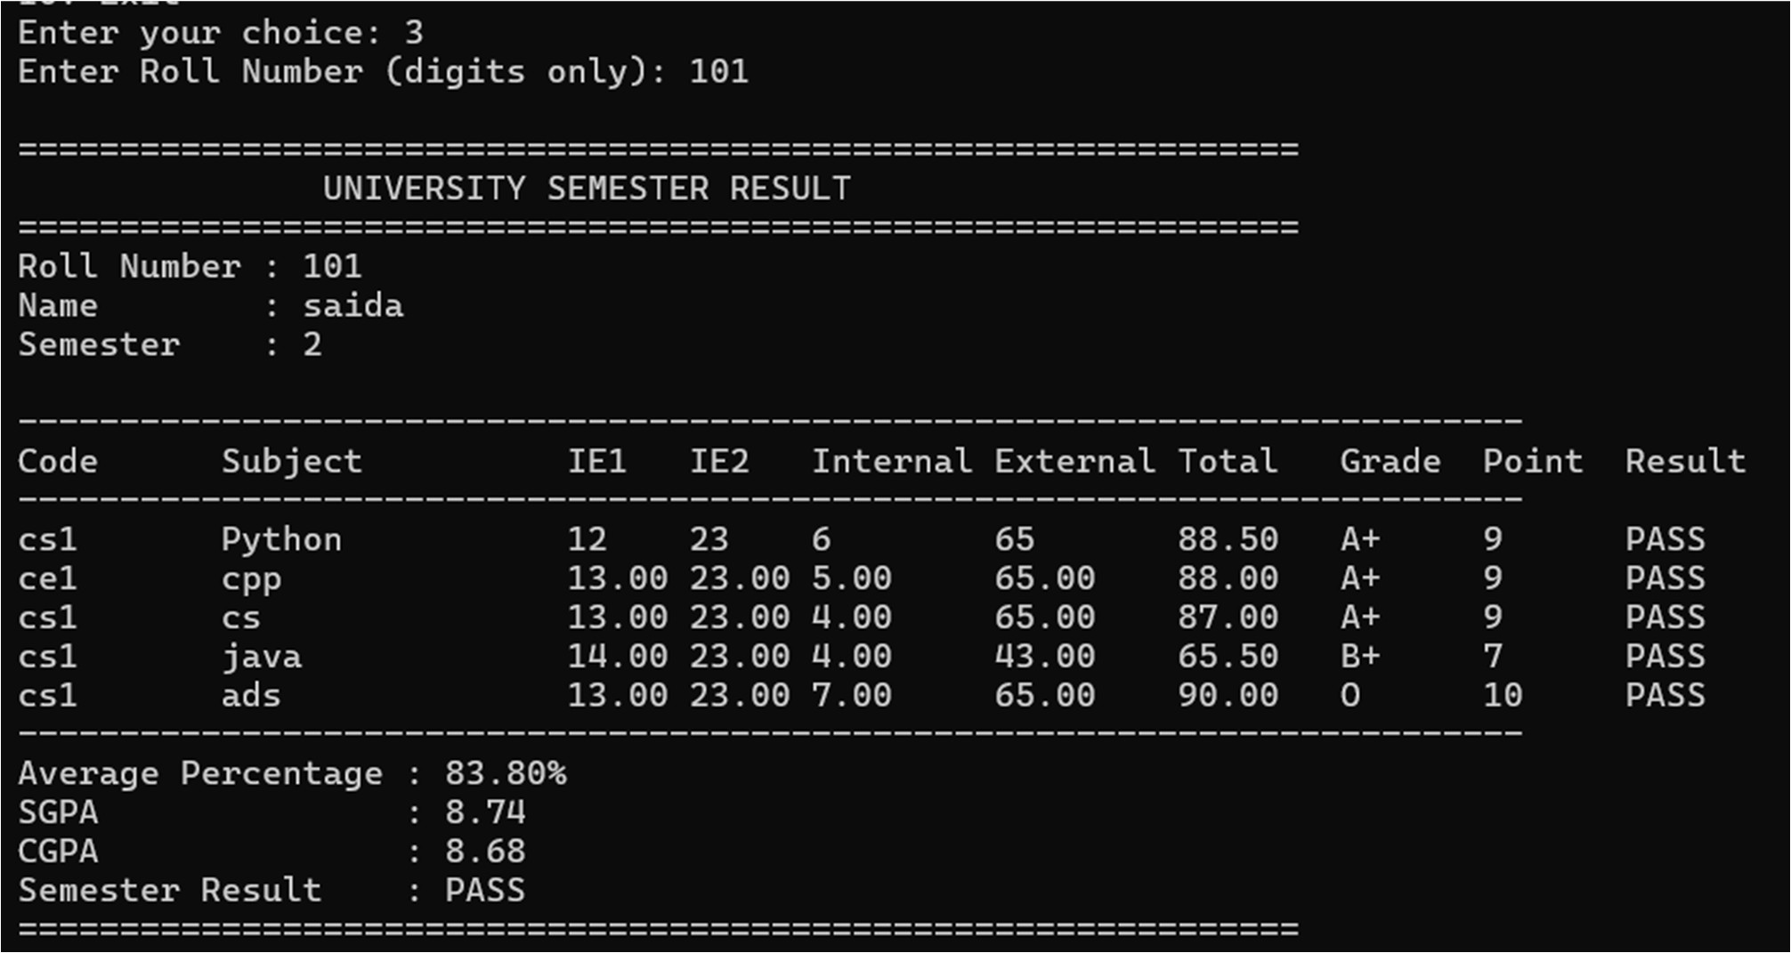

Figure 9: Display Student Semester Result

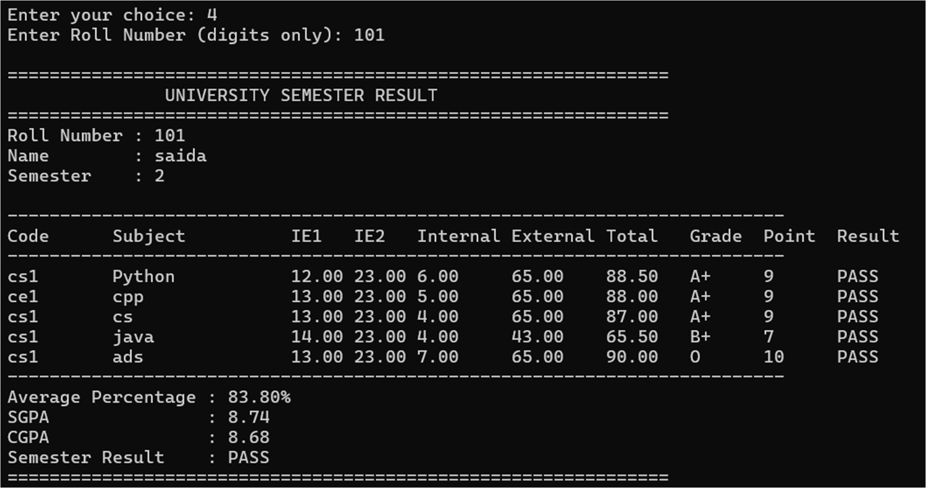
Figure 10 – Search Student by Roll Number
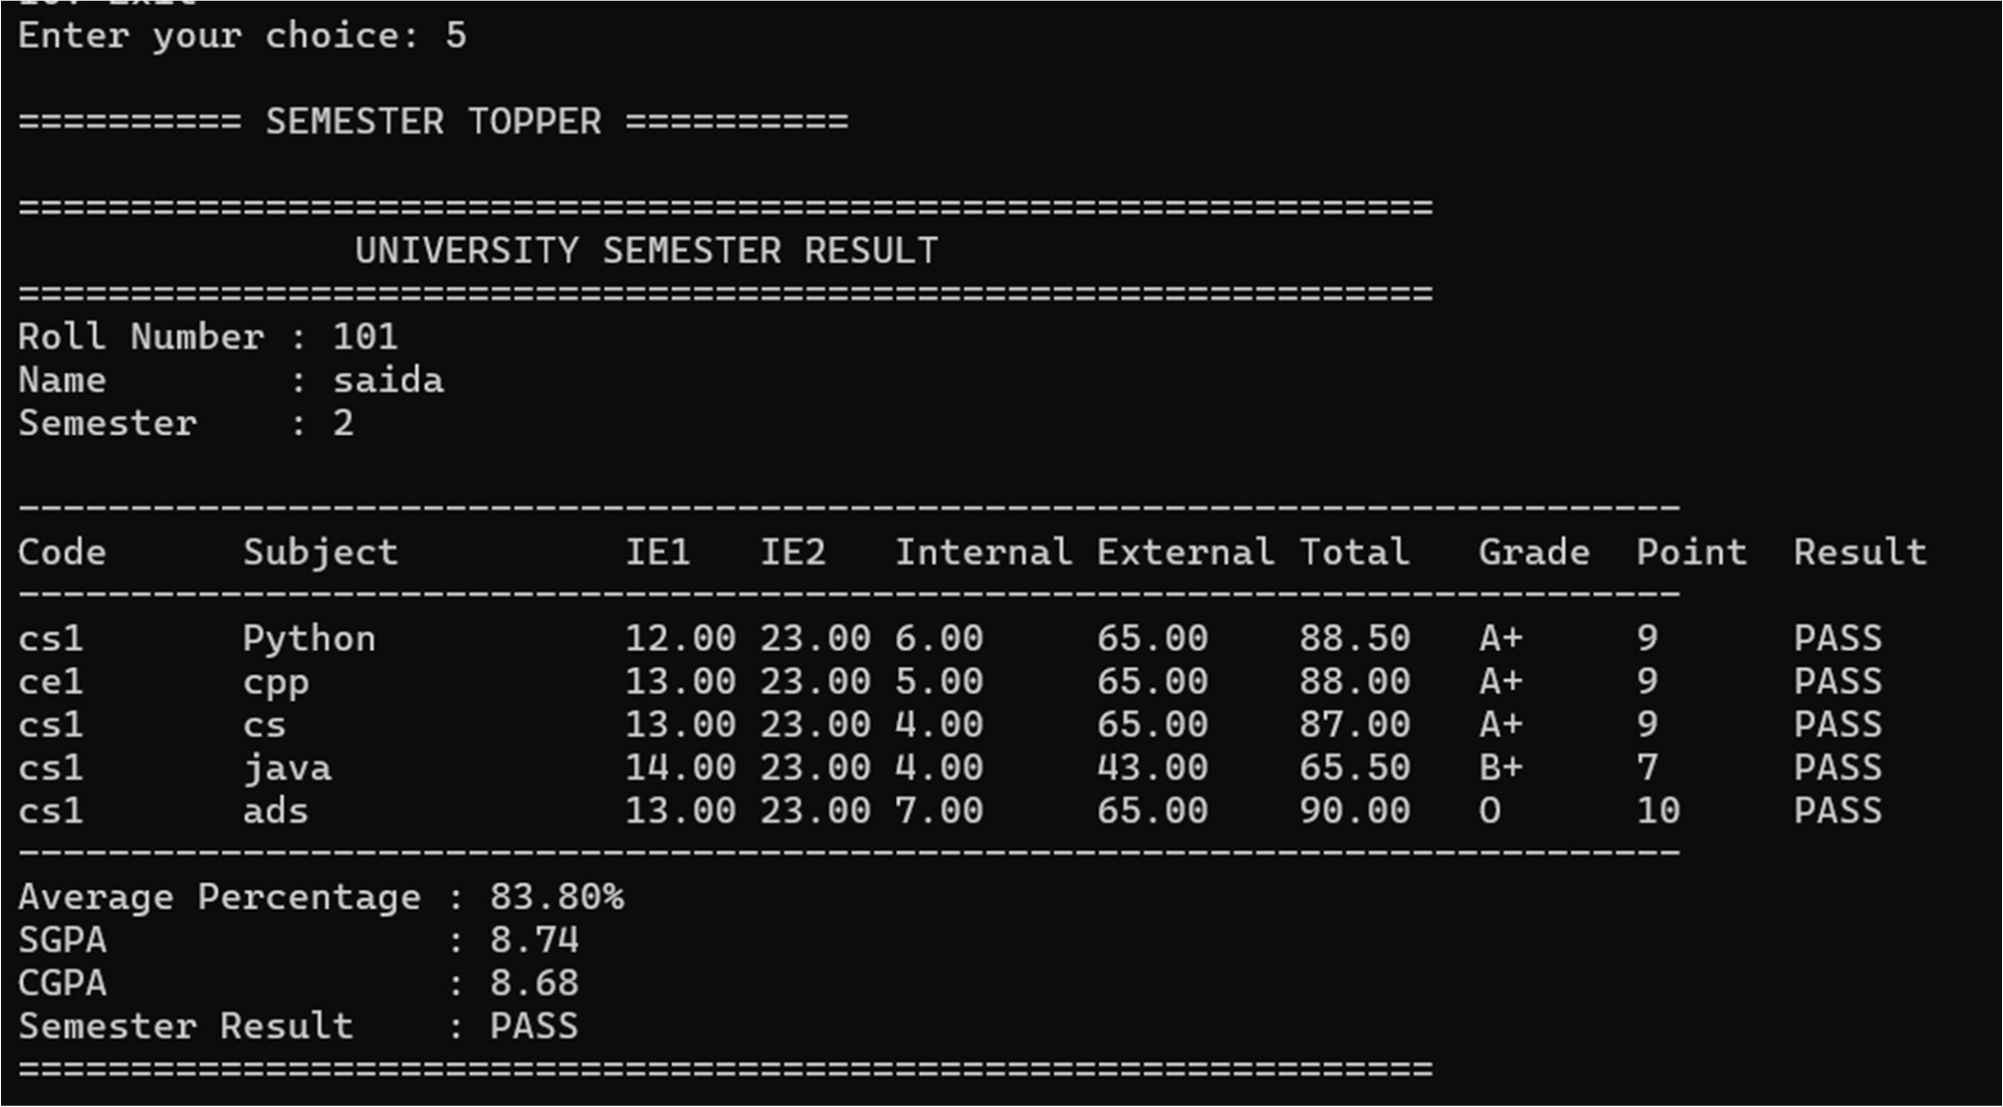

Figure 11 – Show Semester Topper

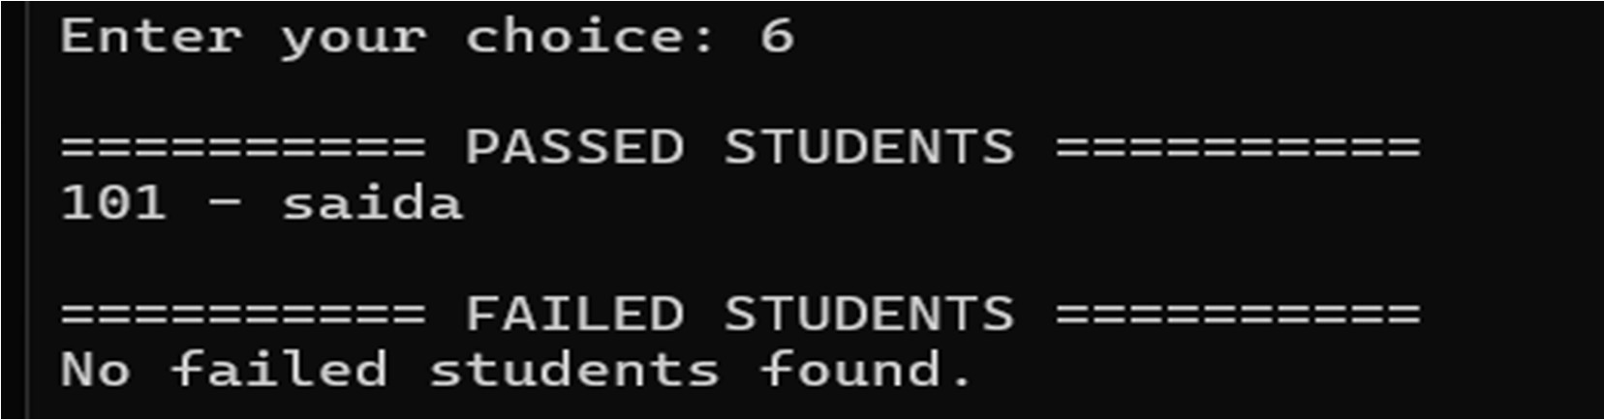

Figure 12 – Show Pass/Fail Student List
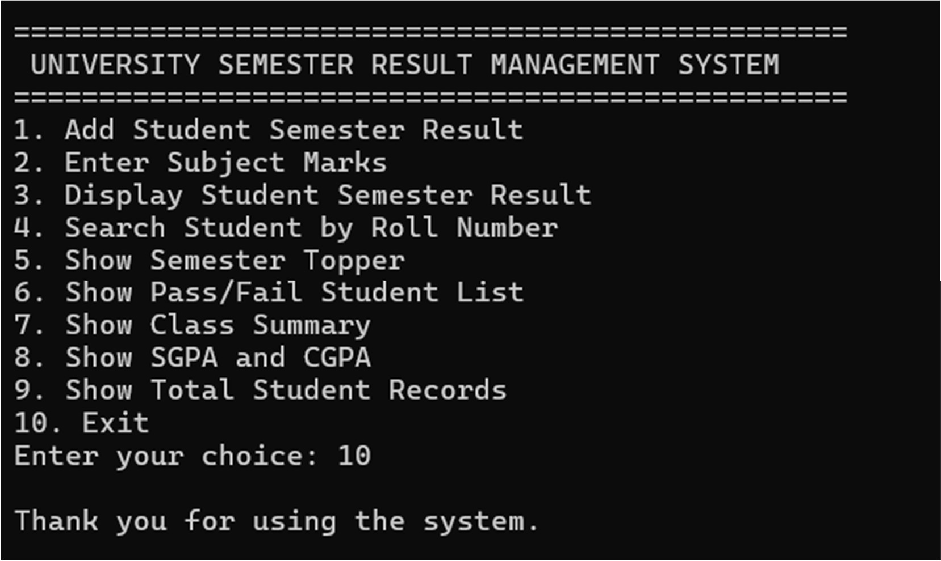
Figure 13 – Exit

Test Cases
These are proposed test cases. Record the observed result and pass/fail status after running them in a working C++ environment.

No. | Test case | Input or condition | Expected result
1 | Valid student registration | Unique roll number, valid name, semester 1 | Student record is added
2 | Duplicate registration | Enter an existing roll number | Duplicate message; record is not added
3 | Invalid semester | Enter a value outside 1–8 | Range validation message and another prompt

4 | Invalid marks | Enter a value outside the allowed range | Range validation message and another prompt
5 | Missing student for marks entry | Enter an unknown roll number | Student-not-found message
6 | Subject passes | Total at least 40 and external marks at least 24 | Subject is marked PASS
7 | External requirement fails | Total at least 40 but external marks below 24 | Subject is marked FAIL
8 | Student result display | Search for a student with marks entered | Subject marks, grades, percentage, SGPA, CGPA, and semester result display
9 | Student has no marks | Search for registered student before marks entry | Marks-not-entered message
10 | Topper report | At least one student has marks entered | Student with the highest SGPA is displayed
11 | Class summary | Multiple students have results | Result, pass, fail counts, and average SGPA display
12 | Menu input outside range | Enter a value outside 1–10 | Range validation message and another prompt

Input and Output Summary

Inputs | Outputs
Roll number, name, semester | Registration confirmation or duplicate message
Previous credits and CGPA for semesters after 1 | Student record with prior academic totals
Subject code, name, credits, and marks | Subject grade, grade point, and pass/fail result
Menu selection and roll number | Student result or not-found message
Report selection | Topper, pass/fail list, class summary, or total record count

CHAPTER 3
CONCLUSION & FUTURE SCOPE

Conclusion
The Student Result Management System demonstrates how C++ can be used to organize student and semester result data. It accepts marks for five subjects, calculates subject grades and averages, and provides student and class reports.
The project uses a Student class, a Subject structure, arrays, vectors, member functions, loops, and input validation. Its current records exist only while the program runs, making it suitable as a basic console-based academic project.

Future Scope
    - ◻ Save student records and results to files or a database.
    - ◻ Add editing and deletion of student records.
    - ◻ Support configurable subject counts and grading scales.
    - ◻ Generate printable result sheets.
    - ◻ Add separate subject and semester reports.
    - ◻ Add a graphical or web interface.
    - ◻ Add authentication for staff and administrators.
    - ◻ Export result data to CSV or spreadsheet files.

REFERENCES

      - B. Stroustrup, The C++ Programming Language, 4th ed., Addison-Wesley, 2013.
      - E. Balagurusamy, Object-Oriented Programming with C++, McGraw Hill Education.
      - C++ Standard Library documentation.
      - Course material for Object Oriented Programming through C++ ([course code], [institution]).
      - Student Result Management System project source code.

APPENDIX
TEAM MEMBERS AND RESPONSIBILITIES

Roll No. | Name | Role / Responsibility
25B11AIA99 | SHAIK.BALASAIDA | Student class and registration
25B11AI666 | M.SUSWAR | Marks entry and result calculations
25B11AI040 | G.AJAY KUMAR | Search, reports, and menu operations
25B11AI087 | N.JAYA NAGA SATISH | Documentation and result verification

